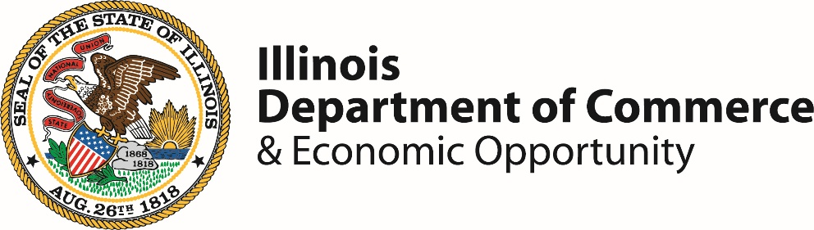

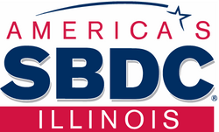
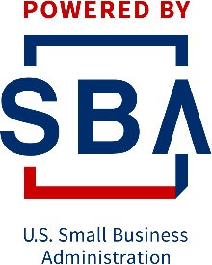
2026 NOFO
Illinois SBDC Program
Frequently Asked Questions
Contents
Illinois SBDC Program Frequently Asked Questions 3
Introduction 3
Eligibility and Program Basics 3
Q. What is the mission and value proposition of the Illinois SBDC Network? 4
Q. Who is eligible to apply for funding under this NOFO? 4
Q: If we apply as an SBDC Center and are not approved, are we still eligible for consideration as a satellite? 4
Q. What is the period of performance? 4
Specialty Designations 5
Q. What is a specialty designation? 5
Q. Who is eligible to apply for a specialty designation? 5
Q. What are the specialty designation options? 5
Q. What is an ITC? 5
Q. What is the manufacturing specialty designation? 5
Q. Are there additional performance metrics required of specialty designations? 5
Q. How do I apply for a specialty designation? 5
Q. Can I apply for more both specialty designations? 5
Q. Are specialty designations funded separately? 6
Q. Should I include my anticipated costs for operating a specialty designation in my SBDC budget and application? 6
Program Structure & Roles 6
Q. What are the staffing requirements for an SBDC? 6
Q. What are the staffing requirements for specialty designations like ITC or Manufacturing? 6
Q. Can we use volunteers or interns in our staffing model? 6
Q. What are the branding and marketing requirements? 6
Funding, Match & Budget 6
Q. What are the funding amounts and match requirements? 6
Q. Is this a reimbursement-based grant? 6
Q: What is the match requirement? 6
Q: What qualifies as cash match? 7
Q. Are there restrictions on indirect costs? 7
Q. What are the budget submission requirements? 7
Performance & Metrics 7
Q: How will metrics be assigned? 7
Q: What is expected of staff regarding advising hours? 7
Q. What are the performance expectations? 7
Q. What are the reporting and compliance requirements? 7
Submission & Deadlines 8
Q: What is required for application submission? 8
Q: When is the application due? 8
Q: How should applications be submitted? 8
Q. What is the review process? 8
Q. When will we know if we receive an award? 8
Q. Where can I get help or more information? 8

Illinois SBDC Program Frequently Asked Questions

Introduction
This Frequently Asked Questions (FAQ) document has been developed to accompany the 2026 Notice of Funding Opportunity (NOFO) for the Illinois Small Business Development Center (SBDC) Program. The information contained below consolidates common inquiries received from current and prospective centers. All responses below are taken from the posted NOFO and Illinois SBDC Program Requirements & Definitions Guide.

While this document is intended to serve as a practical resource to aid applicants in the preparation of compliant and competitive proposals, it does not replace or supersede the requirements of the NOFO, the Cooperative Agreement, or applicable state and federal regulations. In the event of a conflict, the NOFO and governing regulations shall prevail.

Eligibility and Program Basics

Q. What is the mission and value proposition of the Illinois SBDC Network?
A. Mission: The Illinois SBDC Network’s mission is to provide professional guidance for business growth.
Value Proposition: The Illinois Small Business Development Center (SBDC) Network supports thousands of businesses like yours, providing valued assistance to launch dreams, secure financing, and increase profitability. We deliver expert small business guidance and connect owners to vital resources needed to compete, grow, and succeed. We provide confidential, professional business advice, strengthened by our experience, expertise, and specialized training. As your trusted partner, we are focused on your success. The services provided by Illinois SBDCs, SBDC International Trade Centers (ITC) and the Apex Accelerator program set the stage for personal and professional growth, which directly impacts our local economies for the better.

Q. Who is eligible to apply for funding under this NOFO?
A. Eligible applicants include:
- Accredited institutions of higher education (public/private universities, community colleges)
- Nonprofit organizations engaged in economic development
- Local governments with economic development departments
- Public economic development institutions (e.g., workforce boards, EDCs)

Applicants must:
- Be in operation for at least 5 years
- Be fiscally sound and able to cash flow operations
- Have experience managing government funds
- Define a clear service area by county (or neighborhood in Cook County)

Q: If we apply as an SBDC Center and are not approved, are we still eligible for consideration as a satellite?
A: Yes. Please note interest of being a satellite within your program application.

Q. What is the period of performance?
A. The grant covers a three-year period (January 1, 2026 – December 31, 2028), with annual grant agreements.

Specialty Designations

Q. What is a specialty designation?
A. A specialty designation within the Illinois SBDC program refers to an optional, enhanced service focus that a host organization can apply for in addition to operating a standard SBDC service center. These designations allow centers to provide targeted expertise in specific areas of business development that align with state and federal priorities.

Q. Who is eligible to apply for a specialty designation?
A. Organizations that have operated an SBDC for at least three years are eligible to apply for a specialty designation.

Q. What are the specialty designation options?
A. There are two types of specialty designations: International Trade Center (ITC) and Manufacturing

Q. What is an ITC?
A. An ITC provides technical assistance to small businesses as they expand into international markets.
Services provided by an ITC include:
- Export readiness assessments
- International market research
- Export documentation and compliance
- Trade mission participation
- Export sales strategy development

Q. What is the manufacturing specialty designation?
A. The manufacturing specialty designated centers will provide technical assistance and support to small manufacturers and businesses involved in onshoring.
Services provided by the manufacturing specialty include:
- Advising on advanced manufacturing technologies (e.g. automation, AI, cybersecurity)
- Lean practices and process improvement
- Workforce and supply chain strategies

Q. Are there additional performance metrics required of specialty designations?
A. Yes. These designations come with additional performance metrics and reporting requirements. Additionally, specialty designations must coordinate statewide with fellow specialty designations to avoid duplication and ensure consistent service delivery.

Q. How do I apply for a specialty designation?
A. To apply for a specialty designation, complete Section 5 of the program application.

Q. Can I apply for more both specialty designations?
A. Yes. You may apply for one or both specialty designations in the same application.

Q. Are specialty designations funded separately?
A. No. Specialty designations are not funded separately but are included in your total award request.

Q. Should I include my anticipated costs for operating a specialty designation in my SBDC budget and application?
A. Yes.

Program Structure & Roles

Q. What are the staffing requirements for an SBDC?
A. SBDC’s must have a full-time Director, full-time program coordinator/administrative assistant, and several business advisors/consultants based on client needs.

Q. What are the staffing requirements for specialty designations like ITC or Manufacturing?
A. ITC’s must have a full-time Director and full-time Trade Specialist. Manufacturing must have a full-time Manufacturing Specialist. Both specialties may share administrative support with the SBDC.

Q. Can we use volunteers or interns in our staffing model?
A. Yes. Use of part-time staff, interns, faculty, consultants, and volunteers is encouraged.

Q. What are the branding and marketing requirements?
A. Centers must follow the Illinois SBDC branding and marketing guide, including display SBDC signage prominently, both internally and externally to the center. The branding and marketing guide will be provided to centers upon grant award.

Funding, Match & Budget

Q. What are the funding amounts and match requirements?
A: Awards range from $80,000 to $525,000 per year
- A 100% match is required (50% must be cash, 50% may be in-kind)
- Cash match must be committed upfront and documented

Q. Is this a reimbursement-based grant?
A. Yes, the Illinois SBDC program is a reimbursement-based grant. All costs must be incurred, documented, and reported before reimbursement is issued.

Q: What is the match requirement?
A: All awardees must provide a 100% match, of which 50% must be a cash match. In-kind contributions and indirect costs cannot be counted toward the 50% cash match requirement. Match must be committed upfront, identified by source, and verifiable back to the service center ledger

Q: What qualifies as cash match?
A. Cash match may include host institution funds, local or state government contributions, contributions from private donors.

Q. Are there restrictions on food costs?
A. Yes. Limited reasonable food costs are allowed. Any events must be four hours or more in duration to provide a reasonable meal (i.e. box lunch). Anything under four hours a light beverage and light snack are acceptable. All food costs should be approved by the lead center before procuring. Effort should be made to seek sponsorships/donations for food items.

Q. Are there restrictions on indirect costs?
A. Yes. Indirect costs cannot be charged to the grant but may be used as in-kind match if properly documented and approved.

Q. What are the budget submission requirements?
A. Applicants must complete the Uniform Budget Template provided with the NOFO materials. This budget must reflect one-year of funding being requested, including match (cash & in-kind) contributions.

Performance & Metrics

Q: How will metrics be assigned?
A: Performance metrics will be assigned based on the proposed scope of work submitted and data such as population, regional business demographics, historical performance, and strategic priorities of the Lead Center.

Q: What is expected of staff regarding advising hours?
A: Each professional full-time staff must provide a minimum of 1,100 hours of direct one-on-one advising per $80,000 in funding. Directors: ~60% advising; Advisors: ~75% advising

Q. What are the performance expectations?
Centers must track and report:
- Jobs created/retained
- New business starts
- Capital infusion (debt/equity)
- Advising hours (minimum 1,100 per $80,000)
- Training events
- Success stories (minimum 8/year)
- Stakeholder events (minimum 2/year)

Q. What are the reporting and compliance requirements?
A. Centers must submit:
- Quarterly performance and financial reports
- Cash Reimbursement Request Workbooks and Backup documentation
- Client advising notes and economic impact data
- Training documentation
- Time and effort certifications

Submission & Deadlines

Q: What is required for application submission?
A: Applications must include:
- Illinois SBDC Program Application
- DCEO Conflict of Interest Disclosure
- DCEO Mandatory Disclosure
- Uniform Budget Template
- Uniform Grant Applications
- Illinois SBDC Personnel Detail Form and Organizational Charts
- Proposed Scope of Work
- Proposed Training Calendar
- Listing of Office Closures and Holidays for Program Year 2026
- Letters of Support (optional)
- Listing of Satellite Locations (if applicable)

Q: How should applications be submitted?
A: Applications must be submitted electronically through [system name]. Paper applications will not be accepted.

Q. What is the review process?
A. Applications are scored on a 300-point scale based on:
- Need (100 points)
- Capacity (150 points)
- Quality (50 points)
- Specialty designations (50 additional points for 350/400 point totals dependent on the number of designations being applied for).

Q. When will we know if we receive an award?
A. Intent to fund notifications are scheduled for mid-December 2025.

Q. Where can I get help or more information?
Contact: Ericka A. White
Illinois Department of Commerce & Economic Opportunity
Ericka.White@illinois.gov

