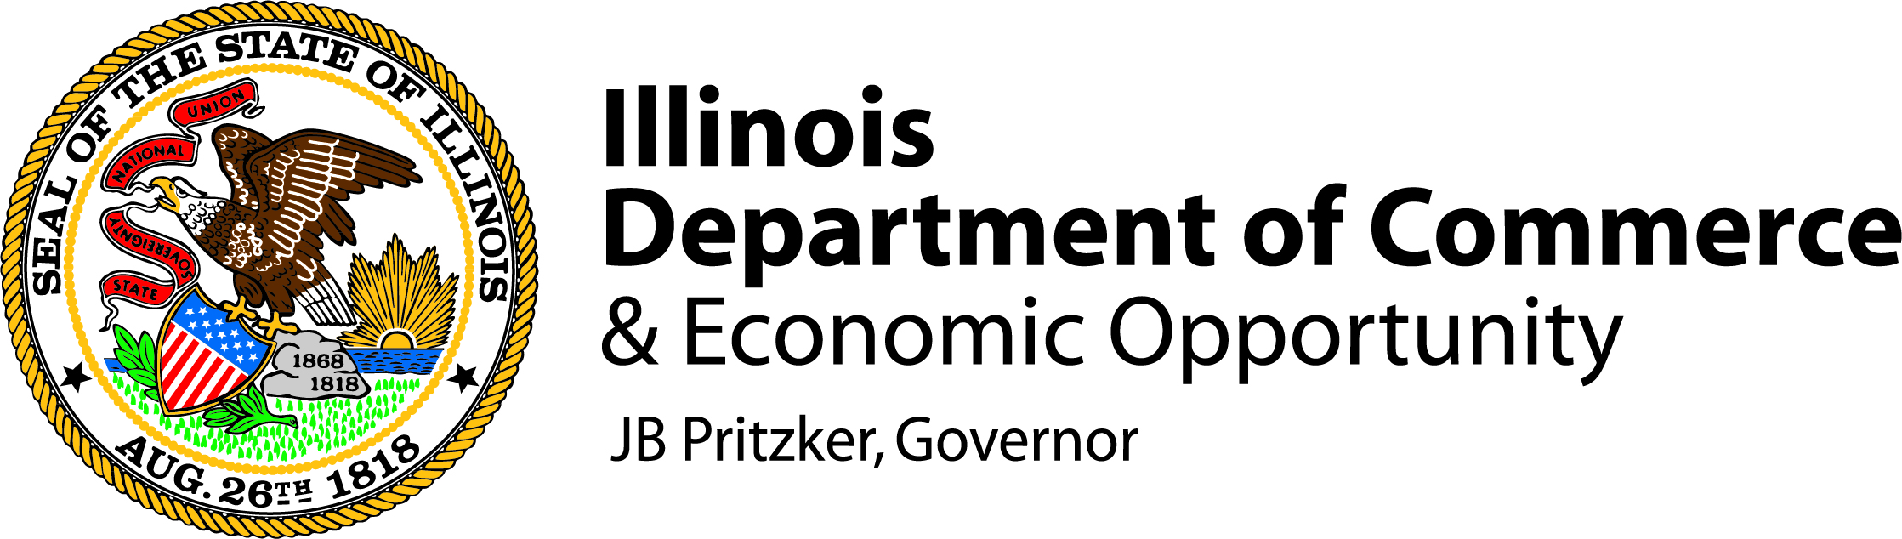

Cannabis Social Equity Direct Forgivable Loan Program
Demographic Disclosure Survey

Applicants are encouraged to answer all the questions below.
This information is being collected to help analyze the populations that are being funded through the Cannabis Social Equity Direct Forgivable Loan Program.*

Legal Name: | Click or tap here to enter text.
1. Minority-owned or controlled business status
For purposes of this form, minority individual means a natural person who identifies as American Indian or Alaska Native; Asian American; Black or African American; Hispanic or Latino/a/x; Native Hawaiian or Other Pacific Islander; or one or more than one of these groups. For purposes of this form, an applicant is a minority-owned or controlled business if the business meets one or more of the following:
(1) if privately owned, 51% or more is owned by minority individuals; (2) if publicly owned, 51% or more of the stock is owned by minority individuals; (3) in the case of a mutual institution, a majority of the board of directors, account holders, and the community which the institution services is predominantly comprised of minority individuals; or (4) one or more minority individuals have the power to exercise a controlling influence over the business.
Is the applicant a minority-owned or controlled business? |  | ☐ Yes | ☐ No | ☐ Prefer not to respond
2. Women-owned or controlled business status
For purposes of this form, an applicant is a women-owned or controlled business if the business meets one or more of the following:
(1) if privately owned, 51% or more is owned by females; (2) if publicly owned, 51% or more of the stock is owned by females; (3) in the case of a mutual institution, a majority of the board of directors, account holders, and the community which the institution services is predominantly comprised of females; or (4) one or more individuals who are females have the power to exercise a controlling influence over the business.
Is the applicant a women-owned or controlled business? |  | ☐ Yes | ☐ No | ☐ Prefer not to respond
3. Veteran-owned or controlled business status
For purposes of this form, an applicant is a veteran-owned or controlled business if the business meets one or more of the following:
(1) if privately owned, 51% or more is owned by veterans; (2) if publicly owned, 51% or more of the stock is owned by veterans; (3) in the case of a mutual institution, a majority of the board of directors, account holders, and the community which the institution services is predominantly comprised of veterans; or (4) one or more individuals who are veterans have the power to exercise a controlling influence over the business.
Is the applicant a veteran-owned or controlled business? |  | ☐ Yes | ☐ No | ☐ Prefer not to respond

Each owner(s) of the applicant is encouraged to answer the questions below.
This information is being collected to help analyze the populations that are being funded through the Cannabis Social Equity Direct Forgivable Loan Program.

For each owner(s), indicate which of the following categories the owner(s) identifies with. Submit a separate copy of this table for each owner(s).

Owner Name: Click or tap here to enter text.
Percentage of ownership interest: Click or tap here to enter text.%

1. Race, Ethnicity, and National Origin (select as many as apply)
☐ African American / Black  ☐ Hispanic / Latino / Latina / Latine / Latinx  ☐ White / Caucasian  ☐ Prefer to specify: Click or tap here to enter text.  ☐ Prefer not to answer | ☐ East or Southeast Asian (please specify: Click or tap here to enter text.)  ☐ South Asian (please specify Click or tap here to enter text.)  ☐ Middle Eastern and North African (please specify: Click or tap here to enter text.)  ☐ Native American / American Indian / Alaskan Native / Pacific Islander / Native Hawaiian
2. Gender Identity  ☐ Male  ☐ Female  ☐ Non-binary or prefer to specify: Click or tap here to enter text.  ☐ Prefer not to answer | 3. Do you identify as LGBTQIA+?  ☐ Yes (please specify: Click or tap here to enter text.)  ☐ No  ☐ Prefer not to answer  4. Do you identify as Transgender?  ☐ Yes  ☐ No  ☐ Prefer not to answer
5. Spoken Languages  Primary Language: Click or tap here to enter text.  Second/Additional Language(s): Click or tap here to enter text. | 6. Age  ☐ Under 21 years old  ☐ 21-30 years old  ☐ 31-40 years old  ☐ 41-50 years old  ☐ 51-60 years old  ☐ 61-70 years old  ☐ 71 or more years old  ☐ Prefer not to answer
7. Veteran  ☐ Yes (branch: Click or tap here to enter text.)  ☐ No  ☐ Prefer not to answer | 8. Person with Disability (as defined in the Business Enterprise for Minorities, Women, and Persons with Disabilities Act, 30 ILCS 575)  ☐ Yes (what is your disability: Click or tap here to enter text.)  ☐ No  ☐ Prefer not to answer

