2023
Community Development Block Grant (CDBG)
APPLICATION GUIDEBOOK AND FORMS

Funded by the U.S. Department of Housing and Urban Development
Title I, Housing and Community Development Act of 1974 (42 U.S.C. 5301 et seq.).
Regulations: 24 CFR 570, 2 CFR 200

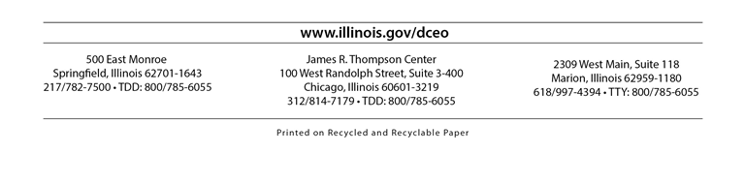
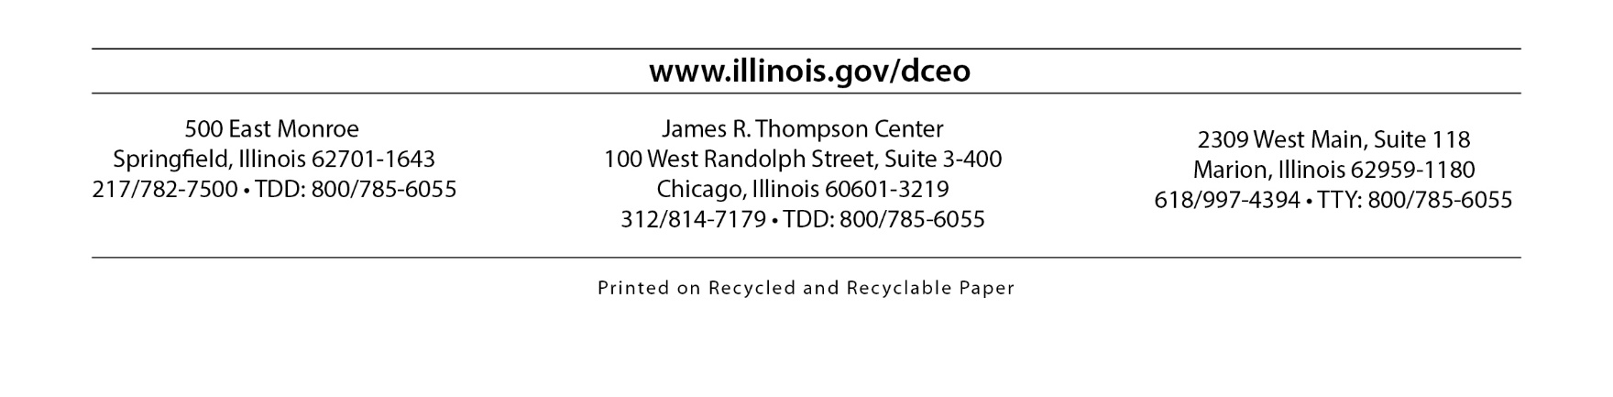
Office of Community Development
1 West Old State Capitol Plaza
Springfield, Illinois 62701
217/785-6174
2309 West Main, Suite 118
Marion, Illinois 62959-1180
618/997-4394

TABLE OF CONTENTS

SECTION I: OBJECTIVES AND GENERAL APPLICANT INFORMATION PAGE

Federal and State Program Objectives 2
A. Funding Availability 3
B. Eligible Applicants 4
C. Ineligible Communities 4
D. Application Materials 5
E. Technical Assistance 5

SECTION II: CDBG PROGRAM INFORMATION AND POLICIES

A. Requirements and Disclaimers 8
B. State and Federal Compliance Areas 10
C. Citizen Participation 11
D. Activity Delivery Costs and Associated Costs 13
E. Initial Grantee Responsibility 14

SECTION III: COMPETITIVE PUBLIC INFRASTRUCTURE (PI) PROGRAM

Funding Opportunity Information…………………………………………………………………….17
A. Eligible Activities 18
B. Ineligible Activities 20
C. Eligibility Thresholds 21
1. Low-to-Moderate Income Benefit Requirements 21
2. Documentation of Threat to Health and Safety 25
3. Water and Sewer Rates 26
D. Funding Sources 26
E. Narrative Responses 28 1. Letter of Transmittal 28
2. Project Summary 28
3. Project Readiness Summary 28
F. Inclusions 29
1. Project Maps 29
2. Engineer’s Cost Estimate 30
3. Fair Housing Resolution 30
G. Application Review and Evaluation Process 31
H. Ranking Criteria 32
1. Opportunity Zones 32
2. DCEO Underserved Area 32
3. Project Impact/Per Capita Cost 32
4. Additional Funding 33
5. Threat to Health & Safety/Urgency 33
6. Project Readiness 34
I. Submission Information 35
State of Illinois Uniform Grant Application 36
State of Illinois Uniform Budget Template 36
IRS Certification Letter 36
W-9 Form 36
SAM Registration/UEI# 36
Packaging Your Application 37
J. Application Forms 38
Letter of Transmittal 39
CDBG Submission Checklist/Table of Contents 40
State of Illinois - DCEO Uniform Grant Application 41
CDBG Applicant Project Information Public Infrastructure 42
Project Summary 44
Project Readiness Summary 45
FEMA Issued Floodplain Map 46
Project Maps 47
State of Illinois - Uniform Budget Template 48
Public Infrastructure Working Cost Estimate 49
Engineer’s Cost Estimate 50
Private Property Easements 51
LMISD Area Benefit Printout(s) 52
Low-to-Moderate Income Blending Worksheet 53
Analysis of Benefit to Low-to-Moderate Income Persons 54
Low-to-Moderate Income Survey Summary 55
Income Survey Worksheet 56
Income Survey Map 59
Minority Benefit/Affirmative Housing Statement 60
CDBG Community Need/Project Benefit Determination 61
Public Hearing Notice 62
Newspaper Clipping 63
Publisher’s Certification 64
Certified Minutes 65
Attendance Sheet(s) 66
Council Resolution of Support 67
Local Government Certifications 68
Mandatory Disclosures 69
Conflict of Interest Disclosure 70
Intergovernmental Cooperation Agreement 71
Health & Safety Documentation 72
Firm Documentation of Commitment from other Funding Source(s) 73
Copy of IEPA Construction Permit(s) 74
Copy of Water Purchase or Wastewater Treatment Agreement 75
Copy of Option to Purchase 76
Fair Housing Ordinance/Resolution 77
W-9 78
Sam Registration (UEI#) 79
IRS Certification Letter 80
GATA Registration Printout 81
Oversized Maps 82

SECTION IV: COMPETITIVE HOUSING REHABILITATION COMPONENT

Funding Opportunity Information…………………………………………………………………….84
A. Eligible Activities 85
B. Ineligible Activities 86
C. Eligibility Thresholds 86
D. Housing Rehabilitation Project Requirements 87
E. Narrative Responses/Inclusions 87
1. Letter of Transmittal 87
2. Project Summary 87
3. Housing Project Design 87
4. Project Maps 88
5. Firm Commitment Letters – “Coordination of Resources” 89
6. Cost Estimates for Housing Rehabilitation Work 89
F. Application Review and Evaluation Process 89
G. Ranking Criteria for Housing Rehabilitation 90
1. Project Need 90
2. Project Impact 91
3. Coordination of Resources 92
4. Project Readiness 93
H. Submission Information 93
Packaging Your Application 95
I. Application Forms 96
CDBG Submission Checklist and Table of Contents 97
Letter of Transmittal for Housing 98
State of Illinois – DCEO Uniform Grant Application 99
CDBG Applicant Project Information 100
Housing Fact Sheet 101
Project Summary 102
Housing Project Design 103
Housing Rehabilitation Working Cost Estimate 104
Income Survey Cover Sheet 105
CDBG Income Survey 106
Housing Needs Survey 107
Minority Benefit/Affirmative Housing Statement 108
Project Need Map of Community 109
Letters from General Contractors 110
Resumes/Copy of License of IDPH Inspector/Assessor 111
Cost Estimates of Three Specific Housing Units 112
Public Hearing Notice 113
Newspaper Clipping 114
Publisher’s Certification 115
Certified Minutes 116
Attendance Sheet(s) 117
Council Resolution of Support 118
Local Government Certifications 119
Mandatory Disclosures 120
Conflict of Interest Disclosure 121
Environmental Review for Activity/Project 122
Project Location Map 125
FEMA Issued Floodplain Map 126
Letters of Commitment for Leveraging Sources 127
Local Administrative Policy & Procedures Manual 128
Local General Contractor’s Information 129
Fair Housing Ordinance/Resolution 130
W-9 131
Sam Registration (UEI#) 132
IRS Certification Letter 133
GATA Registration Printout 134

SECTION V: ECONOMIC DEVELOPMENT PROGRAM

Funding Opportunity Information…………………………………………………………………………….136
- Application Requirements 136
- Eligible Activities 137
- Ineligible Activities 138
- Special Requirements 140
- Additional Program Information and Requirements 142
- Project Summary 143
- Project Location Map(s) 144
- Application Review and Evaluation Process 144
1. Project Benefit 145
2. CDBG National Objective 145
3. CDBG Dollars 146
4. Resource Leveraging 146
5. Application Denial 146
I. Submission Information 147
Packaging Your Application 148
J. Application Forms 149
CDBG Application Submission Checklist 150
Letter of Transmittal 151
CDBG Applicant Project Information Economic Development Component 152
Project Narrative and Need for Assistance 154
ED Fact Sheet - General Supported Company Information 155
ED Fact Sheet - Supported Company Information History 158
ED Fact Sheet - General Supported Company Information -Products or Services 159
ED Working Cost Estimate 160
Projected Jobs Created and Jobs Retained 162
Analysis of Benefit to LMI Persons 163
K. Documentation/Certifications/Resolutions 164
Private Investment Commitment Letter 165
Business Certifications 166
Jobs created/Retained 167
Board Resolution - Designation of Authorized Official 168

SECTION VI: DISASTER RESPONSE PROGRAM

Funding Opportunity Information…………………………………………………………………..170
- Eligible Activities 171
- Ineligible Activities 171
- Eligibility Thresholds 171
- Documentation Requirements 171
- Narrative Response/Inclusions 172
- Letter of Transmittal 172
- Project Summary 172
- Project Maps 172
- Governor’s Disaster Declaration 172
- Application Review and Evaluation Process 172
- Submission Information 172
Packaging Your Application 174
- Application Forms 175
CD BG Disaster Response Application Submission Checklist 176
Letter of Transmittal 177
State of Illinois – DCEO Uniform Grant Application……………………………………….178
CDBG Applicant Project Information 179
Project Summary…………………………………………………………………………….180
Project Maps…………………………………………………………………………………181
FEMA Issued Floodplain Map………………………………………………………………182
State of Illinois – Uniform Budget Template………………………………………………..183
Force Account Labor Summary Record (FEMA Form 90-123) 184
Materials Summary Record (FEMA Form 90-124) 185
Rented Equipment Summary Form (FEMA Form 90-125) 186
Contract Work Summary Record (FEMA Form 90-126) 187
Force Account Equipment Summary Record (FEMA Form 90-127) 188
Disaster Response Costs Summary 189
Minority Benefit/Affirmative Housing Statement 190
Public Hearing Notice 191
Newspaper Clipping………………………………………………………………………….192
Publisher’s Certification……………………………………………………………………...193
Certified Minutes…………………………………………………………………………….194
Attendance Sheet(S)…………………………………………………………………………195
Council Resolution of Support………………………………………………………………196
Local Government Certifications……………………………………………………………197
Mandatory Disclosures………………………………………………………………………198
Conflict of Interest Disclosure 199
Intergovernmental Cooperation Agreement 200
Unit of Local Government’s Most Recent Financial Audit………………………………….201
Governor’s Diester Declaration……………………………………………………………...202
W-9…………………………………………………………………………………………..203
Sam Registration (UEI#) 204
IRS Certification Letter 205

SECTION VII: STANDARD DOCUMENTS & INFORMATION

State of Illinois - DCEO Uniform Grant Application 208
State of Illinois - Uniform Budget Template 209
Minority Benefit/Affirmative Housing Statement 210
Public Hearing Notice 211
Council Resolution of Support 212
Resolution of Support and Commitment of Local Funds 213
Local Government Certifications 214
Mandatory Disclosures 215
Conflict of Interest Disclosure 216
Intergovernmental Cooperation Agreement 218
Income Survey Cover Sheet, Community Development Survey 219
CDBG Income Survey 220
CDBG Housing Needs Guide 221
Housing Rehabilitation Request for Qualifications (RFQ) 222
Economic Development Job Classifications 227

