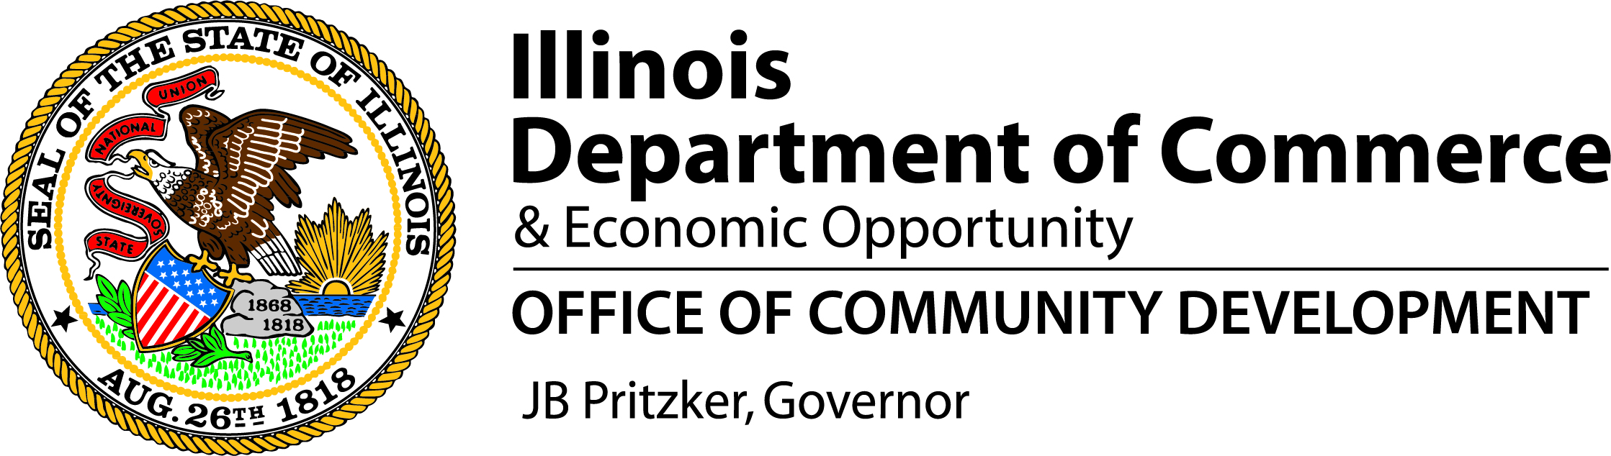

**Grant Administrators**

**and**

**Application Workshops**

**October 1 & 2, 2024**

**Northfield Conference Center**

**3280 Northfield Drive**

**Springfield, Illinois**

**Workshop Overview**

In an effort to streamline, reduce travel time and costs, the Department of Commerce and Economic Opportunity’s Office of Community Development is combining three specific training opportunities:

* **2025 Application Workshops for Community Development Block Grant Programs (CDBG)** 
  + All those who intend to write and submit an application for competitive CDBG programs (Public Infrastructure and/or Housing Rehabilitation) in December, 2024 must attend **both** the 2025 Application Workshop and the Grant Administrator’s Workshop
* **Administrator’s Workshop for CDBG funded grants**
  + All Grant Administrators of CDBG grants awarded in calendar year 2024 must attend.
  + All Local Governments awarded a CDBG grant in 2024 must send a representative (preferably the person handling financial transactions).
  + All Housing Inspectors for Housing Rehabilitation grants awarded in 2024 must attend the entire first half of the Administrator’s Workshop on October 1st, and are welcome to join us for lunch.
  + All those who intend to write and submit an application for competitive CDBG programs (Public Infrastructure and/or Housing Rehabilitation) in December, 2024 must attend **both** the 2023/2024 Application Workshop and the Grant Administrator’s Workshop
* **Administrator’s Workshop for recipients of an Urban Shelter Construction grant funded through Community Development Block Grant – Coronavirus (CDBG-CV)**
  + All staff related to fiscal and performance requirements of the grant as well as the grant administrators are required to attend this Workshop.

**All educational sessions will be held in Northfield Center I while breaks and lunch are in Center II.** We have planned the sessions in a way that some attendees will not need to spend the night while others will have the opportunity to travel in the morning and just stay one night. As requested by our Administrators, we have structured the sessions so components do not overlap. See Agenda on the next page for details.

**Registration and Lodging Information**

* There is no fee for this Workshop. However, please plan to pay for your personal meals, travel and lodging.
* Please register for all the program segments you plan to attend. This will allow us to plan refreshments appropriately.
* Please include the grant numbers for the grant(s) you received or are administering on the registration form to ensure proper credit for attendance.
* In an effort to reduce waste, all registration forms must be filled out and returned electronically to [ceo.cdbg@illinois.gov](mailto:ceo.cdbg@illinois.gov) by **Friday, September 20, 2024.** A confirmation e-mail will be sent upon registration.
* Northfield has reserved a block of rooms for our conference attendees. Please call 217/523-7900 and ask for the CDBG room block. Room fees will be the standard state rate of $107/night plus tax. A continental breakfast is available for registered guests.

**Tentative Agenda**

# Tuesday, October 1, 2024

|  |  |
| --- | --- |
|  |  |
| 8:00 AM | Registration Opens |
|  | Continental Breakfast *– Center Il* |
| 9:00 AM – 12:15 PM | **CDBG Administrator’s Workshop –** *Center I* |
|  | *Environmentals, Procurement, BABA, Labor Standards, Section 3, Construction Management* |
| 12:45 PM – 2:00 PM | Lunch will be provided - *Center II* |
| 1:45 PM – 4:30 PM | CDBG Administrator’s Workshop (continued) |
|  | *Cash Draws, Modifications, Reports, Closeouts, Record Retention, Monitoring, Common Mistakes, Review and Prizes* |

# Wednesday, October 2, 2024

|  |  |
| --- | --- |
|  |  |
| 8:00 AM | Registration Opens for Application Workshop |
| 8:30 AM – 12:30 PM | **2025 CDBG Application Workshop –** *Center I* |
| 1:00 PM | Registration Opens for Urban Shelter Workshop |
| 1:30 PM – 5:00 PM | **CDBG-CV Urban Shelter Administrator’s Workshop –** *Center I* |

**Workshop Materials** will be e-mailed the week of September 23rd to all those registered.

**PLEASE MAKE AND BRING COPIES WITH YOU.** Copies will not be available at the Workshop.

**FOR QUESTIONS –** please email [ceo.ocd@illinois.gov](mailto:ceo.ocd@illinois.gov) or call 217/558-4222.

