STATE OF ILLINOIS


CDBG DISASTER RECOVERY "IKE" PROGRAM
Special Allocation of the Community Development Block Grant (CDBG) Program

Housing Repair/Rehabilitation and Reconstruction Program (HRR)

APPLICATION GUIDEBOOK & FORMS
(IKE-HRR) Applications

* * *
IKE-HRR Applications Can Be Submitted Between
March 12, 2012 – april 16, 2012

* * *
Guidebook Updated March 05, 2012
* * *


CDBG DISASTER RECOVERY "IKE" PROGRAM
Special Allocation of the Community Development Block Grant (CDBG) Program
Housing Repair/Rehabilitation and Reconstruction Program (HRR)
Application Cover Sheet

* * *

Ike-HRR APPLICATIONS May be Submitted between
March 12, 2012 thru April 16, 2012
* * *

Please Complete the application information/ forms in Parts I & II

Mail or deliver one (1) signed original APPLICATION Packet with (1) one copy of the APPLICATION packet to:

Illinois Department of Commerce and Economic Opportunity
Attn: IKE- HRR APPLICATION
Office of Community Development
500 E. Monroe Street
Springfield, IL 62701

(Electronic or facsimile copies will not be accepted.)

For further information, contact:
DCEO CDBG Program Office-Springfield
(217) 785-6174;
TDD: (800) 785-6055
If you have questions concerning the Ike- APPLICATION process, please contact the
Ike Disaster Recovery Program office at 1-866-234-2065.

The Illinois Department of Commerce and Economic Opportunity (DCEO) is requesting APPLICATIONs for the CDBG “IKE” Disaster Recovery Housing Repair/Rehabilitation and Reconstruction Program from communities determined eligible under the CDBG “IKE” Disaster Recovery Program. DCEO is authorized to grant project funding for homeowner housing repairs for homes substantially damaged by the 2008 floods.

Program Purpose

Congress passed the Consolidated Security, Disaster Assistance, and Continuing Appropriations Act, 2009 (Pub. Law 110-329) on September 30, 2008, appropriating $6.5 billion through the Community Development Block Grant (CDBG) program for “...necessary expenses related to disaster relief, long-term recovery, and restoration of infrastructure, housing, and economic revitalization in areas affected by hurricanes, floods, and other natural disasters occurring during 2008 for which the President declared a major disaster...”.

The State of Illinois submitted its Community Development Block Grant- Disaster Recovery 1800 ("CDBG Ike") plan to HUD on September 30, 2009. Illinois received an official Notice of Award on February 3, 2010, in reflection of HUD's approval and acceptance of the plan. The Ike plan and other related updates can be found on DCEO's website at:

www.ildceo.net/DisasterRecovery

The purpose of the Housing Repair/Rehabilitation and Reconstruction Program (HRR) Application Guidebook is to provide guidance to the Applicant who is applying for disaster recovery funding through the Illinois Disaster Recovery Housing Repair/Rehabilitation and Reconstruction Program (HRR) administered by the Illinois Department of Commerce and Economic Opportunity (DCEO). The Consolidated Security, Disaster Assistance, and Continuing Appropriations Act, 2009 (Public Law 110-329), enacted on September 30, 2008, appropriated $6.5 billion through the Community Development Block Grant (CDBG) Disaster Recovery (DR) Program for “necessary expenses related to disaster relief, long-term recovery, and restoration of infrastructure, housing, and economic revitalization in areas affected by hurricanes, floods, and other natural disasters occurring during 2008 for which the President declared a major disaster…”. The CDBG DR Program is administered at the federal level by the U.S. Department of Housing and Urban Development (HUD). HUD reduced the amount of funding to $6.1 billion in response to a budget rescission requirement from Congress. The State of Illinois received a total of $169,191,249 from this appropriation. Of this amount $7 million has been allocated for housing repair and/or reconstruction projects.

The purpose of this guidebook is to solicit applications for these housing repair/reconstruction funds.
Each application received by DCEO will be evaluated in accordance with a pre-determined project evaluation and rating system based on the rating criteria identified in herein. The rating system includes a comprehensive process to evaluate and select projects on a competitive basis. This system is intended to objectively, equitably and consistently evaluate all applications received. Further, it ensures that all proposed projects are eligible activities and meet the requisite requirements of the CDBG DR Program. The projects selected must be approved by the Director of the DCEO.

The following sections provide an overview of the Illinois CDBG DR Program and the Housing Repair/Rehabilitation and Reconstruction Program (HRR) which includes program background information, eligible applicants, national objectives, eligible activities, and applicable federal regulations and program rules. The HRR Application Guidebook also includes the HRR Program application schedule and information about the application screening, evaluation and selection methodology.

Most importantly, the “Application Guidebook” includes the instructions that describe and explain the documentation that must be provided to properly quantify, qualify, and substantiate the proposal, as well as the “Application Forms” to be used by the Applicant.

IMPORTANT NOTICE

Please be sure to read all of the enclosed materials carefully prior to preparing the application. In order to be considered for funding, applications must satisfy the threshold criteria before the application will be rated and ranked. With the demand for grants typically far exceeding the funds available, the project evaluation and rating system is designed with strict parameters in order to promote objectivity, equity, and consistency in the rating and ranking of proposals. This selection system has been established with pre-determined evaluation elements that have specific point ranges and criteria assigned. As such, applications should be complete, include appropriate and quantifiable information, and be presented in a manner that will enable the application to be adequately screened (threshold criteria) and evaluated on all rating criteria.

The open application period begins on March 12, 2012 and ends on Monday, April 16, 2012 at 5 p.m. CST. The timeframe of the submission period is firm. Applications received by the DCEO after the date and time deadline will not be accepted. Only information submitted by the deadline will be considered in the selection process. DCEO may request additional information as needed and promulgated by the CDBG DR Program rules to comply with the State Action Plan and Amendments.

NOTE—there will be an IKE-HRR application conference call before the deadline to assist eligible local governments in the application process. Please monitor the Illinois "Ike" Disaster Recovery website for dates and times: www.ildceo.net/DisasterRecovery.

Funding Availability
The HUD approved Action Plan allocates $7,112,750 for the Housing Repair/Rehabilitation and Reconstruction Program (HRR). DCEO will attempt to award all HRR funding through the competitive round process.

Eligible Applicants

Eligible HRR applicants are restricted to:
- Local governments (including cities, towns, counties, etc.) within Illinois counties identified as federal disaster areas as a result of the disasters of 2008 (“Ike-eligible communities”). See Attachment A-2 for a list of qualifying counties.

Program Activities and Requirements
- CDBG National Objective Requirements:
Proposed projects seeking CDBG DR funding must meet the following national objective:
Principally benefit low- and moderate-income persons;
- Eligible Activities-Homeowner Rehabilitation or Reconstruction
To be eligible for the program all of the following requirements must be met:
- Home must have been damaged by the disaster
- Home must be a single family unit structure
- Home must be affixed to a permanent foundation on land owned by the property owner being assisted
- Dwelling and site is taxed as real property by the community
- Home must be located outside the 100 year flood plain
- Home must have been the homeowner’s primary residence
- Homeowner must have been the owner of record at the time of the disaster and continue to be the owner
- Homeowner must have applied to FEMA for disaster assistance
- Household must be considered Low and Moderate Income
- Home must still have an estimated minimum of $10,000 worth of damage

- Program Recipient Priorities:
Applicants who meet the following Priority Recipient designation will receive priority for funding.

Income:

Priority 1 – Low and Moderate Income under 50%
- Homeowners who are of low income defined as a household earning 50% or less of the Median Family Income for the County as published by the U.S. Department of Housing and Urban Development (HUD).

Priority 2 – Low and Moderate Income 50-80%
- Homeowners who are of low income defined as a household earning 50%-80% of the Median Family Income for the County as published by the U.S. Department of Housing and Urban Development (HUD).

Type of Remaining Damage:

Priority 1 - $28,800 or greater
- Applications for homes that have been severely damaged are considered Priority One Applicants and will be considered first for funding.
Priority 2 - $10,000 to $28,800
- Applications for homes that sustained high major damage are Priority Two Applicants and will be considered for funding once all Priority One applications have been funded.
Damage designations are based on FEMA damage assessment data. For those homeowners who did not receive FEMA funding and do not have a FEMA damage designation, HRR will use the homeowner’s insurance damage assessment.

Note that these priorities will be followed until funding runs out. It is conceivable that depending on the number of applicants qualifying under damage priority number one, funding could run out leaving unfunded requests under priority two.

4. Eligible Types of Assistance

Housing Rehabilitation/Reconstruction
Applicants may apply for assistance for housing repairs/reconstruction through the HRR. The level of damage to the home will determine the type of assistance received.

Housing Rehabilitation
Eligibility for rehabilitation requires that the 75% rule be met. The 75% rule states that a housing unit is suitable for rehabilitation if the estimated cost of improvements will be 75% or less of the pre-storm appraisal value. Estimated cost of improvements includes the damage from the disaster and code violations that are not associated with flood damage. Homes that qualify for housing rehabilitation assistance may receive up to $60,000.

Housing Reconstruction
Housing units which do not meet the 75% rule described above will be considered for reconstruction. Homes that qualify for reconstruction assistance may receive up to $100,000.

Elevation
The house must be elevated if it is located in a 500-year flood plain and the damages are considered a “Substantial Improvement”. A substantially improved building is one that will be reconstructed, rehabilitated, or otherwise be improved and the improvement cost equals or exceeds 50 percent of the market value of the structure before the start of construction. Properties with over 50% damage assessment will have to be raised to the Advisory Base Flood Elevation (meet National Flood Insurance Program (NFIP) minimum requirements, and current building code).

If elevation is required, a homeowner may receive up to an additional $40,000 to cover the costs of elevation in addition to any assistance provided under the Rehabilitation or Reconstruction categories.

Reimbursement
Homeowners, who have already completed all of the repairs, are not eligible for assistance or any reimbursement costs for repairs under the HRR.

- Additional Requirements:
  - Basic CDBG Requirements: All CDBG-funded activities are subject to a variety of applicable federal statutes and waivers. These requirements are defined at length within HUD’s regulations from Title 24 Part 570 of the Code of Federal Regulations (24 CFR Part 570).
  - Other Federal Requirements: Depending on the nature of the activity, a variety of additional statutory-regulatory requirements may accompany HRR activities, including but not limited to the following areas:
- Citizen Participation
- Environmental
- Uniform Administrative Requirements
- Document Management and Record Retention
- Labor Standards
- Procurement
- Acquisition and Relocation
- Financial Management
- Civil Rights (Fair Housing and Equal Opportunity)
- Other requirements as indicated via federal regulations
  - Disaster Requirements: Since the Ike program is funded via supplemental disaster appropriations, additional disaster-related requirements may be associated with the project activity. These requirements are primarily defined within the following statutes and regulations:
- Robert T. Stafford Disaster Relief and Emergency Assistance Act
- Consolidated Security, Disaster Assistance, and Continuing Appropriations Act of 2009 (Public Law 110.329)
- HUD disaster appropriation regulations found within the Federal Register at F.R. Vol. 74, No. 29 (02/13/2009) and F.R. Vol. 74, No. 156 (08/14/2009).
  - State and Local Requirements: Additional requirements (laws, regulations, codes, etc.) may be imposed at the state and local level, depending on the area and the activity. When a state/local requirement conflicts with a federal requirement, the more stringent of the requirements must be adopted.
- Duplication of Benefits: Disaster recovery and community development efforts can be funded by a number of entities (public and private). Any use of HRR funds must consider any other project funding sources and deduct all funds that could be considered a duplication of benefits. The DCEO will work with the FEMA Region V, Illinois Emergency Management Agency, U.S. Housing and Urban Development (HUD), the National Flood Insurance Program (NFIP), the U.S. Small Business Administration (SBA), private insurance carriers, and any other applicable organizations in order to assist local governments in determining any such duplication. Some sources of recovery/development funding include, but are not limited to:
  - FEMA benefits (Public Assistance, Individual Assistance, HMGP, etc.)
  - Army Corps of Engineers assistance
  - HUD community development programs
  - Other State or Charitable assistance

- Assurances: Each applicant must agree to comply with all applicable federal and state requirements. These can have a significant impact on the costs and complexity of a project. As part of this application, applicants will be required to sign assurances that they will comply with all federal program requirements. Some areas which applicants and DCEO must comply with include:
  - The National Environmental Policy Act (NEPA) established procedures for protecting the environment. In order to use the CDBG funds awarded, DCEO has to comply with environmental procedures, standards and guidelines mandated by NEPA and all other applicable environmental regulations (e.g., prime farmland protection, historic preservation, and floodplain hazards, etc.).
  - The Interagency Wetland Policy Act of 1989 requires applicants to certify that the proposed project is compatible with established State of Illinois policy regarding wetlands (i.e., to minimize the destruction of existing wetlands in Illinois as a result of state and state-supported activity).
  - The Illinois Endangered Species Protection Act and the Illinois Natural Area Preservation Act requires consultation with the Endangered Species Consultation Program of the Illinois Department of Natural Resources to assure compliance. The consultation process must be implemented to avoid or minimize adverse impacts to state listed species and their essential habitats that may result from the actions of state and local units of government. Applicants must certify the completion of the consultation process for all non-exempt proposed projects.
  - The Davis-Bacon Prevailing Wage Act requires the payment of prevailing wages for all construction funded in whole or in part with CDBG funds.
  - The Uniform Relocation Assistance and Real Property Acquisition Policies Act of 1987 applies to federally assisted activities that involve the acquisition of real property or the displacement of persons, including displacement caused by rehabilitation and demolition activities. Any person or business displaced as a direct result of federal assistance must be provided with Uniform Relocation benefits.
  - Equal Opportunity and Fair Housing Accessibility Laws require that CDBG grantees administer their project in a manner that affirmatively furthers equal opportunity and fair housing. All CDBG grantees will be required to undertake specific activities to further fair housing. CDBG grantees must assure all activities and services are accessible to persons with disabilities.
  - Section 3 under the Housing and Urban Development Act of 1968 requires recipients to give, to the greatest extent feasible and consistent with the existing federal, state, and local laws and regulations, job training, employment, contracting and other economic opportunities to Section 3 residents and Section 3 business concerns.
  - The regulations, policies, guidelines and requirements of 24 CFR Part 85 (local governmental recipients), Part 84 (Non-profits), OMB Circular Nos. A-87 (local governmental recipients), A-122 (Non-profits) and A-133 as they relate to the acceptance and use of federal funds under this federally assisted program; which requires recipients of federal funds establish a written procurement procedure that at a minimum avoids purchasing unnecessary items, provides analysis for the most economical and practical procurement of goods and services and states a clear and accurate description of the requirements for material, product or services procured.
  - The grantee will allow HUD, DCEO and/or any authorized representatives access to and the right to examine all records, books, papers or documents related to the grant.

Applicant Information

- Costs incurred in preparation of applications are not reimbursable under this grant program.
- DCEO reserves the right to reject any or all applications received, to negotiate or to cancel in part, or in their entirety, grants resulting from application awards if it is in their best interest to do so.
- DCEO reserves the right to withdraw a commitment for CDBG DR funds where special grant conditions have not been satisfied 90 days after the date of the executed grant agreement, or at the their discretion if it is determined the project will not progress.
- DCEO reserves the right to establish the amount of grant funds awarded. DCEO also reserves the right to award funds to the next highest rated application(s) should funds become available.
- DCEO reserves the right to deny funding when submitted applications involve eligible units of government with serious unresolved audit or monitoring findings related to performance capacity.
- DCEO will not allow any duplication of funding. Applicants must clearly indicate private insurance claims applicable to the project and any other Federal, State, or other assistance applicable to the project and deduct such assistance from the total project cost when identifying the gap and request CDBG disaster recovery assistance.

Application Process

- Technical Assistance
If you have questions concerning the Ike-HRR application process, please contact the Ike Disaster Recovery Program office at 1-866-234-2065.

- Citizen Participation Requirement:

Standard CDBG requirements for citizen participation have been waived for the CDBG disaster recovery programs. The applicant must post a notice concerning the project, allowing at least 7 days for citizen comment prior to submittal of an IKE application.

The notice should be posted in public buildings within the community with broad public use and should include information about the grant program, the proposed project, and the amount being requested. A copy of the notice should be included indicating the date it was posted and the location(s) where it was posted. The notice should also be placed on applicant’s website if available. A sample notice is provided in the Part II, Section 6.

- Application Submission Information
IKE-HRR Applications may be submitted between March 12, 2012 – April 16, 2012.

The following address should be used for the application submissions:

Illinois Disaster Recovery Program
Attn: Ike Housing Rehab & Repair Application
427 E Monroe, Suite 200
Springfield, IL 62701

The following must be submitted with the application:

- Original and one copy of the application. Be sure to clearly label the original.
- Original annual audit report for the fiscal year ending in 2009 of the applicant unit of local government.

- Threshold Criteria
In order to be considered for evaluation for funding the project must first meet certain minimum requirements as established by HUD and DCEO. These requirements are identified as “Threshold Criteria” and include application submission requirements, application eligibility, project eligibility, HUD national objectives, and DCEO action plan requirements.
The threshold criteria are:
a) The applicant local government must be an eligible applicant under Illinois IKE program and be located in one of the disaster declared counties (see Attachment A)
b) The activity must be eligible under the CDBG DR program pursuant to 24 CFR 570.200 – 570.205 and not expressly ineligible pursuant to 570.207. It must also be an eligible Ike-HRR project as specified in the Illinois Ike Action Plan, and any plan amendments, or amendments for Supplemental “Ike” Funding.
c) The project must meet the CDBG national objective of primarily benefitting persons of low and moderate income persons.
d) The project must address low and moderate income homeowners that were impacted by the 2008 floods.
Criteria for Selection
Each eligible application that has passed the threshold criteria screening will be reviewed, rated, and ranked by an evaluation and selection committee using the following criteria for selection.

The following are the criteria for rating and ranking applications:
- Level of seriousness by county (see Attachment F)- Maximum of 40 points
- Low and Moderate Income- Maximum of 20 points
- Level of remaining damage- Maximum of 20 points
- Elderly- Maximum of 10 points
- Disabled- Maximum of 10 points
The rating factors and possible points awarded for each are as follows:
Selection Criteria | Score
a) Damage  1. Level of seriousness >.10  2. Level of seriousness <.10 | 40 points  20 points
b) LMI 0-50%  75-100% homeowners on app  50-75% homeowners on app  25-50% homeowners on app  0-25% homeowners on app | 20 points  15 points  10 points  5 points
c) Damage $28,800 or more  75-100% homeowners on app  50-75% homeowners on app  25-50% homeowners on app  0-25% homeowners on app | 20 points  15 points  10 points  5 points
e) Elderly (62 or older)  75-100% homeowners on app  50-75% homeowners on app  25-50% homeowners on app  0-25% homeowners on app | 10 points  7 points  4 points  0 points
f) Disabled  75-100% homeowners on app  50-75% homeowners on app  25-50% homeowners on app  0-25% homeowners on app | 10 points  7 points  4 points  0 points
As outlined above, if selected, applicants will be held accountable for delivering on their projections (e.g. total units, total low income units, etc.) and will risk jeopardizing their award if they are not able to meet the goals stated in the application for funding.

DCEO will review and rank the applications based on the principles outlined above. Jurisdictions will be encouraged to maximize the number of units that require significant rehabilitation or replacement, the number of units that will serve low income families, elderly, and disabled. Jurisdictions will be asked to submit a list of expressions of interest from homeowners with damage to support their applications. Based on these rankings, DCEO will make a conditional allocation to those jurisdictions with the highest rankings. DCEO reserves the right to make conditional awards that are less than the full amount contained in the jurisdiction’s applications.
Those counties that receive a conditional allocation will then be given 30 days to provide a final list of the homeowner applicants and addresses with the homeowner applicant survey completed for each homeowner. The amount of proposed rehabilitation on this list must be at least 130 percent greater than the jurisdiction’s conditional allocation amount in order to compensate for homeowner applicants that may not be able to meet the program requirements and therefore drop out of the program. The jurisdiction must ensure that they are able to achieve its program objectives with regard to targeting low income and special needs populations and directing funds to “high need” target areas. Once this information and the necessary supporting documentation is received and reviewed, the community will receive its official funding allocation. If one or more of those jurisdictions that are selected for a conditional allocation do not provide the required list of projects within the allowable time frame, they will be dropped from the program and replaced by the next highest ranking jurisdiction.

- Application Review:
The HRR Application (Parts I and II of this guidebook) must be submitted along with the HRR Program Cover Sheet (Page two of this guidebook). Applications will be reviewed in accordance with the guidelines set forth for this program as established by the State of Illinois Ike Action Plan, all relevant Ike plan amendments and the content of this guidebook. DCEO will subsequently make public announcement of the award decisions in a manner it determines appropriate. DCEO reserves the right to request additions, modifications, and/or clarifications to submitted applications.

Administrative Costs
Applicant jurisdictions will not be responsible for the day to day management of this program. DCEO/HRR case managers will determine homeowner eligibility and verify income. In addition, DCEO/HRR is responsible for conducting inspections, developing scopes of works, selecting contractors, and overseeing the construction process. However, if selected, the applicant jurisdiction will be responsible for marketing the program and for ensuring that a sufficient number of eligible homeowner applications are received and forwarded to the HRR review team put in place by DCEO. Applicant jurisdictions are eligible for one percent of the total award for marketing and outreach to eligible homeowners.

Applicant/Grantee Disclosure
Subsequent to Section 102 of the Housing and Urban Development Reform Act of 1989, a number of provisions ensure greater accountability and integrity in the way HUD and its grantees make funds available. The HRR is one of the HUD programs covered by Section 102. Applicants will be required to complete a disclosure form (attached) at the time of application.

Project Maps:
- A project location map must be included in the application. It is expected to be sufficiently detailed to show the following information: 1) specific boundaries of the target area;

- The most recently issued FEMA FLOOD INSURANCE RATE MAP (FIRM) should be included in the application. You can obtain this map by calling FEMA at 1(800) 358-9616 or by using the website http://msc.fema.gov.

Initial Grantee Responsibility:
Successful applicants will receive a separate grant award document, with a contract period of twenty-four months, specifying terms and conditions of the grant. The Department reserves the right to specify special grant conditions and terms of the grant agreement. The grant award document will include the following:
- Scope of Work
- Special Grant Conditions
- Grant Budget
- Reporting requirements
- Program Assurances and Certifications.

In general, grantees will be expected to sign and return the grant award document within 30 days from the date of the letter transmitting the grant award document to the grantee. Grantees are expected to meet all special grant conditions within 90 days of the grant award execution date.

Termination of Grant Agreements:
DCEO reserves the right to terminate any awarded grant agreement with a thirty day written notice at any time during the agreement period if the intermediary, in the state’s judgment, has not provided evidence of substantial progress; has not implemented the agreement as defined in its application or on schedule to a reasonable degree; is delinquent with required reports and documentation; has misused funds or not delivered services as proposed.

Additional Considerations
- By submitting its application, each applicant authorizes DCEO to contact any and all other persons identified in its application or in any inquiry conducted by or on behalf of DCEO or the State, and to obtain the release of pertinent financial and other information, as well as to obtain verification of the information provided by each applicant.

- The program funds and any remuneration for contracted services will be funded in whole by Federal funds made available through HUD. Grant Agreements will therefore be subject to all applicable provisions required by HUD.

- The Department will not allow any duplication of funding. Applicants must clearly indicate private insurance claims applicable to the project and any other Federal, State or other assistance applicable to the project and deduct such assistance from the total project cost when identifying the gap and requesting HRR assistance.

- DCEO will not be held liable for any costs incurred by any application for work performed in the preparation and production of an application, including any requests for additional information, interviews or negotiations; nor for any work performed prior to written authorization from DCEO to proceed.

- Environmental review, civil rights, fair housing, labor standards, financial management, and contract management all apply as they do in the regular CDBG Program.

- Costs incurred in preparation of applications are not reimbursable under this grant program.

- The Department reserves the right to reject any or all applications received, to negotiate or to cancel in part, or in their entirety, grants resulting from application awards if it is in the Department’s best interest to do so.

- The Department reserves the right to withdraw a commitment for HRR program funds where special grant conditions have not been satisfied 90 days after the date of the executed grant agreement, or at the discretion of the Department if it is determined the project will not progress.

- The Department reserves the right to establish the amount of grant funds awarded, raise the individual grant ceilings, and to shift funds from one HRR project funding area to another. The Department also reserves the right to award funds to the next highest rated applicant(s) for any component should funds become available due to de-obligations, etc.

- The Department reserves the right to deny funding when submitted applications involve eligible applicants with serious unresolved audit or monitoring findings related to performance capacity.

- On an annual basis, the Department will re-evaluate the timely distribution of funds under all program components, as well as the availability of unspent and recaptured funds. Unspent and recaptured funds will be awarded to fund additional projects.

- To be eligible to receive program funds from DCEO, an Applicant must:

- Be legally able to receive and use the proceeds as herein stated.
- Meet any other requirements herein stated for the specific purpose of the program.
- Meet HUD requirements, including the gathering and reporting to DCEO of all required information, and the maintenance of all applicable records pertaining to program activities.

PART I-
DCEO COVER PAGES BEGIN ON THE NEXT PAGE

DCEO Use Only:
Application #: ______________
Grant #: _________________

Section 1: Applicant Information
1.1 | Legal Name of Applicant: (Attach copy of W-9)
1.2 | Address of Applicant:  (Include your extended 9-digit zip code):
1.3 | Chief Officer:  (If more than one, attach a list with all Officers) | Name:
1.3 |  | Title:
1.3 |  | Address:
1.3 |  | Phone:
1.3 |  | Fax:
1.3 |  | E-Mail:
1.4 | Description of Applicant:  (200 Character maximum)
1.5 | NAICS Code: |  |  | (6-digit Industry Classification Code)
1.6 | Applicant Website:
1.7 | Applicant FEIN:
1.8 | Applicant SSN:
1.9 | Applicant’s DUNS Number:
1.10 | Applicant Fiscal Year: | From: |  | To:

Section 2: Applicant History
2.1 | Have you received a grant from the State of Illinois within the last 3-years? |  |  |  |  | Yes No
2.1 | Provide total number of grants received from the State of Illinois within the last 3 years.
2.1 | If yes, provide the following for each grant received in last 3 years: | Agency:
2.1 |  | Grant #:
2.1 |  | Grant Amount:
2.1 |  | Grant Term:
2.1 |  | General Description:
2.1 |  | Issues:
2.2 | If applicable, list all Names and FEINs that are registered to your organization or have been registered during the past 3 years.
2.2 | Name |  |  |  | FEIN

Section 2: Applicant History
2.3 | In the past twelve months, have there been any changes in the following key staff? Check all that apply. Provide detail for any boxes checked including names of the person who left the position and the name of their replacement. Indicate the number of months the position has been vacant if the position is currently vacant.
2.3 |  | CEO/Executive Director/Chief Elected Official
2.3 |  | CFO/Controller
2.3 |  | Grant Administrator
2.3 |  | Grant Administrative Support Staff (i.e. Reporting, correspondence, document control)
2.3 |  | Bookkeeper/Accountant for Grant
2.3 |  | No Changes
2.3 |  | Provide detail for any checked boxes.
2.4 | If your proposed budget includes any staff costs for this grant, please indicate the type of documentation that will be maintained and used to allocate staff costs to the DCEO grant.
2.4 |  | Time sheets
2.4 |  | Cost allocation plans
2.4 |  | Certifications of time spent
2.4 |  | Other, please describe:
2.4 |  | None
2.5 | Has the applicant or any principal formed a business that existed for less than two years? |  |  |  |  | Yes No
2.5 | If yes, provide name(s) of the business and reason(s) that it existed for less than two years.
2.6 | Has the applicant or any principal experienced foreclosure, repossession, civil judgment or criminal penalty (or been a party to a consent decree) within the past seven years as a result of any violation of federal, state or local law applicable to its business? |  |  |  |  | Yes No
2.6 | If yes, identify the nature (including case number and venue) of the action and the disposition. If the action/proceeding is still pending or unresolved, provide a status identifying the unresolved issues.
2.7 | Is the applicant or any principal the subject of any proceedings that are pending, or to the best of applicant’s knowledge, threatened against applicant and/or any principal that may result in any adverse change in applicant’s financial condition or materially and adversely affect applicant’s operations? |  |  |  |  | Yes No
2.7 | If yes, provide requested information.
2.8 | Does the applicant or any principal owe any debt to the State? |  |  |  |  | Yes No
2.8 | If yes, list reason and amount:

Section 3: Proposal Information
3.1 | Submittal Date:
3.2 | Project Title:
3.3 | Brief Project Description: (Complete attached Scope of Work)  (550 Character maximum)
3.4 | Project Location: | Street Address:
3.4 | Project Location: | City: |  |  | County:
3.5 | Areas Served:
3.6 | Project Contact: | Name:
3.6 | Project Contact: | Title:
3.6 | Project Contact: | Address:
3.6 | Project Contact: | Phone:
3.6 | Project Contact: | Fax:
3.6 | Project Contact: | E-Mail:
3.7 | Project Period: | Start Date: |  |  |  | End Date:
3.8 | Project Costs:  (Complete attached Budget) | Funding provided by the applicant:
3.8 | Project Costs:  (Complete attached Budget) | Secured funding from other sources:
3.8 | Project Costs:  (Complete attached Budget) | Funding requested from DCEO:
3.8 | Project Costs:  (Complete attached Budget) | Total Project Cost |  |  |  |  | $0.00

Section 4: Scope of Work
Project Title
Description of project:

Grantee will complete the following tasks:
DESCRIPTION OF TASKS | Estimated Completion Date
Task 1.
Task 2.
Task 3.
Task 4.
Task 5.
Task 6.
Task 7.
Task 8.

Section 5: Performance Measures
Performance Measure | Target

Section 6: Projected Employment Impact
6.1 | Number of permanent full-time individuals currently employed by applicant:
6.2 | Number of permanent part-time individuals currently employed by applicant:
6.3 | Number of permanent full-time jobs that would be created by applicant as a direct result of receiving the grant award:
6.4 | Number of permanent part-time jobs that would be created by applicant as a direct result of receiving the grant award:
6.5 | Number of permanent full-time jobs that would be retained by applicant as a direct result of receiving the grant award:
6.6 | Number of permanent part-time jobs that would be retained by applicant as a direct result of receiving the grant award:
6.7 | Describe any other projected employment impact as a result of receiving the grant award:

Section 7: Budget
Line Item or Cost Category Description | Requested Grant Budget Amount | Proposed Match Budget Amount
Total Cost | $0.00 | $0.00

Section 8: Program Specific Information
Ike-Program and Project Specific Information will be provided in the CDBG-"IKE" Specific Forms/ Instructions That are Part II of the CDBG-IKE Application.

Section 9: Applicant Certification
Applicant Certification
Under penalty of perjury, I certify that I have examined this application and the document(s), schedule(s), and statement(s) submitted in conjunction herewith, and that, to the best of my information and belief, the information contained herein is true, correct, and complete. I represent that I am the person authorized to submit this application on behalf of the applicant, and that I am authorized to execute a legally binding grant agreement on behalf of the applicant if this application is approved for funding.

I hereby release to DCEO the rights and use of photographs and/or any written statements or information, regardless of format (whether they are direct quotes or paraphrased by DCEO), contained in or provided after grant application for the purpose of publication on DCEO's website. I hereby also release any and all claims against DCEO its officers, agents, employees and/or affiliates arising out of, or in connection with, the usage of photographs and/or written statements or information, regardless of format (whether they are direct quotes or paraphrased by DCEO), for the purpose of publication on DCEO's website.

Signature | Name & Title | Date

PART II-
IKE- SPECIFIC PROGRAM APPLICATION
BEGINS ON THE NEXT PAGE

Part II- Section 1: Project Details
Complete Application – Part II.
Project Name: |  | Total Project Cost: $
 |  | CDBG Funds Requested: $
ACTION PLAN
Action Plan. Eligible counties and municipalities are being asked to gather information about the ongoing needs in their communities, provide information on potential beneficiaries in their jurisdictions, and propose a responsive action plan. The action plan should include a description of the amount of funds requested, the target area to be served, the number of homes to receive assistance, and the number of homeowners that will qualify in specified special needs categories:
IKE-HRR Eligible Activities
Project activities funded under the IKE-HRR program must be among the Eligible Activities defined in Section 105(a) of the Housing and Community Development Act of 1974 (HCDA). List each Eligible Activity associated with the project and IKE-HRR funding request.
Project Activity Description- List Each Project Activity: (Add additional rows if needed): |  |  | TOTAL CDBG FUNDS Requested for Activity |  | Eligible Activity CDBG Regulatory Citation  (For DCEO Internal Use)
Housing Rehabilitation |  |  | $ |  | 105(a)
Housing Reconstruction |  |  | $ |  | 105(a)
Elevation |  |  | $ |  | 105(a)
Local Government Administration (1%) |  |  | $ |  | 105(a)
Total IKE-HRR Funding Request |  |  | $
National Objective(s)
Project activities funded under this program must meet the CDBG National Objective (as defined in 24 CFR 570.483) of principally benefitting low and moderate income persons. Check the box below if your proposed project proposes to benefit 100% low and moderate income persons.

Low-Moderate Income Housing

Describe how the project activities meet the selected national objective(s). Attach all COMPLETED Homeowner Applicant Survey FORMS

IKE-HRR Project Need
discuss how the disasters of 2008 caused the need for this project and provide a basic description of the problems addressed by this project. Be sure to clearly explain the cause and extent of the damage to the homes.

PROJECT BUDGET
List below the estimated costs associated with the project.
ACTIVITY/BUDGET ITEM |  |  | COST
Housing Rehabilitation |  |  | $
Housing Reconstruction |  |  | $
Elevation |  |  | $
Administration |  |  | $
Total Estimated Project Cost |  |  | $
PROJECT RESOURCES
List below the available or proposed resources that will be (or are proposed to be) utilized in the completion of the project.
TOTAL ESTIMATED PROJECT COST: $
FUNDING SOURCE | AMOUNT |  |  | STATUS (AVAILABLE, PARTIAL, IN PROGRESS, PROPOSED, ETC.)
CDBG-IKE | $
LOCAL FUNDS | $
PRIVATE FUNDS | $
OTHER FEDERAL FUNDS | $
STATE FUNDS | $
OTHER FUNDS: | $
TOTAL | $

PART II Section 2: Submission Checklist

All CDBG applications will be screened for completeness. Applicants must complete and submit this checklist with the application. All pages of the application must be sequentially numbered. Use the right-hand column, labeled "Page Number" to indicate the page for each item.
One Original and one copy of the application (indicate the "original" on the cover)
One Annual Audit of the Local Government (Under separate cover)

Description | Complete
APPLICATION FORM COVER SHEET
COMPLETED SUBMISSION CHECKLIST
CDBG HRR APPLICATION
Documentation, Certifications, Resolutions
APPLICANT CERTIFICATIONS
COUNCIL RESOLUTION OF SUPPORT
COPY OF PUBLIC NOTICE (WITH INITIAL DATE OF POSTING AND POSTING LOCATION (S)) NOTIFYING PUBLIC OF INTENT TO SUBMIT APPLICATION
RESOLUTION COMMITTING LOCAL FUNDS (IF APPLICABLE)
INTERGOVERNMENTAL COOPERATION AGREEMENT (IF APPLICABLE)
Attachments
COMPLETED HOMEOWNER APPLICANT SURVEYS
FIRM LETTERS OF COMMITMENT FROM OTHER LEVERAGING SOURCES (IF APPLICABLE)
TABULATION OF HOMEOWNER APPLICANT SURVEYS
PROJECT LOCATION MAP
MOST RECENT FEMA FLOOD INSURANCE RATE MAP (FIRM)
ADMINISTRATIVE COSTS BUDGET (IF APPLICABLE)
MINORITY BENEFIT/AFFIRMATIVE HOUSING STATEMENT
MOST RECENT AUDIT

PART II-
IKE APPLICATION CONTINUED
SECTION 3

DOCUMENTATION, CERTIFICATIONS,
AND RESOLUTIONS

ILLINOIS DISASTER RECOVERY PROGRAM

ILLINOIS DEPARTMENT OF COMMERCE AND ECONOMIC OPPORTUNITY

ILLINOIS DISASTER RECOVERY

HOUSING REPAIR/REHABILITATION AND RECONCONSTRUCTION PROGRAM

APPLICATION FORM COVER SHEET

Note: Provide as a Separate Cover with the Application Form

_____________________________________________ ________________________________

Applicant Name County Location

Region: (Select all that apply – see Attachment A)

____ FEMA 1747 Impacted Region

____ FEMA 1771 Impacted Region

____ FEMA 1800 Impacted Region

CDBG National Objective:

__X__ Principally benefit low- and moderate-income persons

Grant Request Amount: $_________

Local Match Amount $_________

Note: Forms generated by the applicant must contain all the information requested on the DCEO forms. Incomplete forms will not be accepted.

APPLICANT CERTIFICATIONS

On this (date) of (month), (year), the (title and name of the Chief Elected Official or Authorized Individual for nonprofits) of (name of applicant) hereby certifies to the Department of Commerce and Economic Opportunity in regard to an application and award of funds through the CDBG "Ike" Disaster Recovery Program:

            - It possesses the legal authority to carry out the program for which it is seeking funding, in accordance with applicable HUD regulations, and no legal actions are underway or being contemplated that would significantly impact its capacity to effectively administer the program, and to fulfill the requirements of the CDBG "Ike" program.

            - It will comply with the National Environmental Policy Act (NEPA) with the submission of this application and it further certifies that no aspect of the project for assistance has or shall commence prior to the award of funds to the community and the receipt of an environmental clearance.

            - It is understood that the obligation of the State will cease immediately without penalty of further payment being required if in any fiscal year the Illinois General Assembly or federal funding source fails to appropriate or otherwise make available sufficient funds for this agreement.

            - No occupied or vacant low-to-moderate income dwellings will be demolished or converted to a use other than low-to-moderate income housing as a direct result of activities assisted with funds provided under the Housing and Community Development Act of 1974, as amended.

            - It will conduct a Section 504 self-evaluation of its policies and practices to determine whether its employment opportunities and services are accessible to persons with disabilities.

            - The grant will be conducted and administered in conformity with title VI of the Civil Rights Act of 1964 (42 U.S.C. 2000d) and the Fair Housing Act (42 U.S.C. 3601-3619) and implementing regulations.

            - It will minimize displacement of persons and provide for reasonable benefits to any person involuntarily and permanently displaced as a result of activities associated with program funds.

            - It will comply with restrictions on lobbying required by 24 CFR Part 87, together with disclosure forms, if required by that Part.

            - If applicable, it will comply with the acquisition and relocation requirements of the Uniform Relocation Assistance and Real Property Acquisition Policies Act of 1970, as amended, and implementing regulations at 49 CFR Part 24, except where waivers or alternative requirements are provided for this grant.

            - Funds will be used solely for necessary expenses related to disaster relief, long term recovery, and restoration of infrastructure in areas covered by a declaration of major disaster under title IV of the Robert T. Stafford Disaster Relief and Emergency Assistance Act (42 U.S.C. 5121 et seq.) as a result of recent natural disasters.

            - It will not attempt to recover any capital costs of public improvements assisted with CDBG "Ike" disaster recovery grant funds, by assessing any amount against properties owned and occupied by persons of low- and moderate-income, including any fee charged or assessment made as a condition of obtaining access to such public improvements, unless (A) disaster recovery grant funds are used to pay the proportion of such fee or assessment that relates to the capital costs of such public improvements that are financed from revenue sources other than under this title; or (B) for purposes of assessing any amount against properties owned and occupied by persons of moderate income, the grantee certifies to the Secretary that it lacks sufficient CDBG funds (in any form) to comply with the requirements of clause (A).

            - It will prohibit the use of excessive force by law enforcement agencies within its jurisdiction against any individuals engaged in non-violent civil rights demonstrations; and

            - It will enforce applicable state and local laws against physically barring entrance to or exit from a facility or location that is the subject of such nonviolent civil rights demonstrations within its jurisdiction.

            - It will not use CDBG "Ike" disaster recovery funds for any activity in an area delineated as a special flood hazard area in FEMA's most current flood advisory maps unless it also ensures that the action is designed or modified to minimize harm to or within the floodplain in accordance with Executive Order 11988 and 24 CFR Part 55.

            - It will comply with applicable laws.

            - Specify whether any of the project activities/area is in a flood plain. Yes ____ No _____

If yes, does it participate in the National Flood Insurance Program? Yes ____ No _____
If no, provide an explanation as to why it does not participate: ____________________________________
_________________________________________________________________________________________

______________________________________________ _____________________

Signature of Chief Elected Official Date

SAMPLE

COUNCIL RESOLUTION OF SUPPORT (Required)

Resolution No. ___________

WHEREAS, the (unit of local government) ____________________________ is applying to the State of Illinois for a CDBG Disaster Recovery program grant, and

WHEREAS, it is necessary that an application be made and agreements entered into with the State of Illinois.

NOW, THEREFORE, BE IT RESOLVED as follows:

1) that the (unit of local government) apply for a grant under the terms and conditions of the State of Illinois and shall enter into and agree to the understandings and assurances contained in said application.

2) that the Mayor (County Board Chairperson) and City Clerk (County Clerk) on behalf of the City (County) execute such documents and all other documents necessary for the carrying out of said application.

3) that the Mayor (County Board Chairperson) and City Clerk (County Clerk) are authorized to provide such additional information as may be required to accomplish the obtaining of such grant.

Passed this _______ day of ________________________, _________. (date required)

ATTEST: ___________________________ ____________________________
City Clerk (County Clerk) Mayor (County Board Chairperson)

SAMPLE

(Public Notice/ Comment Period is Required)

PUBLIC NOTICE

Announcing the Intent to Seek Funding Support For THE PROJECT

Described by this Notice

And

PUBLIC COMMENT PERIOD

DESCRIBING THE METHODS AND TIMEFRAME FOR SUBMITTING COMMENTS CONCERNING THE PROJECT DESCRIBED BY THIS NOTICE

The (Unit of Local Government) will apply for funding under Illinois' Community Development Block Grant (CDBG) IKE-Disaster Recovery Program to support (provide brief project description, including project activity(s), site location). The project will (describe the project benefits).

The proposed project cost is estimated to total $_____________. The CDBG-IKE grant award sought on behalf of the project, if approved, would total $______________ towards the funding needed for this project.

The (Unit of Local Government) invites public comments concerning the above-described project, and will accept comments through (provide the date-- a minimum of seven days from the date this notice will first be posted).

Comments may be submitted by email to (provide the email address for the person or entity responsible for responding to public comments). Comments may be submitted by mail, or in person to (provide the office address where comments cam be mailed or hand-delivered) at the ATTENTION OF: provide the first and last name of the person or entity responsible for responding to public comments).

Notice posted at following locations: ____________________________________________________

_________________________________________________________________________________________________

SAMPLE

RESOLUTION COMMITTING LOCAL FUNDS (If Applicable)

Resolution No. _________

WHEREAS, the City Council (County Board) of the City (County) of ____________________, Illinois has taken action to submit a CDBG-IKE Disaster Recovery application,

WHEREAS, receipt of CDBG grant assistance is essential to allow the City (County) of ___________________ to undertake the project to _____________________________________, and
(project description)

WHEREAS, the City (County) of ____________________________ has certain monies allocated for the above-referenced project with cash on hand, as needed.

NOW, THEREFORE, BE IT RESOLVED THAT the City (County) of _____________________ does hereby commit funds from _____(account/fund)________ for use in conjunction with a CDBG Disaster Recovery Public Infrastructure Program grant, such funds to equal __________% of the estimated total project cost of $________________, or $____________________.

PASSED and APPROVED at its regular (special) City Council (County Board) Meeting, held on the _____ day of _____________________, __________. (date required)

_______________________________________

Mayor (County Board Chairperson)

ATTEST:

________________________________________

City Clerk (County Clerk)

SAMPLE

INTERGOVERNMENTAL COOPERATION AGREEMENT

(If Applicable)

The __________________, ______________________ County, Illinois, seeks to support the efforts of the ____________________________________ to obtain CDBG Disaster Recovery HRR funds from the Illinois Department of Commerce and Economic Opportunity for (proposed project)____________________________ located in _______________________.
As the chief executives of our respective local governments, we are signing this agreement to cooperate as much as needed to accomplish these improvements.

The ______________________ is hereby designated as the lead agency for this application and will be the applicant for the funds. The __________________ will be liable for all program administration functions should the grant be awarded.

____________________________________ _________________________________

____________________________________ _________________________________
Attest Attest

Date: ____________________________

NOTE: This general form (or a suitable variation) is to be used by local government applicants whose proposed project or project area involves more than one jurisdiction. It is a required part of any "on behalf of" or joint application with appropriate modifications as may be required to fit local conditions.

MINORITY BENEFIT/AFFIRMATIVE HOUSING STATEMENT
(Required)

a. What is the percentage of the minority group(s) population residing in the community? |  |  |  |  | %
What is the percentage of the minority group(s) population residing in the proposed project ("targeted") area? |  |  |  |  | %
Identify the characteristics of the population of the project (targeted) area by specific ethnic group. This information may be obtained from the most recent Census Data ("Summary of Population and Housing Characteristics CPH 1-15 Table 3") or from the income survey if a survey was conducted. (If survey data is being used, and less than a 100% response rate was received, extrapolated data should be used, rounding fractions to whole numbers)
 | Ethnic Category | Total Persons |  | # Also Hispanic
 | White
 | Black/African American
 | Asian
 | American Indian/Alaskan Native
 | Native Hawaiian/Other Pacific Islander
 | American Indian/Alaskan Native and White
 | Asian and White
 | Black/African American and White
 | American Indian/Alaskan Native and Black/African American
 | Other Individuals Reporting more than One Race
 | # of Female Headed Households
With the exception of "Female Heads of Households", the above numbers should
equal the total number of persons to benefit from the project ("targeted" area).
b. What is the goal for the percentage of IKE-HRR funded contracts to be awarded to  minority contractors? |  |  | %
c. If the percentage goal in b is substantially less than the percentage of minorities
residing in the community, please explain.
__________________________________________________________________
__________________________________________________________________
d. If funded, the applicant agrees to affirmatively further fair housing by posting Fair Housing Posters and by making HUD Fair Housing Complaint Forms available to the public.
In addition, the Department recommends that the unit of local government pass a fair housing ordinance. Please check one below:
❑ We already have a Fair Housing Ordinance on file. (Indicate Number and Date Passed _______________________)
❑ If funded, we will pass a Fair Housing Ordinance
❑ We do not plan to pass a Fair Housing Ordinance at this time.

Signature of Chief Elected Official:

ADMINISTRATIVE COSTS BUDGET
Complete This Section If CDBG Funds Are Requested For Grant Administrative Activities.
PERSONNEL COSTS
Position | Compensation | % of Time to HRR | Number of Months |  | HRR Total Amount
GENERAL MANAGEMENT COSTS
Item |  |  |  | Amount
Phone |  |  |  | $
Postage |  |  |  | $
Supplies/Materials |  |  |  | $
Copying/Printing |  |  |  | $
Equipment (List) |  |  |  | $
Travel |  |  |  | $
 |  |  |  | $
 |  |  |  | $
 |  |  |  | $
 |  |  |  | $
CONTRACTUAL COSTS (IDENTIFY)
 |  |  |  | $
 |  |  |  | $
 |  |  |  | $
 |  |  |  | $
OTHER (IDENTIFY IN DETAIL)
 |  |  |  | $
 |  |  |  | $
 |  |  |  | $
TOTAL
Total Amount of Funds Requested For Administration |  |  |  | $

APPLICATION INSTRUCTIONS

Part 1 Instructions

All questions in the following sections must be completed by the applicant. Additional documentation should be attached as necessary to adequately respond to the question or to provide the detail requested.

Section 1: Applicant Information - Instructions

Question #1.1: Provide the applicant’s legal name which is reflected on your Federal W-9 form. If the applicant is a Limited Liability Company with a tax classification of "C" - the IRS acceptance letter needs to be submitted along with the W-9 in order for the vendor to be certified.
Question #1.2: Provide the applicant's business address, including the 9-digit zip code.
Question #1.3: Complete this section by indicating the Chief Officer of the applicant. If the applicant organization has more than one chief officer, please attach additional documentation providing all names and appropriate contact information.
Question #1.4: Provide a brief explicit description of the applicant indicating the type of business, business history, typical clientele, etc. The applicant description should not exceed 200 characters.
Question #1.5: Provide the applicant’s North American Industry Classification System (NAICS) Code. The NAICS (pronounced Nakes) was developed as the standard for use by Federal statistical agencies in classifying business establishments for the collection, analysis, and publication of statistical data related to the business economy of the U.S. If you do not know your NAICS Code, you may look it up at: http://www.naics.com/index.html
Question #1.6: If applicable, provide the applicant’s website address.
Question #1.7: Provide the applicant’s Federal Employer Identification Number (FEIN). The FEIN is also known as a Federal Tax Identification Number, and is used to identify a business entity. Generally, businesses need a FEIN. If your business does not have a FEIN, you may apply for it at http://www.irs.gov/. You are required to have a FEIN in order to be eligible for a DCEO award.
Question #1.8: If the applicant is an individual with no FEIN, provide the applicant’s Social Security Number (SSN). Do not provide a Social Security Number if you are also providing a FEIN for Question #7.
Question #1.9: A DUNS Number is a unique nine-digit sequence recognized as the universal standard for identifying and keeping track of over 100 million businesses worldwide. Provide the applicant’s DUNS number. If your business does not have a DUNS number, you may request one at: http://www.dnb.com/us/duns_update/
Question #1.10: Indicate the start date and end date of the applicant’s fiscal year (accounting year) with month, day and year.

Section 2: Applicant History - Instructions

Question #2.1: Complete this section with information on any grants received from the state of Illinois by the applicant within the last 3 years from the date of this application. Applicant must provide the information detailed below for each grant received. However, if applicant received more than 10 grants within the last 3 years the information below is only required for any grants with outstanding programmatic and financial issues.
Agency: List the name of the agency from which the grant was received.
Grant #: List the number related to the grant.
Grant Amount: List the total amount of the grant
Grant Term: List the term to include the beginning and end date of the grant.
General description of grant: Provide a brief description of the grant project.
Issues: Provide a description of any financial or programmatic issues that were identified with this grant by either the grantor agency and/or grantee. State whether the issues are resolved or unresolved. If the issues are unresolved, state the reason why and provide a current status.

Question #2.2: If the applicant's organization has operated under any other names or FEIN numbers during the past 3 years from the date of this application, this information must be provided in this section.
Question #2.3: Indicate which key staff positions have changed within the past twelve months from the date of this application. Provide additional documentation for the requested information for any vacancies, new hires, layoffs, and terminations. Also provide the same information for any changes relating to key staff positions that may become involved with the administration and/or management of potential grants.
Question #2.4: Indicate in the list provided the type of documentation that the applicant's organization will maintain to support and allocate staff costs to the DCEO grant. Any staff costs incurred need to be adequately supported to ensure appropriate allocation to the DCEO grant.
Question #2.5: Indicate whether a previous business existed for less than two years. Principal is defined as any officer or member of the governing board of the applicant, as well as any individual in the organization who exerts significant control over the activities of the applicant or who has the authority to make decisions on behalf of the applicant.
- If yes, provide name(s) of business and reason(s) supporting why the business is no longer in existence. Be as descriptive as possible for reason(s) why the business is no longer in existence. Attach additional supporting documentation to support your response to this question.
Question #2.6: Indicate yes or no and provide additional information in subsequent question. Principal is defined as any officer or member of the governing board of the applicant, as well as any individual in the organization who exerts significant control over the activities of the applicant or who has the authority to make decisions on behalf of the applicant.
- If yes, identify the nature (including case number and venue) of the action and the disposition. If the action/proceeding is still pending or unresolved, provide a status identifying the unresolved issues. Be as descriptive as possible and attach additional supporting documentation to support the response to this question.
Question #2.7: Indicate yes or no and provide additional information in subsequent question. Principal is defined as any officer or member of the governing board of the applicant, as well as any individual in the organization who exerts significant control over the activities of the applicant or who has the authority to make decisions on behalf of the applicant.
- If yes, describe the proceedings and provide the current status. Be as descriptive as possible and attach additional supporting documentation to support the response to this question.
Question #2.8: Indicate any debt owed to the state by listing the specific reason(s) and amount(s). Attach additional documentation to explain the debt owed to the state.
Section 3: Proposal Information - Instructions

Question #3.1: Indicate the date on which the applicant is submitting this proposal.
Question #3.2: Provide a short title that accurately describes the proposal. The title should be limited to approximately 40 characters.
Question #3.3: Provide a brief description of the proposed project that summarizes the use of the grant award. The description should not exceed 550 characters. The brief project description should be consistent with the information provided in the attached Scope of Work. The description provided here may be used on the Department’s website.
Question #3.4: Complete this section with the address of the proposed project location.
Question #3.5: Identify the area(s) served if the project location serves more than one location or if it serves a geographical region. Identify these areas by cities, towns, villages, counties or other defined programmatic or geographical regions.
Question #3.6: Complete this section by providing the name, business address and other required business contact information of the individual that will serve as the primary project contact. This person will serve as the Department’s primary contact from application intake through closure of the grant, if awarded by the Department. Please note that the Department may publish copies of applications on its public website so it is preferable that you submit your business contact information. If the applicant does not have a business to use for contact information, then please provide personal information (home address, personal cell phone number, personal email address) as an attachment to the application.
Question #3.7: Indicate the projected project time period with a start and end date.
Question #3.8: Identify the funding sources for the proposed project. The applicant must identify the amount of funding the applicant is proposing to provide to the project, any secured funding from other sources, and the amount of funding being requested from the Department. The total project cost should be the sum of all three sources of funds. The project costs in this section should be consistent with the information provided in the attached Budget.
Section 4: Scope of Work - Instructions
- Provide the Project Title and it needs to be the same as or consistent with the title provided in the Proposal Information above.
- Provide a detailed description of the proposed project and the intended use of grant funds. Unlike Line 3 of the Proposal Information Section, the applicant is not restricted in their description of the proposed project. The information provided in this description will assist the Department in development of the Scope of Work for the grant agreement if the project is awarded. It will also facilitate the periodic reporting that will be required to update the Department on the status of the projects major milestones if the project is awarded.
- Briefly describe each task in the Description of Tasks column. These tasks will be used to develop the grant agreement. The applicant should assign an estimated completion date for each task. If a grant is awarded, the applicant will have the opportunity to modify these dates prior to the execution of the grant.
Section 5: Performance Measures - Instructions
- If the applicant is aware of any performance measures required by the program, the measure(s) should be listed in this section. If known, the applicant should provide the target numbers for each measure.

Section 6: Projected Employment Impact - Instructions
Definitions for Question #1 - #7:
Employee: An individual that agrees to participate in an employer/employee business relationship and provide services for the employer in return for a defined salary or wage; the employer files forms and withholds taxes per the IRS requirements for an employee.
Created job: A new position to be developed and filled, or an existing unfilled position to be filled; either of which could not be filled but for the DCEO grant/loan provided.
Retained job: An existing position to be maintained that otherwise would be eliminated but for the DCEO grant/loan provided. . Note: A job previously reported as retained during the course of a previous DCEO grant cannot be projected again as retained in the current DCEO grant application if the end date of the previous grant is less than 18 months prior to the current application date. However, a job reported as retained during the course of a previous DCEO grant can be projected again as retained in the current DCEO grant application, if the end date of the previous DCEO grant occurred more than 18 months prior to the date of the current DCEO application.
Permanent job: A job intended to last indefinitely; does not have a finite ending date.
Temporary job: A job that is tyPIcally short term, and will last only for a specified period of time (example: a seasonal job).
Full time job: Employee will be expected to work the full number of hours in a standard work week in the organization, as defined by the employer; full time positions often approximate 40 hours per week and tyPIcally include benefits such as a pension plan, insurance, and vacation benefits.
Part time job: Employee will be expected to work fewer hours per week than the hours required in a full time position; this type of job often does not include benefits or receives reduced benefits.
Other projected employment impact: The count may include other impacts with the applicant organization, such as temporary jobs or independent contractors needed by the applicant; and/or other employment impacts elsewhere in the economy.
Section 7: Budget - Instructions
- This section will be used to establish the cost categories of the grant agreement. List each budget line item for which the grant funds are proposed to be expended.
- Indicate the requested grant amount for each budget line item.
- Provide the proposed match amount for each budget line item.
- Provide the total of each column.
Section 8: Program Specific Information - Instructions
Program specific information must be provided in Part 2 of the CDBG-IKE application.
Section 9: Applicant Certification - Instructions
The applicant should read and understand the certification statement provided in this section. The individual that signs this section should be the one that is authorized to sign the grant agreement if grant funds are awarded. The authorized individual should sign their name; print their name and title and date of certification. Please note the certification authorizes the Department to publish a copy of the completed application on the Department’s website.

Part 2 Instructions

The applicant may, at its discretion, provide attachments to the application for sections within Part 2 requiring extended narrative. If an attachment is required for a specific section, indicate within the space provided for the section that the required information is included as an attachment. Directions for each Section are provided in Part II and the referenced Attachments.

PART III- ATTACHMENTS

Attachment A
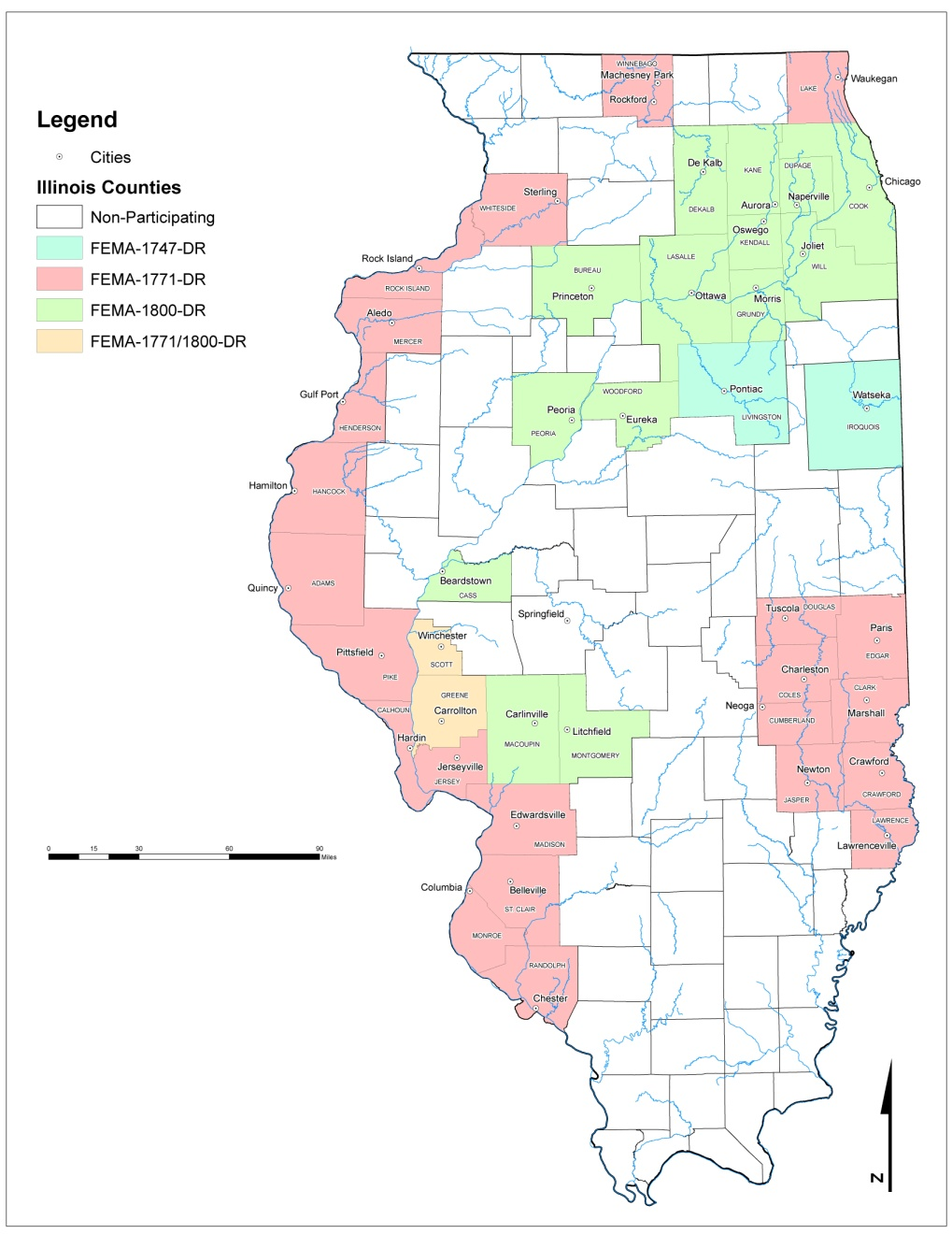

Federally-Designated Areas Eligible for CDBG "Ike" Assistance
The following Illinois counties were declared eligible for federal assistance in the three 2008 Disaster Declarations:

Illinois Counties Declared Under FEMA-1800-DR

1. Bureau County | 9. Kendall County
2 Cass County | 10. LaSalle County
3. Cook County | 11. Macon County
4. DeKalb County | 12. Montgomery County
5. DuPage County | 13. Peoria County
6. Greene County* | 14. Scott County*
7. Grundy County | 15. Will County
8. Kane County | 16. Woodford County

Illinois Counties Declared Under FEMA-1771-DR

1. Adams County | 14. Lake County
2. Calhoun County | 15. Lawrence County
3. Clark County | 16. Madison County
4. Coles County | 17. Mercer County
5. Crawford County | 18. Monroe County
6. Cumberland County | 19. Pike County
7. Douglas County | 20. Randolph County
8. Edgar County | 21. Rock Island County
9. Greene County* | 22. St. Clair County
10. Hancock County | 23. Scott County*
11. Henderson County | 24. Whiteside County
12. Jasper County | 25. Winnebago County
13. Jersey County

Illinois Counties Declared Under FEMA-1747-DR

1. Iroquois County | 2. Livingston County

* Greene and Scott counties were declared under both the FEMA 1771 and 1800 declarations
Attachment B

HOMEOWNER APPLICANT SURVEY

SECTION 1: APPLICANT INFORMATION
1.1 | Applicant Name:
1.2 | Address:
1.3 | Email:

SECTION 2: SURVEY
2.1 | Did you apply for FEMA for your damaged home?  What is your FEMA number? | YES NO
2.2 | Did you apply to SBA?  What is your SBA number? | YES NO
2.3 | Do you still have severe damage greater than $28,000? | YES NO
2.4 | Do you still have damage between $10,000 and $28,000? | YES NO
2.5 | Is this an elderly household (62 or older)? | YES NO
2.6 | Is the head of household disabled? | YES NO
2.7 | Please complete the attached HUD Income Limit Form | YES NO
2.8 | Dwelling and land are taxed as real property | YES NO

Attachment B-1

INSTRUCTIONS FOR COMPLETING HOMEOWNER APPLICANT SURVEYS

- Please complete the homeowner applicant survey for each homeowner.
- The jurisdictions should attach a survey for each homeowner with the application.
- The homeowner should complete the survey to the best of his/her knowledge.
- The amount of damage can be based upon a contractor’s estimate, insurance, SBA, or homeowner’s estimate.
- Each homeowner should complete an income limit form by circling the group that reflects the family’s current total household income.

Attachment C

LEVERAGE FUNDS

If the Applicant plans on leveraging other funding sources discuss the status of those commitments. Also discuss whether or not other disaster funds were applied for, giving specific programs, dollar amounts, and status of application(s).

The following outlines the elements necessary for a firm leverage commitment.

A firm commitment letter from a Financial Institution must include: language which indicates that the loan will be approved and that the institution will lend subject to certain conditions; the specific dollar amount of the loan; the specific term of the loan (not to exceed twelve months); and the projected interest rate of the loan.

For projects which intend to secure leverage funding from the Illinois Environmental Protection Agency (IEPA), the CDAP application must include a copy of the IEPA letter approving the community's Facilities Plan (for waste water system projects) or Project Plan (for public water system projects). Loan funds are available for a maximum term of 20 years. Historically, interest rates have been below 3%. At a minimum, the applicant's proposed project must be on the current IEPA priority list.

A firm commitment of funding from the united states department of agriculture rural development (RD) must include, at a minimum, issuance of “Notice of Application Review Action” requesting the applicant to file a complete application with USDA. This letter is issued after receipt and acceptance of an initial application, preliminary engineering report and environmental report. In instances where USDA has already approved funding, attach a copy of the letter of conditions and Form RD 1940-1, “Request for Obligation of Funds.” Loan and grant funds are available with loans up to 38 years. Generally, interest rates have been 5% or lower. Applicants proposing to apply for RD funding may conduct the required income surveys and the required public hearings at the same time. Applicants should contact Patrick Davis at 217/785-6142; TDD: 800/785-6055 to request "combined" instructions.

When a local government is proposing to use its own funds (i.e., cash on hand) as leverage, a local council or board resolution committing a specific dollar amount to the project must be included. When a local government is proposing to issue revenue or general obligation bonds as leverage, the application must include a local council/board resolution approving the intent to issue bonds and specifying a dollar amount. When a local government is proposing to use in-kind labor as leverage, the application must include a "schedule" which details the activities to be completed by city employees, their titles and hourly wages, and projected number of hours needed to complete the activity. These figures should then be used to calculate the value of the in-kind labor.

Attachment D

TABULATON OF HOMEOWNER APPLICANT SURVEYS

Provide the following using the Homeowner Applicant Surveys performed:
1.1 | Total Number of Homes to be Repaired
1.2 | Total Number of Homes to be Reconstructed
1.3 | Total Number of Elderly Homeowners to be Rehabilitated/Reconstructed
1.4 | Total Number of Disabled Homeowners to be Rehabilitated/Reconstructed
1.5 | Total Number of Homes to be Rehabilitated/Reconstructed with incomes below 50% of HUD Median Family Income (See Attachment E for income limits for counties and cities).
1.6 | Estimated cost per unit for rehabilitation
1.7 | Estimated cost per unit for reconstruction
1.8 | Total number of Homeowner Applicant Surveys conducted (attach surveys)
1.9 | Total funds requested for administration (marketing and outreach to homeowners)

Attachment D-1

INSTRUCTIONS FOR COMPLETING TABULATION OF HOMEOWNER APPLICANT SURVEYS

Please use the information in the Applicant Homeowner Survey and the application to complete the Tabulation form.

Attachment E

HUD INCOME LIMITS BY COUNTY
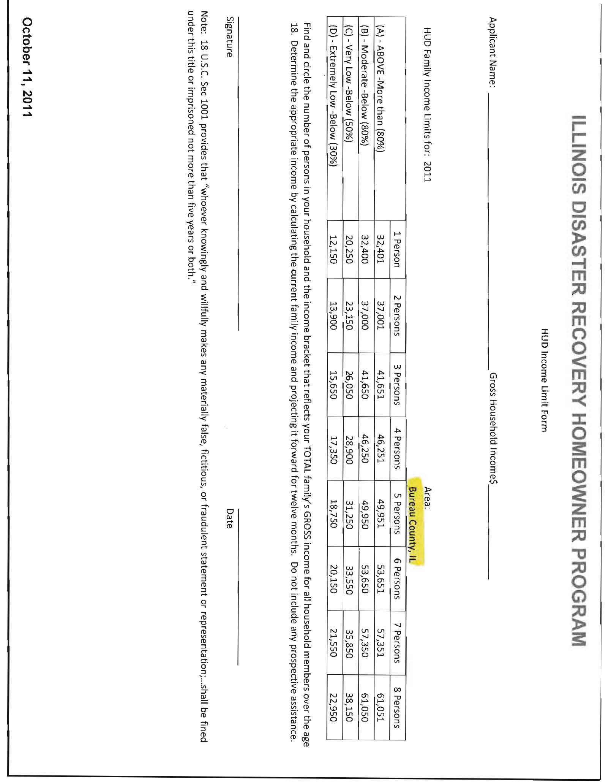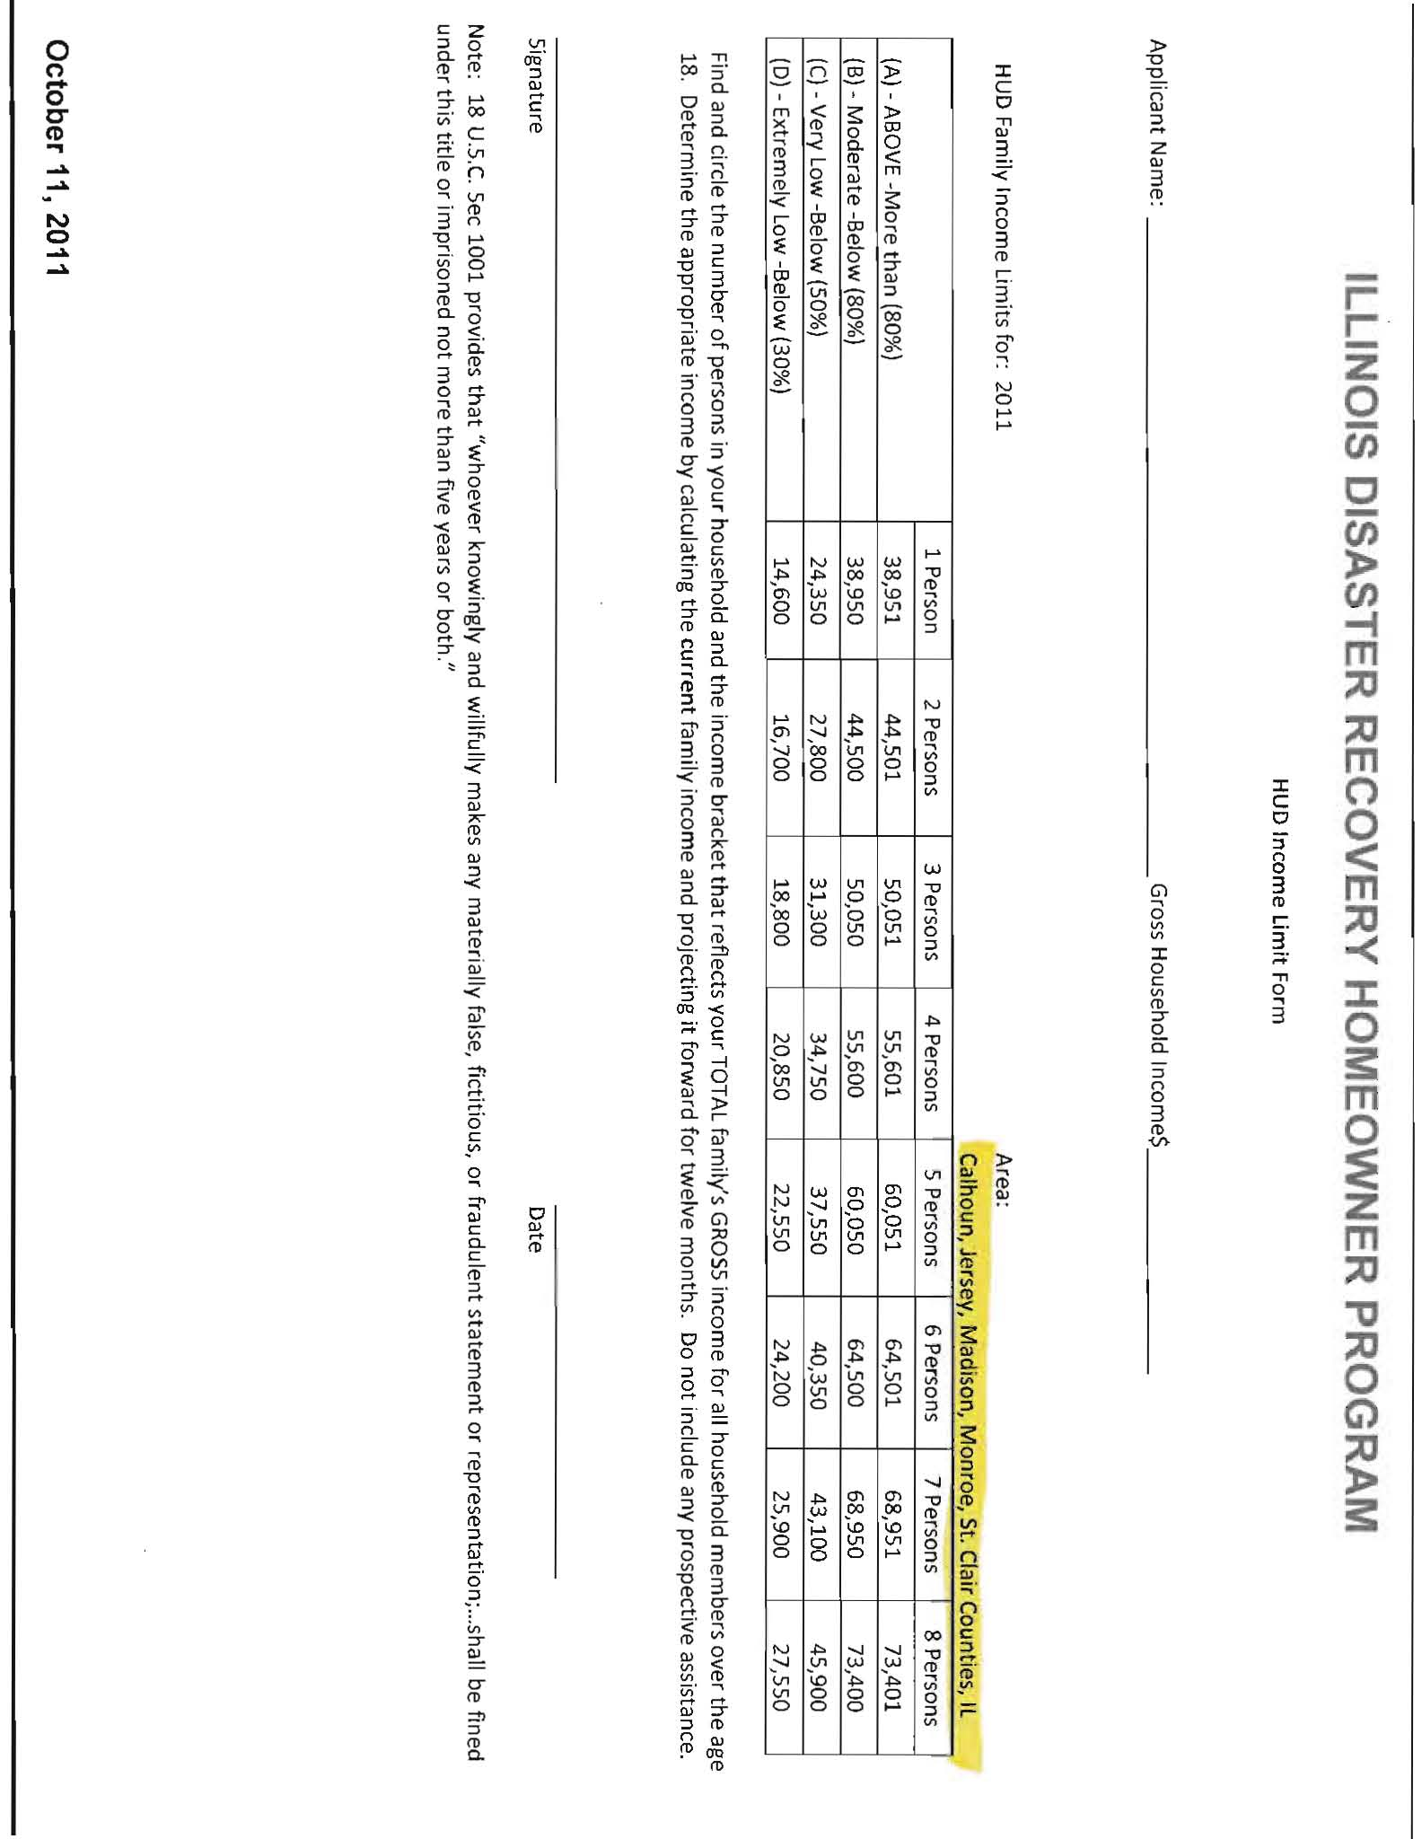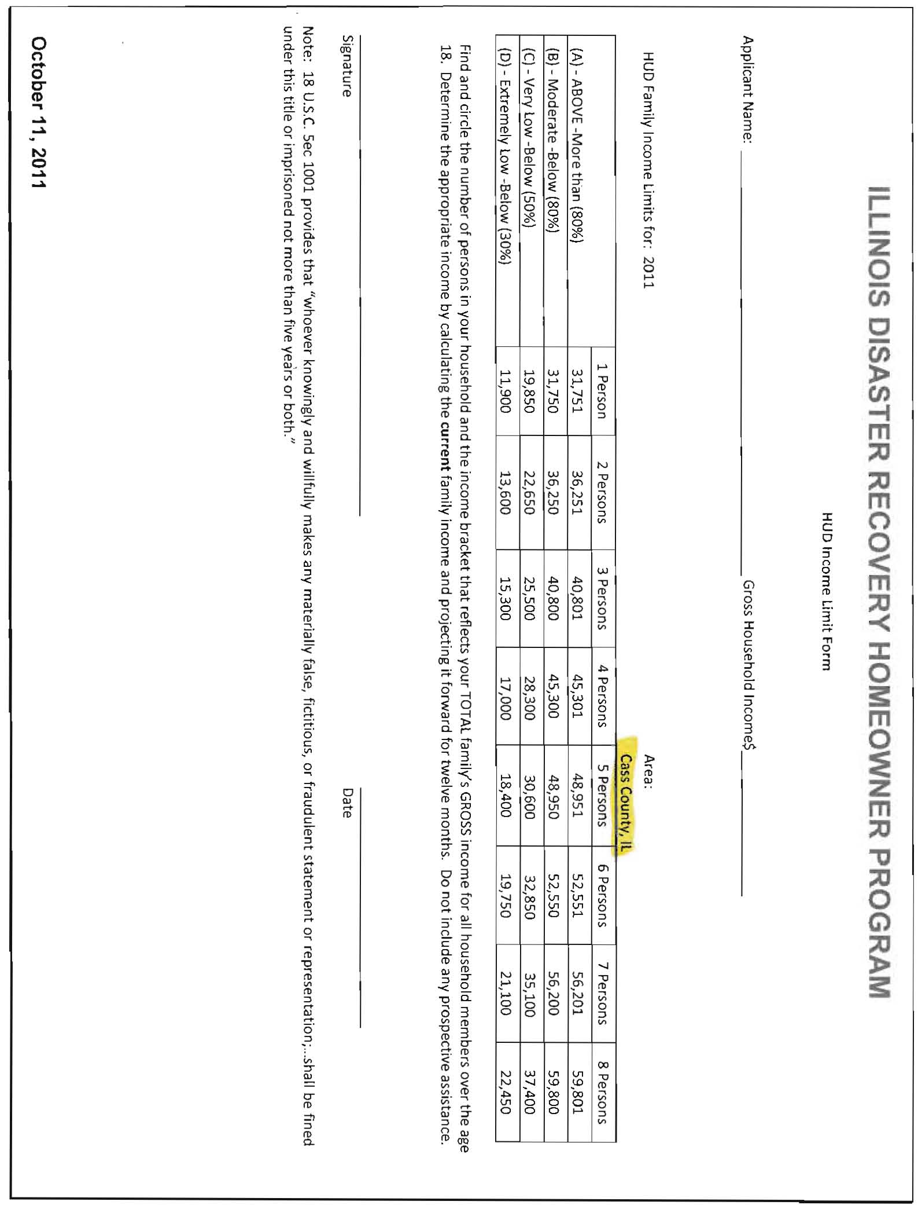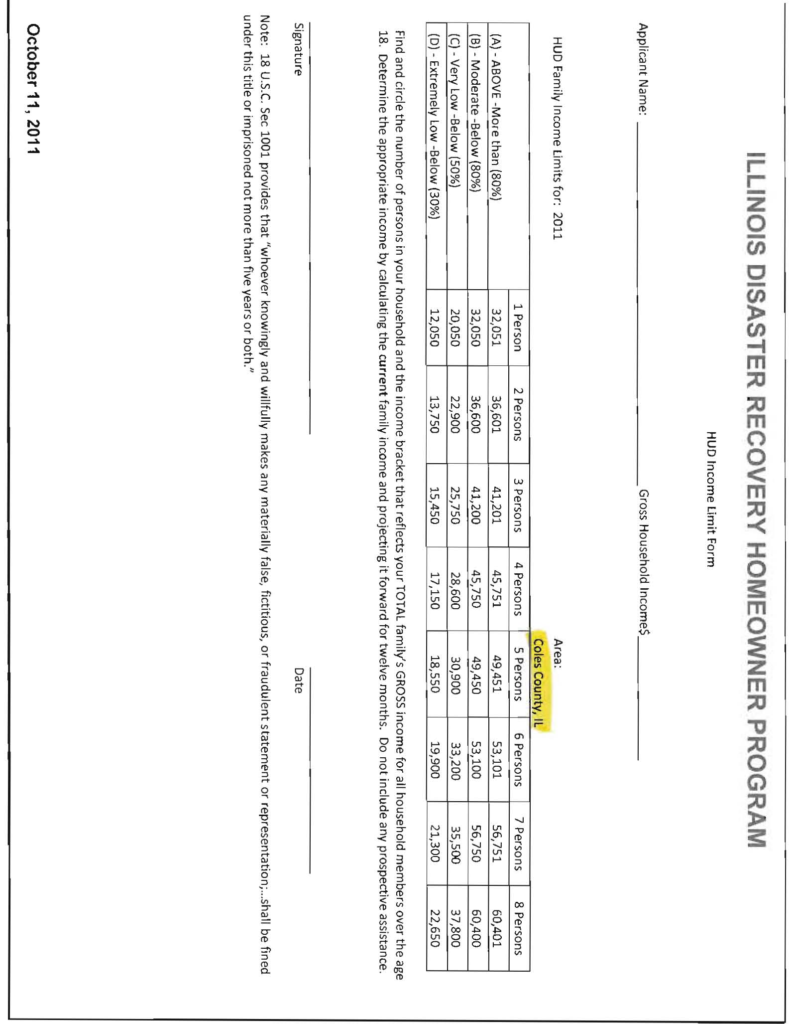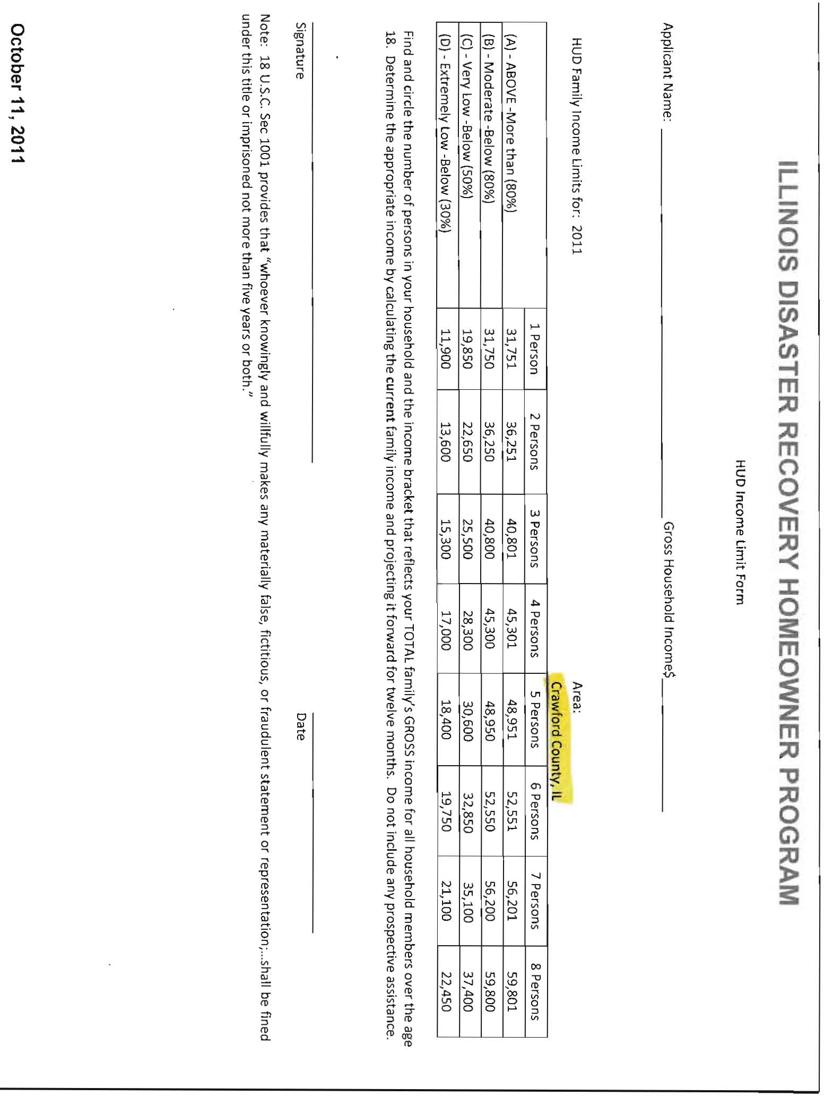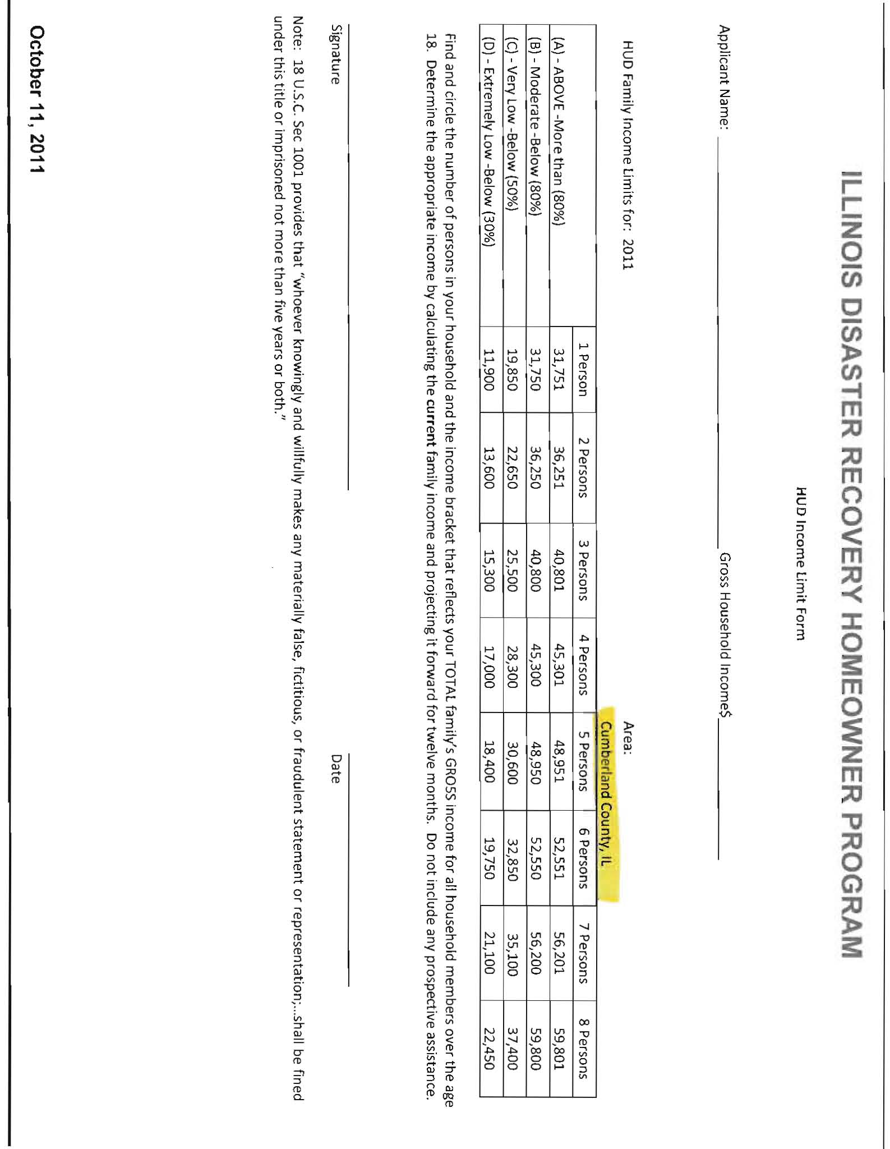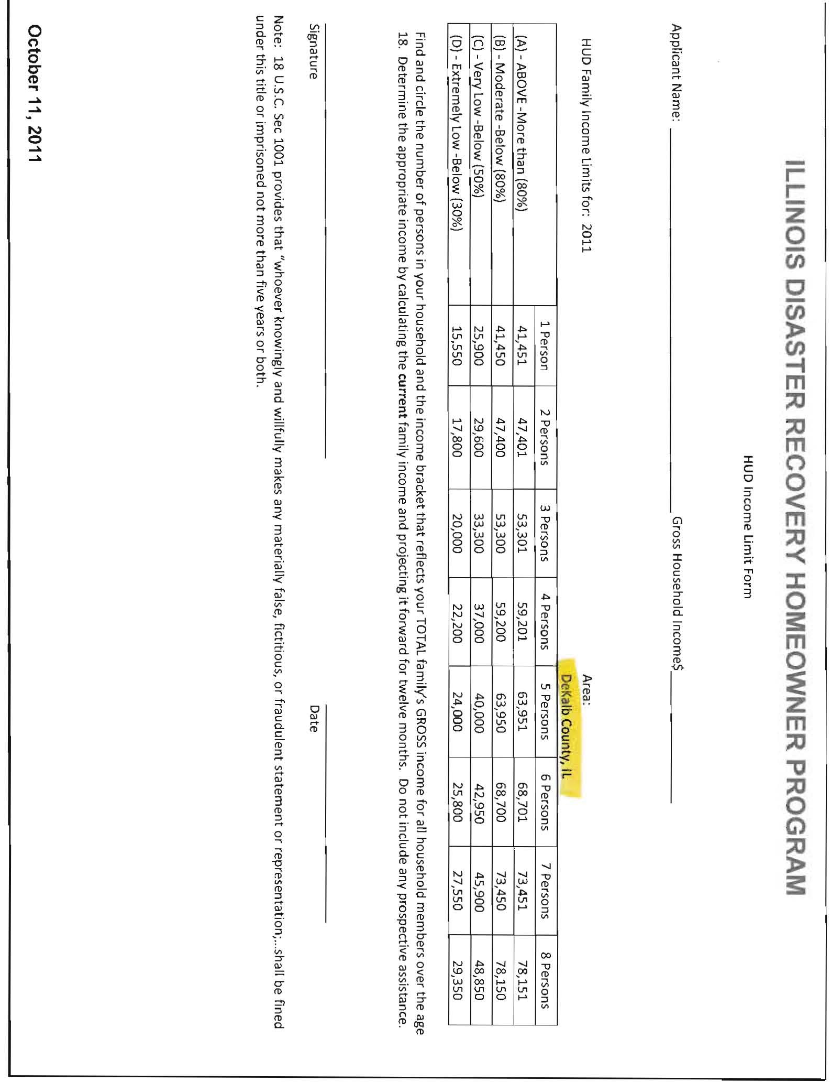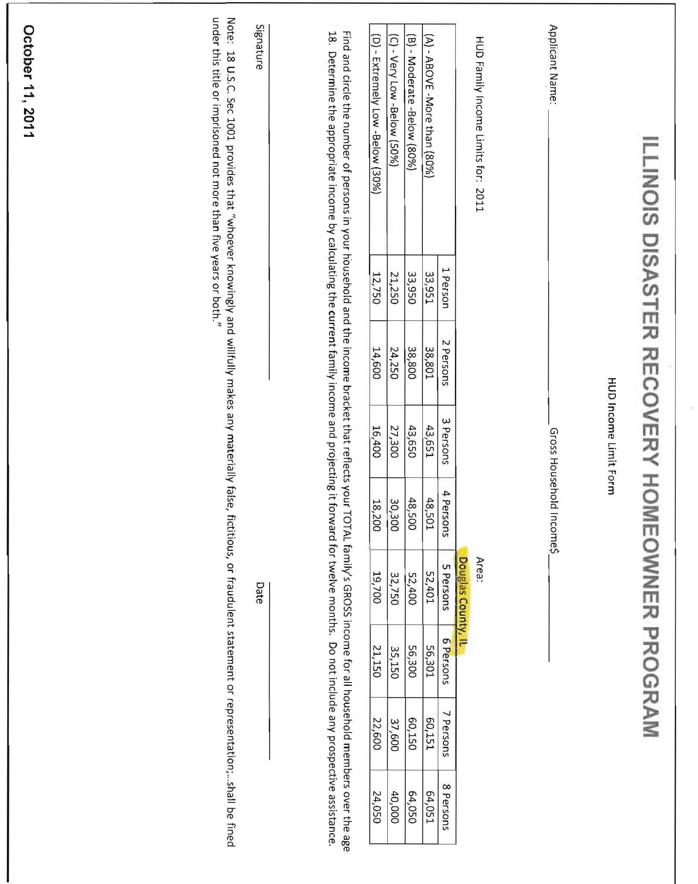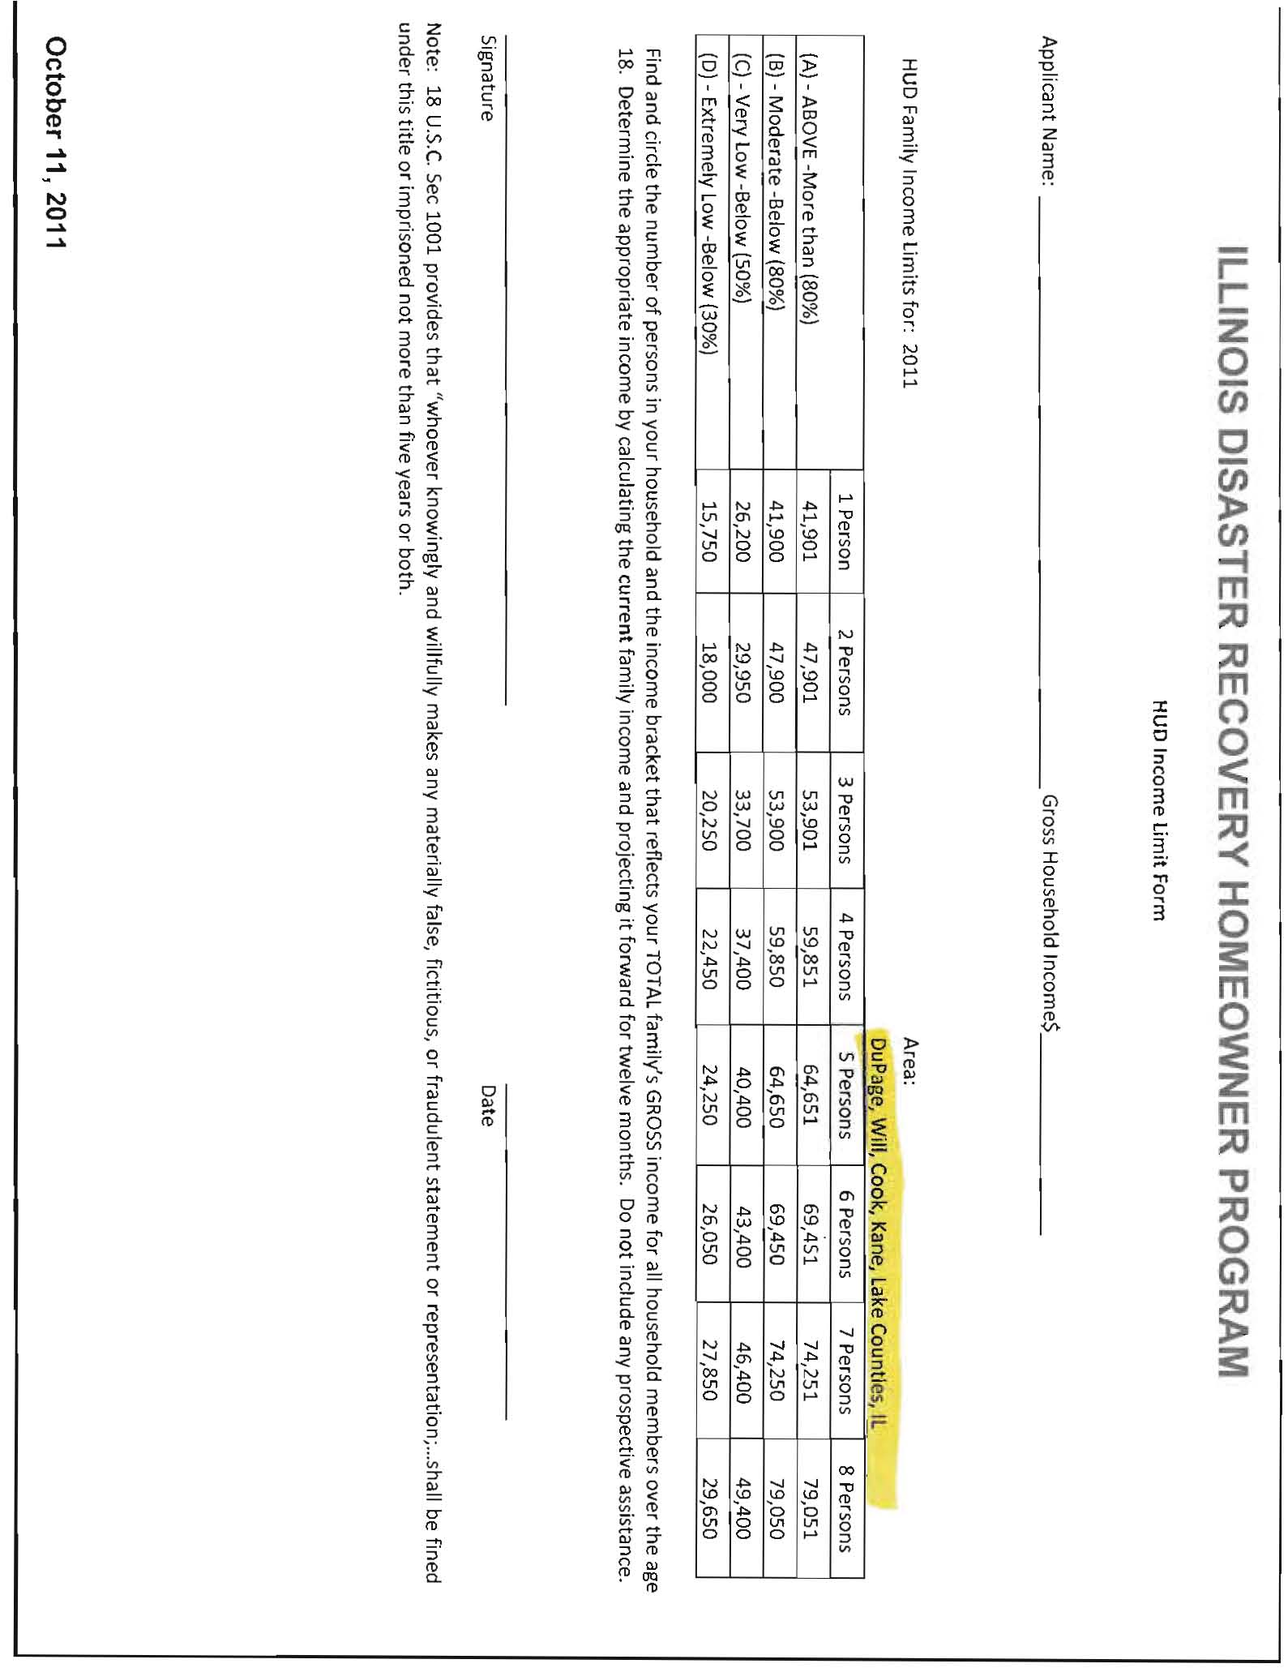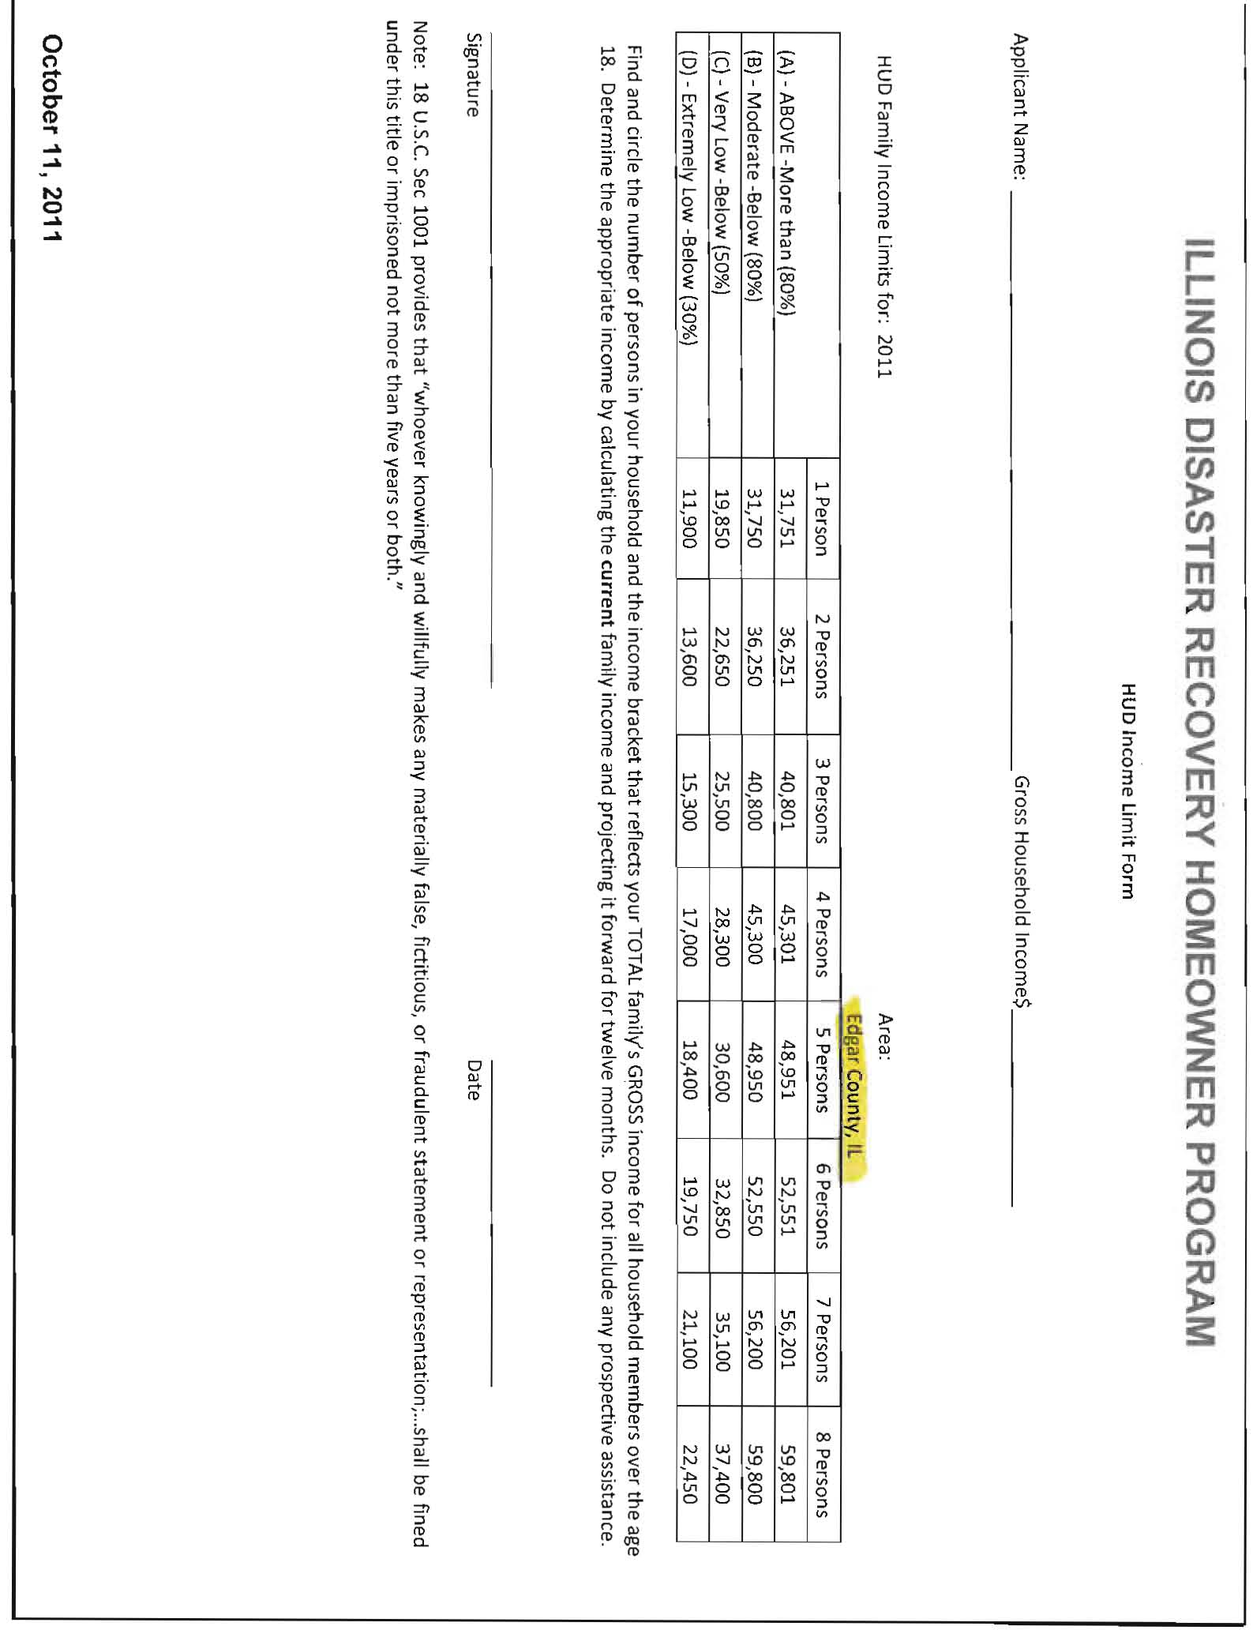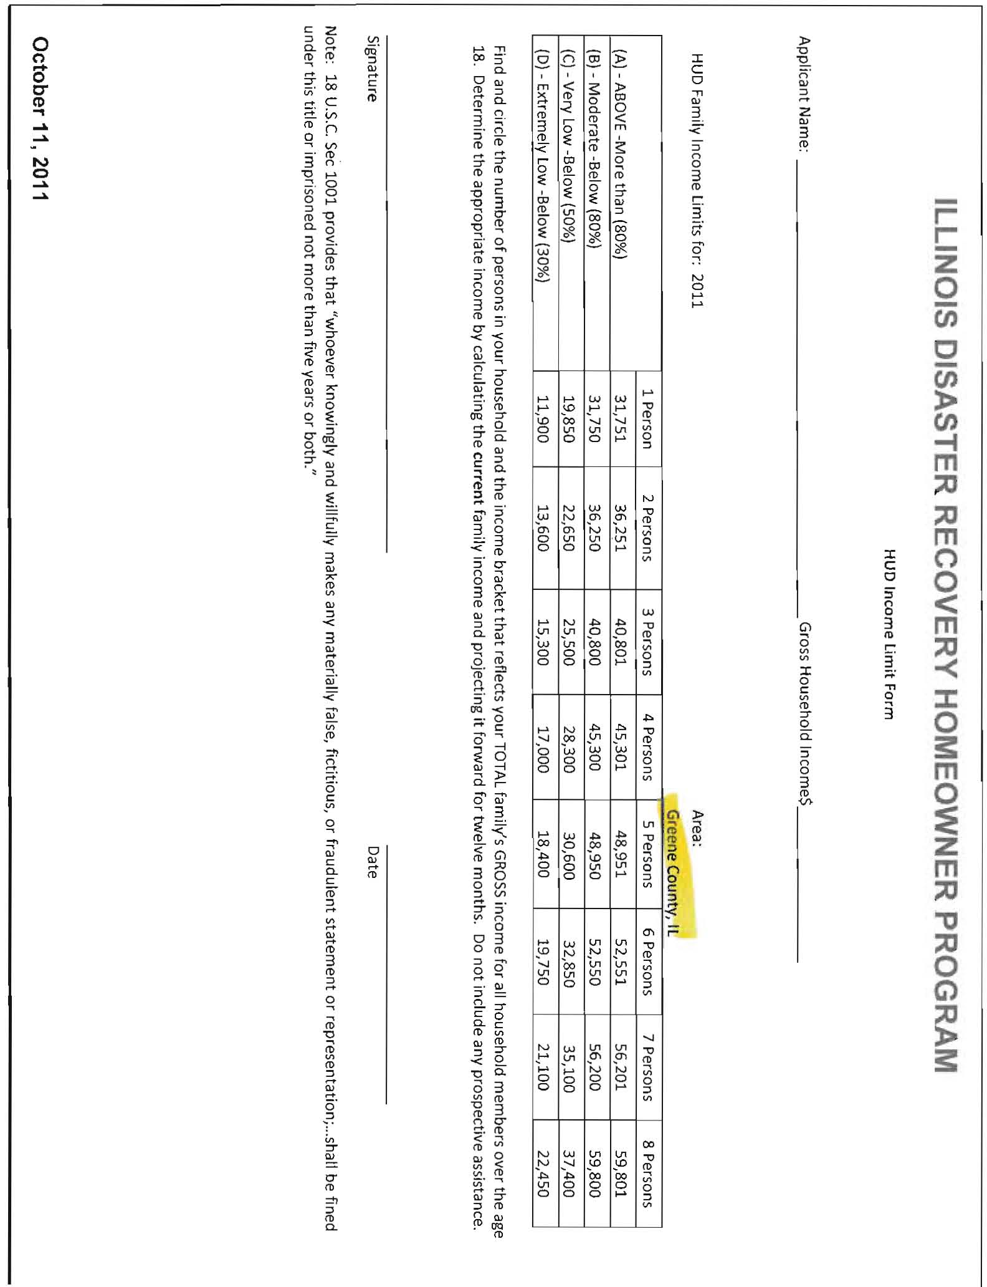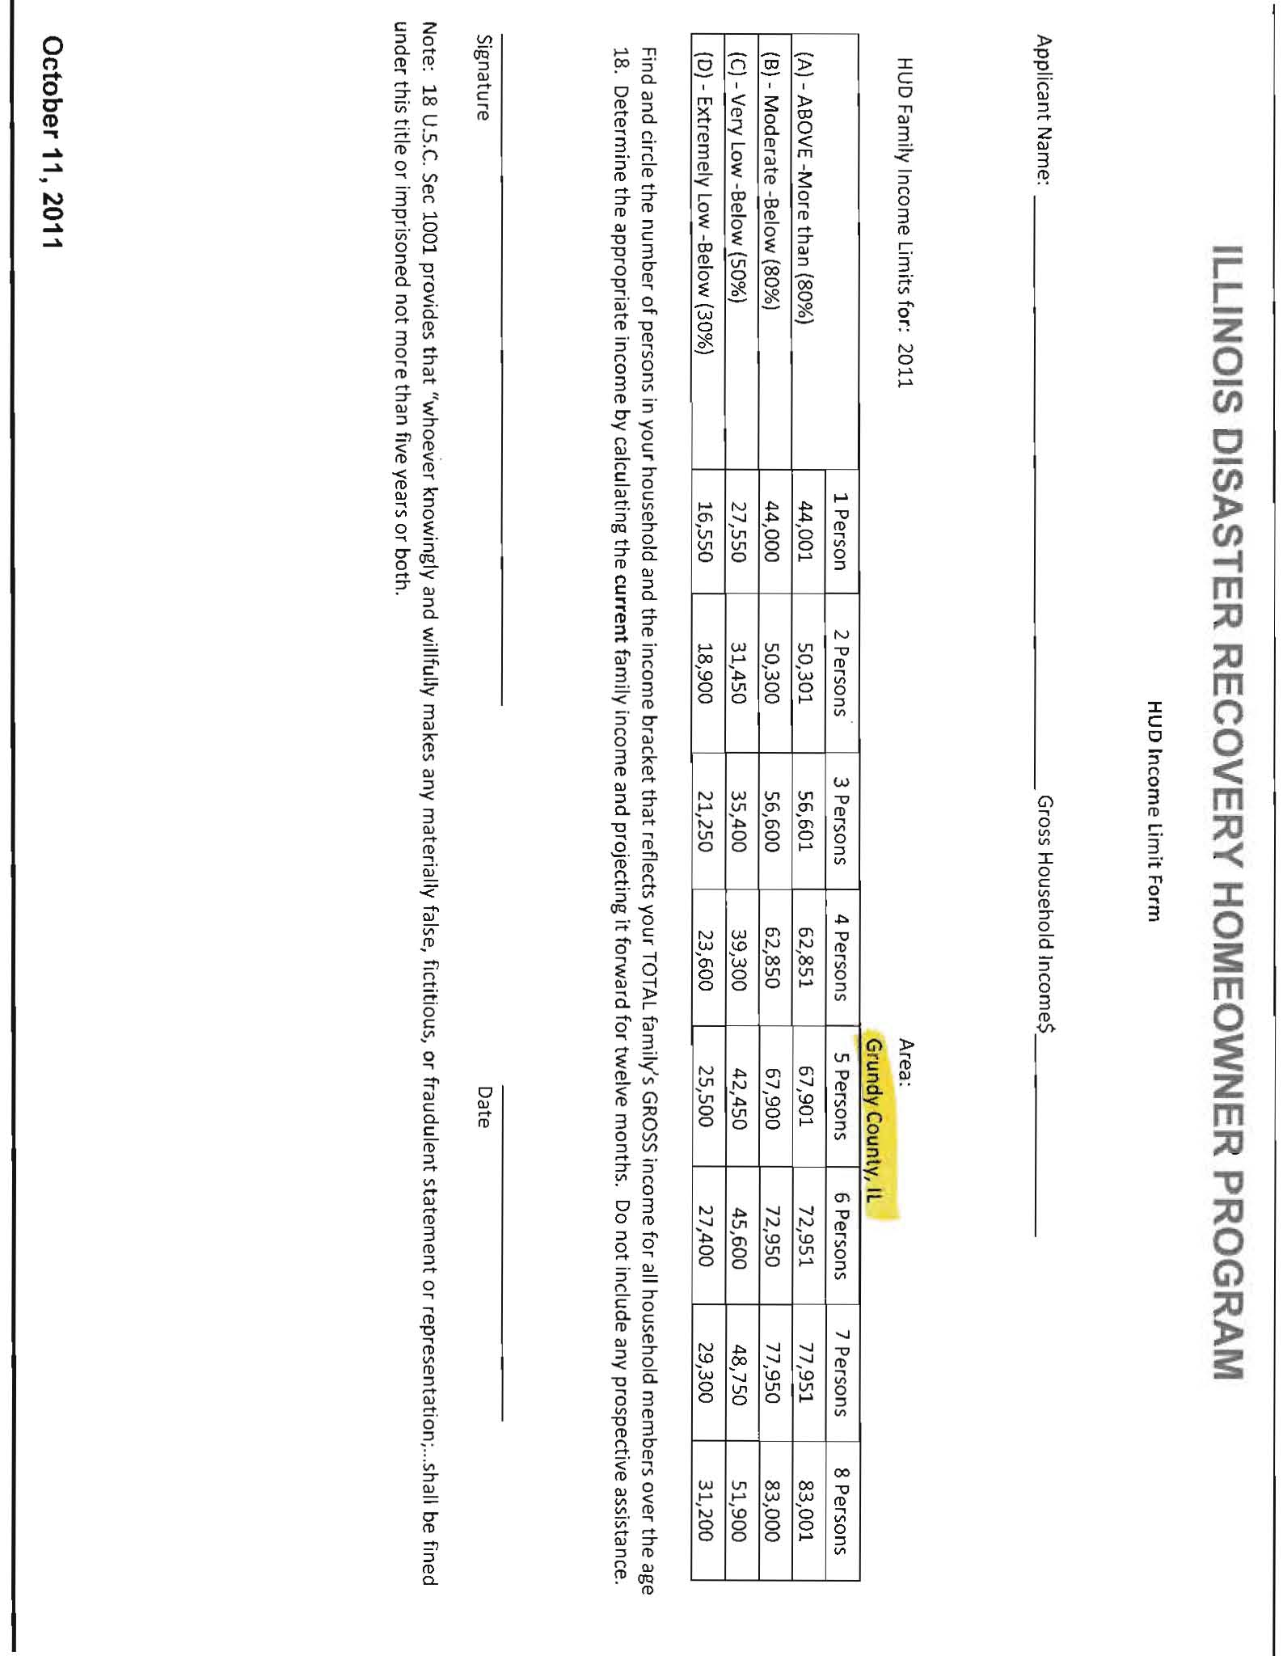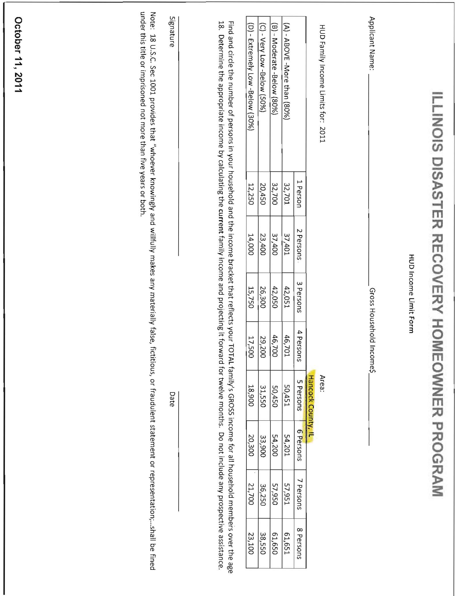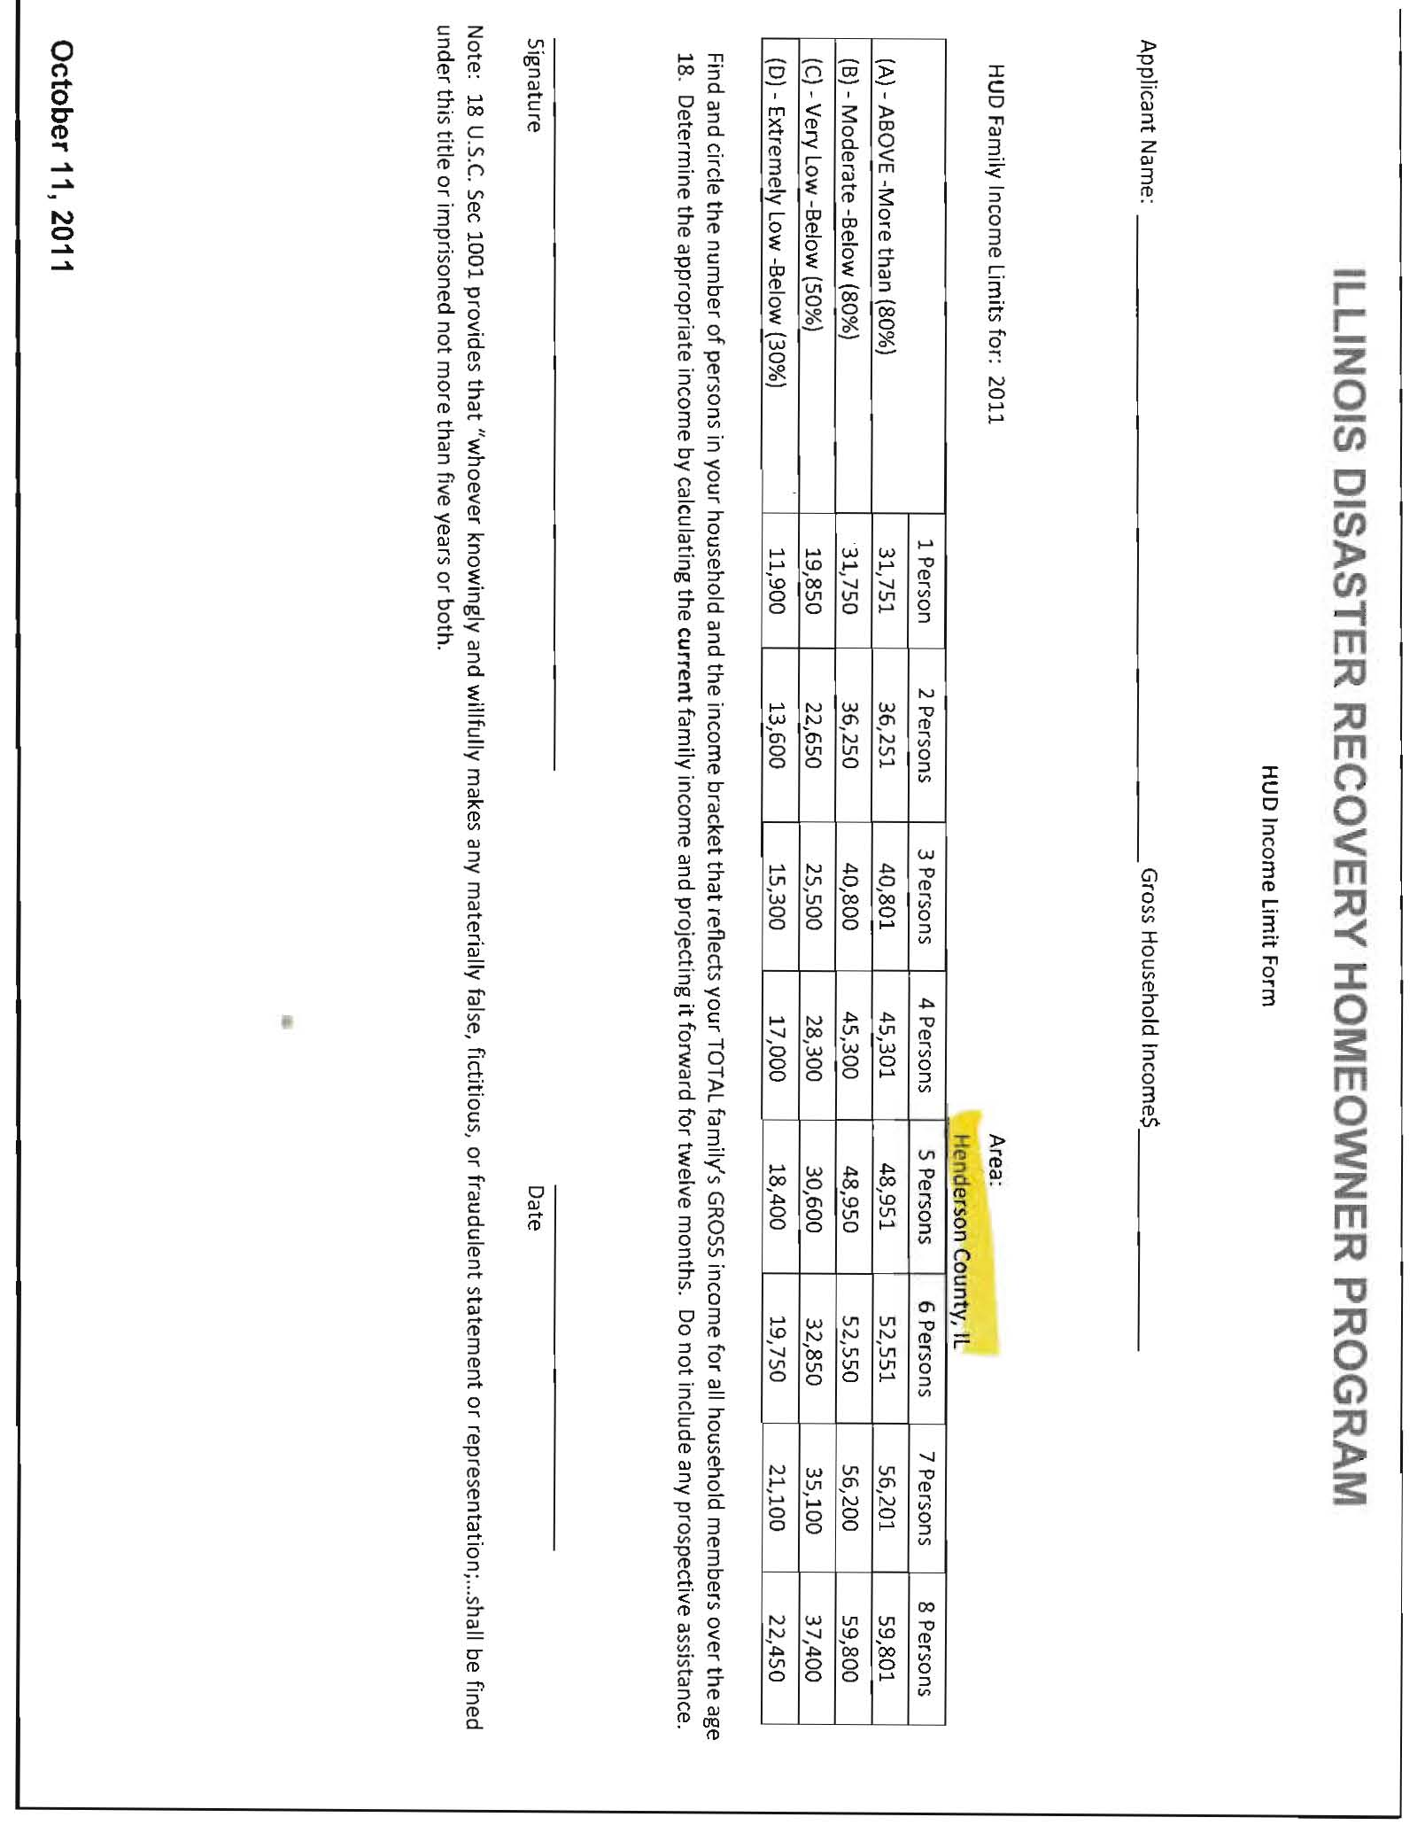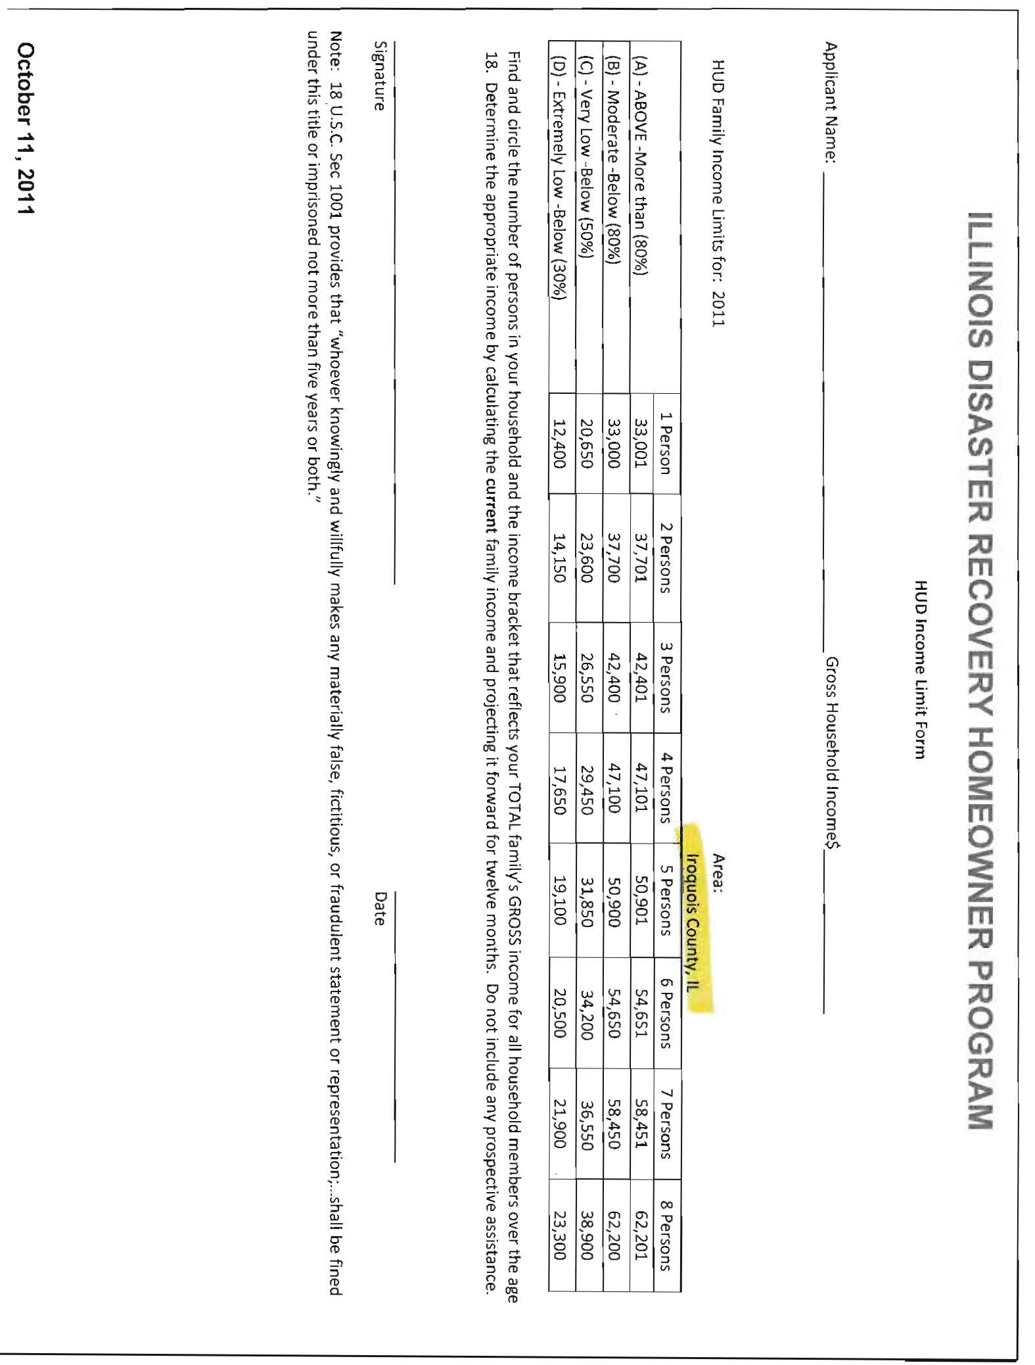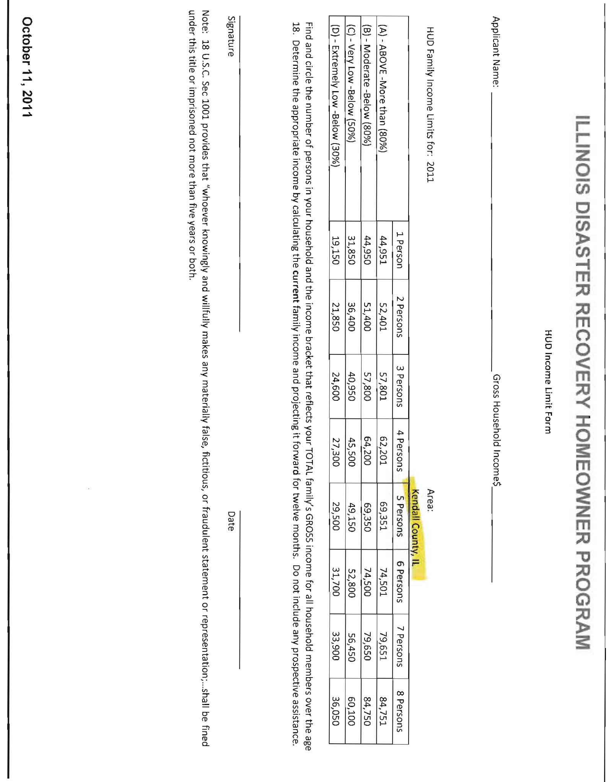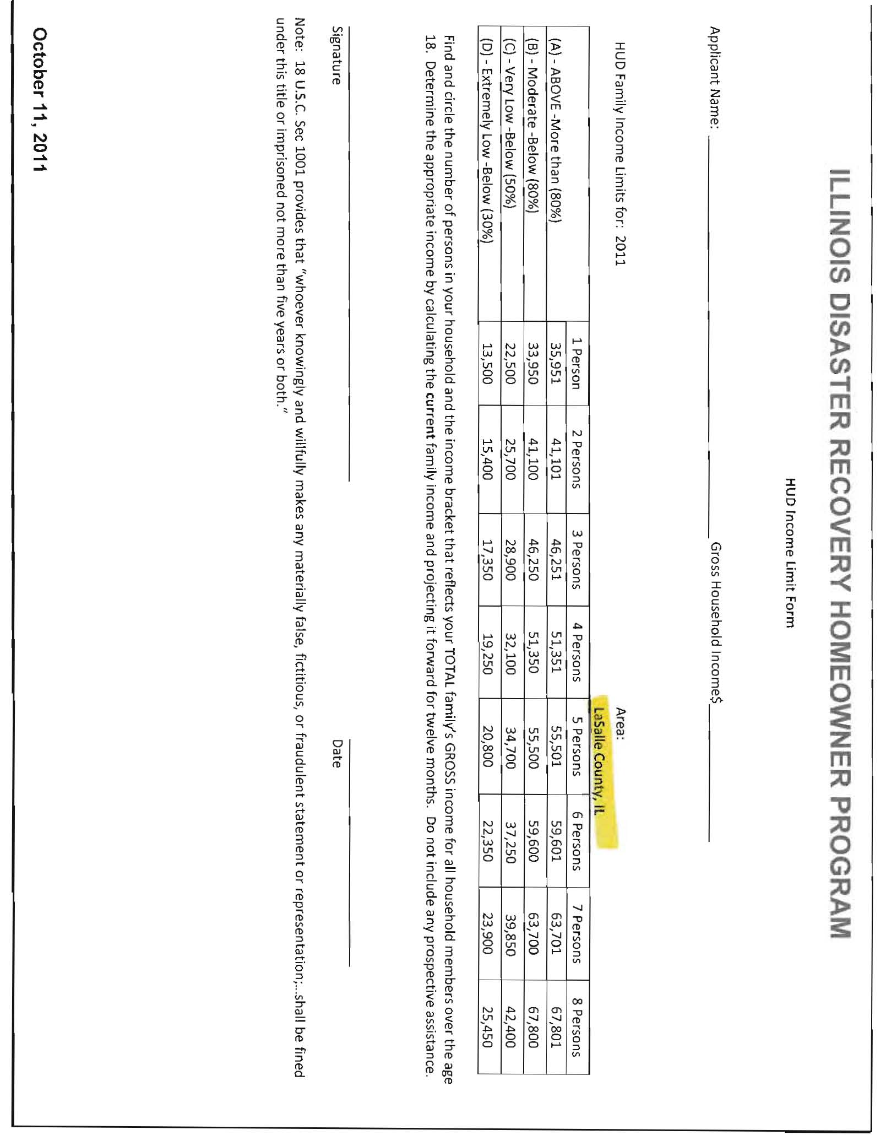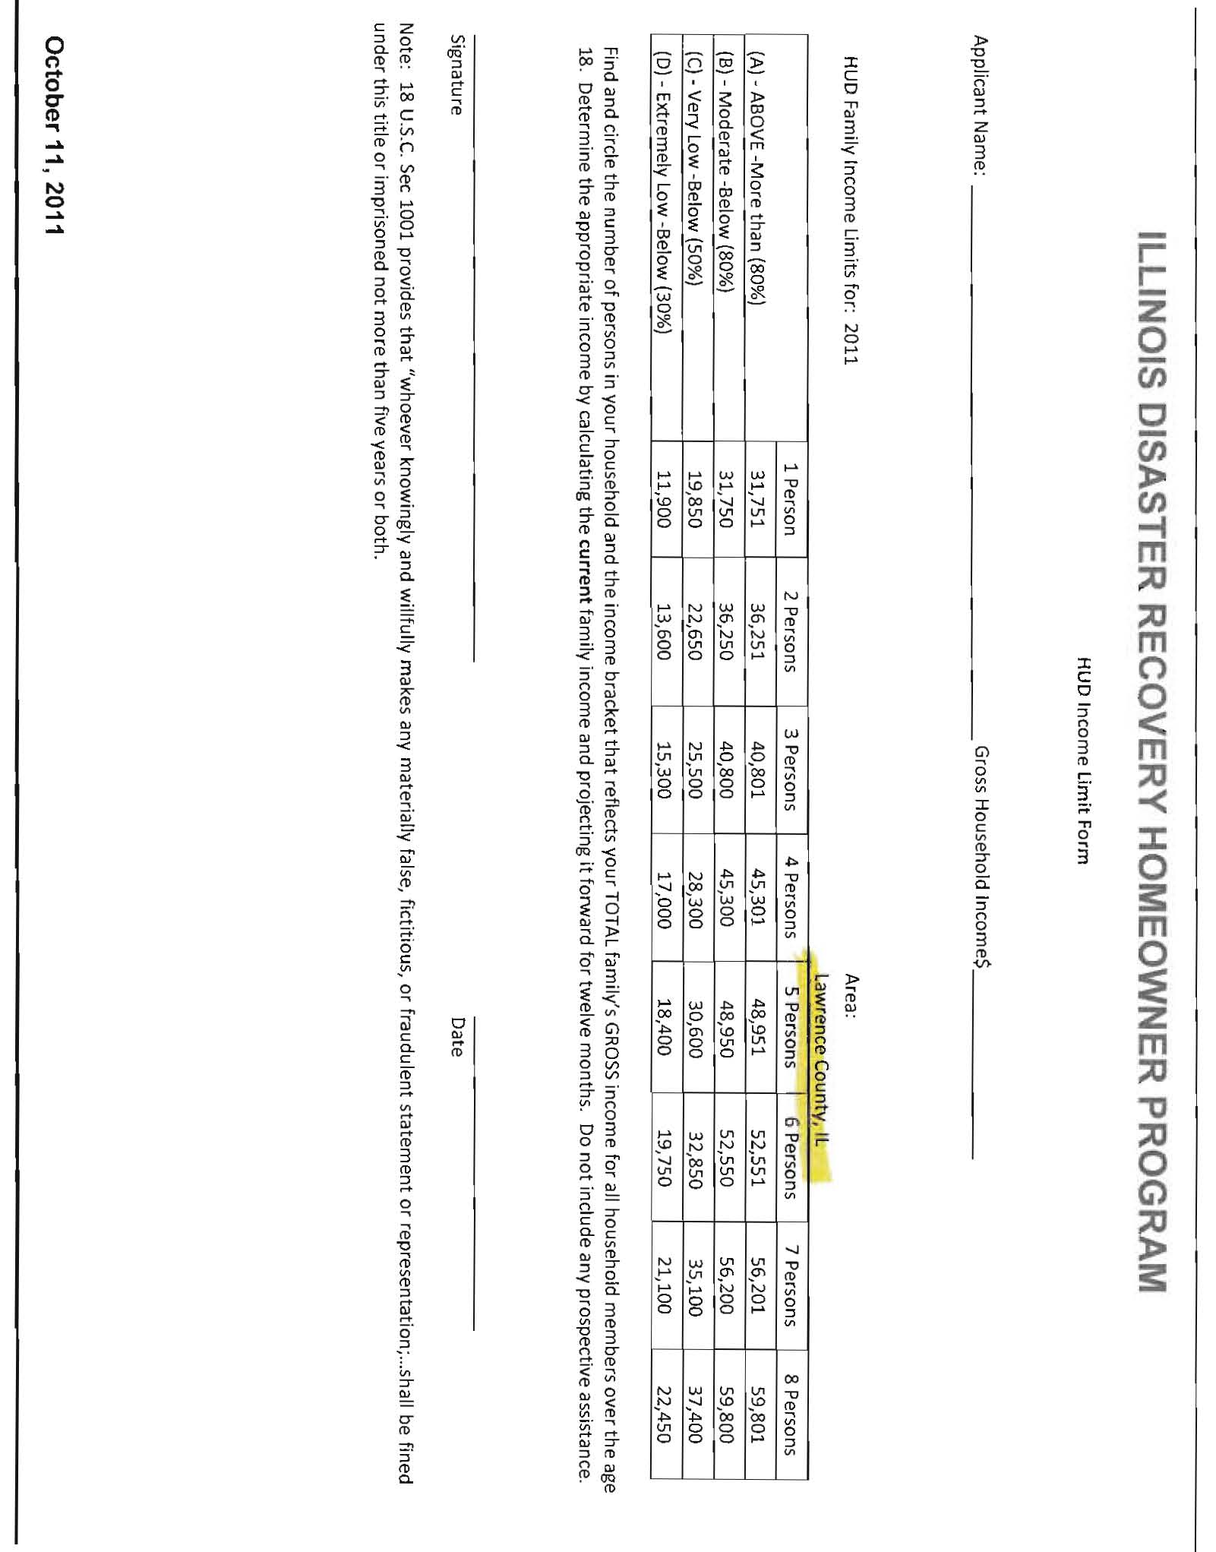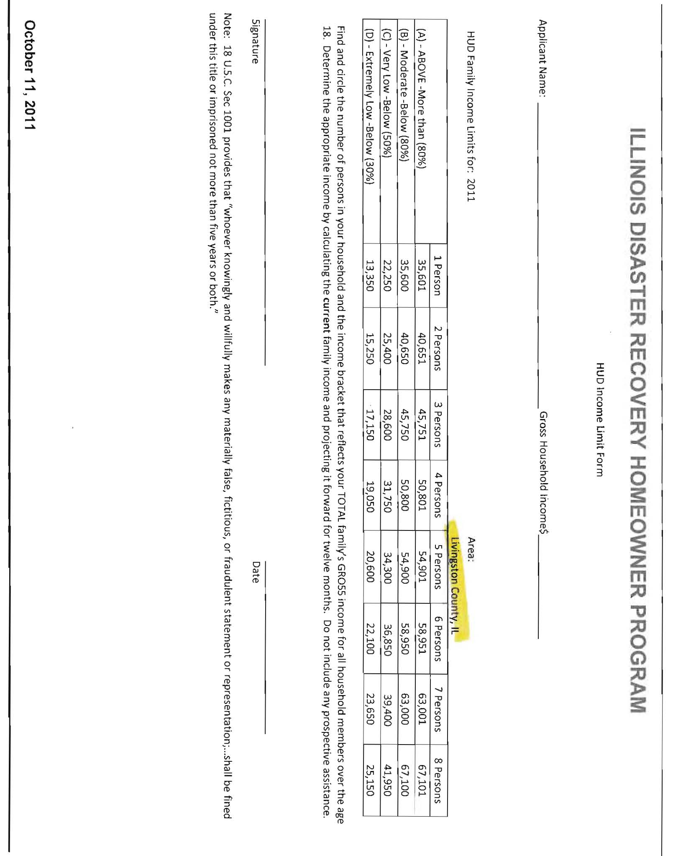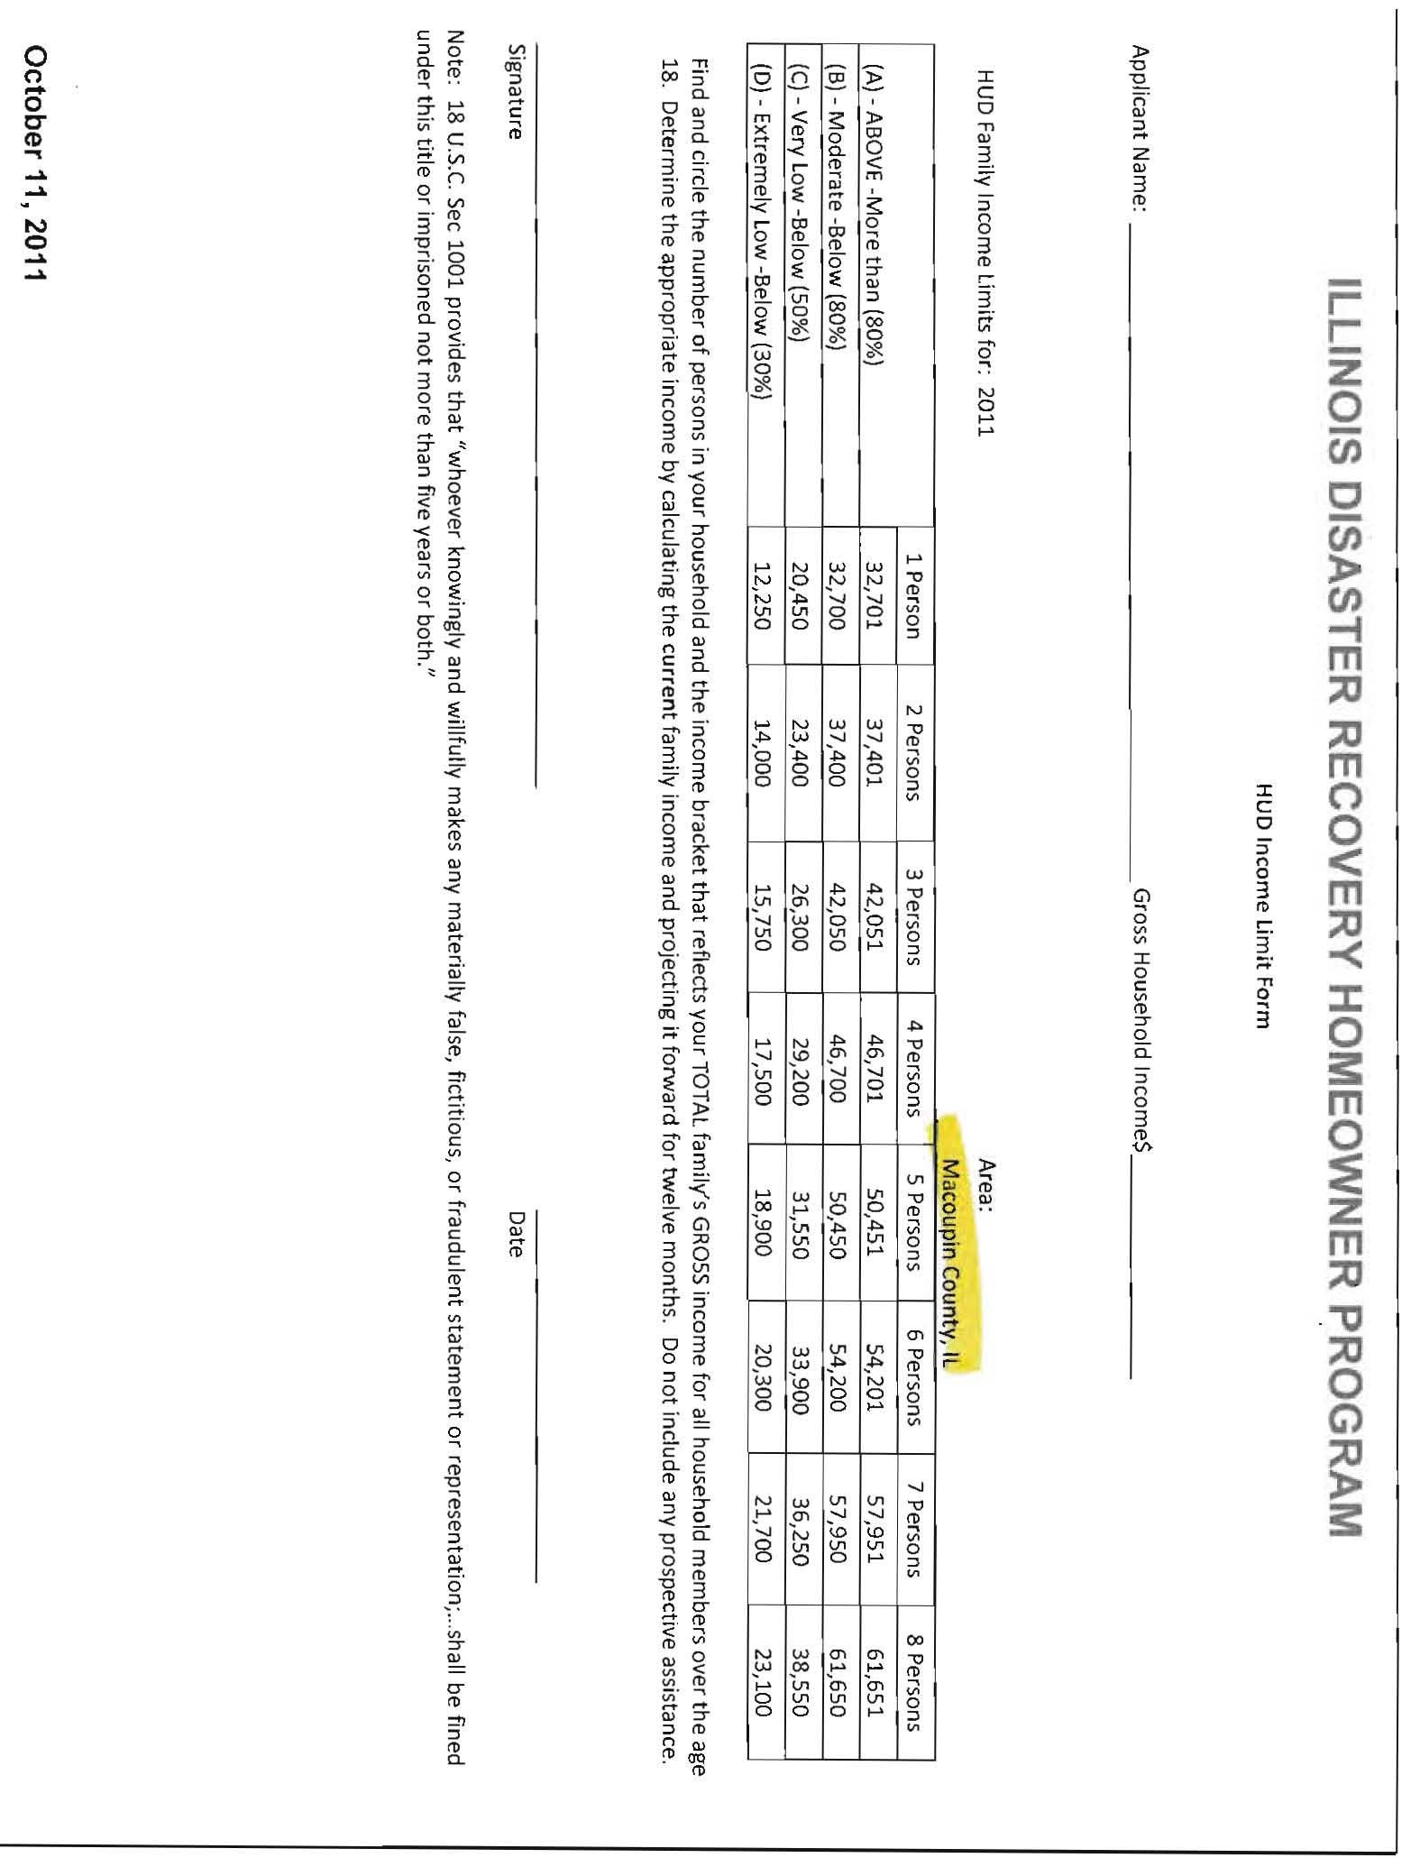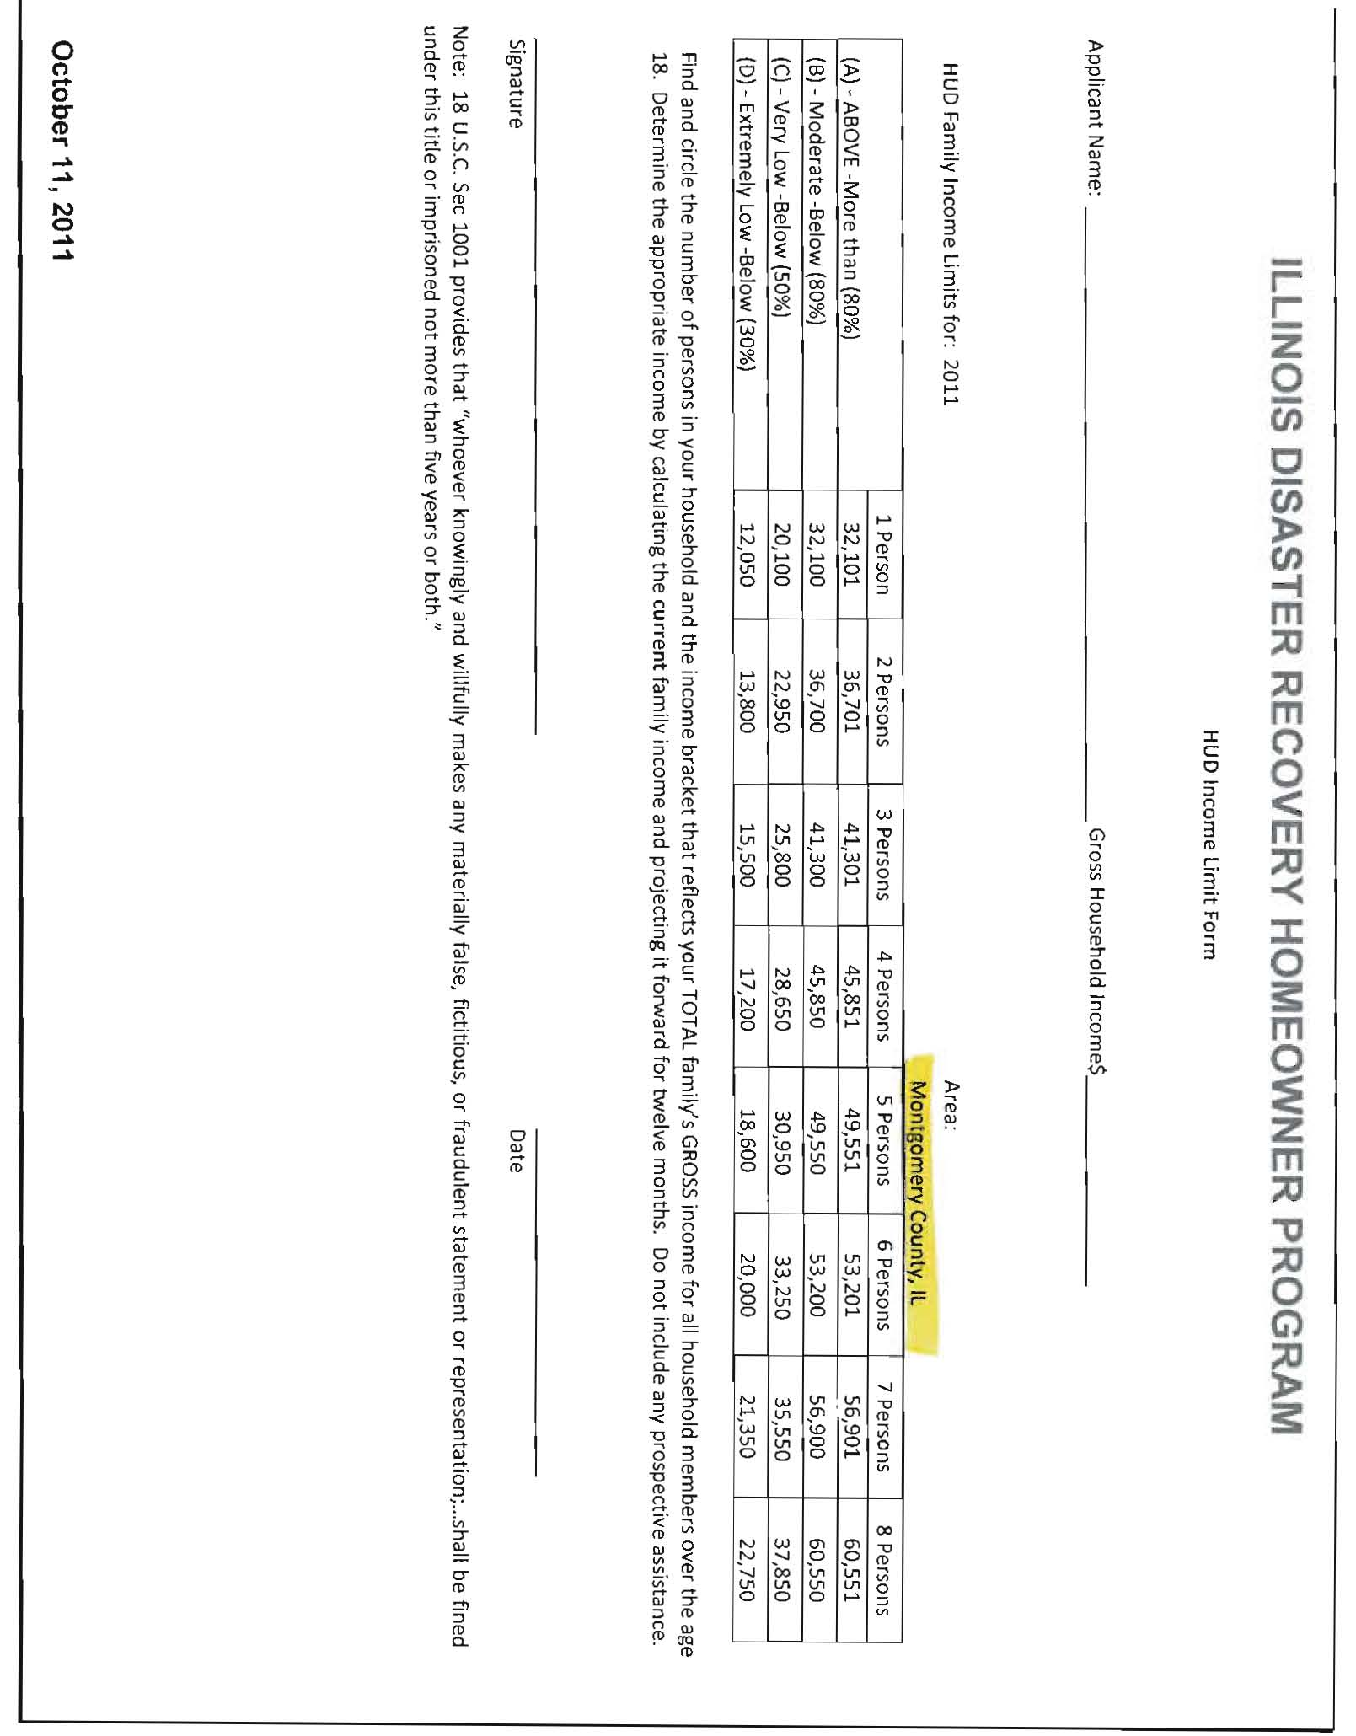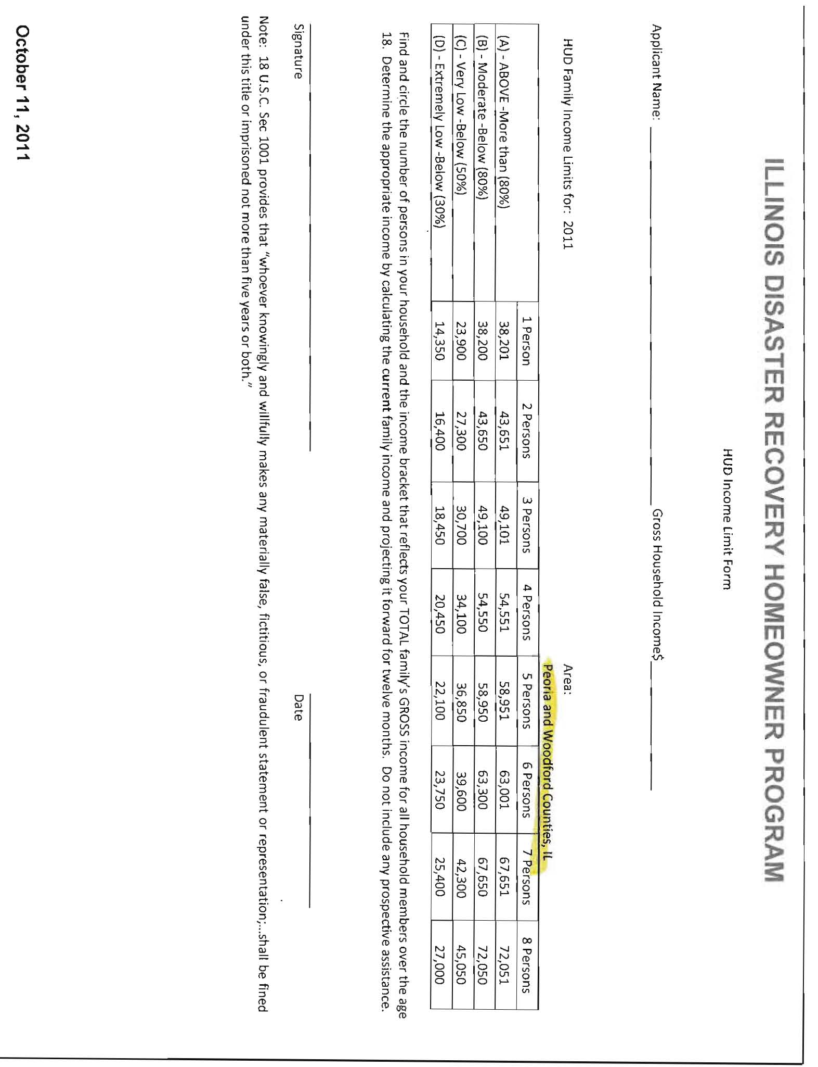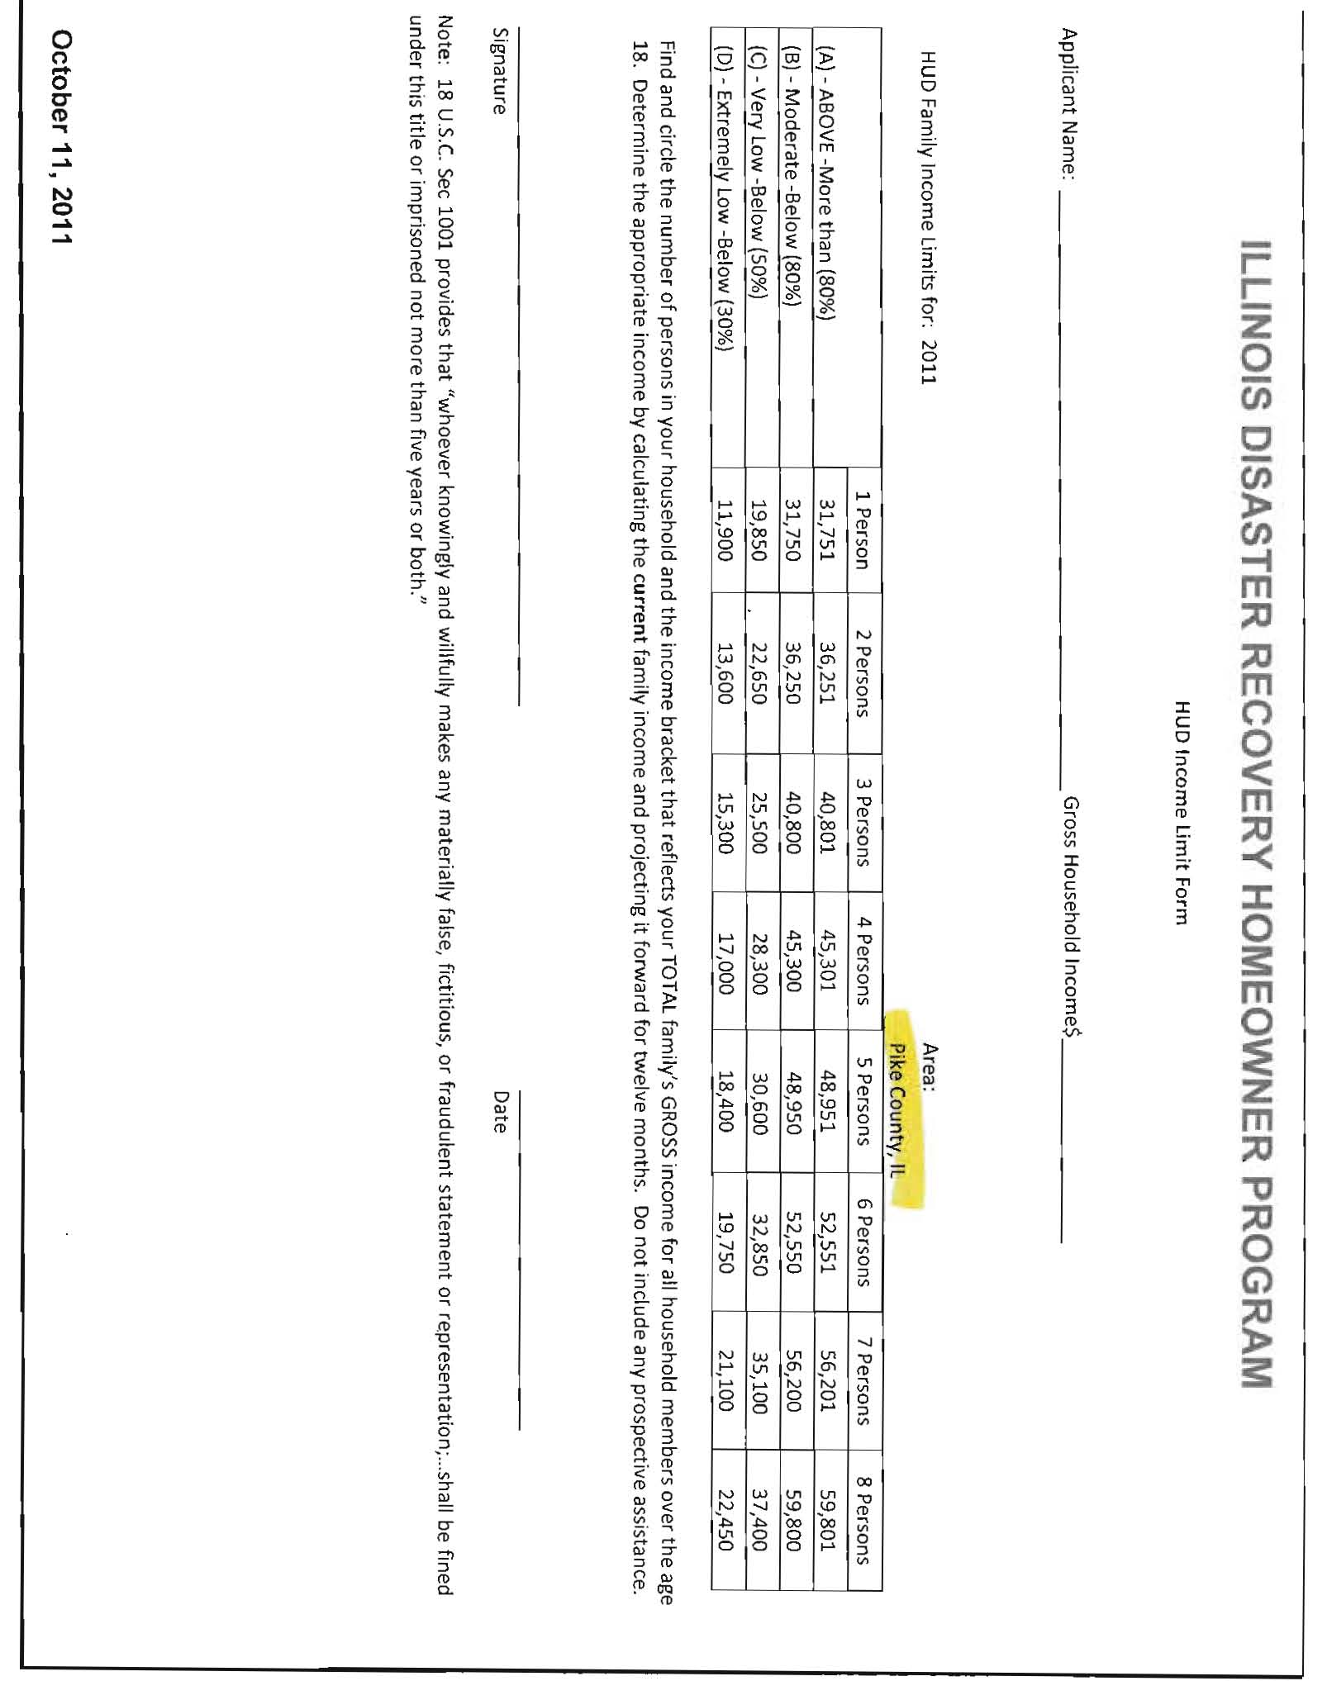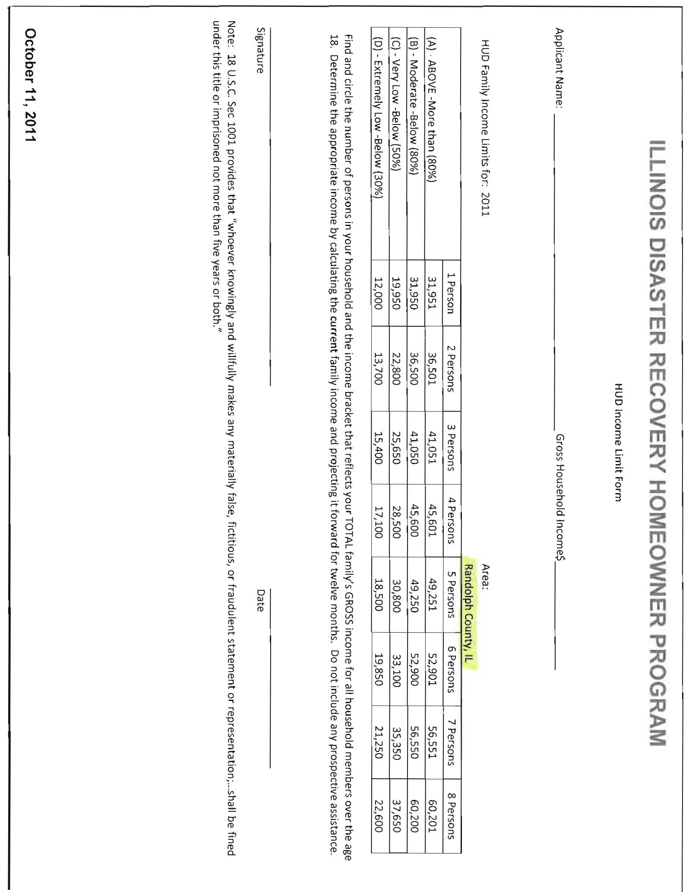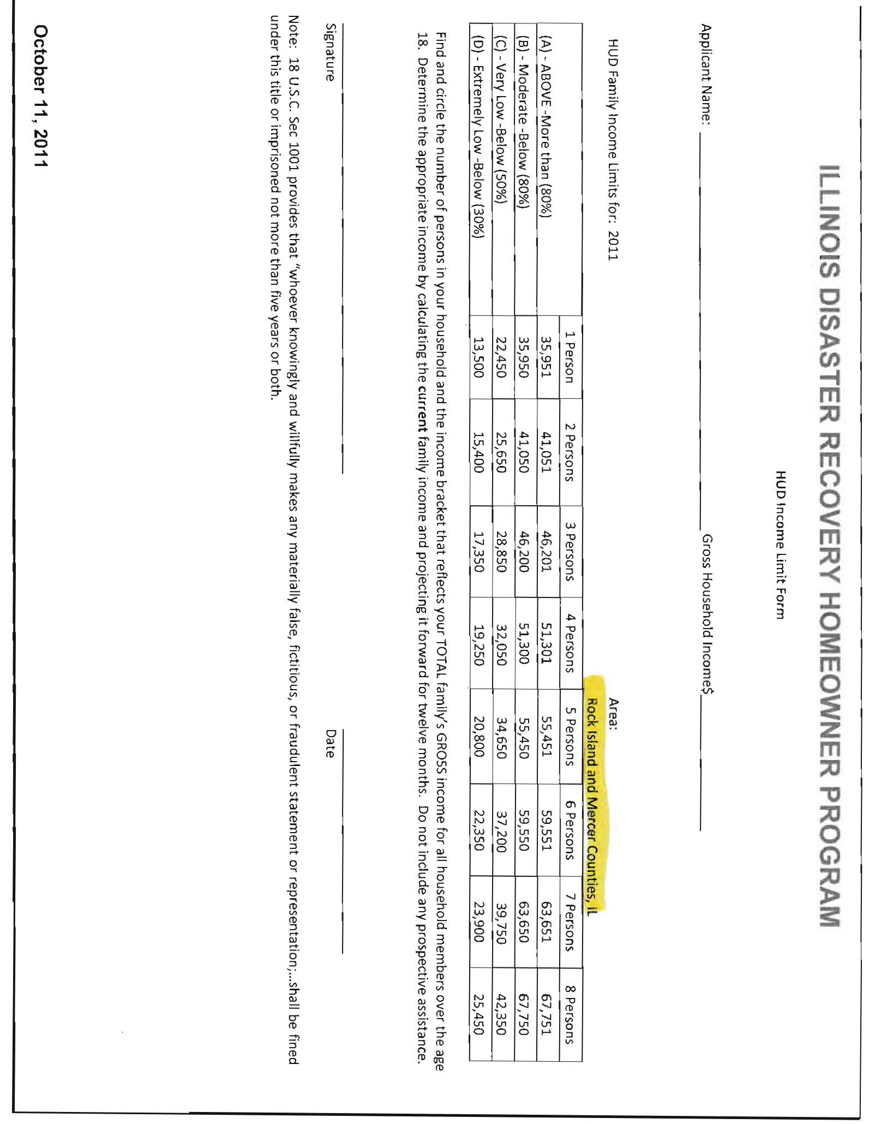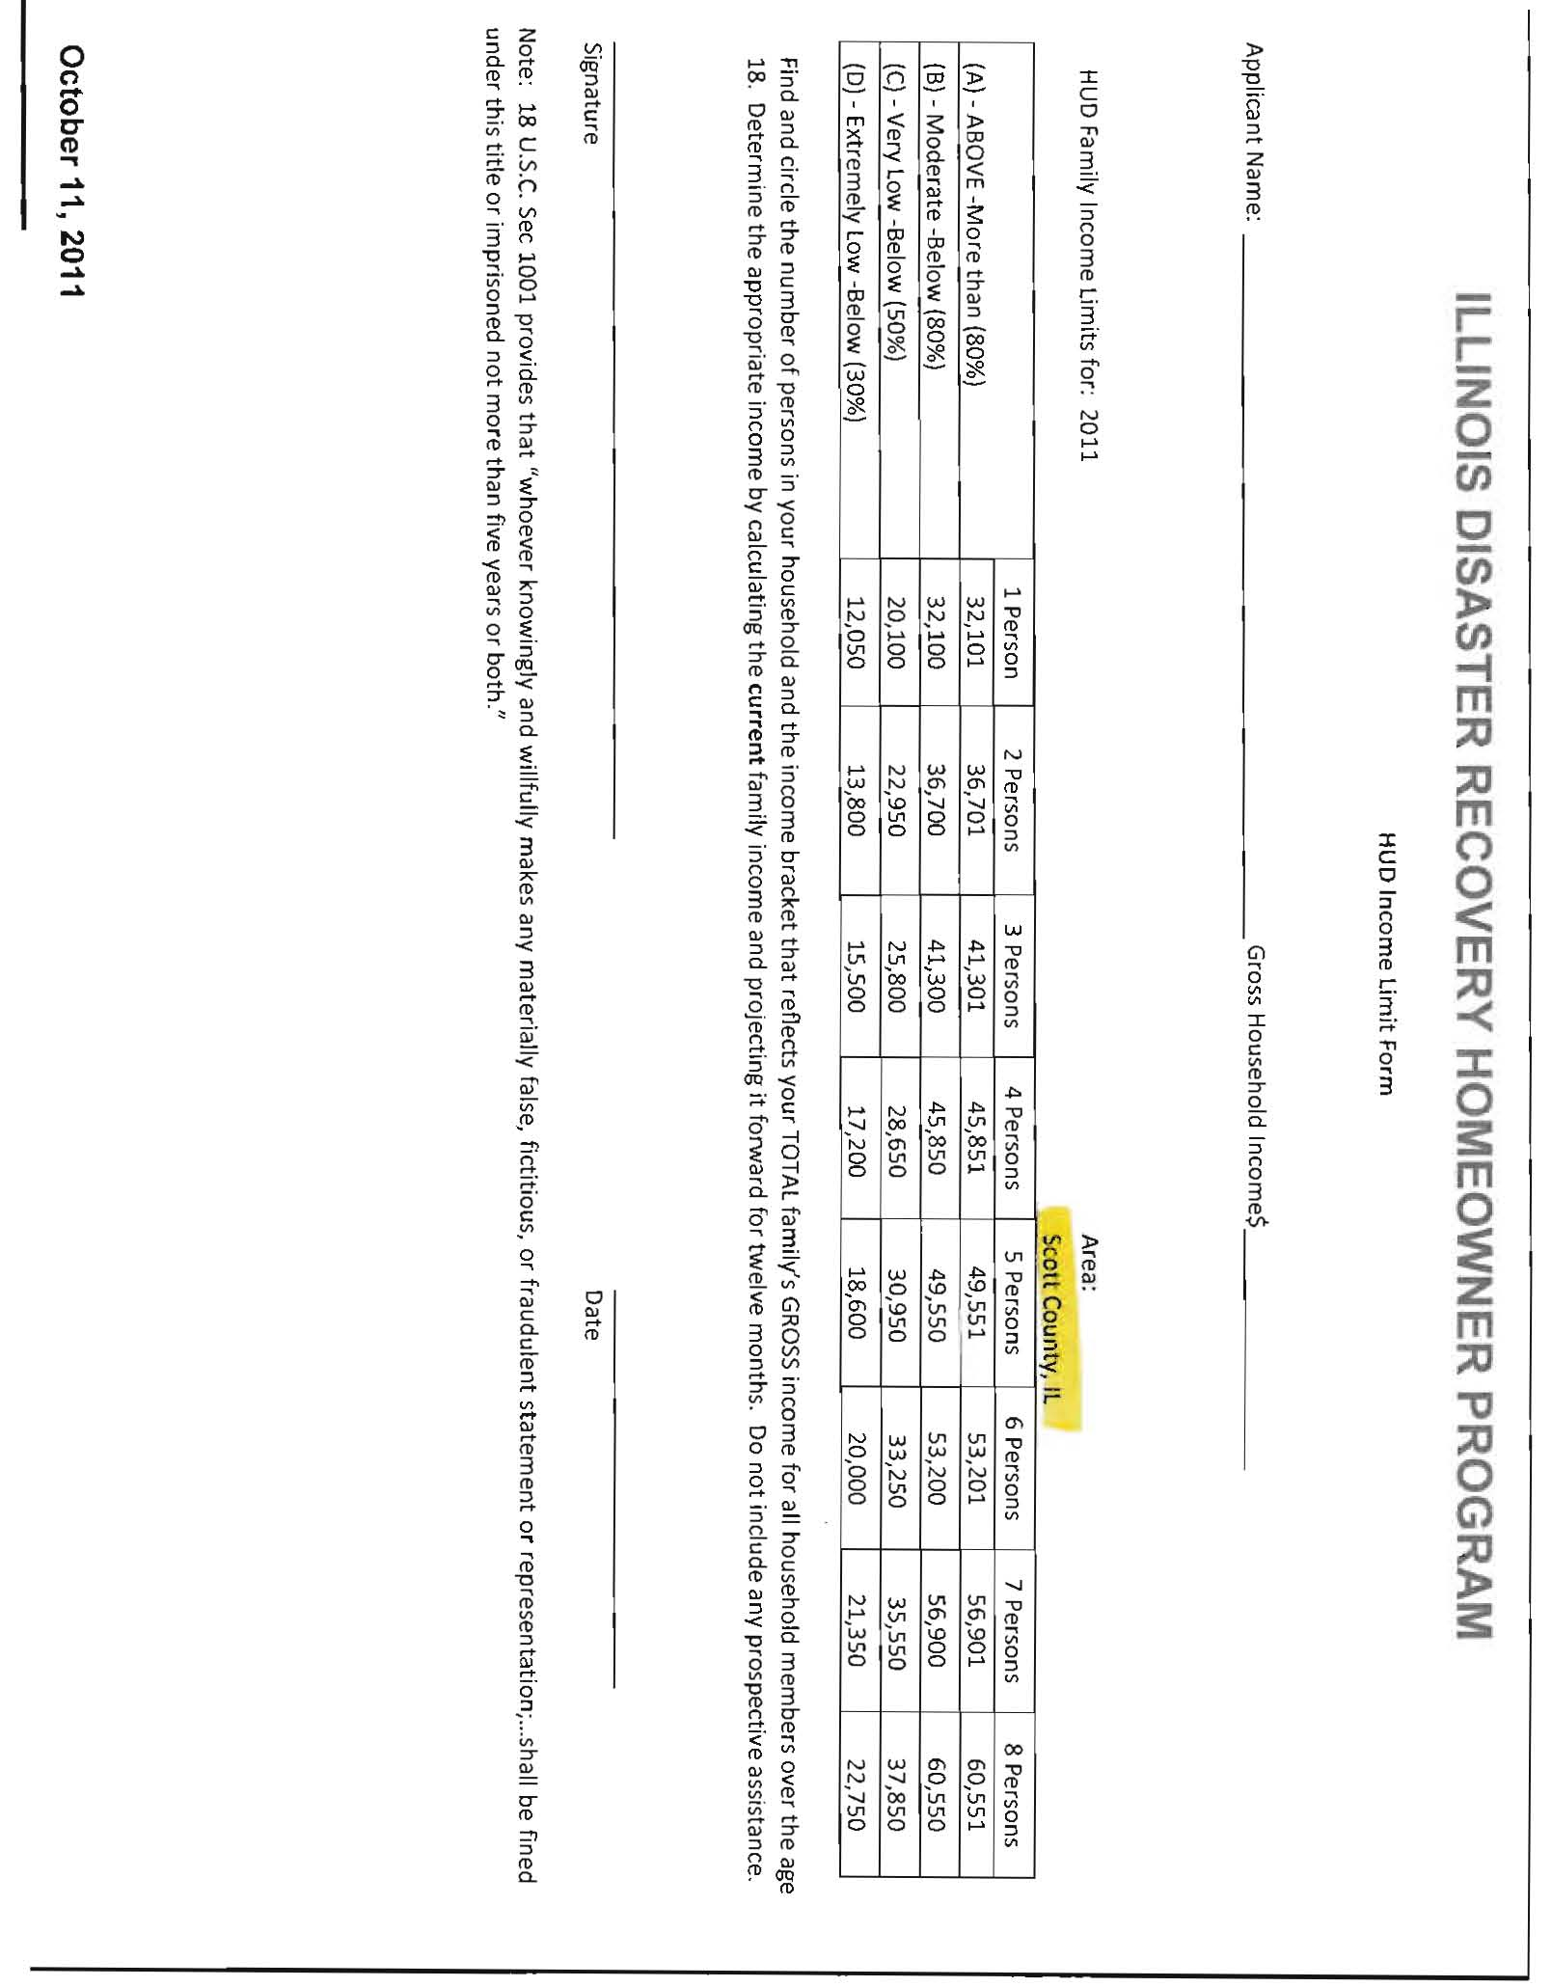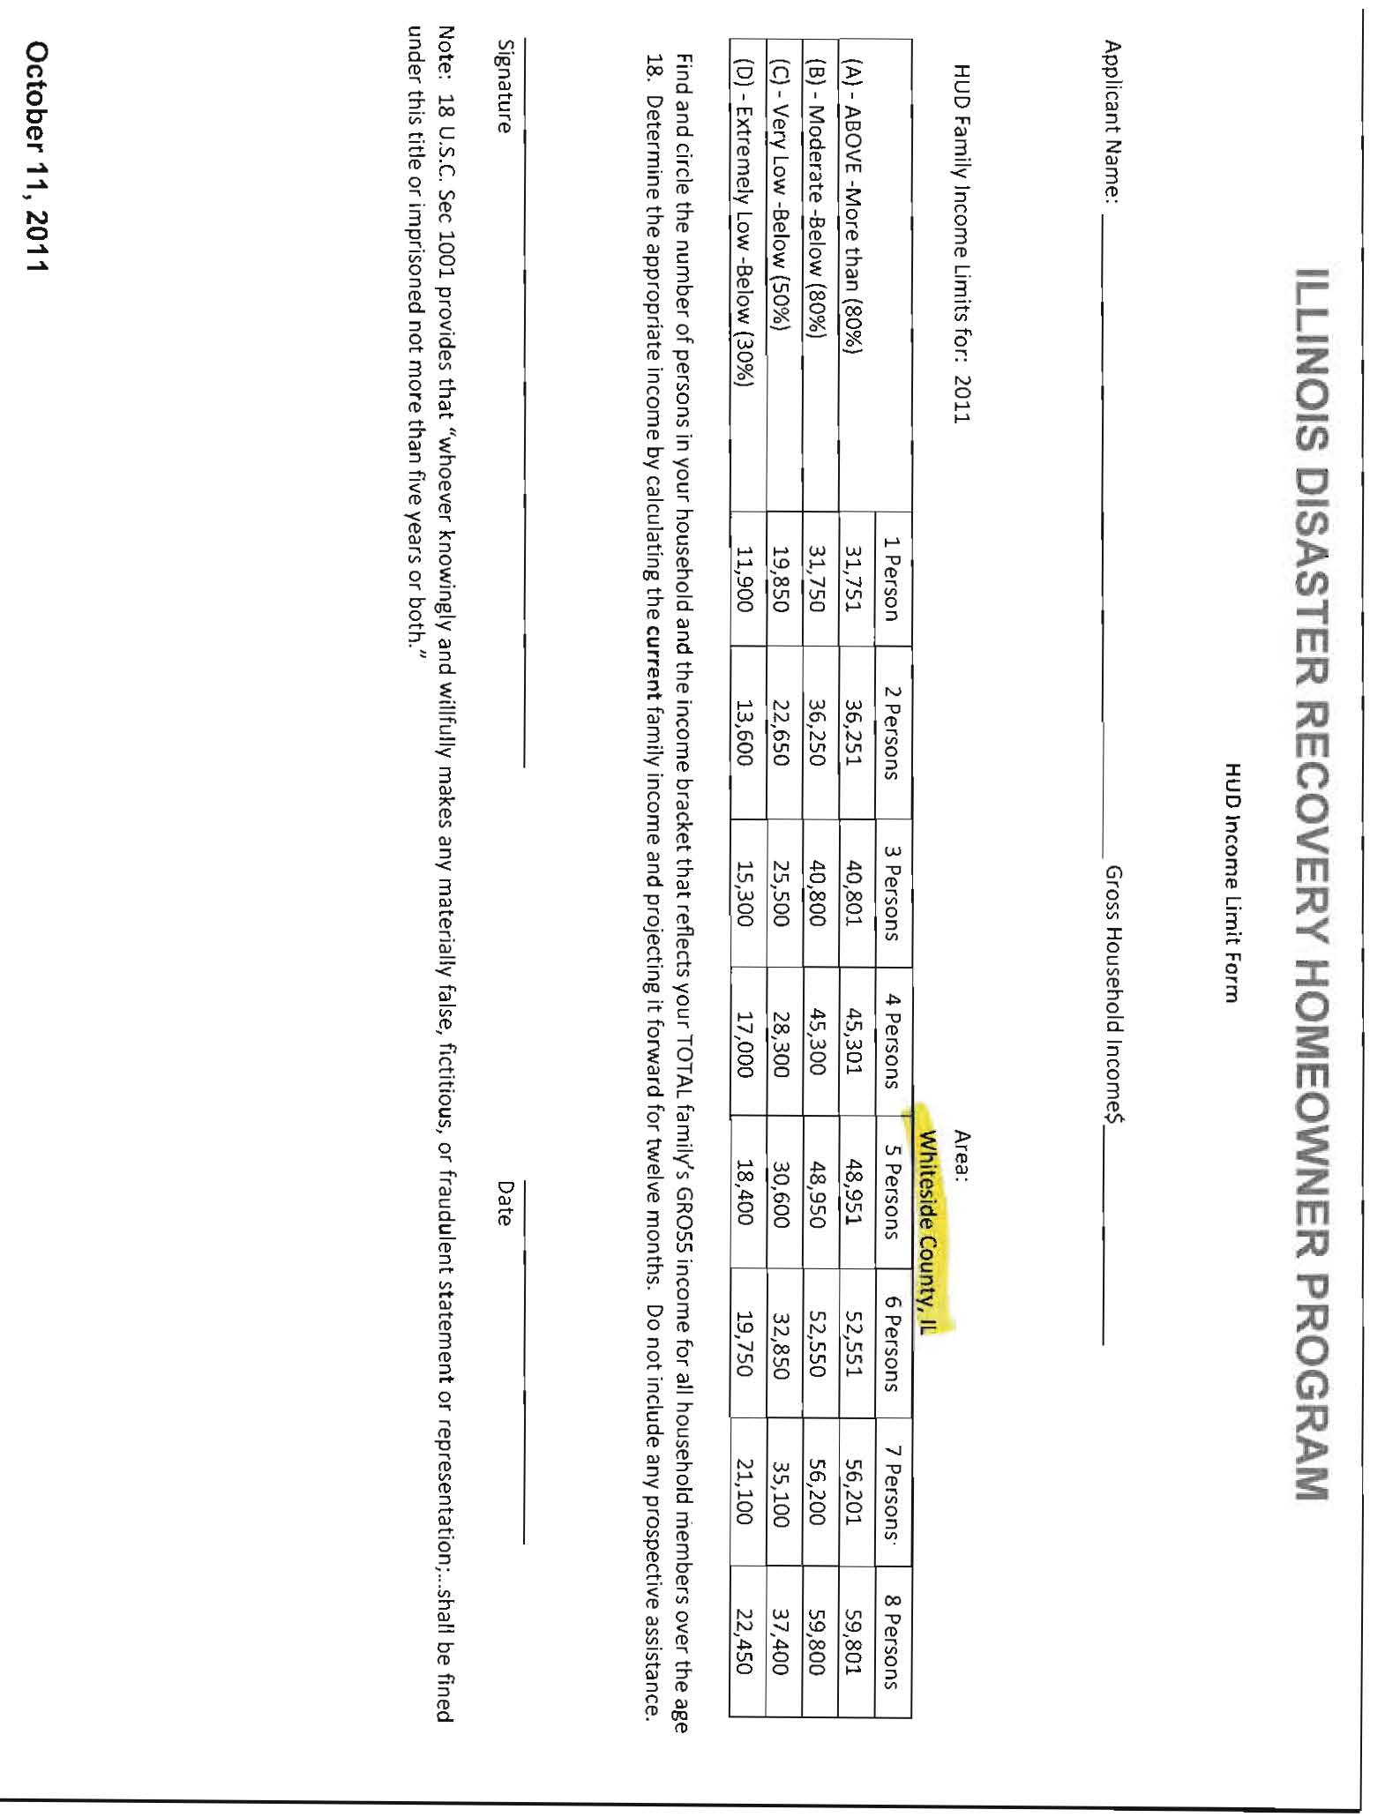
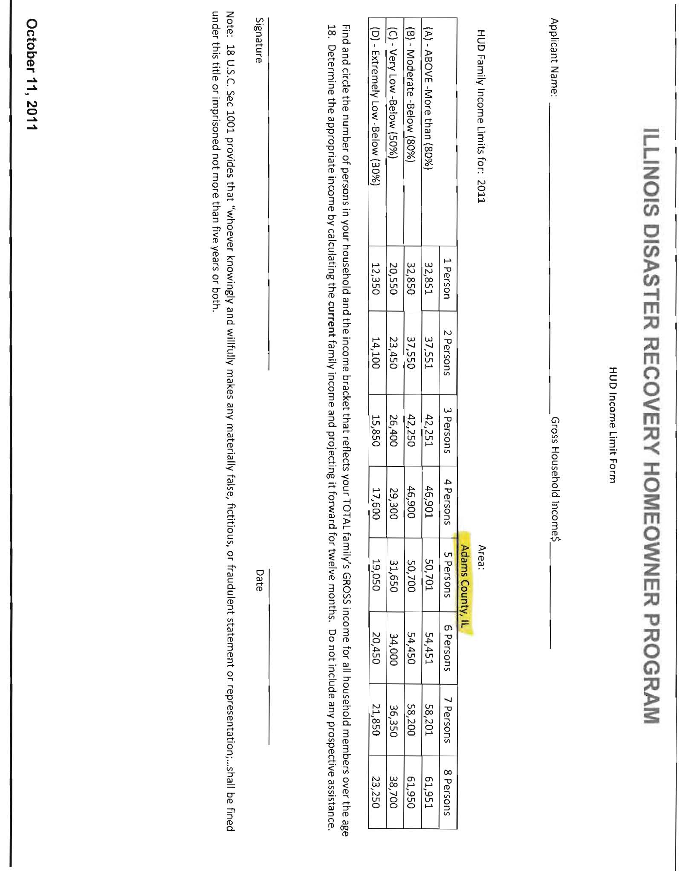

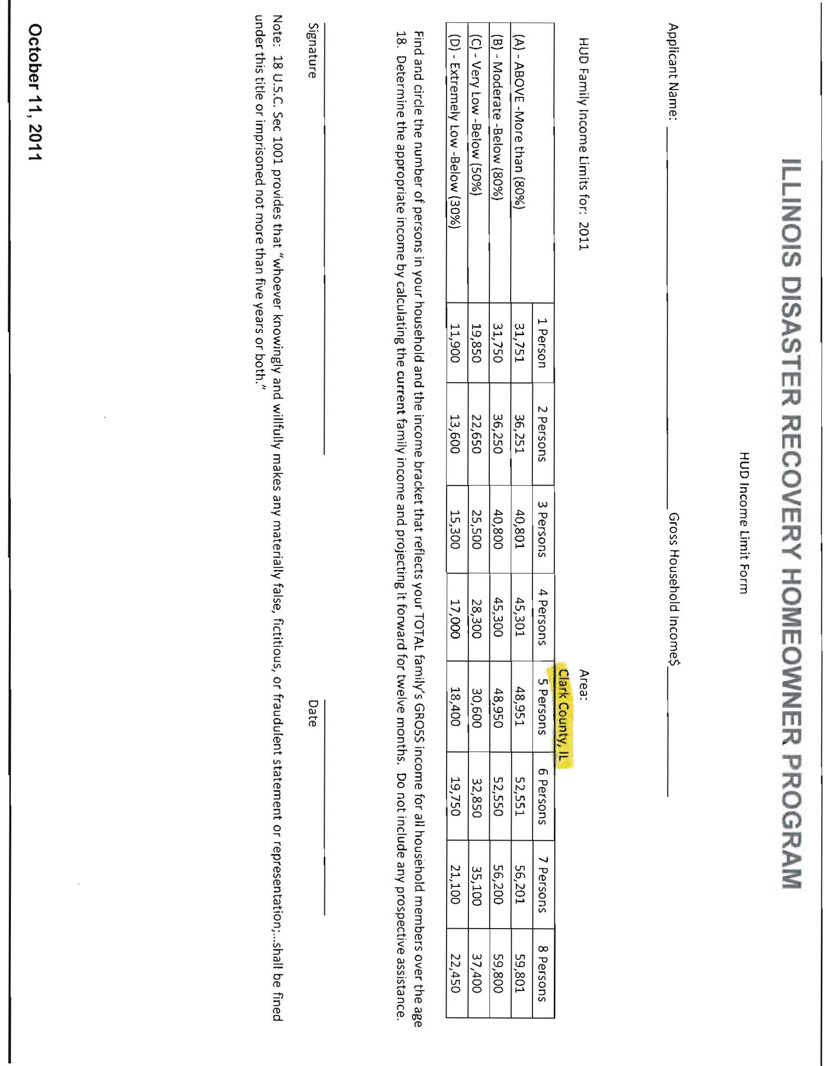
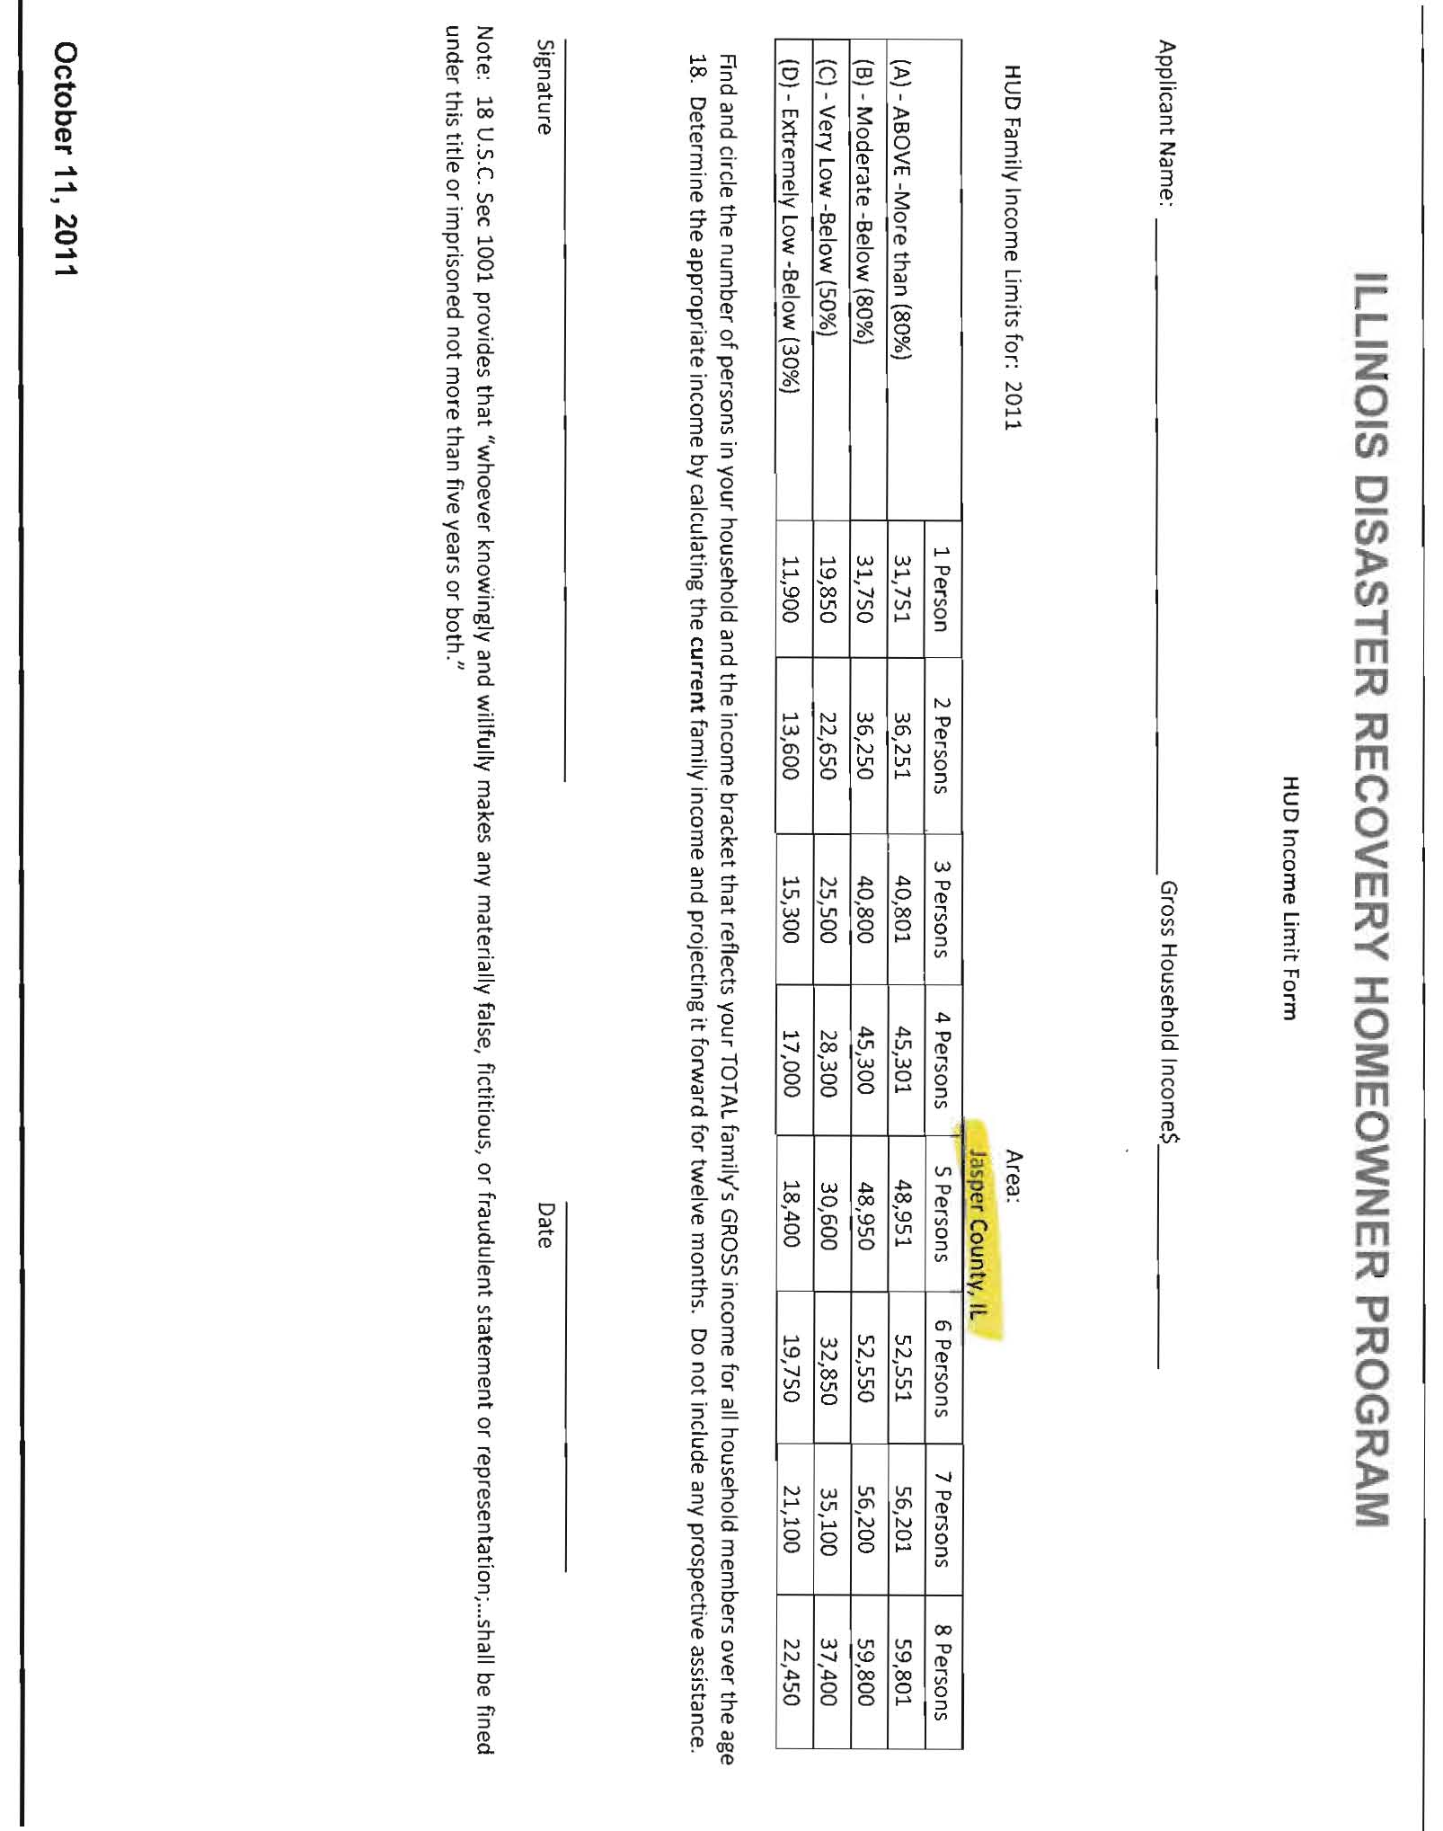
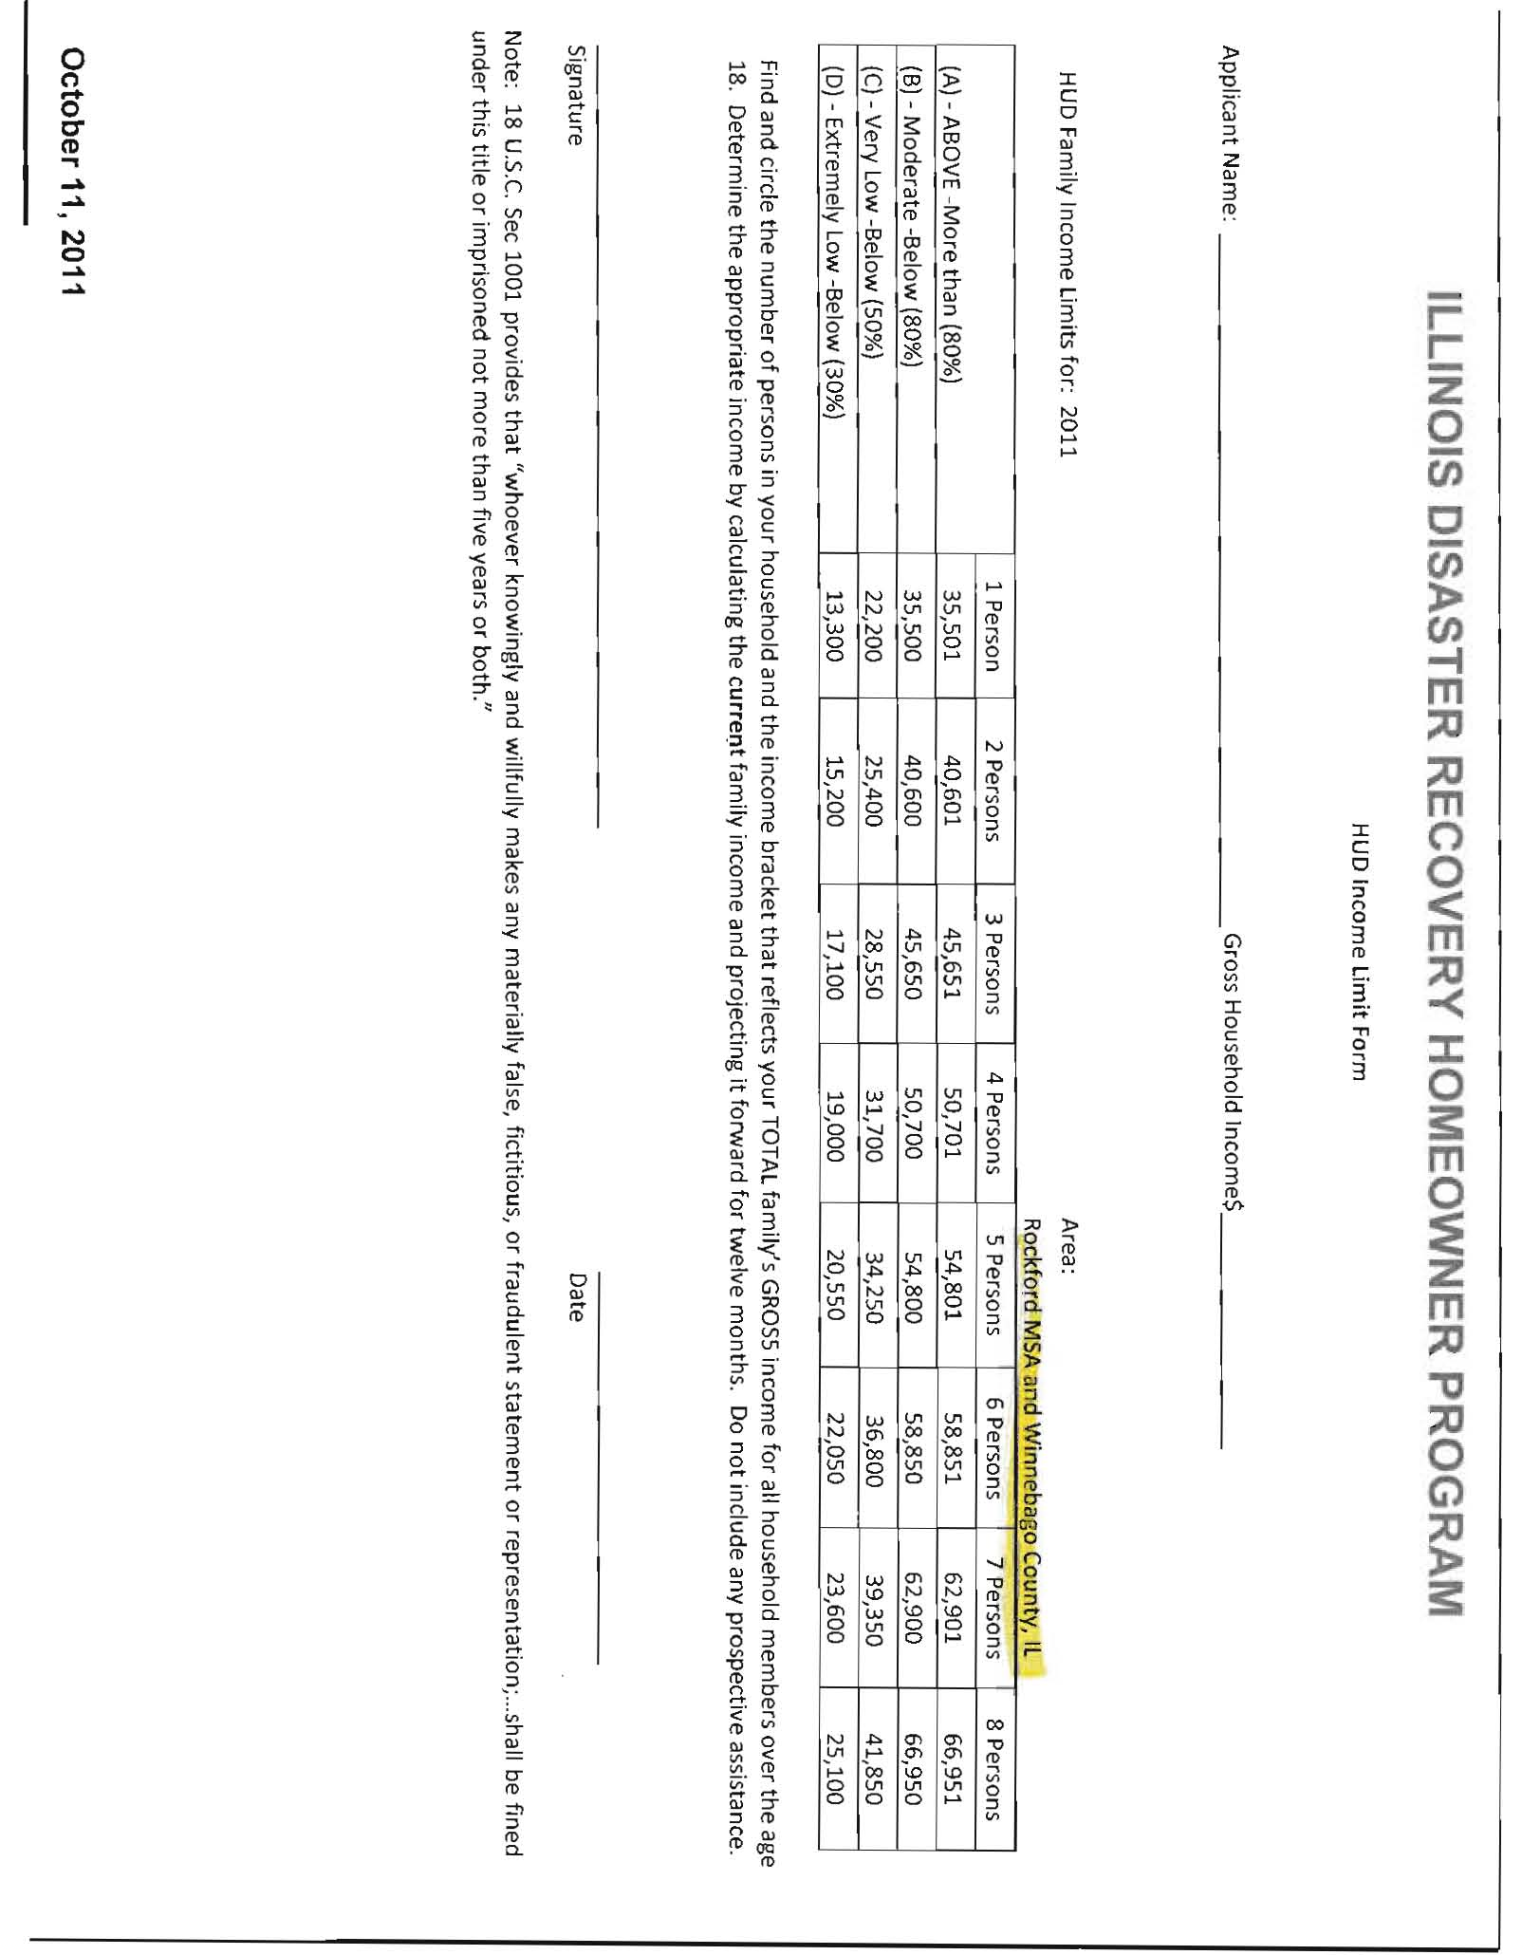
Attachment F

LEVEL OF SERIOUSNESS BY COUNTY



