Hispanic Heritage Month & National Support Latino Business Day
Social Media Toolkit 2024

Join the Illinois Department of Commerce and Economic Opportunity (DCEO) as we celebrate National Support Latino Business Day on September 14th and Hispanic Heritage Month from September 15th through October 15th. Below you will find tips, sample social media posts, graphics and ideas on how to celebrate and promote Latin@/e/x and Hispanic businesses.

SOCIAL MEDIA TIPS:
- Be sure to use the official hashtags in order to amplify the movement:
  - #ILSupportLatinoBiz
  - #ILCompraLatinoBiz
  - #ILHHM
  - #SLBD2024

- Follow, Tag & RT (Re-tweet) DCEO and your favorite Latino-owned businesses to show support:
  - DCEO Handle: @IllinoisDCEO
  - DCEO Facebook
  - DCEO Twitter
  - DCEO LinkedIn

- Visit DCEO’s webpage for information on events & Latino-owned businesses – LINK
- Use visuals like the provided graphics or a photo of you at your favorite Latino-owned business.
- Tag your friends, family, and community leaders to encourage them to participate in highlighting their favorite Illinois Latino-owned business.
- For Twitter, be mindful of character limits (280 characters)
- Make it your own! Tailor content to your stakeholders.

SUPPORT LATINO BUSINESS DAY & HISPANIC HERITAGE MONTH POSTS:

National Support Latino Business Day

Facebook/LinkedIn: National Support Latino Business Day
National Support Latino Business Day is September 14th! Be sure to visit your favorite local Latino-owned business and tag them on social media to show your support. Comment your favorite Illinois Latino-owned businesses below. #ILSupportLatinoBiz #ILCompraLatinoBiz #SLBD2024

Find more ways to celebrate National Support Latino Business Day with @IllinoisDCEO here – LINK

Facebook/LinkedIn: National Support Latino Business Day
Today is National Support Latino Business Day! Illinois is home to more than 143,000 Hispanic owned businesses. Tell us about your favorite Hispanic/Latino owned business? Who are you supporting today? [tag your friends, family, community leaders, etc.] #ILSupportLatinoBiz #ILCompraLatinoBiz #SLBD2024

Facebook/LinkedIn: National Support Latino Business Day
Join me in celebrating National Support Latino Business Day with @IllinoisDCEO to kick off Hispanic Heritage Month!

Find more ways to celebrate and get involved by visiting @IllinoisDCEO website –https://bit.ly/3TadHOa #ILSupportLatinoBiz #ILCompraLatinoBiz #SLBD2024

Facebook/LinkedIn: Business-Specific Highlight
What better way to celebrate National Support Latino Business Day than by highlighting our favorite Illinois based Latino-owned businesses?

Check out [INSERT BUSINESS HANDLE] for the best [EXAMPLES: food, gifts, drinks, clothes, services, etc.]. #ILSupportLatinoBiz #ILCompraLatinoBiz #SLBD2024

Find more ways to celebrate with @IllinoisDCEO – https://bit.ly/3TadHOa

Facebook/LinkedIn: Call to Action
I'm celebrating National Support Latino Business Day by visiting [INSERT BUSINESS HANDLE] to enjoy my favorite [EXAMPLES: food, gifts, drinks, clothes, services, etc.]. #ILSupportLatinoBiz #ILCompraLatinoBiz #SLBD2024

Which local Latino-owned businesses are you supporting today? [TAG FRIENDS, FAMILY, LEADERS, ETC]
Twitter: Support Latino Business Day
Today is National Support Latino Business Day! Visit your favorite local Latino-owned business and tag them on social media to show your support. #ILSupportLatinoBiz #SLBD2024

Find more ways to celebrate with @IllinoisDCEO – https://bit.ly/3TadHOa

Twitter: National Support Latino Business Day
Join me in celebrating National Support Latino Business Day with @IllinoisDCEO to kick off Hispanic Heritage Month! Which Latino owned business are you supporting?

#ILSupportLatinoBiz #ILCompraLatinoBiz #SLBD2024

Twitter: Business-Specific Highlight
Celebrate National Support Latino Business Day by highlighting your favorite Latino-owned businesses!

Check out [INSERT BUSINESS HANDLE] for the best [EXAMPLES: food, gifts, drinks, clothes, services, etc.]. #ILSupportLatinoBiz #ILCompraLatinoBiz

Find more ways to celebrate with @IllinoisDCEO: https://bit.ly/3TadHOa

Twitter: Call to Action
I'm celebrating National Support Latino Business Day by visiting [INSERT BUSINESS HANDLE] to enjoy my favorite [EXAMPLES: food, gifts, drinks, clothes, services, etc.]. #ILSupportLatinoBiz

Which local Latino-owned businesses are you supporting today? [TAG FRIENDS]

Instagram: Support Latino Business Day Business-Specific Highlight
Today is National Support Latino Business Day! Check out one of my favorite local Latino-owned businesses, [Insert Business Social Media Tag], for [EXAMPLES: delicious food, stylish clothes, best haircuts, best services, etc.] #ILSupportLatinoBiz #ILCompraLatinoBiz #SLBD2024

Hispanic Heritage Month

Facebook/LinkedIn: Hispanic Heritage Month
Happy Hispanic Heritage Month! Get involved and support Illinois' Latino entrepreneurs this month and beyond:
✅Attend events hosted by @IllinoisDCEO LINK
✅Visit Latino-owned businesses
✅Spread the word using #ILHHM

Facebook/LinkedIn: Hispanic Heritage Month (during October 1 – 15th)
In early October, Hispanic Heritage Month overlaps with National Women’s Small Business Month. Show your support for Illinois’ Latina-owned businesses by sharing a photo on your social media, tagging them, and using the #ILHHM hashtag.

Twitter: Hispanic Heritage Month
Happy Hispanic Heritage Month! Get involved and support Illinois' Latino entrepreneurs:
✅Attend events hosted by @IllinoisDCEO – https://bit.ly/3TadHOa
✅Visit Latino-owned businesses
✅Spread the word on social media using #ILHHM

SAMPLE NEWSLETTER/EBLAST:

The Illinois Department of Commerce & Economic Opportunity (DCEO) is celebrating National Support Latino Business Day on September 14th and Hispanic Heritage Month from September 15th through October 15th. The celebration includes a series of events highlighting DCEO’s business resources, an initiative inviting Illinoisans to support Latin@/e/x-owned businesses, as well as social media campaign recognizing Latin@/e/x-owned businesses throughout the state.

Join the celebration to help sustain the nearly 143,000 Illinois Latin@/e/x-owned businesses who play a pivotal role in Illinois’ vibrant economy. Visit DCEO’s website for more information on resources and events – https://bit.ly/3TadHOa

GRAPHICS:
Below is a collection of graphics for social media and newsletters/e-blasts. Right click and select “save as picture” to use.

Support Latino Business Day

FACEBOOK-Support Latino Business Day:

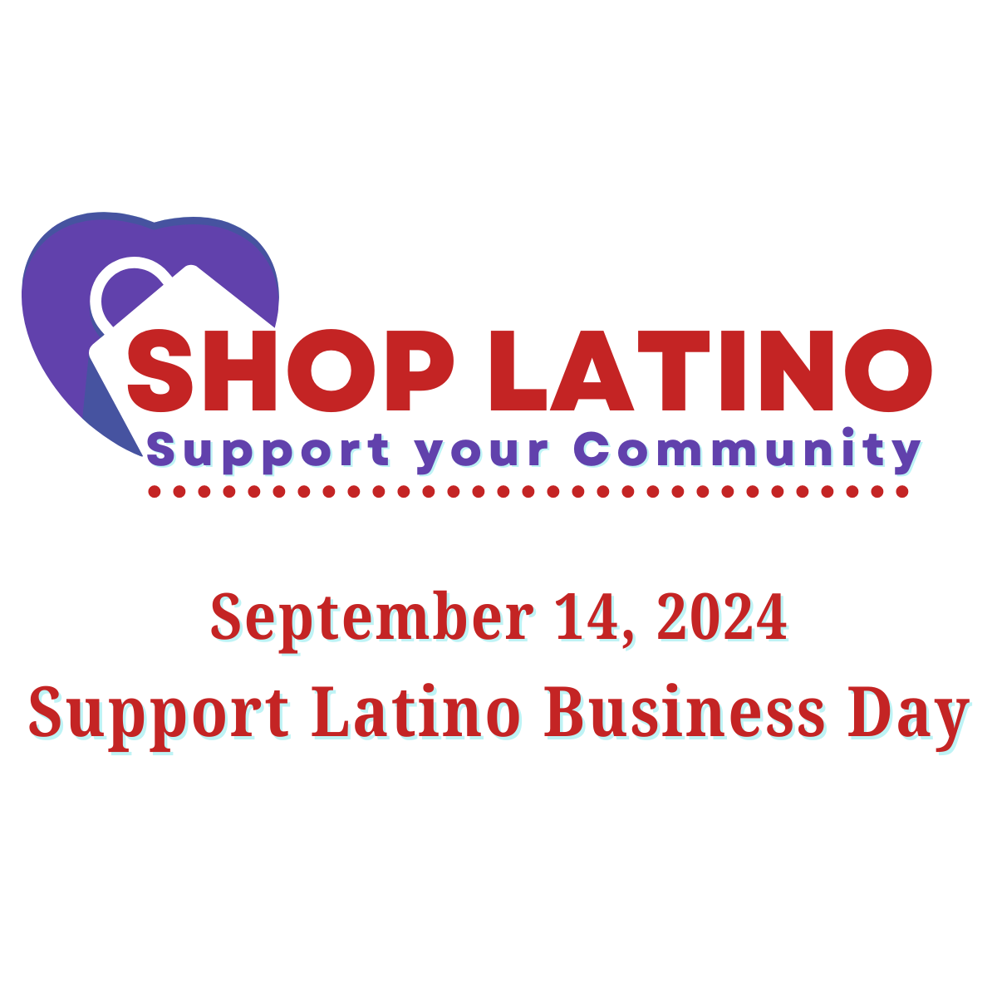

TWITTER Support Latino Business Day:
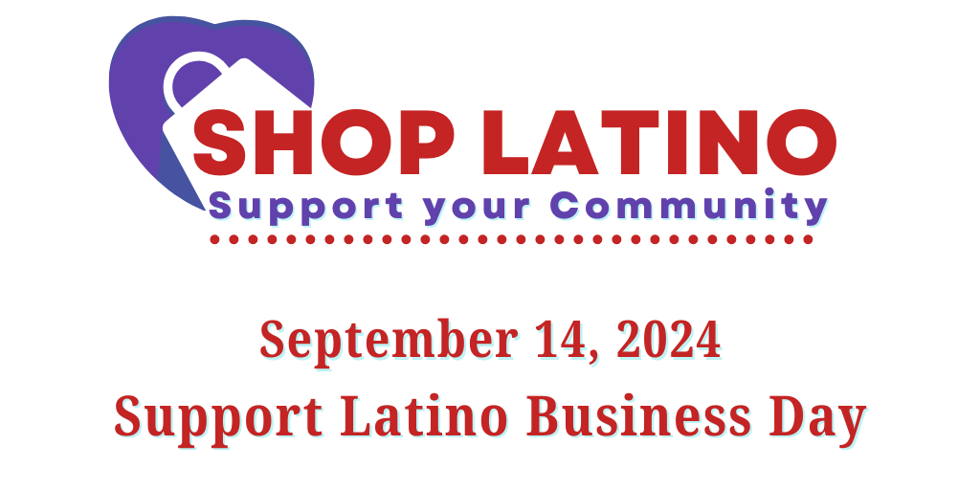
LINKEDIN Support Latino Business Day:
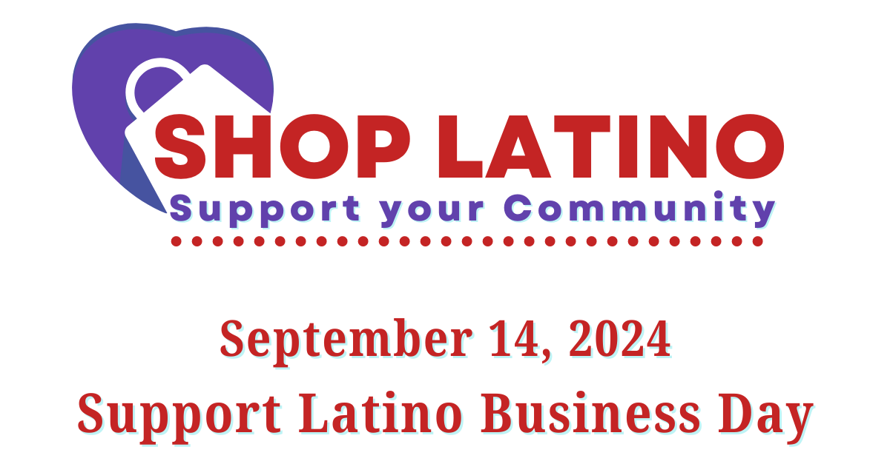

Hispanic Heritage Month

FACEBOOK-Hispanic Heritage Month:

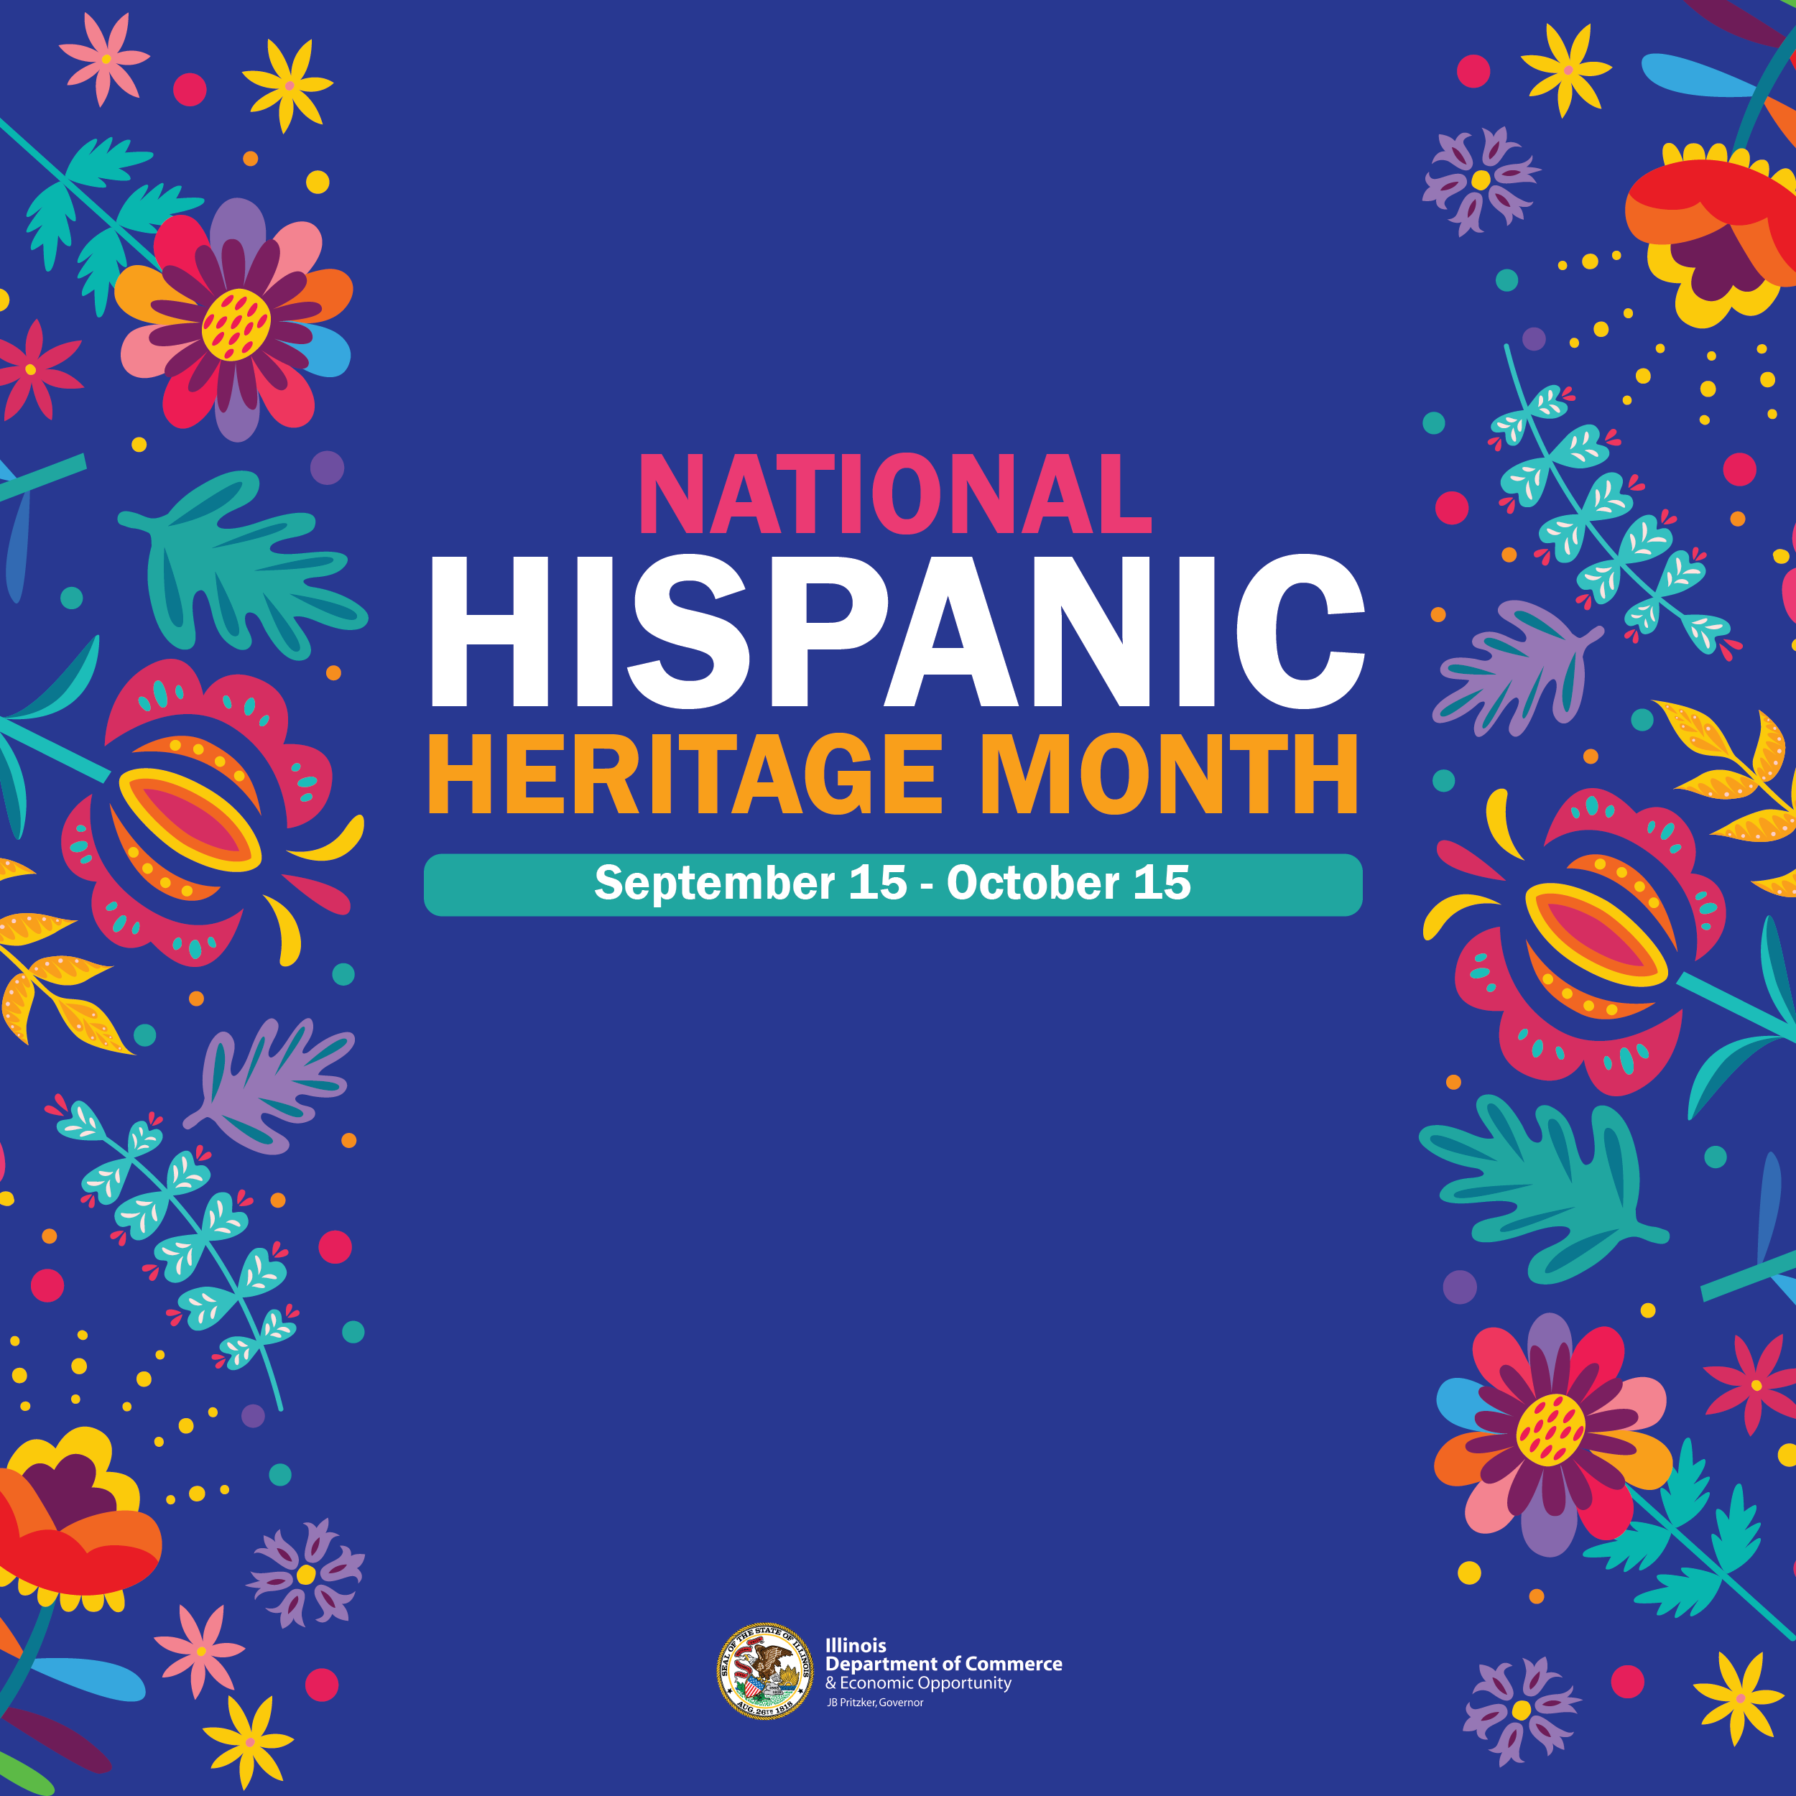

TWITTER Hispanic Heritage Month:
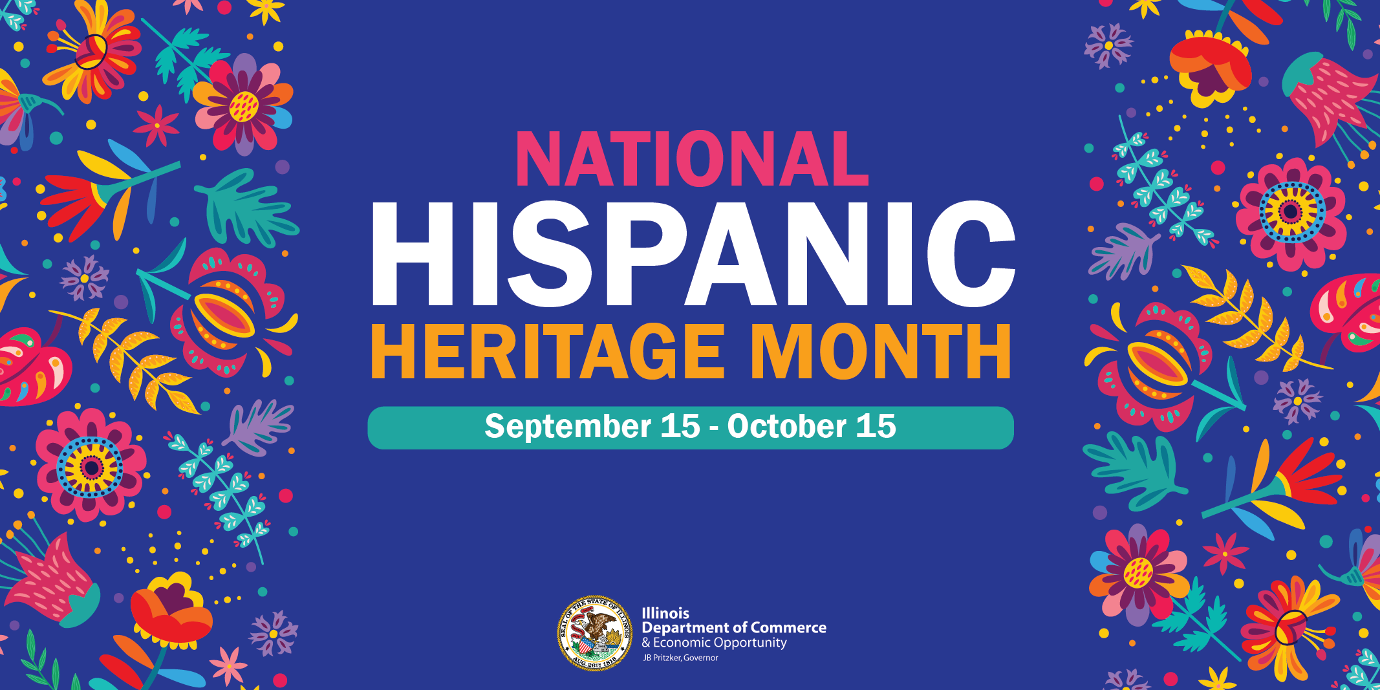

LINKEDIN Hispanic Heritage Month:
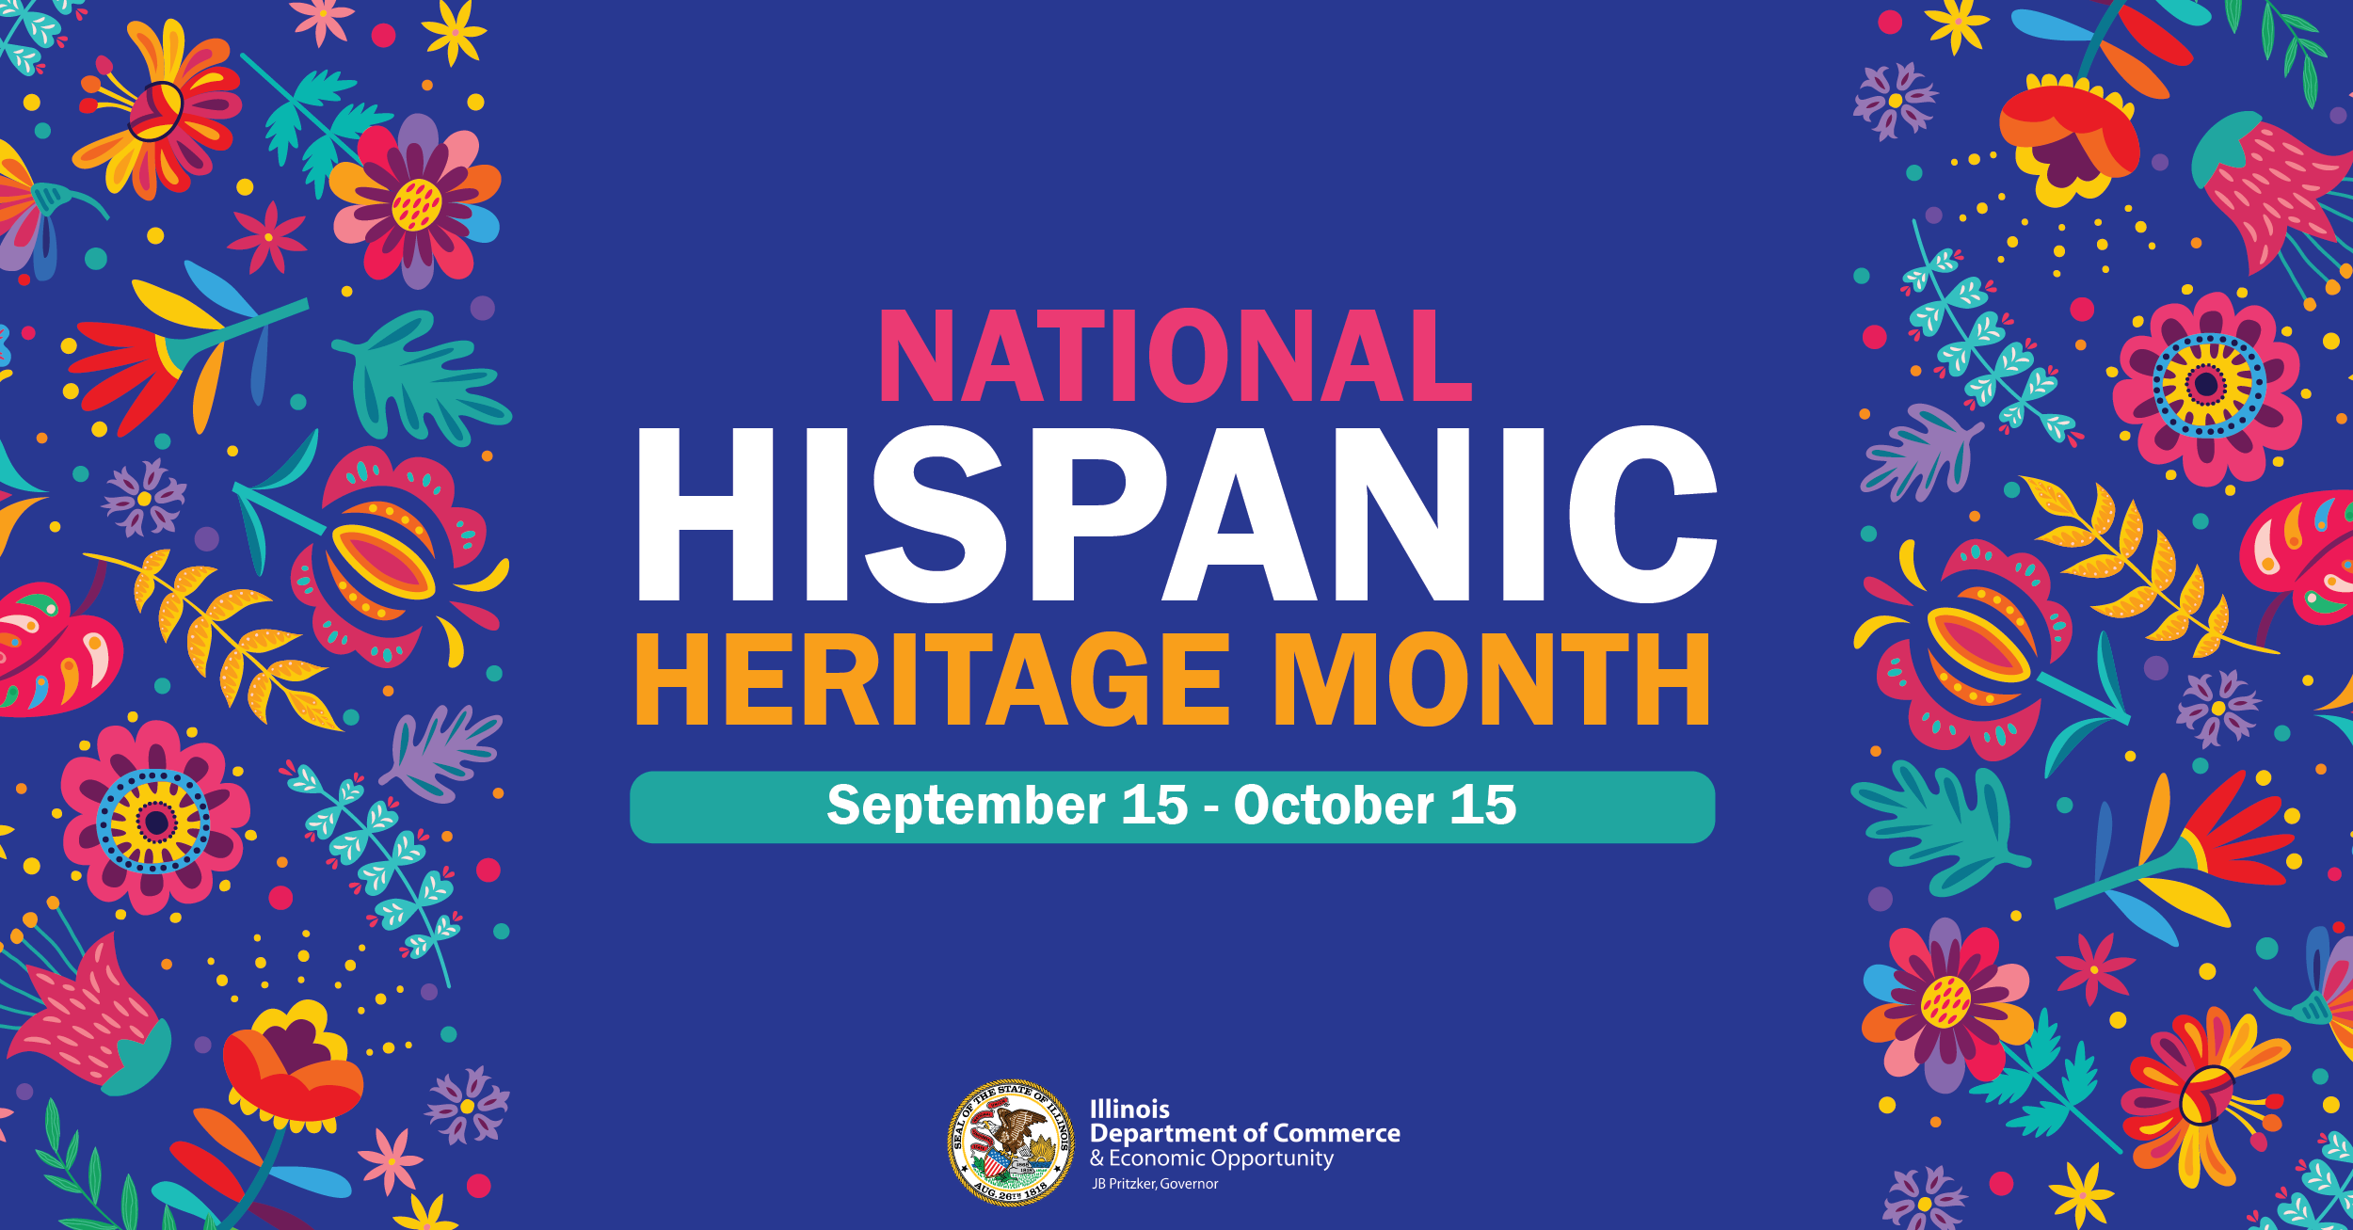

CONTACT:
For questions on the toolkit, please reach out to Diana Alfaro, Latinx Business Development Manager, at diana.alfaro@illinois.gov.

