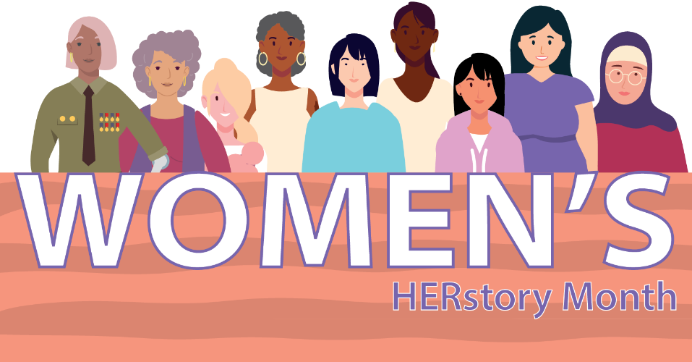

Illinois Women’s HERstory Month 2024 Toolkit Celebrating Women-Owned Businesses

Please join the Illinois Department of Commerce & Economic Opportunity (DCEO) as we celebrate and honor HER, Illinois women-owned businesses, during national Women’s HERstory Month. Throughout March, DCEO is hosting events and elevating resources to advance women-owned businesses throughout the state. We’ll also spotlight businesses owned by women in Illinois – learn more about how to get involved and support women-owned businesses here in our 2024 Illinois Women’s HERstory Month Toolkit!

Below, you will find tips, sample social media posts, graphics and ideas on how to raise awareness and encourage those in your network to celebrate Women’s HERstory Month.

SOCIAL MEDIA TIPS:
- Be sure to use the official hashtags in order amplify the movement:
  - #ILWHM2024
- Follow, Tag & RT DCEO and your favorite Women-owned businesses to show support:
  - DCEO Handle: @IllinoisDCEO
  - DCEO Twitter
  - DCEO Facebook
  - DCEO LinkedIn
- Use visuals like the provided graphics below or a photo of you at your favorite Women-owned business
- Link to DCEO’s Women’s HERstory Month landing page for helpful resources
- Make it your own! Tailor content to your stakeholders.

LINKS AND RESOURCES:
Below are links where you can find information about upcoming events and resources and programs through DCEO:
- DCEO’s Women’s HERstory Month page
  - includes events and resources for celebrating Women’s HERstory Month, as well as resources for women-owned businesses and future women entrepreneurs

- Illinois Office of Minority Economic Empowerment (OMEE)
  - resources for women-owned businesses
- Enjoy Illinois’ How to Celebrate Women’s History Month in Illinois
  - ideas for road trips & women-owned businesses throughout Illinois to support

- Directories Featuring Illinois Women-owned Businesses
  - Champaign County Chamber of Commerce’s Woman Owned Business List
  - Choose Chicago
  - City of Peoria’s Minority and Women Business Enterprise (M/WBE) Directory
  - City of Rockford’s List of Certified Woman Business Enterprises (WBEs)
  - Federation of Women Contractors
  - Illinois Made
  - Illinois Office of Tourism
  - Let’s Talk Womxn Chicago
  - Marketplace (featuring Chicago area businesses)
  - National Association of Minority & Women Owned Law Firms
  - Refine Collective
  - Small Business Majority Holiday Guide
  - State of Illinois BEP and VEP Certification Directory (click on commodity codes to look up industries)
    - Step 1: Click on BEP and/or VBP Certified Directory.
    - Step 2: In the “Search by Certification Type” area, click on Women Business Enterprise (WBE) and/or Women/Minority Business Enterprise (WMBE).
    - Step 3: In the “Search by Reference” area, navigate to the Gender section and select Female.
    - Step 4: To look for a woman-owned business in a particular industry, go to the “Search by Commodity Code” area and select “Click to Lookup Commodity Codes” then click “Browse Codes”.
  - Women Entrepreneurs Central Illinois Directory
  - YWCA Shop for Good in Evanston & Wilmette
    - 100% of profits help support the YWCA Evanston/North Shore’s domestic violence and economic advancement programs that serve women across northeastern Cook County

SAMPLE SOCIAL MEDIA POSTS:

GENERAL WOMEN’s HERstory MONTH 2024 KICKOFF POST:

This Women’s HERstory Month, Illinois is proud to celebrate the rich contributions and accomplishments of women, women-owned businesses & entrepreneurs. Visit DCEO’s website for information about events and resources – https://bit.ly/3SOFTFh #ILWHM2024

Join the State of Illinois in celebrating Women’s HERstory Month:
✅Attend events hosted by @illinoisDCEO https://bit.ly/3SOFTFh
✅Support women-owned businesses
✅Spread the word using #ILWHM2024

POST ENCOURAGING STAKEHOLDERS TO HIGHLIGHT LOCAL WOMEN-OWNED BUSINESSES:
Have a favorite women-owned business? Show your support this #ILWHM2024 by utilizing their professional services, visiting their businesses & tagging them on social media. Learn more ways to celebrate by visiting @illinoisDCEO’s site https://bit.ly/3SOFTFh

SAMPLE NEWSLETTER OR E-BLAST
Celebrate Women’s HERstory Month 2024 with the State of Illinois
Throughout Women’s HERstory Month, the Illinois Department of Commerce and Economic Opportunity (DCEO) is honoring the contributions of women in Illinois through a series of events to assist their businesses, women-owned businesses spotlights, and a social media campaign that encourages elevation of women-owned businesses in March and beyond.

Visit DCEO’s Women’s HERstory Month events and resources page.

GRAPHICS/IMAGES
Below is a collection of graphics that can be shared and used in eblasts/newsletters and via social media to help promote Women’s HERstory Month 2024. To save graphics, right click on the preferred graphic and “Save as Picture” to your files.

Facebook
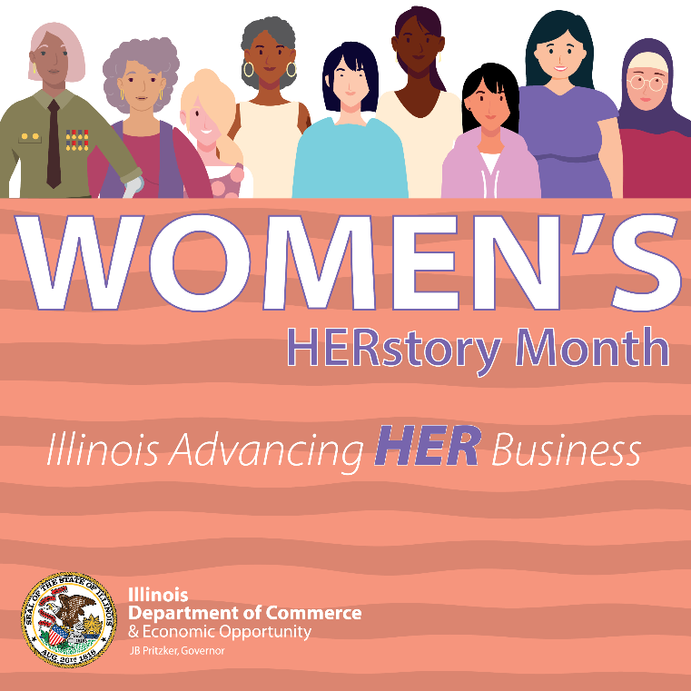

LinkedIn
