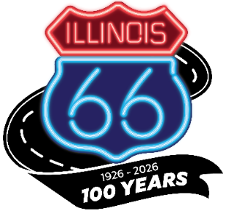

Illinois Route 66 Centennial Commission Meeting
October 31, 2024
West End Service Station
620 St. Louis Avenue
Edwardsville, IL 62025
10:00 A.M.

*Note: This meeting is being held in compliance with the Open Meetings Act (See 5 ILCS 12/7(e)). Parking is available at First Baptist Church, 534 St. Louis Stret, Edwardsville, IL 62025

Zoom Link: https://us02web.zoom.us/j/81735119350?pwd=zoxdCtssmHh0iBtmgdA1PuN56OLVz8.1

- Call Meeting to Order, Cory M Jobe, Chair

- Roll Call

- Welcome-Hon. Mayor Art Risavy, City of Edwardsville

- Introduction of Guests in Attendance

- Route 66 Road Ahead Partnership & National Park Service Route 66 Corridor Preservation Program- Bill Thomas & Kaisa Barthuli

- National Route 66 Centennial Commission

- Route 66 Illinois-Marketing & Trade Update, Cory M Jobe

- Future Forward-Centennial Projects
Illinois Office of Tourism-Daniel Thomas, Deputy Director

- Commissioner’s Comment Period

- Public Comment Period

- Adjourn

