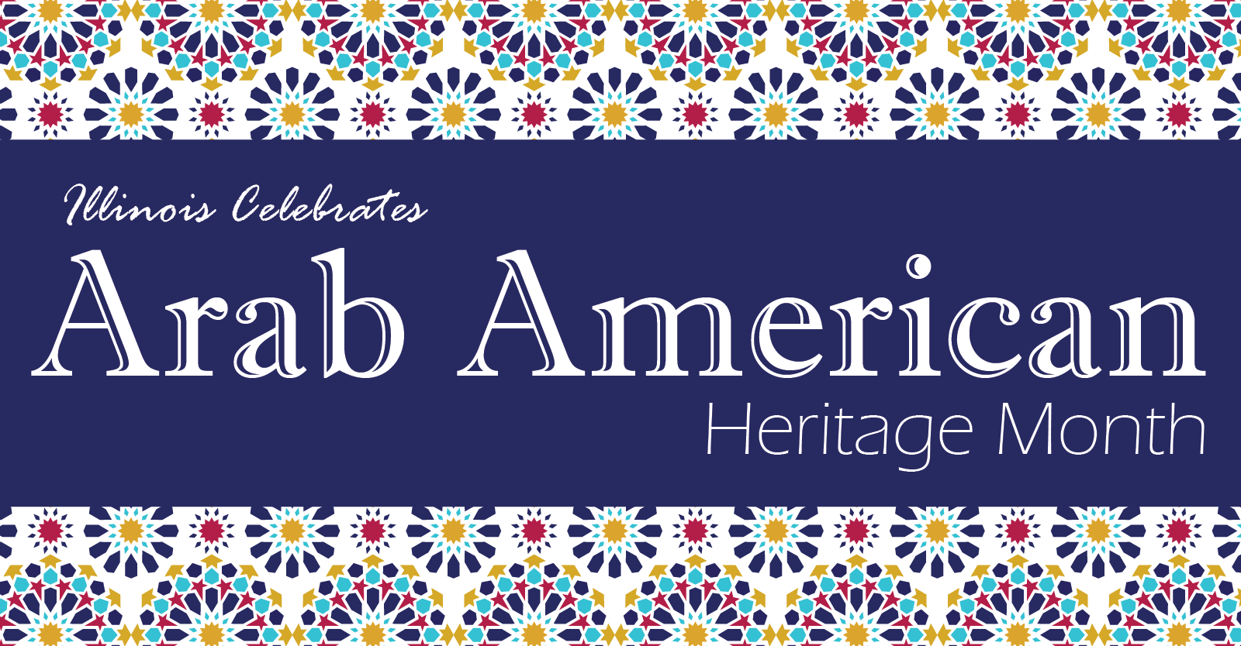

**2025 Arab American Heritage Month Social Media Toolkit**

Throughout April, the Illinois Department of Commerce and Economic Opportunity (DCEO) is celebrating Arab American Heritage Month. DCEO, through its Offices of Economic Equity and Empowerment (OE3) and Regional Economic Development (RED), is spotlighting Arab American businesses across the state and elevating resources to advance Illinois’ Arab American businesses, showcasing DCEO’s continued commitment to their growth and development.

Below, you will find tips, sample social media posts, graphics and ideas on how to raise awareness and encourage those in your network to celebrate Arab American Heritage Month.

**SOCIAL MEDIA TIPS**

* Be sure to use the official hashtags to amplify your content:
  + #AAHM2025
* Follow, Tag & RT DCEO and your favorite Arab American-owned businesses to show support:

DCEO Handle: @IllinoisDCEO

* + [DCEO Facebook](https://www.facebook.com/illinoisdceo)
  + [DCEO Twitter](https://twitter.com/IllinoisDCEO)
  + [DCEO LinkedIn](https://www.linkedin.com/company/illinoisdceo)
  + [DCEO Bluesky](https://bsky.app/profile/illinoisdceo.bsky.social)
* Use visuals like the graphics provided below or a photo of you at your favorite Arab American-owned business.
* Make it your own! Tailor content to your stakeholders.

**LINKS AND RESOURCES**

Below are links where you can find information about upcoming events and resources and programs through DCEO:

* DCEO’s Arab American Heritage Month Landing Page - <https://bit.ly/4ijVRTH>
  + Includes events and resources for celebrating Arab American Heritage Month, as well as resources for Arab American-owned businesses and future entrepreneurs.
* [**Illinois Office of Economic Equity & Empowerment (OE3)**](https://dceo.illinois.gov/oe3.html)
* [**Small Business Development Center (SBDC)**](https://dceo.illinois.gov/smallbizassistance/beginhere/sbdc.html) – They are centers located across the state that provide free business counseling for small for-profit businesses.
  + If assistance is needed in Arabic the SBDC at the Arab Business and Professional Association (ABPA) has that capacity to assist- <https://abpaillinois.com/about-sbdc-at-abpa/>

**SAMPLE SOCIAL MEDIA POSTS**

**GENERAL ARAB AMERICAN HERITAGE MONTH KICKOFF POST:**

**Option 1**

Illinois is proud to celebrate **Arab American Heritage Month** and honor the incredible contributions of Arab American-owned businesses and entrepreneurs across our state!

Join us in recognizing their rich history, resilience, and success. Check out @IllinoisDCEO’s website for upcoming events and resources: <https://bit.ly/4ijVRTH> #AAHM2025

**Option 2**

Join the State of Illinois in celebrating Arab American Heritage Month by:

✅ Attending an event hosted by @illinoisDCEO – <https://bit.ly/4ijVRTH>

✅ Supporting Arab American-owned businesses

✅ Spreading the word using #AAHM2025

**POST ENCOURAGING STAKEHOLDERS TO HIGHLIGHT LOCAL ARAB AMERICAN-OWNED BUSINESSES**

Have a favorite Arab American-owned business? Show your support this #AAHM2025

by visiting & tagging them on social media. Learn more ways to celebrate by visiting @illinoisDCEO’s site – <https://bit.ly/4ijVRTH>

**SAMPLE NEWSLETTER OR E-BLAST**

This **Arab American Heritage Month,** we’re celebrating the incredible contributions of Arab American entrepreneurs and businesses to Illinois’ econmy! Throughout the month, **DCEO** is hosting sharing businesses resources to support the growth of our Illinois’ Arab American-owned businesses and aspiring entrepreneurs. DCEO will also be highlighting **Arab American-owned businesses** across the state.

Join us in recognizing and supporting this vibrant community today and all year round! Visit **DCEO’s Arab American Heritage Month page** for event details and valuable resources. <https://bit.ly/4ijVRTH>

**GRAPHICS**

Below is a collection of graphics that can be shared and used in eblasts/newsletters and via social media to help promote Arab American Heritage Month. To save graphics, right click on the preferred graphic and “Save as Picture” to your files.

**Facebook**

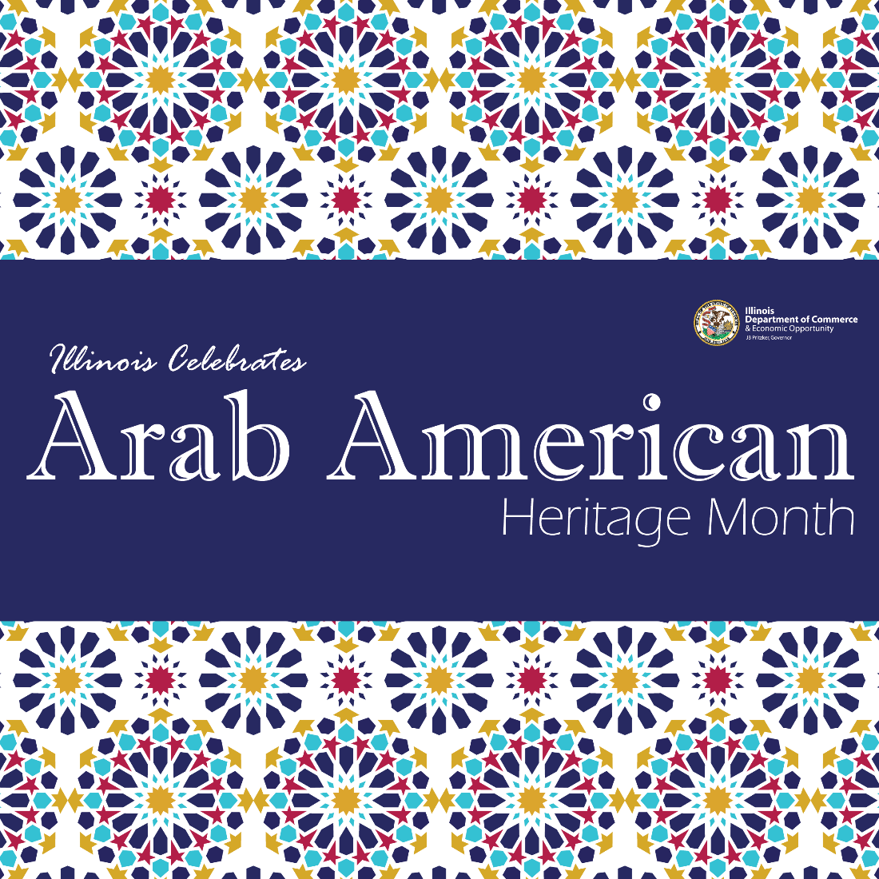

**LinkedIn**

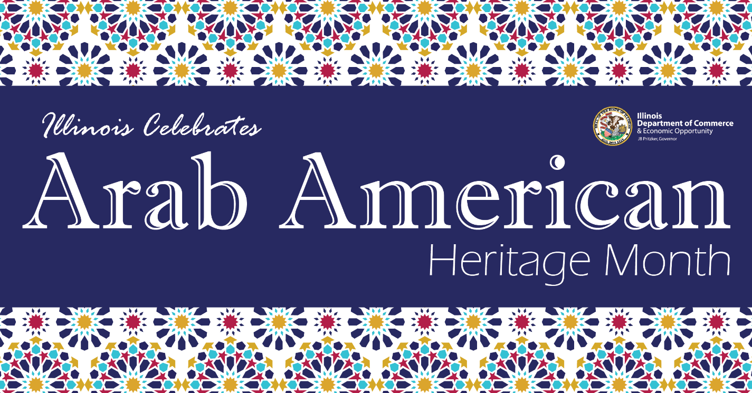

**Twitter**

