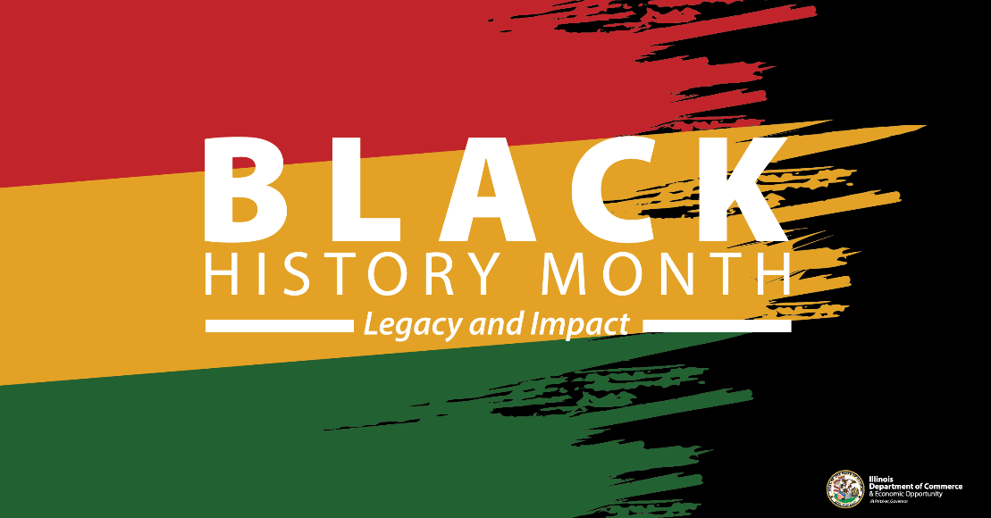

***Illinois DCEO Black History Month 2025***

***“Legacy and Impact”***

The Illinois Department of Commerce and Economic Opportunity (DCEO) will celebrate Black History Month throughout February 2025. DCEO, through its Office of Economic Equity & Empowerment (OE3), will host virtual and in-person events to spotlight long-standing Black businesses across the state, highlight Black business accomplishments and contributions to our state, and showcase our commitment to growing and investing in Black businesses.

Learn more about how to get involved here in our 2025 Illinois Black History Month Toolkit!

Below, you will find tips, sample social media posts, graphics and ideas on how to raise awareness and encourage those in your network to celebrate Women’s Business Month.

**SOCIAL MEDIA TIPS**

* Be sure to use the official hashtags to amplify your content:
  + #BHM2025
  + #ILBHM2025
* Follow, Tag & RT DCEO and your favorite Black-owned businesses to show support:
  + DCEO Handle: @IllinoisDCEO
  + [DCEO Facebook](https://www.facebook.com/illinoisdceo)
  + [DCEO Twitter](https://twitter.com/IllinoisDCEO)
  + [DCEO LinkedIn](https://www.linkedin.com/company/illinoisdceo)
  + [DCEO Bluesky](https://bsky.app/profile/illinoisdceo.bsky.social)
* Use visuals like the graphics provided below or a photo of you at your favorite Black-owned business.
* Link to [DCEO’s Black History Month Landing page](https://dceo.illinois.gov/oe3/events/bhm2025.html) to share events and resources with your network & community.
* Share Enjoy Illinois resources to help promote historical Black businesses and sites in Illinois.
* Make it your own! Tailor content to your stakeholders.

**LINKS AND RESOURCES**

Below are links where you can find information about upcoming events, resources and programs through DCEO:

* [DCEO Black History Month Landing Page](https://dceo.illinois.gov/oe3/events/bhm2025.html)
  + Learn more about everything DCEO is doing to celebrate Black History Month
* Illinois Office of Economic Equity & Empowerment (OE3)
  + Share resources and grant opportunities for small and minority-owned businesses like the [OE3 Capital Grant.](https://dceo.illinois.gov/aboutdceo/grantopportunities/2160-2940.html)
* Enjoy Illinois Black History Month Resources
  + [Enjoy Illinois Black History Month Landing Page](https://www.enjoyillinois.com/things-to-do/arts-and-culture/celebrate-black-history-month-in-illinois/)
* Resource guides for supporting Black businesses across the state
  + [Peoria](https://www.bbapeoria.org/member-directory/)
  + [Kendall, DuPage, Kane and Will Counties](https://quadcountyaachamber.chambermaster.com/list/ql/african-american-owned-28)
  + [Southern Illinois](https://www.blackchamberofsi.com/members)

**SAMPLE SOCIAL MEDIA POSTS**

**GENERAL BLACK HISTORY MONTH KICKOFF POST:**

This #BlackHistoryMonth, Illinois is proud to celebrate the legacy and impact of Black Illinoisans on our state’s economy and history. Make sure to visit DCEO’s website for information about events and resources – <https://bit.ly/42B0fZe> #BHM2025

Join the State of Illinois in celebrating Black History Month by:

✅ Attending an event hosted by @IllinoisDCEO

✅ Supporting & highlighting Black-owned businesses

✅ Visiting historic Black sites & businesses

**POST ENCOURAGING STAKEHOLDERS TO VISIT HISTORICAL BLACK SITES ACROSS ILLINOIS**

This #BlackHistoryMonth, Enjoy Illinois is sharing some of Illinois’ historical Black attractions and businesses to visit. Make your plan today -

**POST ENCOURAGING STAKEHOLDERS TO HIGHLIGHT LOCAL BLACK-OWNED BUSINESSES**

Have a favorite Black-owned business? Show your support this #ILBHM2025 by visiting & tagging them on social media. Learn more ways to celebrate by visiting @IllinoisDCEO’s website - <https://bit.ly/42B0fZe>

**SAMPLE NEWSLETTER OR E-BLAST:**

The Illinois Department of Commerce and Economic Opportunity (DCEO) will celebrate Black History Month throughout February 2025. DCEO, through its Office of Economic Equity & Empowerment (OE3), will host virtual and in-person events to spotlight long-standing Black businesses across the state, highlight Black business accomplishments and contributions to our state, and showcase our commitment to growing and investing in Black businesses.

Make sure to check out DCEO’s events and resources for Black History Month - Visit [Enjoy Illinois Black History Month webpage](https://www.enjoyillinois.com/things-to-do/arts-and-culture/celebrate-black-history-month-in-illinois/) to learn about Black History Month events, attractions and Black Illinois Made Makers.

**GRAPHICS**

Below is a collection of graphics that can be shared and used in eblasts/newsletters and via social media to help promote Black History Month. To save graphics, right click on the preferred graphic and “Save as Picture” to your files.

**Facebook Graphic**

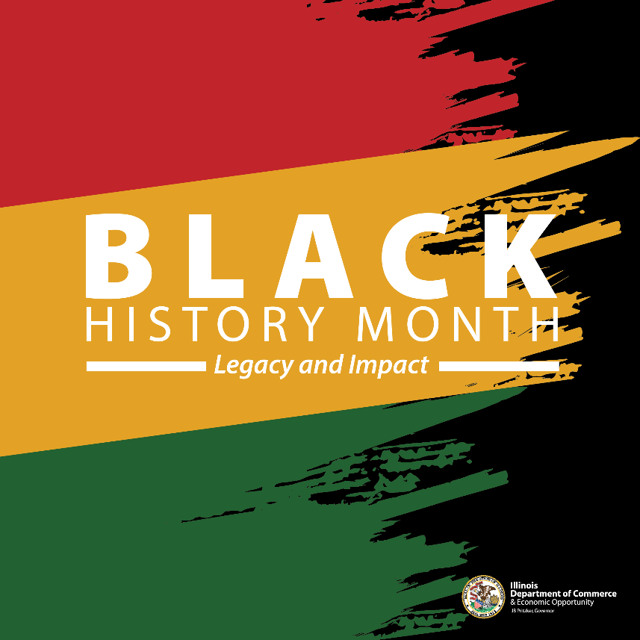

**LinkedIn Graphic**



**Twitter (X) Graphic**

