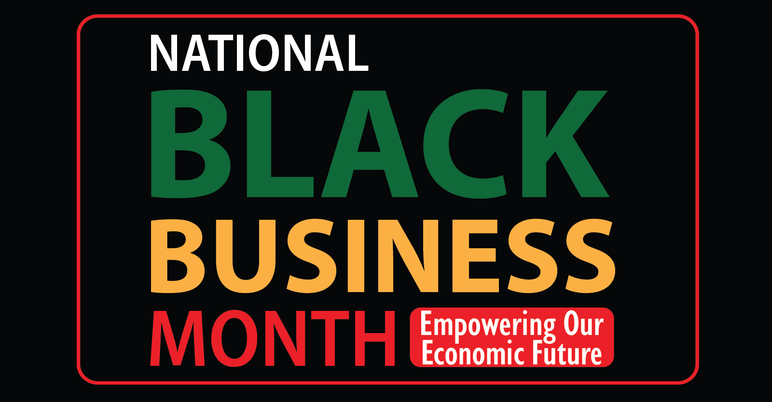

2026 Black Business Month Toolkit

“Illinois Black Businesses Series: Empowering our Economic Future”
This August, the Illinois Department of Commerce and Economic Opportunity (DCEO) is celebrating and honoring Black business month. Throughout the month, DCEO will be celebrating Black businesses across Illinois. Find information about upcoming events and resources to support the month-long celebration of Black business month in Illinois below.

SOCIAL MEDIA TIPS:
- Be sure to use the official hashtags in order amplify the movement:
  - #ILBlackBizMonth
- Follow, Tag & RT DCEO and your favorite Black-owned businesses to show support:
  - DCEO Handle: @IllinoisDCEO
  - DCEO Facebook
  - DCEO Twitter
  - DCEO LinkedIn
  - DCEO Bluesky
- Use visuals like the provided graphics or a photo of you at your favorite Black-owned business
- Link to DCEO’s Black Business Month landing page for events and resources - bit.ly/4qfX2bD
- Make it your own! Tailor content to your stakeholders.

LINKS AND RESOURCES:
- Resources for Illinois Black-owned businesses: Illinois Office of Economic Equity & Empowerment

- List of Illinois’ Black-Owned Businesses: Meet Black Illinois Makers

- Resources for supporting Black Businesses: DCEO Current Grant Opportunities

SAMPLE SOCIAL MEDIA POSTS:

Twitter Post #1: (General Black Business Month Post)
Illinois’ Black businesses are foundational to our economy. Join DCEO as we celebrate #NationalBlackBusinessMonth by:
- 📆 Attending DCEO's events
- 🛍️ Shopping Black-Owned Businesses
- 💼 Sharing business resources
- Learn more - bit.ly/4qfX2bD

Facebook/LinkedIn: Post #1 (General Black Business Month Post)
Join DCEO in celebrating #NationalBlackBusinessMonth! Throughout August DCEO will be sharing business resources and hosting events to uplift Black businesses and entrepreneurs across the state.

Learn more about what DCEO’s plans and how you can get involved - bit.ly/4qfX2bD #ILBlackBizMonth

SAMPLE NEWSLETTER/EBLAST:

Celebrate National Black Business Month this August!
This August, the Illinois Department of Commerce and Economic Opportunity (DCEO) is celebrating National Black Business Month. Throughout the month, DCEO, through its office of Office of Economic Equity & Empowerment (OE3), will be uplifting Black businesses and entrepreneurs across Illinois through a series of events. Black businesses and entrepreneurs are foundational to our state’s economy, and they enrich our everyday lives. DCEO is committed to supporting Black business year-round. Make sure to visit DCEO’s website for more information on resources and events.

GRAPHICS/IMAGES:
Below is a collection of graphics for social media/e-blasts. Simply right click and “save as picture” to use.

Facebook
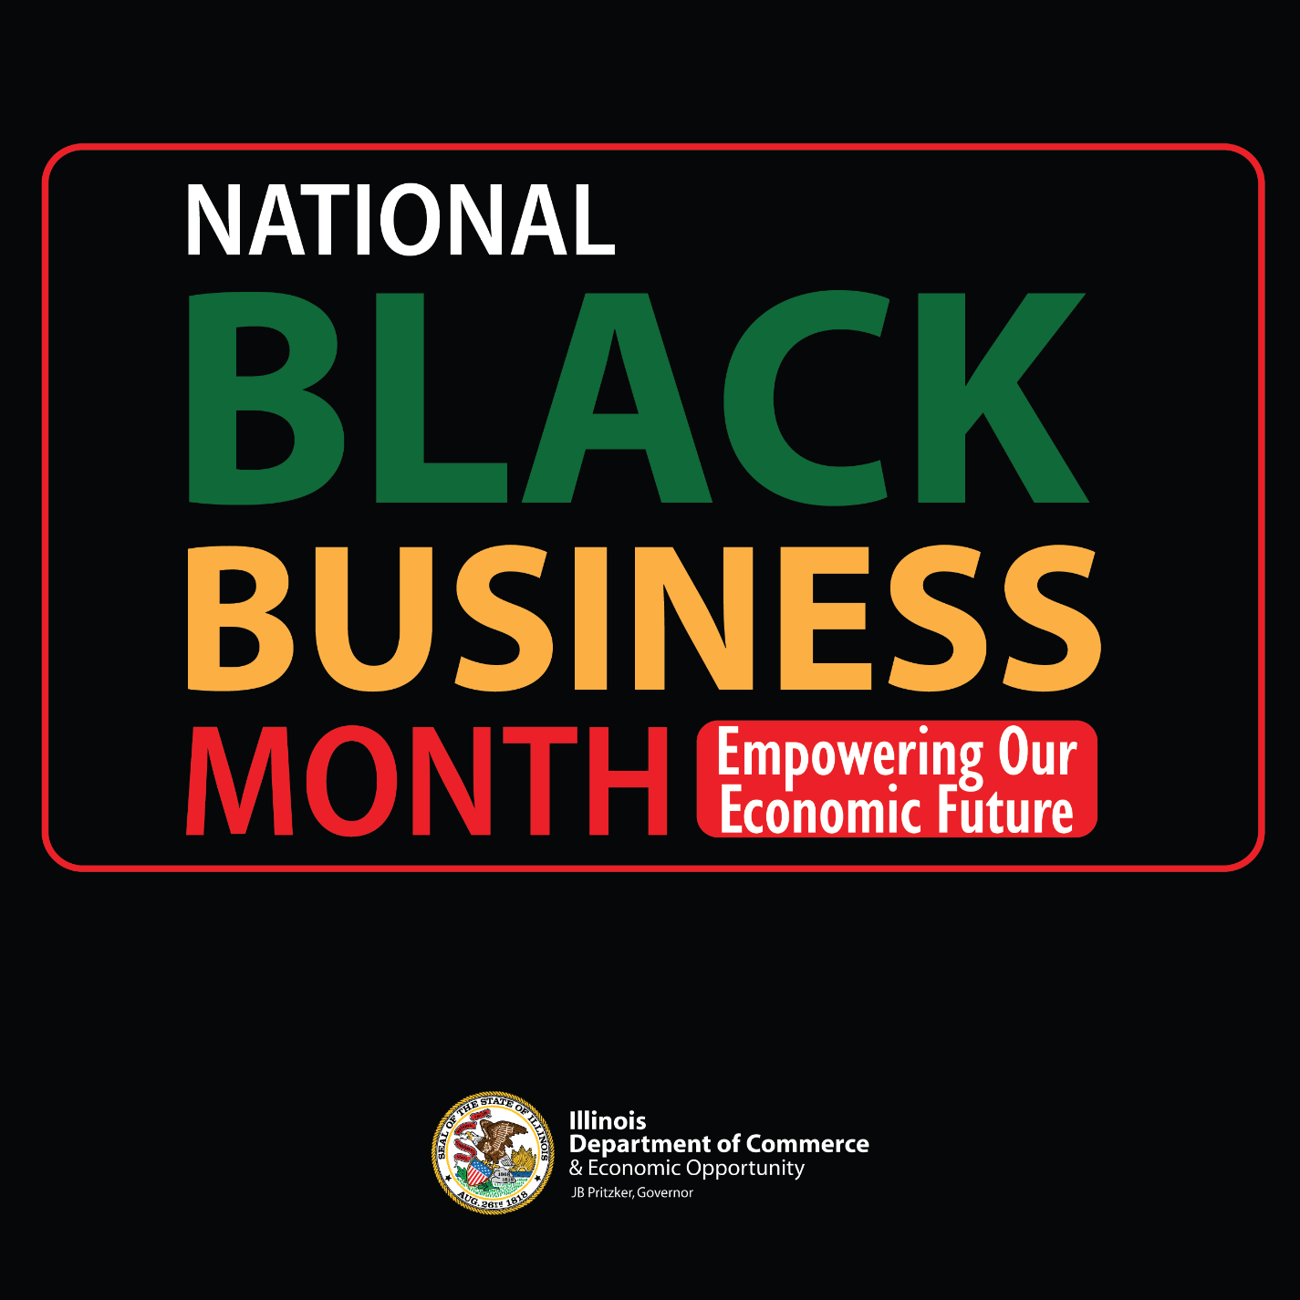

LinkedIn
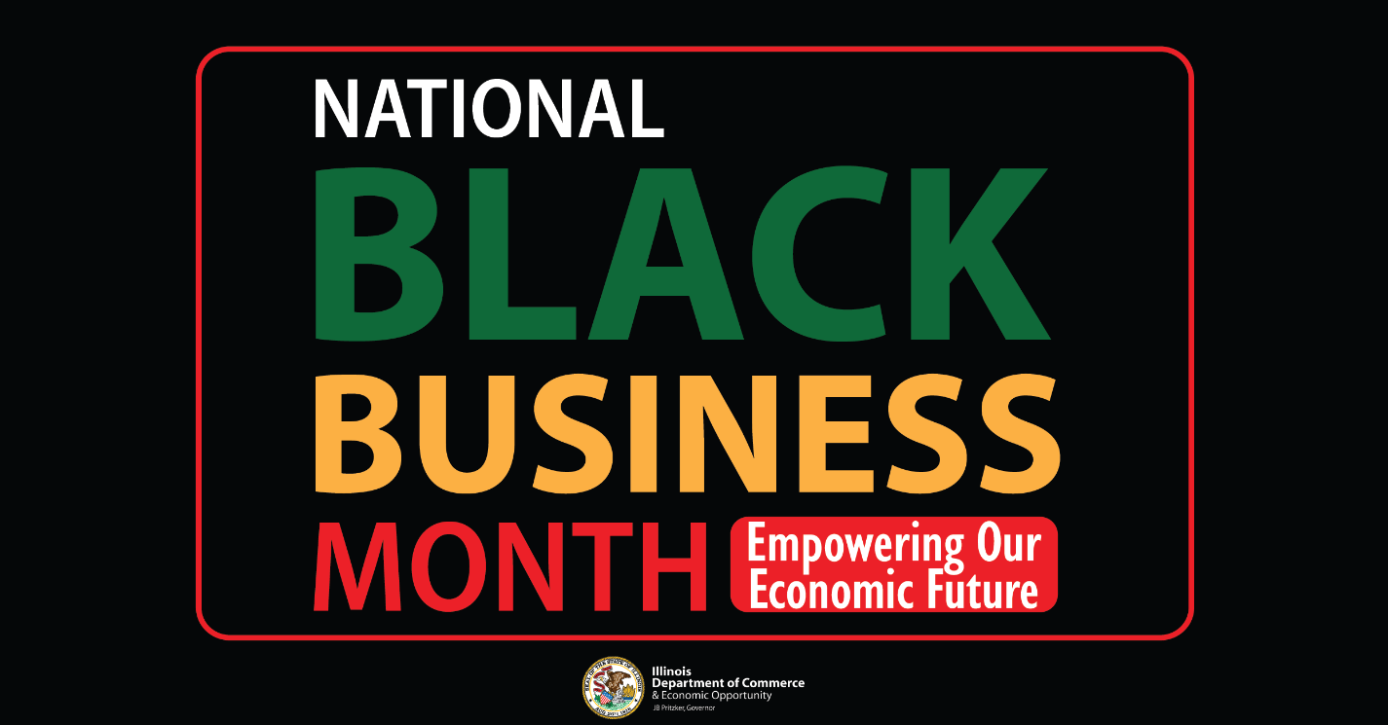

Twitter/BlueSky
