Hispanic Heritage Month & National Support Latino Business Day
Social Media Toolkit 2026

Illinois is honored to celebrate our diverse Latino and Hispanic communities in observation of Hispanic Heritage Month, September 15th through October 15th. Illinois will also take part in amplifying Support Latino Business Day on September 14th - a national call to action that acknowledges and encourages support for Latino-owned businesses.
During this monthlong celebration, DCEO will be hosting a series of events including Outreach Tour, Open Office Hours to meet with members of the Latino business community across the state. Through a monthlong social media campaign, DCEO will also highlight Latino community leaders, organizations, and business enterprises throughout the state.

SOCIAL MEDIA TIPS:
- Be sure to use the official hashtags in order to amplify the movement:
  - #ILHHM
  - #SLBD2026

- Follow, Tag & RT DCEO and your favorite Latino-owned businesses to show support:
  - DCEO Handle: @IllinoisDCEO
  - DCEO Facebook
  - DCEO Twitter
  - DCEO LinkedIn
  - DCEO Bluesky

- Visit DCEO’s webpage for information on events & Latino-owned businesses - https://bit.ly/3UKEqoe
- Use visuals like the provided graphics or a photo of you at your favorite Latino-owned business.
- Tag your friends, family, and community leaders to encourage them to participate in highlighting their favorite Illinois Latino-owned business.
- Make it your own! Tailor content to your stakeholders.

SUPPORT LATINO BUSINESS DAY & HISPANIC HERITAGE MONTH POSTS:

National Support Latino Business Day

Facebook/LinkedIn: National Support Latino Business Day
National Support Latino Business Day is September 14th! Be sure to visit your favorite local Latino-owned business and tag them on social media to show your support. Comment your favorite Illinois Latino-owned businesses below. #ILSupportLatinoBiz #SLBD2026

Find more ways to celebrate National Support Latino Business Day with @IllinoisDCEO here – https://bit.ly/3UKEqoe

Facebook/LinkedIn: National Support Latino Business Day
Today is National Support Latino Business Day! Illinois is home to more than 156,000 Hispanic owned businesses. Tell us about your favorite Hispanic/Latino owned business? Who are you supporting today? [tag your friends, family, community leaders, etc.] #ILSupportLatinoBiz #SLBD2026

Facebook/LinkedIn: National Support Latino Business Day
Join me in celebrating National Support Latino Business Day with @IllinoisDCEO to kick off Hispanic Heritage Month!

Find more ways to celebrate and get involved by visiting @IllinoisDCEO website –
#ILSupportLatinoBiz #ILCompraLatinoBiz #SLBD2026

Facebook/LinkedIn: Business-Specific Highlight
What better way to celebrate National Support Latino Business Day than by highlighting our favorite Illinois based Latino-owned businesses?

Check out [INSERT BUSINESS HANDLE] for the best [EXAMPLES: food, gifts, drinks, clothes, services, etc.]. #ILSupportLatinoBiz #SLBD2026

Find more ways to celebrate with @IllinoisDCEO – https://bit.ly/3UKEqoe

Facebook/LinkedIn: Call to Action
I'm celebrating National Support Latino Business Day by visiting [INSERT BUSINESS HANDLE] to enjoy my favorite [EXAMPLES: food, gifts, drinks, clothes, services, etc.]. #ILSupportLatinoBiz #SLBD2026

Which local Latino-owned businesses are you supporting today? [TAG FRIENDS, FAMILY, LEADERS, ETC]
X/Bluesky: Latino Business Day
Today is National Support Latino Business Day! Visit your favorite local Latino-owned business and tag them on social media to show your support. #ILSupportLatinoBiz #SLBD2026

Find more ways to celebrate with @IllinoisDCEO – https://bit.ly/3UKEqoe

X/Bluesky: National Support Latino Business Day
Join me in celebrating National Support Latino Business Day with @IllinoisDCEO to kick off Hispanic Heritage Month! Which Latino owned business are you supporting? #ILSupportLatinoBiz #SLBD2026

X/Bluesky: Business-Specific Highlight
Celebrate National Support Latino Business Day by highlighting your favorite Latino-owned businesses!

Check out [INSERT BUSINESS HANDLE] for the best [EXAMPLES: food, gifts, drinks, clothes, services, etc.]. #ILSupportLatinoBiz

Find more ways to celebrate with @IllinoisDCEO:

X/Bluesky: Call to Action
I'm celebrating National Support Latino Business Day by visiting [INSERT BUSINESS HANDLE] to enjoy my favorite [EXAMPLES: food, gifts, drinks, clothes, services, etc.]. #ILSupportLatinoBiz

Which local Latino-owned businesses are you supporting today? [TAG FRIENDS]

Instagram: Support Latino Business Day Business-Specific Highlight
Today is National Support Latino Business Day! Check out one of my favorite local Latino-owned businesses, [Insert Business Social Media Tag], for [EXAMPLES: delicious food, stylish clothes, best haircuts, best services, etc.] #ILSupportLatinoBiz #SLBD2026

Hispanic Heritage Month

Facebook/LinkedIn Option 1: Hispanic Heritage Month
Happy Hispanic Heritage Month! Get involved and support Illinois' Latino entrepreneurs this month and beyond:
✅Attend events hosted by @IllinoisDCEO - https://bit.ly/3UKEqoe
✅Visit Latino-owned businesses
✅Spread the word using #ILHHM

Facebook/LinkedIn Option 2: We’re proud to celebrate Latino cultures, values, and accomplishments that have shaped generations. Join us in uplifting the voices and stories that make our communities stronger.
✅Attend events hosted by @IllinoisDCEO - https://bit.ly/3UKEqoe
✅Visit Latino-owned businesses
✅Spread the word using #ILHHM

X and Bluesky Option 1: Hispanic Heritage Month
Happy Hispanic Heritage Month! Get involved and support Illinois' Latino entrepreneurs:
✅Attend events hosted by @IllinoisDCEO
✅Visit Latino-owned businesses
✅Spread the word on social media using #ILHHM

X and Bluesky Option 2: We’re proud to celebrate Latino cultures, values, and accomplishments that have shaped generations. Join us in uplifting the voices and stories that make our communities stronger.
✅Attend events hosted by @IllinoisDCEO
✅Visit Latino-owned businesses
✅Spread the word on social media using #ILHHM

SAMPLE NEWSLETTER/EBLAST:

The Illinois Department of Commerce & Economic Opportunity (DCEO) is celebrating National Support Latino Business Day on September 14th and Hispanic Heritage Month from September 15th through October 15th. The celebration includes a series of events highlighting DCEO’s business resources, an initiative inviting Illinoisans to support Latino-owned businesses, as well as social media campaign recognizing Latino-owned businesses throughout the state.

Join the celebration to help sustain the nearly 156,000 Illinois Latino-owned businesses who play a pivotal role in Illinois’ vibrant economy. Visit DCEO’s website for more information on resources and events.

GRAPHICS:
Below is a collection of graphics for social media and newsletters/e-blasts. Right click and select “save as picture” to use.

Support Latino Business
Facebook
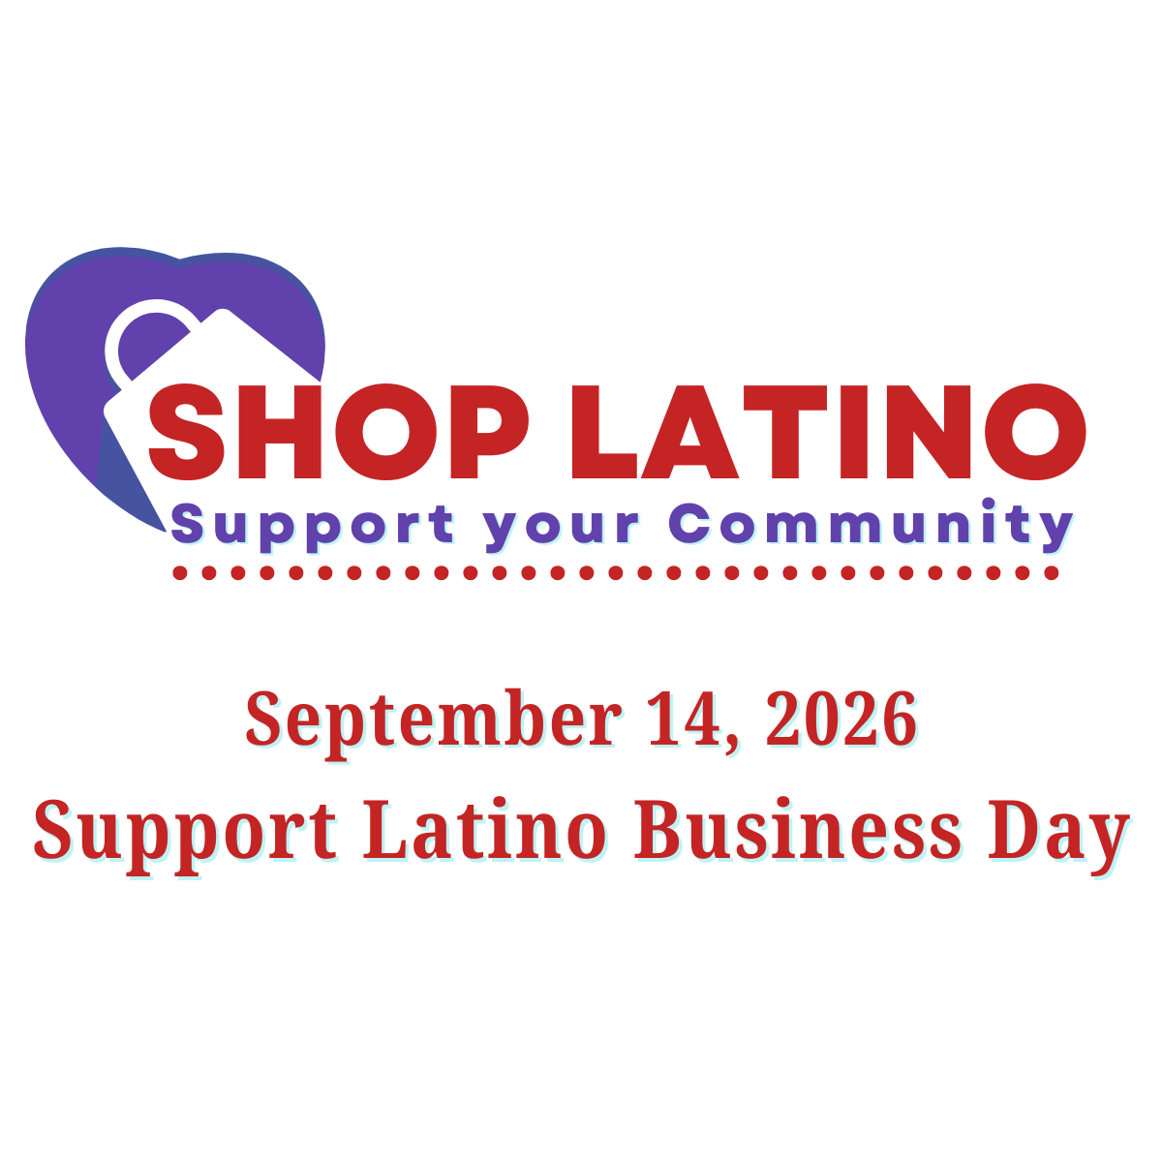
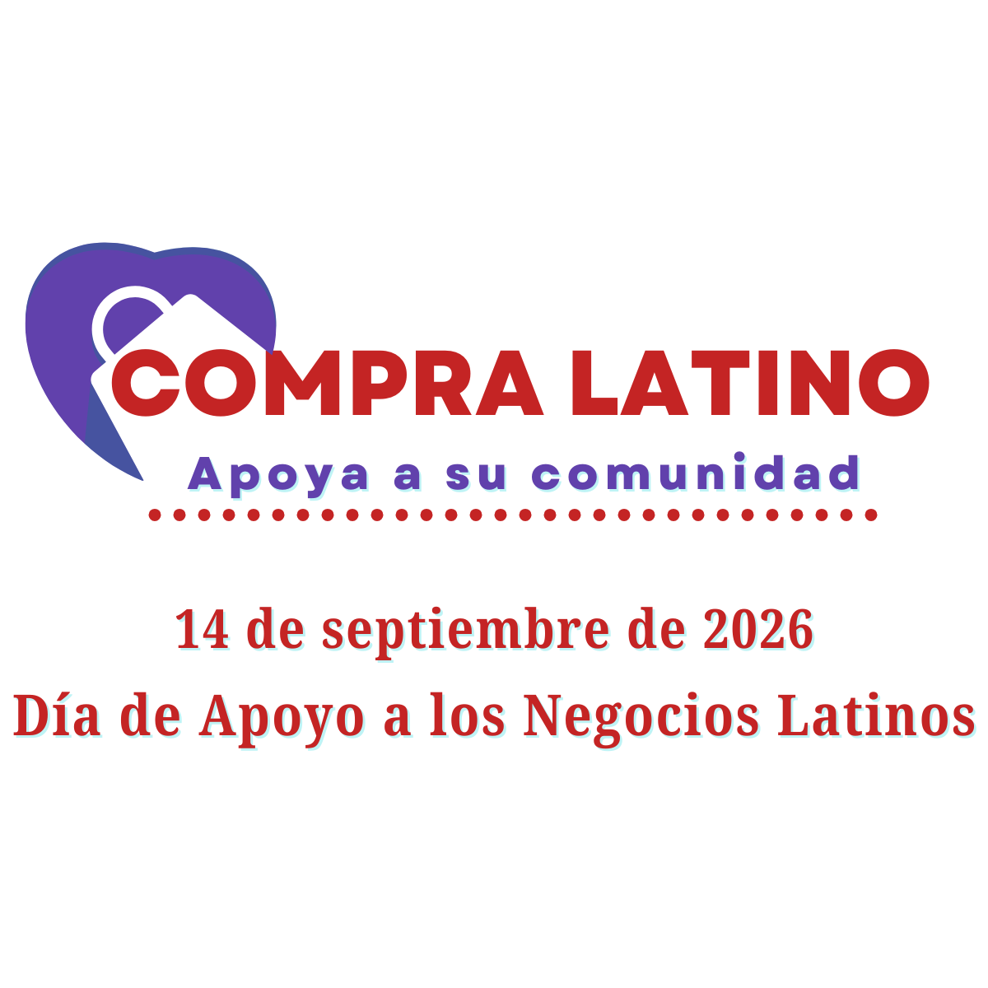

Twitter/X
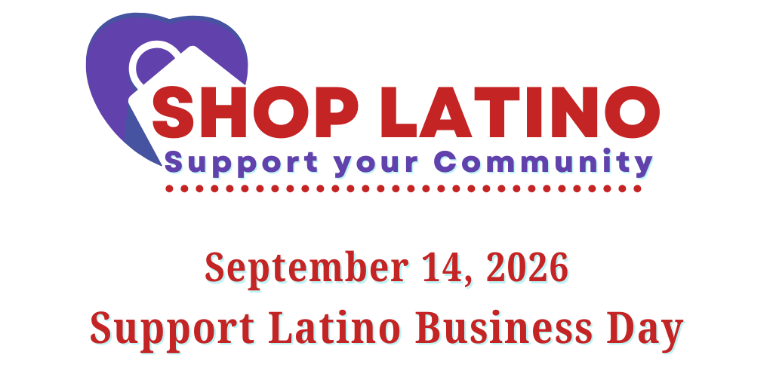
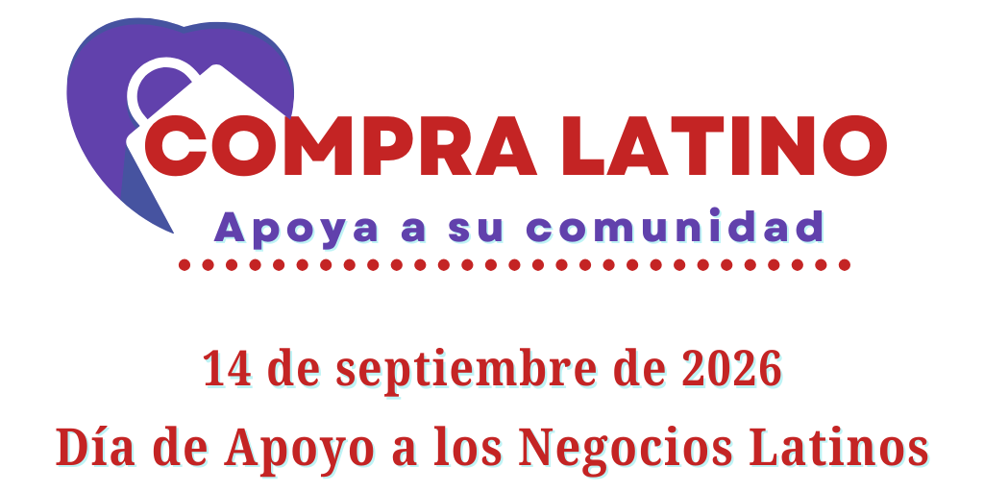

LinkedIn
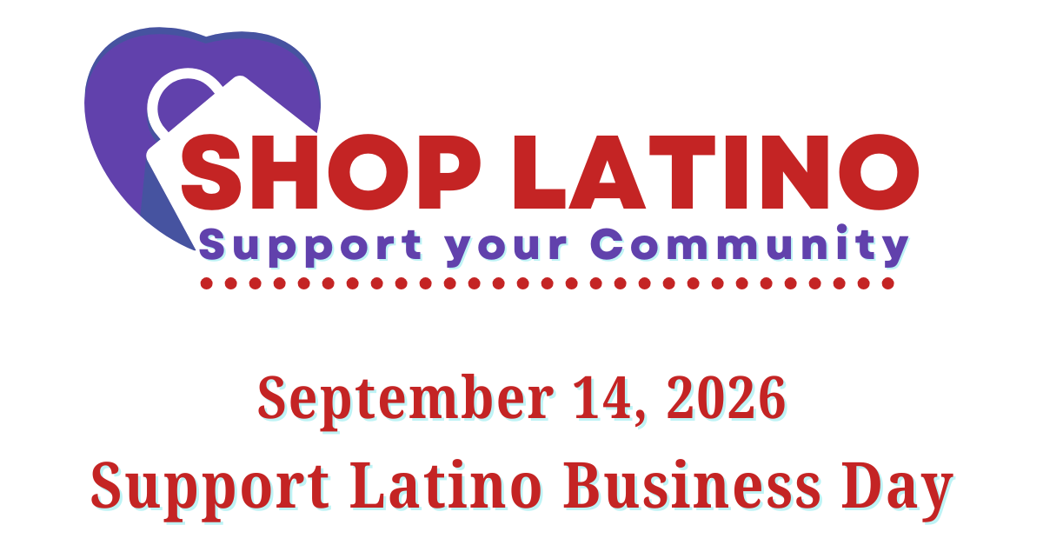
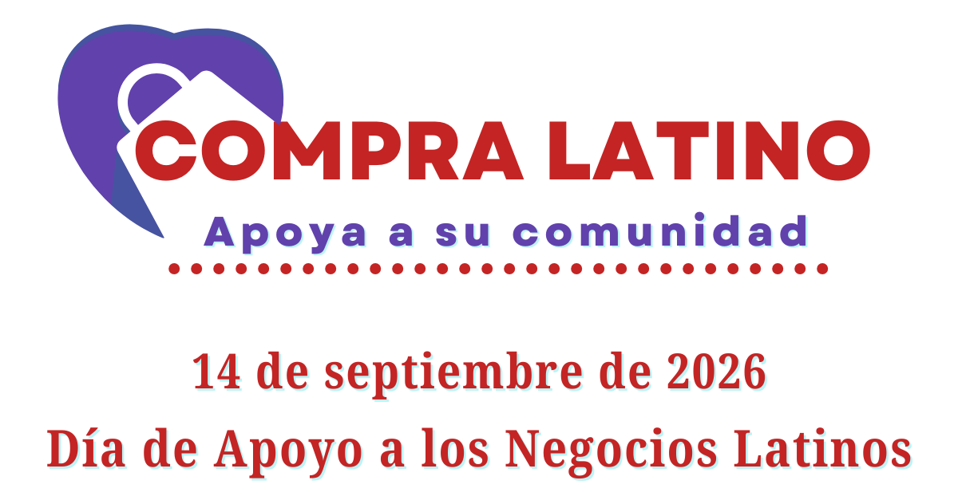

Hispanic Heritage Month
Facebook
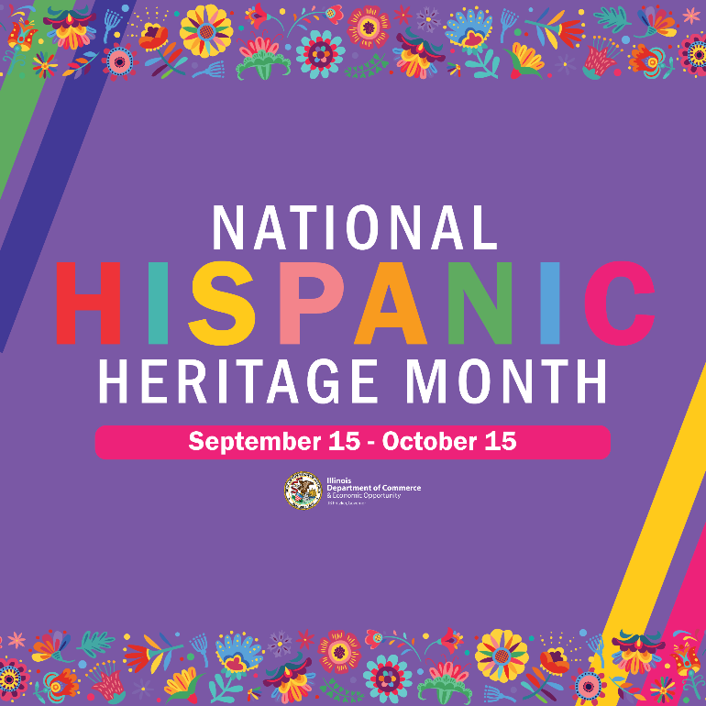

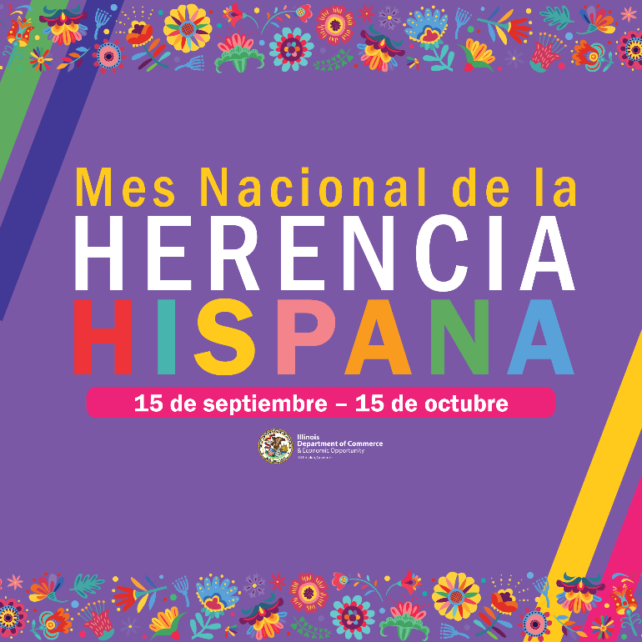

Twitter/X
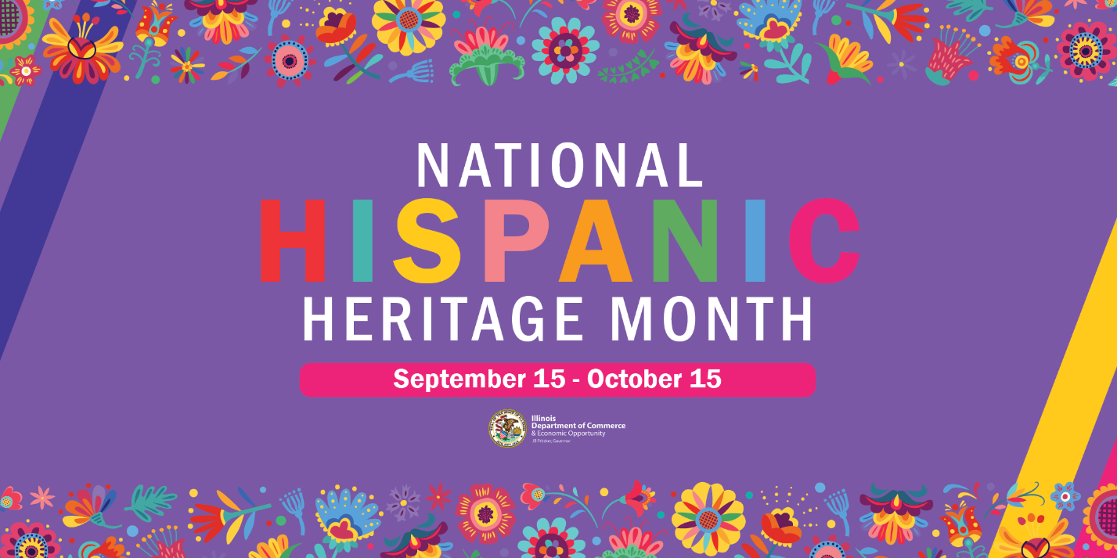

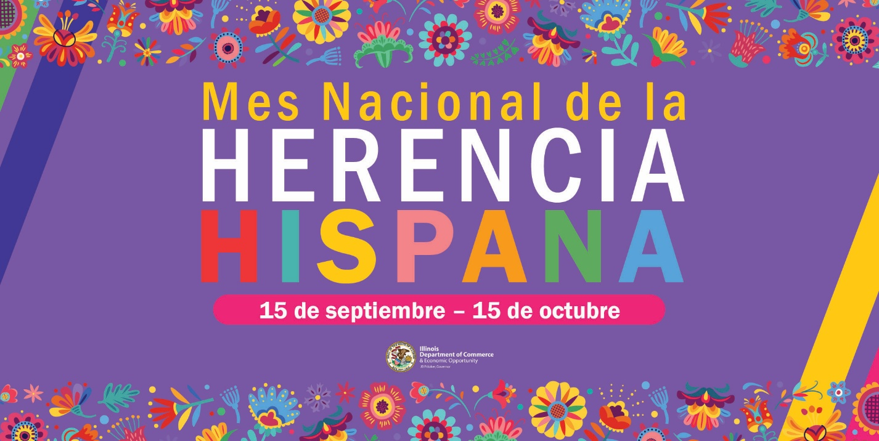

LinkedIn
