**Hispanic Heritage Month & National Support Latino Business Day**

**Social Media Toolkit 2025**

Illinois is honored to celebrate our diverse Latino and Hispanic communities in observation of Hispanic Heritage Month, September 15th through October 15th. Illinois will also take part in amplifying Support Latino Business Day on September 14th - a national call to action that acknowledges and encourages support for Latino-owned businesses.

During this monthlong celebration, DCEO will be hosting a series of events including Office Hour Roadshow to meet with members of the Latino businesses across the state. Through a monthlong social media campaign, DCEO will also highlight Latino community leaders, organizations, and business enterprises throughout the state.

**SOCIAL MEDIA TIPS:**

* Be sure to use the official hashtags in order to amplify the movement:
  + #ILSupportLatinoBiz
  + #ILCompraLatinoBiz
  + #ILHHM
  + #SLBD2025

* Follow, Tag & RT (Re-tweet) DCEO and your favorite Latino-owned businesses to show support:
  + DCEO Handle: @IllinoisDCEO
  + [DCEO Facebook](https://www.facebook.com/illinoisdceo)
  + [DCEO Twitter](https://twitter.com/IllinoisDCEO)
  + [DCEO LinkedIn](https://www.linkedin.com/company/illinoisdceo)
  + [DCEO Bluesky](https://bsky.app/profile/illinoisdceo.bsky.social)
* Visit DCEO’s webpage for information on events & Latino-owned businesses - <http://bit.ly/3Kdk41v>
* Use visuals like the provided graphics or a photo of you at your favorite Latino-owned business.
* Tag your friends, family, and community leaders to encourage them to participate in highlighting their favorite Illinois Latino-owned business.
* Make it your own! Tailor content to your stakeholders.

**SUPPORT LATINO BUSINESS DAY & HISPANIC HERITAGE MONTH POSTS:**

***National Support Latino Business Day***

***Facebook/LinkedIn: National Support Latino Business Day***

National Support Latino Business Day is September 14th! Be sure to visit your favorite local Latino-owned business and tag them on social media to show your support. Comment your favorite Illinois Latino-owned businesses below. #ILSupportLatinoBiz #ILCompraLatinoBiz #SLBD2025

Find more ways to celebrate National Support Latino Business Day with @IllinoisDCEO here – <http://bit.ly/3Kdk41v>

***Facebook/LinkedIn: National Support Latino Business Day***

Today is National Support Latino Business Day! Illinois is home to more than 152,000 Hispanic owned businesses. Tell us about your favorite Hispanic/Latino owned business? Who are you supporting today? *[tag your friends, family, community leaders, etc.]* #ILSupportLatinoBiz #ILCompraLatinoBiz #SLBD2025

***Facebook/LinkedIn: National Support Latino Business Day***

Join me in celebrating National Support Latino Business Day with @IllinoisDCEO to kick off Hispanic Heritage Month!

Find more ways to celebrate and get involved by visiting @IllinoisDCEO website –

#ILSupportLatinoBiz #ILCompraLatinoBiz #SLBD2025

***Facebook/LinkedIn: Business-Specific Highlight***

What better way to celebrate National Support Latino Business Day than by highlighting our favorite Illinois based Latino-owned businesses?

Check out *[INSERT BUSINESS HANDLE]* for the best *[EXAMPLES: food, gifts, drinks, clothes, services, etc.].* #ILSupportLatinoBiz #ILCompraLatinoBiz #SLBD2025

Find more ways to celebrate with @IllinoisDCEO – <http://bit.ly/3Kdk41v>

***Facebook/LinkedIn: Call to Action***

I'm celebrating National Support Latino Business Day by visiting *[INSERT BUSINESS HANDLE]* to enjoy my favorite *[EXAMPLES: food, gifts, drinks, clothes, services, etc.]*.#ILSupportLatinoBiz #ILCompraLatinoBiz #SLBD2025

Which local Latino-owned businesses are you supporting today*? [TAG FRIENDS, FAMILY, LEADERS, ETC]*

***X/Bluesky: Latino Business Day***

Today is National Support Latino Business Day! Visit your favorite local Latino-owned business and tag them on social media to show your support. #ILSupportLatinoBiz #SLBD2025

Find more ways to celebrate with @IllinoisDCEO – <http://bit.ly/3Kdk41v>

***X/Bluesky: National Support Latino Business Day***

Join me in celebrating National Support Latino Business Day with @IllinoisDCEO to kick off Hispanic Heritage Month! Which Latino owned business are you supporting?

#ILSupportLatinoBiz #ILCompraLatinoBiz #SLBD2025

***X/Bluesky: Business-Specific Highlight***

Celebrate National Support Latino Business Day by highlighting your favorite Latino-owned businesses!

Check out*[INSERT BUSINESS HANDLE]* for the best*[EXAMPLES: food, gifts, drinks, clothes, services, etc.]*. #ILSupportLatinoBiz #ILCompraLatinoBiz

Find more ways to celebrate with @IllinoisDCEO:

***X/Bluesky: Call to Action***

I'm celebrating National Support Latino Business Day by visiting *[INSERT BUSINESS HANDLE]* to enjoy my favorite *[EXAMPLES: food, gifts, drinks, clothes, services, etc.]*. #ILSupportLatinoBiz

Which local Latino-owned businesses are you supporting today?*[TAG FRIENDS]*

***Instagram: Support Latino Business Day Business-Specific Highlight***

Today is National Support Latino Business Day! Check out one of my favorite local Latino-owned businesses, *[Insert Business Social Media Tag],* for *[EXAMPLES: delicious food, stylish clothes, best haircuts, best services, etc.]* #ILSupportLatinoBiz #ILCompraLatinoBiz #SLBD2025

***Hispanic Heritage Month***

***Facebook/LinkedIn: Hispanic Heritage Month***

Happy Hispanic Heritage Month! Get involved and support Illinois' Latino entrepreneurs this month and beyond:

✅Attend events hosted by @IllinoisDCEO - <http://bit.ly/3Kdk41v>

✅Visit Latino-owned businesses

✅Spread the word using #ILHHM

***Twitter/X and Bluesky: Hispanic Heritage Month***

Happy Hispanic Heritage Month! Get involved and support Illinois' Latino entrepreneurs:

✅Attend events hosted by @IllinoisDCEO

✅Visit Latino-owned businesses

✅Spread the word on social media using #ILHHM

**SAMPLE NEWSLETTER/EBLAST:**

The Illinois Department of Commerce & Economic Opportunity (DCEO) is celebrating National Support Latino Business Day on September 14th and Hispanic Heritage Month from September 15th through October 15th. The celebration includes a series of events highlighting DCEO’s business resources, an initiative inviting Illinoisans to support Latino-owned businesses, as well as social media campaign recognizing Latino-owned businesses throughout the state.

Join the celebration to help sustain the nearly 152,000 Illinois Latino-owned businesses who play a pivotal role in Illinois’ vibrant economy. Visit DCEO’s website for more information on resources and events. <http://bit.ly/3Kdk41v>

**GRAPHICS:**

Below is a collection of graphics for social media and newsletters/e-blasts. Right click and select “save as picture” to use.

**Support Latino Business Day**

**FACEBOOK-Support Latino Business Day:**

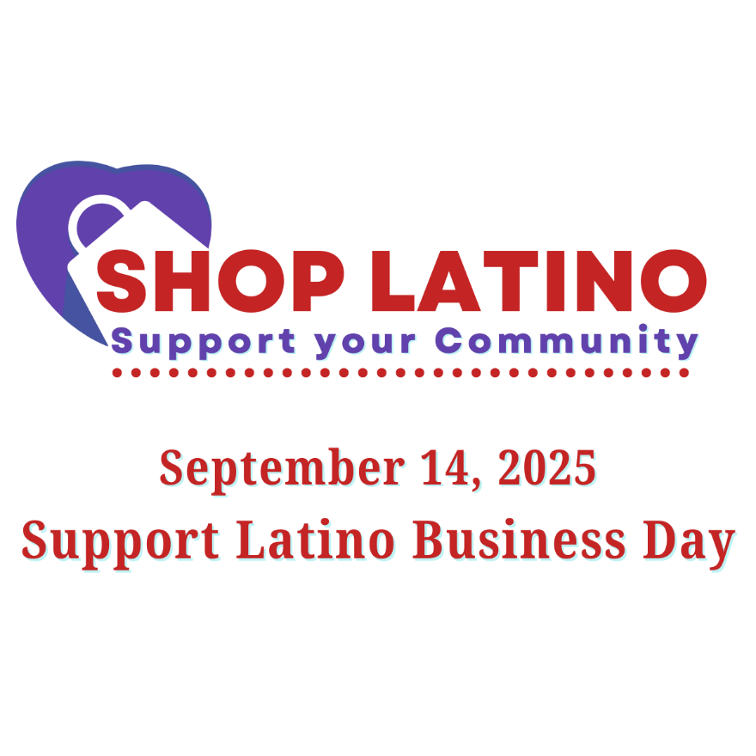

**X/Bluesky Support Latino Business Day:**

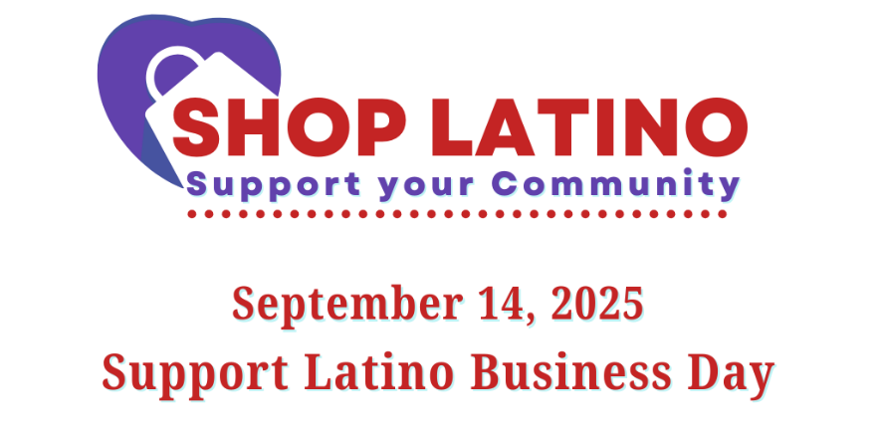

**LINKEDIN Support Latino Business Day:**

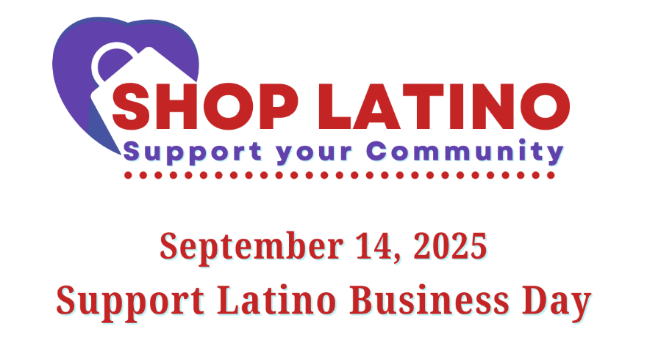

**FACEBOOK- Hispanic Heritage Month**

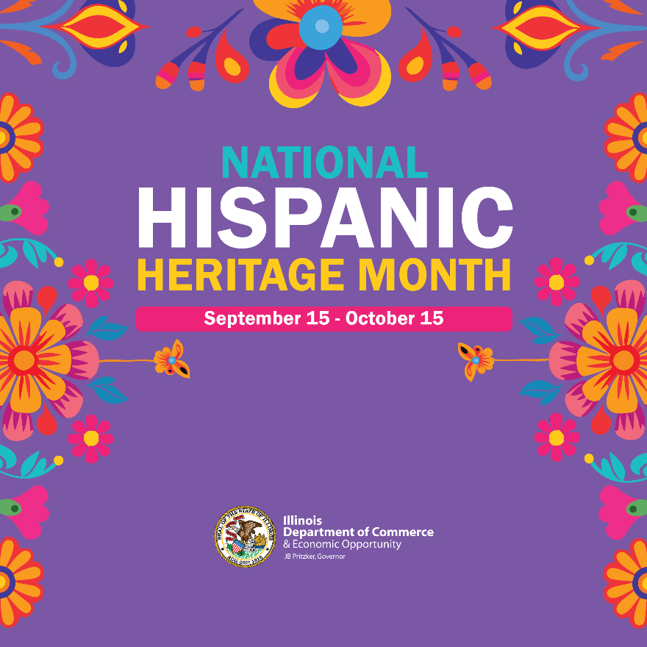

**X/Bluesky - Hispanic Heritage Month:**

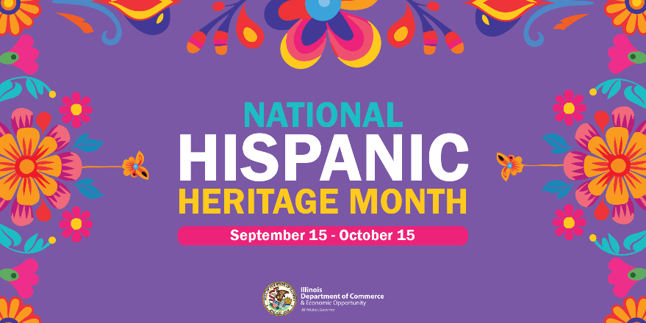

**LINKEDIN - Hispanic Heritage Month:**

