2026 Juneteenth Toolkit
“One Illinois: Celebrating Freedom & Expanding Access”
This June, the Illinois Department of Commerce and Economic Opportunity (DCEO) is celebrating and honoring Juneteenth. Throughout the month, DCEO will be celebrating liberation and resilience across Illinois.
Below, you will find tips, sample social media posts, graphics and ideas on how to raise awareness and encourage those in your network to celebrate Juneteenth.

SOCIAL MEDIA TIPS
- Be sure to use the official hashtags in order to amplify the movement:
- #Juneteenth
- #Juneteenth 26
- #ILJuneteenth
- Be sure to follow, Tag & RT DCEO and your favorite Black-owned businesses to show support:
- DCEO Handle: @IllinoisDCEO
- DCEO Facebook
- DCEO Twitter
- DCEO LinkedIn
- DCEO Bluesky

LINKS AND RESOURCES
Below, you will find tips, sample social media posts, graphics and ideas on how to raise awareness and encourage those in your network to celebrate Juneteenth.

- Juneteenth Landing Page
  - Learn more about everything DCEO is doing to celebrate Juneteenth: bit.ly/3Pz5FA5
- Illinois Office of Economic Equity & Empowerment (OE3)
  - Resources for Black and minority-owned businesses
- Enjoy Illinois
  - Enjoy Illinois Juneteenth page: A Day to Reflect: Juneteenth 2026
- Community Events throughout Illinois
- Chicago – Obama Presidential Center Opening - Jackson Park
- Chicago - Fuller Park
- Chicago - Bronzeville
- Chicagoland
- Beverly/Morgan Park
- Elgin
- Rockford
- Flossmoor
- Springfield

SAMPLE SOCIAL MEDIA POSTS

GENERAL JUNETEENTH KICKOFF POST:

This #Juneteenth, Illinois is proud to celebrate liberation and resilience. Make sure to visit our website for information about events and resources – bit.ly/3Pz5FA5
#ILJuneteenth
Join the State of Illinois in celebrating Juneteenth by:
✅ Attending an event hosted by @illinoisDCEO – bit.ly/3Pz5FA5
✅ Supporting Black-owned businesses
✅ Spreading the word using #ILJuneteenth

POST ENCOURAGING STAKEHOLDERS TO HIGHLIGHT LOCAL BLACK-OWNED BUSINESSES
Have a favorite Black-owned business? Show your support this #ILJuneteenth by visiting & tagging them on social media. Learn more ways to celebrate by visiting @illinoisDCEO’s - bit.ly/3Pz5FA5

SAMPLE NEWSLETTER OR E-BLAST
Throughout Juneteenth, the Illinois Department of Commerce and Economic Opportunity (DCEO) is celebrating liberation and resilience through a series of events that encourage the elevation of the legacy and history of Black Illinoisans on Juneteenth and beyond.

Visit DCEO’s Juneteenth events and resources page for more information.

GRAPHICS
Below is a collection of graphics that can be shared and used in eblasts/newsletters and via social media to help promote Juneteenth. To save graphics, right click on the preferred graphic and “Save as Picture” to your files.

Facebook Graphic
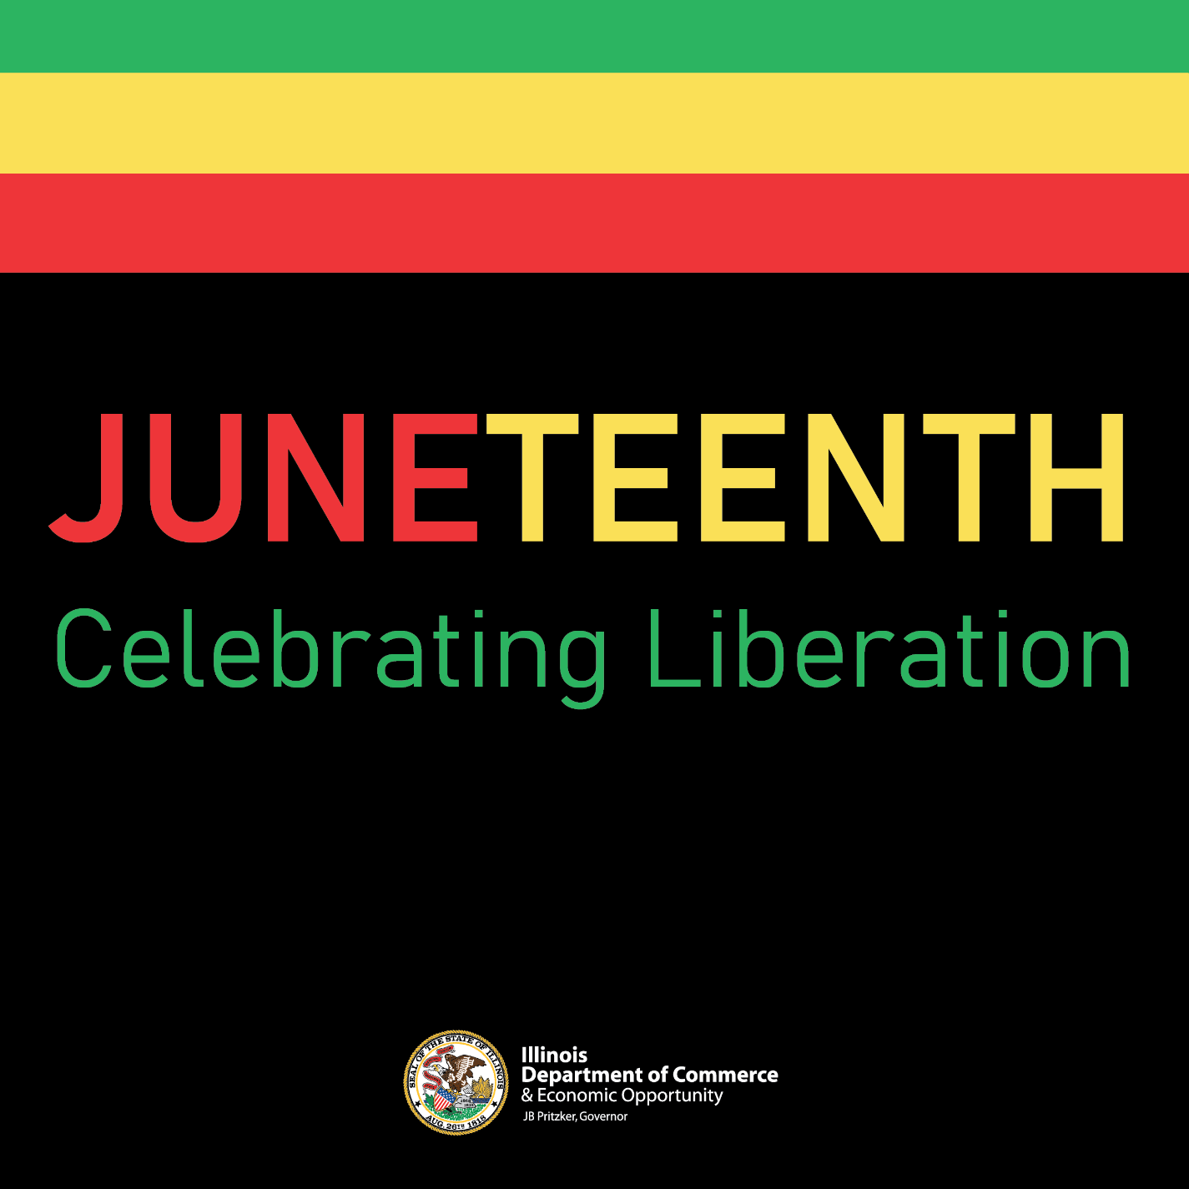

LinkedIn Graphic
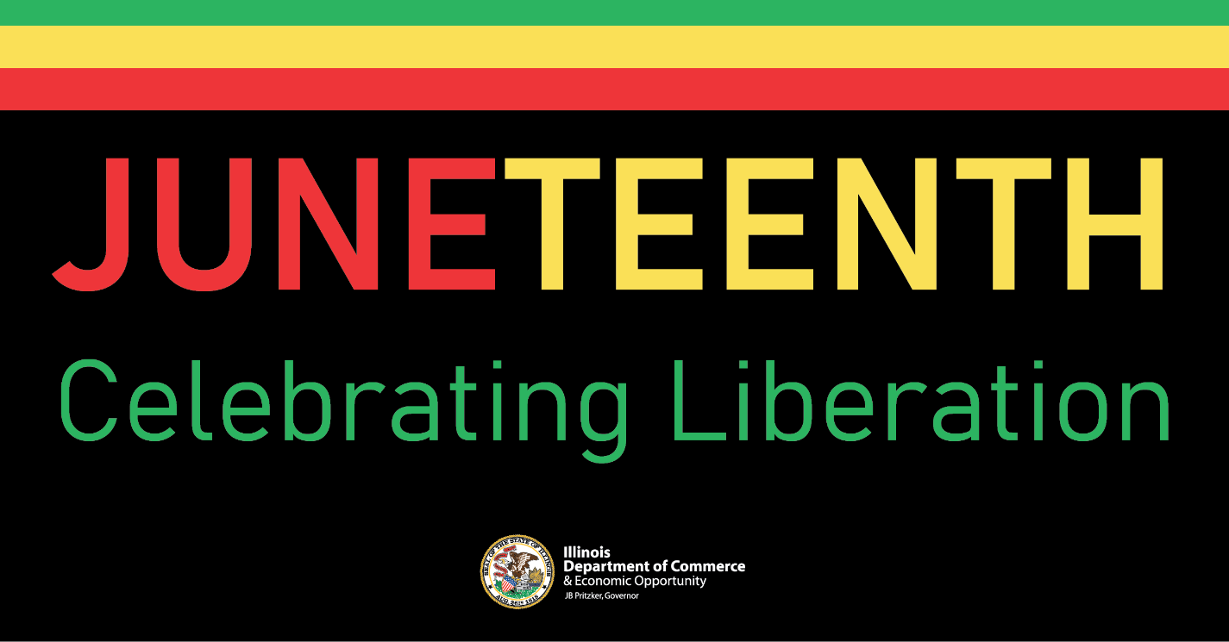
Twitter/X Graphic
