**3rd Annual Latin@ Economic Summit – Unity es Poder**

**Social Media Toolkit**

Join the Illinois Department of Commerce and Economic Opportunity (DCEO) - Office of Economic Equity & Empowerment (OE3), as we host the 3rd Annual Latin@ Economic Summit on Thursday, July 31, 2025. Below you will find tips, sample social media posts, graphics, and ideas on celebrating and promoting the Summit!

**SOCIAL MEDIA TIPS:**

* Be sure to use the official hashtags to amplify the movement
  + #ILSupportLatinoBiz
  + #ILLatinxSummit
  + #ILLatinoEconomicPower
* Follow, Tag & RT (Re-tweet) DCEO and your favorite Latina/o -owned businesses to inform them of the summit and uplift their businesses:
  + - DCEO Handle: @IllinoisDCEO
    - [DCEO Facebook](https://www.facebook.com/illinoisdceo)
    - [DCEO Twitter](https://twitter.com/IllinoisDCEO)
    - [DCEO LinkedIn](https://www.linkedin.com/company/illinoisdceo)
    - [DCEO Bluesky](https://web-cdn.bsky.app/profile/did:plc:3r4ofyuh6xfx3d4xowldaz6f)
* Use visuals like the provided graphics
* For Twitter, be mindful of character limits (280 characters)
* Make it your own! Tailor content to your stakeholders

**AMPLIFY PARTNERS:**

***Show your support by tagging and amplifying posts from our Summit partners:***

|  |  |  |  |  |
| --- | --- | --- | --- | --- |
| **Partner Name** | **Twitter** | **Facebook** | **LinkedIn** | **Bluesky** |
| BMO | [@BMO_US](https://twitter.com/BMO_US) | [BMO](https://www.facebook.com/bmoUSA) | [BMO](https://www.linkedin.com/company/bmo-us/) |  |
| Chicago Latina Business Foundation & Magazine | N/A | [Chicago Latina Magazine](https://www.facebook.com/chicagolatinamagazine) | [Chicago Latina Magazine](https://www.linkedin.com/company/chicago-latina-magazine/) |  |
| Fempreneur Poder Hub | N/A | N/A | [Fempreneur Poder Hub](https://www.linkedin.com/company/fempreneur-poder-hub/) |  |
| Greater Southwest Development Corporation | [@Greater Southwest](https://x.com/greatersw) | [Greater Southwest](https://www.facebook.com/GreaterSW) | [Greater Southwest Development Corporation](https://www.linkedin.com/company/greater-southwest-development-corporation/) |  |
| Hispanic American Construction Industry Association (HACIA) | [@HACIAworks](https://twitter.com/HACIAworks) | [Hispanic American Construction Industry Association (HACIA)](https://www.facebook.com/HACIAWorks/) | [Hispanic American Construction Industry Association (HACIA)](https://www.linkedin.com/company/hacia/) |  |
| IC U Latinas | N/A | [@IC U Latinas](https://www.facebook.com/profile.php?id=100083592601906) | N/A |  |
| IDHR | [@Illinois Department of Human Rights](https://x.com/IllinoisDHR) | [Illinois Department of Human Rights](https://www.facebook.com/IllinoisDHR/) | [Illinois Department of Human Rights](https://www.linkedin.com/company/illinoisdhr/) | [Illinois Department of Human Rights](https://web-cdn.bsky.app/profile/illinoisdhr.bsky.social) |
| Lake County Tech Hub & Business Incubator | [@Lake County TechHub](https://x.com/lakecntytechub?lang=en) | [Lake County Tech Hub](https://www.facebook.com/LakeCountyTechHub/) | [Lake County Tech Hub & Business Incubator](https://www.linkedin.com/company/lake-county-tech-hub-and-business-incubator/) |  |
| LISC | [@LISC](https://x.com/lisc_hq/) | [LISC](https://www.facebook.com/lisc.org/) | [LISC](https://www.linkedin.com/company/local-initiatives-support-corporation-lisc/) |  |
| mHUB | [@mHUBChicago](https://x.com/mHUBChicago) | [mHUB Chicago](https://www.facebook.com/mHUBChicago) | [mHUB](https://www.linkedin.com/company/mhub-chicago/) |  |
| Southland Development Authority | [@BuildSouthland](https://x.com/buildsouthland) | [Southland Development Authority](https://www.facebook.com/SouthlandDevelopmentAuthority) | [Southland Development Authority](https://www.linkedin.com/company/southland-development-authority/?viewAsMember=true) |  |
| The Southwest Collective | N/A | [Southwest Collective](https://www.facebook.com/theswcollective) | [The Southwest Collective](https://www.linkedin.com/company/the-southwest-collective/?viewAsMember=true) | [The Southwest Collective](https://web-cdn.bsky.app/profile/swcollectivechi.bsky.social) |
| Vicinity Credit Union | N/A | [Vicinity Credit Union](https://www.facebook.com/VicinityCreditUnion/) | [Vicinity Credit Union](https://www.linkedin.com/company/vicinity-credit-union/) |  |
| Waterman Bank | [@Waterman Bank](https://x.com/WatermanBank) | [Waterman Bank](https://www.facebook.com/watermanbank) | [Waterman Bank](https://www.linkedin.com/company/waterman-bank/) |  |

**CONTACT:**

For questions on the toolkit, feel free to reach out to Diana Alfaro, Latinx Business Development Manager, at [diana.alfaro@illinois.gov](mailto:diana.alfaro@illinois.gov) or Anggi Lewis, at [anggi.lewis@illinois.gov](mailto:anggi.lewis@illinois.gov)

**SAMPLE POSTS:**

**Facebook/LinkedIn Example #1:**

Celebrate the power and impact of Latina/o-owned businesses at this free, dynamic, and day-long event! Connect with fellow entrepreneurs, expand your network, and discover valuable resources to start, grow, and scale your business at the 3rd annual Latina/o Economic Summit on Thursday, July 31st. The Summit will feature:

✅ Unlocking Capital: Strategies for Securing Funding & Growth

✅Six different topics in breakout sessions that you don’t want to miss!

Don’t miss this incredible opportunity to learn, connect, and thrive. Let’s build economic power—together.

Register Now! In English: <https://bit.ly/4kwO3yD> or Spanish: <https://bit.ly/45mwCMS>

#ILLatinxSummit #ILSupportLatinoBiz #ILLatinoEconomicPower

**Facebook/LinkedIn Example #2 for future entrepreneur:**

Thinking about starting a business? Attend this free event:  
🌟 Get Inspired at the 3rd Annual Latina/o Economic Summit!   
📅 Thursday, July 31st

Whether you're dreaming of launching your own venture or just getting started—this summit is for you! Come connect with successful entrepreneurs, gain real-world insights, and learn what it takes to turn your idea into a thriving business.

🔑 **What You’ll Discover:**  
✅ **Unlocking Capital** – Learn how to fund your startup and fuel your future  
✅ **Six Game-Changing Breakout Sessions** – Gain insight on everything from business planning to marketing and more

You don’t need to have it all figured out—just take the first step. Your business journey starts here. Let’s build your future—together.

Register now in English: <https://bit.ly/4kwO3yD> or Spanish: <https://bit.ly/45mwCMS>

#ILLatinxSummit #ILSupportLatinoBiz #ILLatinoEconomicPower

**Twitter example #1:**  
Attn EntrepreneursBriefcase

Are you a business owner or future entrepreneur looking to take your business to the next level? Join the 3rd Annual Latina/o Economic Summit on 7/31 in Palos Hills! This free event includes networking opportunities, expert speakers, workshops, and more.

Register now in English <https://bit.ly/4kwO3yD> or Spanish: <https://bit.ly/45mwCMS>

#ILLatinxSummit

**Twitter example #2:**

Are you a business owner or future entrepreneur looking to network & learn about resources & strategies to take your business to the next level? Briefcase

Join the 3rd Annual Latina/o Economic Summit in Palos Hills on 7/31 - Register now in English: <https://bit.ly/4kwO3yD> or Spanish: <https://bit.ly/45mwCMS>

#ILLatinxSummit

**Instagram example #1:**

Want to take your business to the next level and learn about resources, network, and celebrate the success of the Latina/o business community?

Join the 3rd Annual Latina/o Economic Summit on 7/31 in Palos Hills! This free event includes networking opportunities, expert speakers, workshops, and more.

Register now in English or Spanish.

(Link in bio Briefcase#ILLatinxSummit #ILSupportLatinoBiz #ILLatinoEconomicPower

**NOTE: Instagram does not enable links in captions; if you are promoting on Instagram please put the link in your bio. and reference it in the caption**

**SAMPLE NEWSLETTER/E-BLAST:**

The Illinois Department of Commerce & Economic Opportunity, through its Office of Economic Equity & Empowerment (OE3) and the Latinx Business Colectivo cordially invites you to the 3rd Annual Latin@ Economic Summit. Attendees will gain valuable insights and knowledge through networking, expert speakers, workshops, and more.

To learn more and register in English: <https://bit.ly/4kwO3yD> or Spanish: <https://bit.ly/45mwCMS>

**GRAPHICS/IMAGES:**

Below is a collection of social media graphics. To save: right-click, select “save as picture”, and save.

**TWITTER**

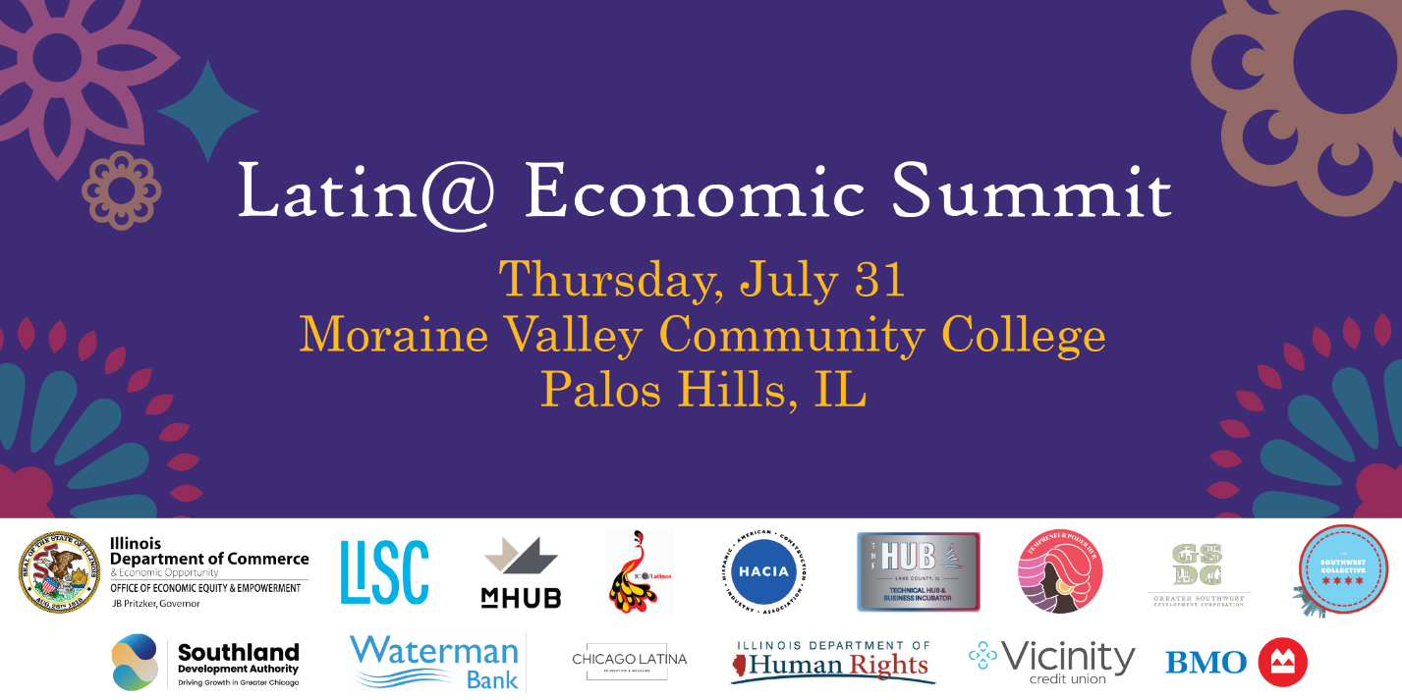

**FACEBOOK**

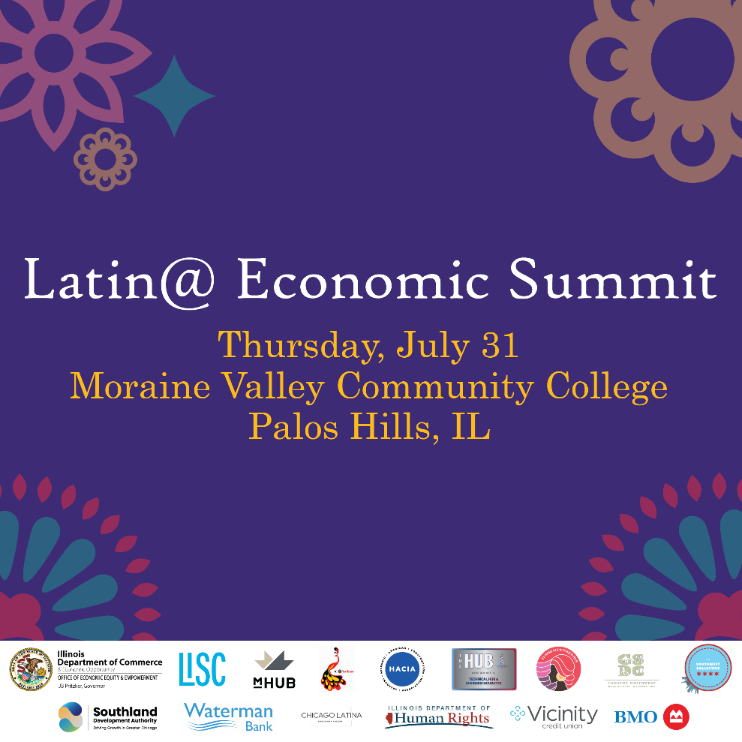

**LINKEDIN**

