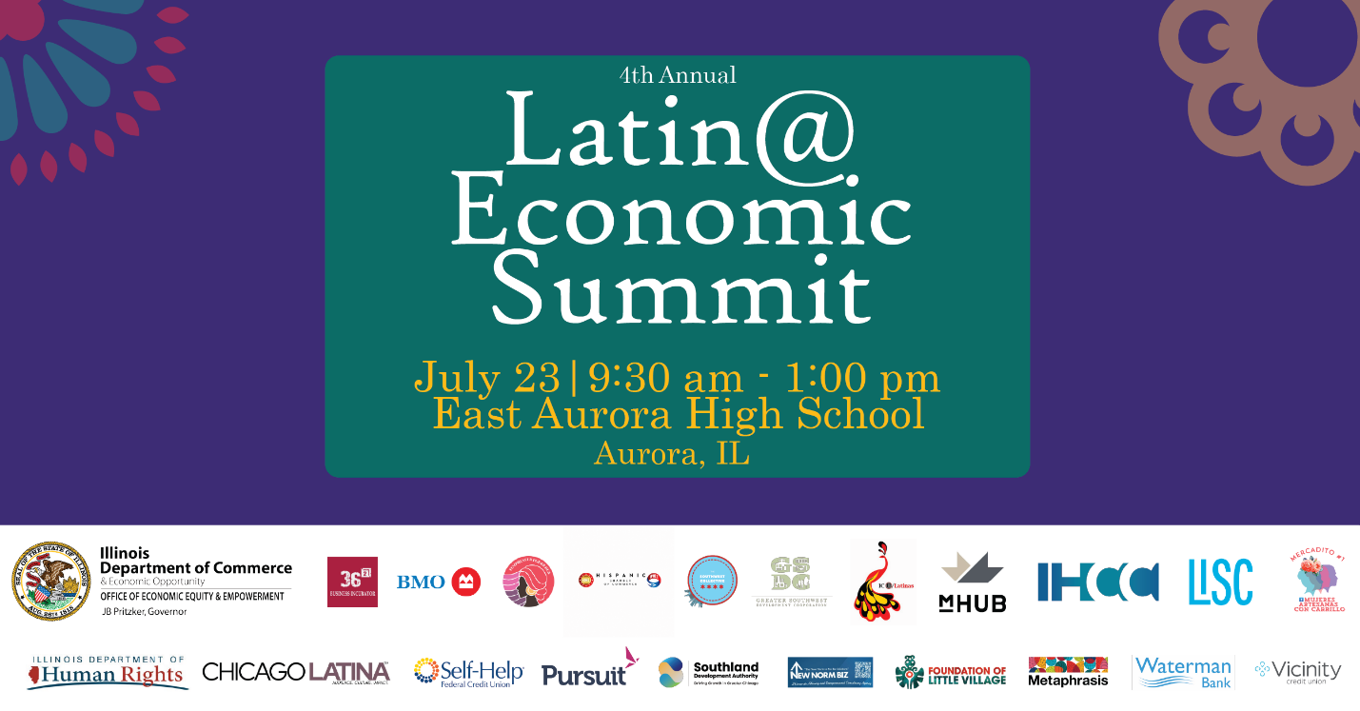
This July, the Illinois Department of Commerce and Economic Opportunity (DCEO) in collaboration with the Latinx Business Colectivo will be hosting the 4th Annual Latin@ Economic Summit. Join Illinois Latino business leaders, innovators, and other aspiring entrepreneurs for a day of networking and connection. Make sure to register and secure your spot - https://bit.ly/3QtmHzz

Below, you will find tips, sample social media posts, graphics, and media relations guidance on how to promote awareness and encourage those in your network to attend.

SOCIAL MEDIA TIPS
- Be sure to use the official hashtags in order to amplify the movement:
  - #ILLatinoEconomicSummit
- Be sure to follow, Tag & RT DCEO and your favorite Latinx-owned businesses to show support:
DCEO Handle: @IllinoisDCEO
  - DCEO Facebook
  - DCEO X/Twitter
  - DCEO LinkedIn
  - DCEO Bluesky

Sample Post

1
The Illinois Department of Commerce & Economic Opportunity, through its Office of Economic Equity & Empowerment and the Latinx Business Colectivo, are inviting you to the 4th Annual Latino/a Economic Summit.

This free event includes networking opportunities, expert speakers, workshops, and more.

Space is limited so, make sure to register in English: [https://bit.ly/3QtmHzz] or Spanish: [https://bit.ly/434gcWX].

#ILLatinoEconomicSummit

2
Join DCEO’s Office of Economic Equity & Empowerment and the Latinx Business Colectivo at the 4th Annual Latino/a Economic Summit on Thursday, July 23rd. Don’t miss this incredible opportunity to learn and connect with leaders in the Latino business community.

Make sure to secure your free spot today - [https://bit.ly/3QtmHzz]
#ILLatinoEconomicSummit
____________

3
Celebrate Illinois’ Latino businesses, network, and get information on resources to start and grow your business at the 4th Annual Latino/a Economic Summit on Thursday, July 23rd.

Register today to secure your spot - [https://bit.ly/3QtmHzz]

#ILLatinoEconomicSummit

4

Looking to start a business or to take your business to the next level? Join DCEO for the 4th Annual Latino/a Economic Summit on July 23rd in Aurora.

Register today - [https://bit.ly/3QtmHzz]

#ILLatinoEconomicSummit

5

Today’s the last day to register for the 4th Annual Latino/a Economic Summit! Connect with fellow entrepreneurs, expand your network, and discover valuable resources to start, grow, and scale your business.

The Summit will feature:
✅ Contracts 101 – Learn how to spot items in contracts that deserve a closer look
✅ Best Business Practices– Gain insight on best practices and strategies to build a resilient business

Register Now! In English: [https://bit.ly/3QtmHzz] or Spanish: [https://bit.ly/434gcWX]
#ILLatinoEconomicSummit

X/BLUESKY
1
Connect with successful Latino entrepreneurs, gain real-world insights, and learn what it takes to turn your idea into a thriving business at DCEO's 4th Annual Latino/a Economic Summit on Thurs, July 23rd.

Register to secure your spot - [https://bit.ly/3QtmHzz]

#ILLatinoEconomicSummit

2
Join the 4th Annual Latino/a Economic Summit on 7/23 in Aurora. The event includes networking opportunities, expert speakers, workshops, and more.

Register now for free in English: [https://bit.ly/3QtmHzz] or Spanish: [https://bit.ly/434gcWX]

#ILLatinoEconomicSummit

3

Celebrate Illinois’ Latino businesses, network, and get information on how to grow your business at the 4th Annual Latino/a Economic Summit on July 23rd.

Register today to secure your spot for free - [https://bit.ly/3QtmHzz]

#ILLatinoEconomicSummit

4

Looking to start a business or to take your business to the next level?
Join the 4th Annual Latino/a Economic Summit on July 23rd in Aurora! Make sure to register -
[https://bit.ly/3QtmHzz]

#ILLatinoEconomicSummit

5

Today’s the last day to register for the 4th Annual Latino/a Economic Summit! Don’t miss this incredible opportunity to learn and connect.

Register now for free in English: [https://bit.ly/3QtmHzz] or Spanish: [https://bit.ly/434gcWX]
#ILLatinoEconomicSummit

GRAPHICS

Below is a collection of graphics that can be shared and used in eblasts/newsletters and via social media to help promote the 4th Annual Latin@ Economic Summit. To save graphics, right-click on the preferred graphic and “Save as Picture” to your files.

Facebook
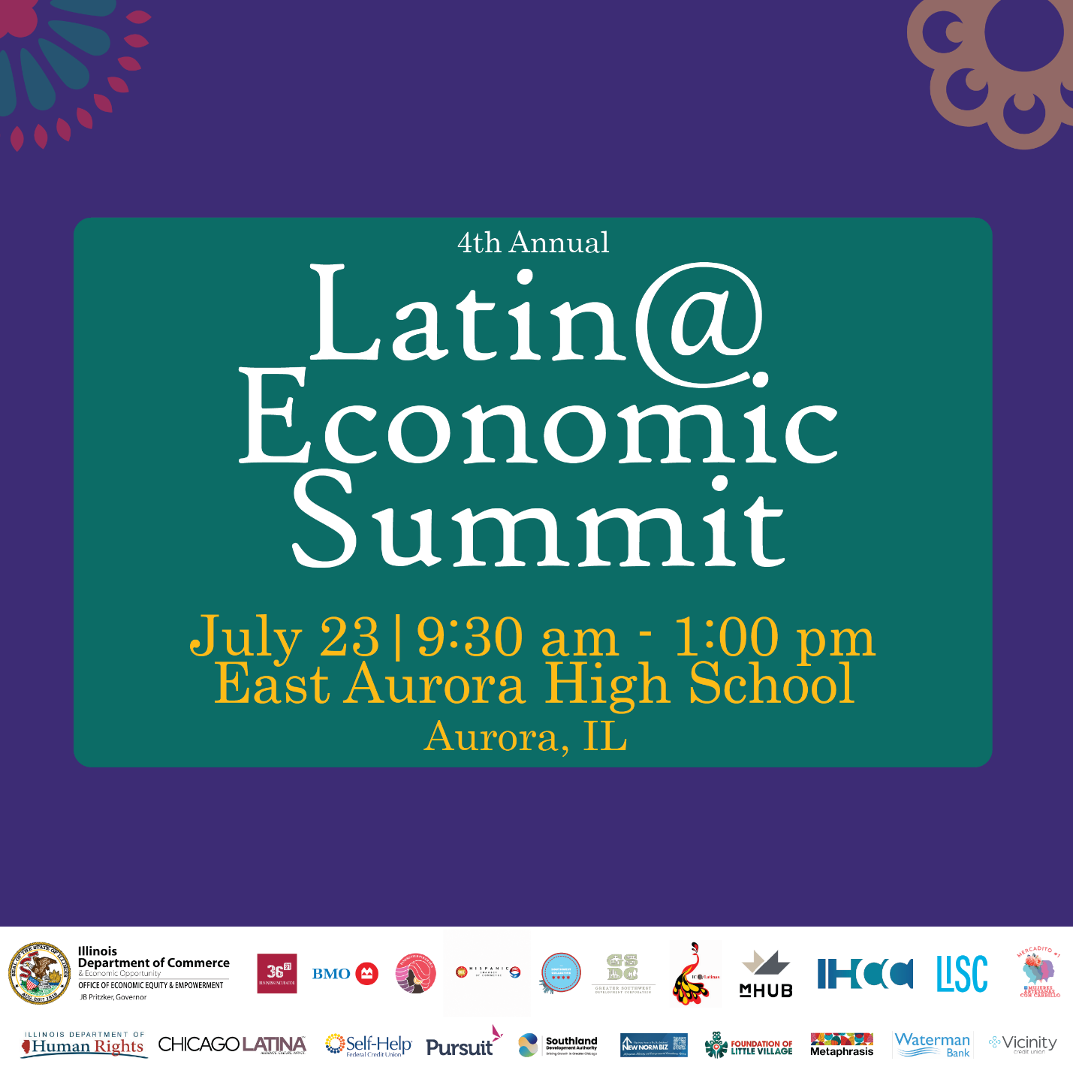

LinkedIn
X/Twitter
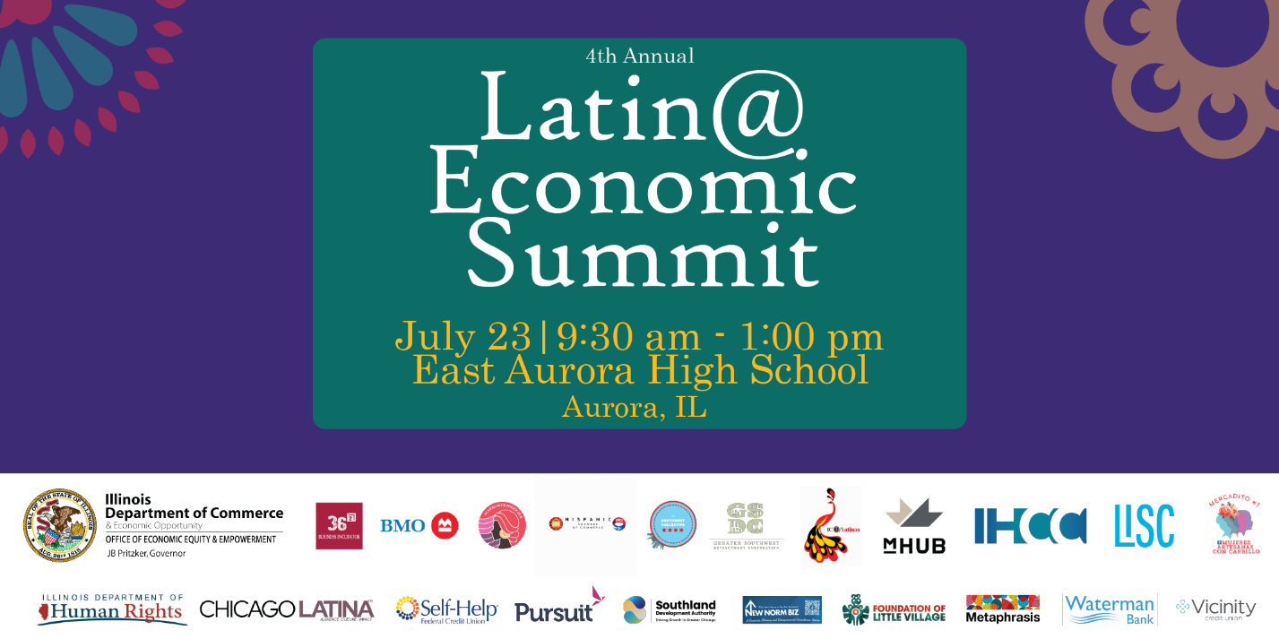

QR CODE FOR REGISTRATION

English:

Spanish:


SAMPLE NEWSLETTER OR E-BLAST

KICK OFF
The Illinois Department of Commerce & Economic Opportunity, through its Office of Economic Equity & Empowerment (OE3) and the Latinx Business Colectivo, cordially invites you to the 4th Annual Latin@ Economic Summit. Attendees will gain valuable insights and knowledge through networking, expert speakers, workshops, and more.

To learn more and register in English: https://bit.ly/3QtmHzz or Spanish: https://bit.ly/434gcWX

REMINDER
Do you know that the Illinois Department of Commerce & Economic Opportunity, through its Office of Economic Equity & Empowerment (OE3) and the Latinx Business Colectivo, is hosting the 4th Annual Latin@ Economic Summit on July 23?

Attendees will gain valuable insights and knowledge through networking, expert speakers, workshops, and more.

To learn more and register in English: https://bit.ly/3QtmHzz or Spanish: https://bit.ly/434gcWX

We look forward to meeting you!
CONTACT INFO
For questions about the toolkit, please do not hesitate to contact Diana Alfaro, Latinx Business Development Manager, at diana.alfaro@illinois.gov, or Erik Castelan, Latinx Business Development Specialist, at erik.castelan@illinois.gov.

