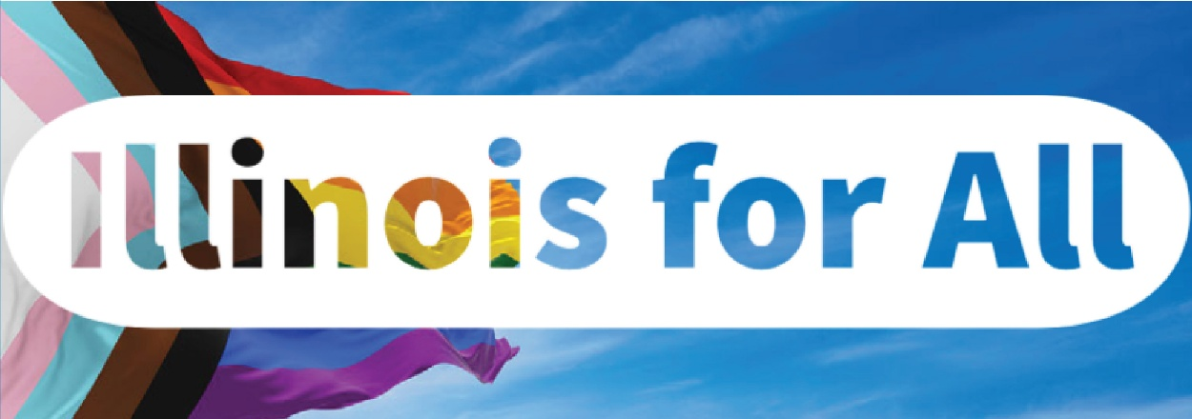

2025 Pride Month Social Media Toolkit

Below, you will find tips, sample social media posts, graphics, and ideas on how to raise awareness and encourage those in your network to celebrate Pride Month.

SOCIAL MEDIA TIPS
- Be sure to use the official hashtags to amplify your content:
  - #Pride2025
  - #Illinoisforall
- Follow, Tag & RT DCEO and your favorite LGBTQIA+ owned businesses to show support:
DCEO Handle: @IllinoisDCEO
  - DCEO Facebook
  - DCEO Twitter
  - DCEO LinkedIn
  - Bluesky
- Use visuals like the graphics provided below or a photo of you at your favorite LGBTQIA+ owned business.
- Make it your own! Tailor content to your stakeholders.
LINKS AND RESOURCES
Below are links where you can find information about upcoming events, resources, and programs through DCEO:
- DCEO’s Pride Month Landing Page: https://bit.ly/4ji3f1D
  - Includes events and resources for celebrating Pride Month, as well as resources for LGBTQIA+ owned businesses and future entrepreneurs.

SAMPLE SOCIAL MEDIA POSTS

GENERAL PRIDE MONTH KICKOFF POST:
Option 1
Illinois is proud to celebrate Pride Month and honor the incredible contributions and achievements of LGBTQIA+ businesses and entrepreneurs across our state!
Join us in recognizing the impact of history and the impact of the LGBTQIA+ in Illinois. Check out @IllinoisDCEO’s website for upcoming events and resources: https://bit.ly/4ji3f1D #Pride2025
Option 2
Join the State of Illinois in celebrating Pride Month by:
✅ Attending an event hosted by @illinoisDCEO – https://bit.ly/4ji3f1D
✅ Supporting LGBTQIA+ owned businesses
✅ Spreading the word using #Pride2025

POST ENCOURAGING STAKEHOLDERS TO HIGHLIGHT LOCAL LGBTQIA+ OWNED BUSINESSES
Have a favorite LGBTQIA+ owned business? Show your support this #Pride2025 by visiting & tagging them on social media. Learn more ways to celebrate by visiting @illinoisDCEO’s site – https://bit.ly/4ji3f1D

SAMPLE NEWSLETTER OR E-BLAST
This Pride Month, we’re celebrating the incredible contributions of LGBTQIA+ entrepreneurs and businesses across Illinois! Throughout the month, DCEO is co-hosting events and sharing tangible business resources that empower Illinois LGBTQIA+ business owners and aspiring entrepreneurs.
Join us in recognizing and supporting the LGBTQIA+ vibrant community! Visit DCEO’s Pride Month page for event details and valuable resources. https://bit.ly/4ji3f1D

GRAPHICS
Below is a collection of graphics that can be shared and used in eblasts/newsletters and via social media to help promote Pride Month. To save graphics, right-click on the preferred graphic and “Save as Picture” to your files.

Facebook
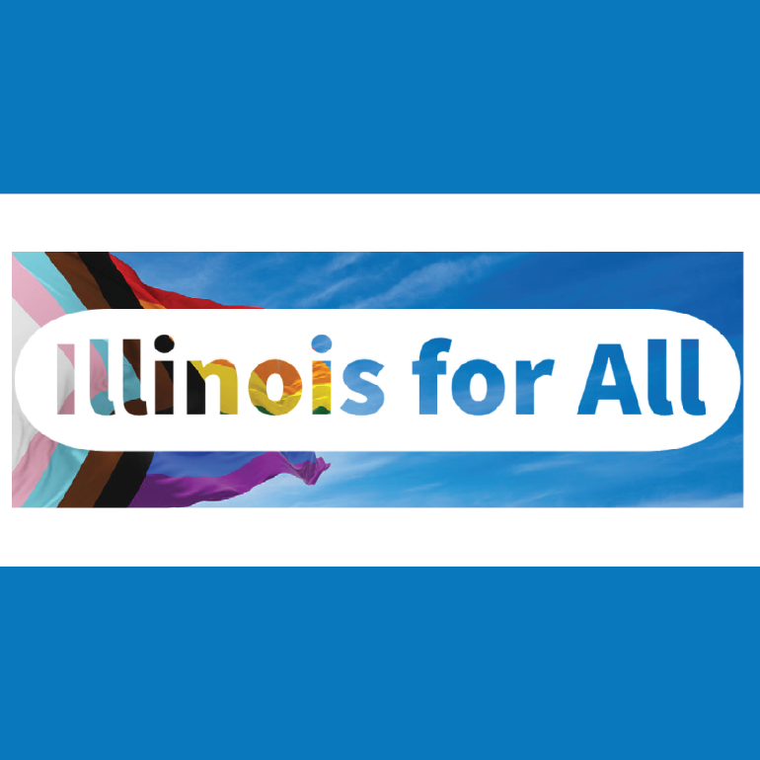
LinkedIn
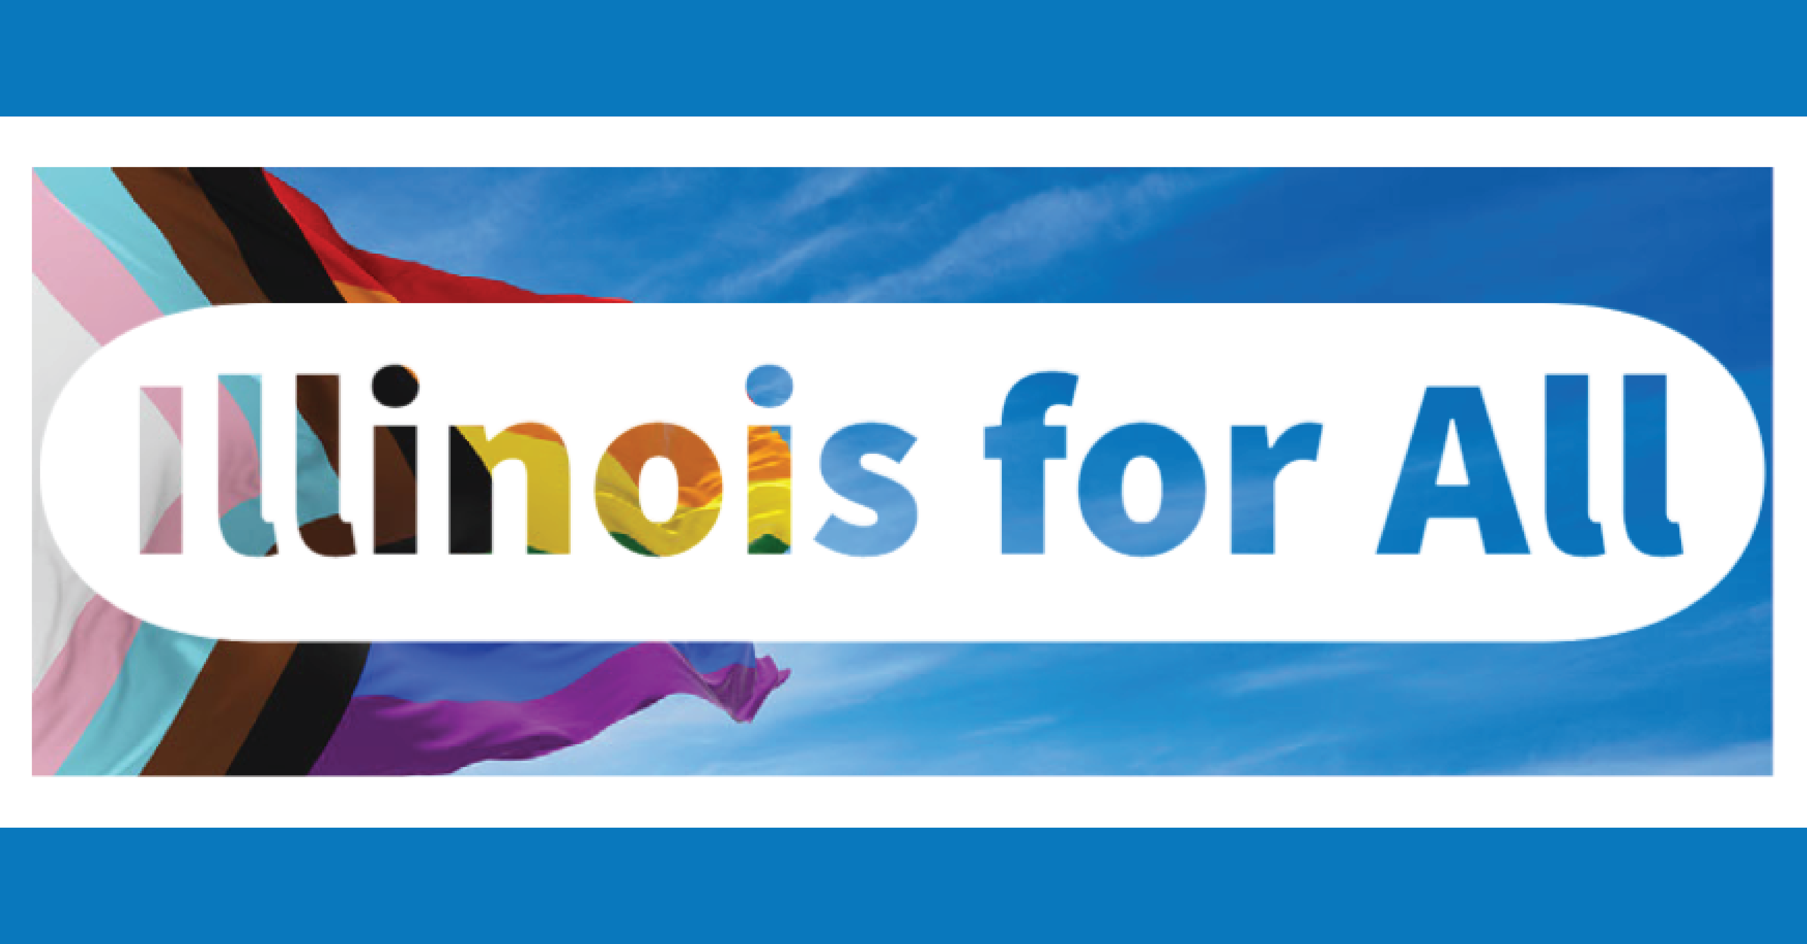

Bluesky/X
