

**Illinois Women’s Business Month 2025 Toolkit Celebrating Women-Owned Businesses**

Please join the [Illinois Department of Commerce & Economic Opportunity (DCEO)](https://dceo.illinois.gov/) as we celebrate and promote Illinois women-owned businesses during National Women’s Business Month. Throughout October, DCEO is elevating resources and opportunities to bolster women-owned businesses throughout the state. Learn more about how to get involved and support women-owned businesses here in our 2025 Illinois Women’s Business Month Toolkit!

Below, you will find tips, sample social media posts, graphics and ideas on how to raise awareness and encourage those in your network to celebrate Women’s Business Month.

**SOCIAL MEDIA TIPS:**

* Be sure to use the official hashtags in order amplify the movement:
  + #ILWBM2025
* Follow, Tag & RT DCEO and your favorite Women-owned businesses to show support:
  + DCEO Handle: @IllinoisDCEO
  + [DCEO Facebook](https://www.facebook.com/illinoisdceo)
  + [DCEO LinkedIn](https://www.linkedin.com/company/illinoisdceo)
  + [DCEO X](https://twitter.com/IllinoisDCEO)
  + [DCEO Bluesky](https://bsky.app/profile/illinoisdceo.bsky.social)
* Use visuals like the provided graphics below, share a photo of you at your favorite Women-owned business, or tell us how HER business helped you.
* Link to [**DCEO’s Women’s Business Month landing page**](https://dceo.illinois.gov/oe3/events/wbm2025.html) for helpful resources
* Make it your own! Tailor content to your stakeholders.

**LINKS AND RESOURCES:**

Below are links where you can find information about upcoming events and resources and programs through DCEO:

* [**DCEO’s Women’s Business Month page**](https://dceo.illinois.gov/oe3/events/wbm2025.html)
  + includes events and resources for celebrating Women’s Business Month, as well as resources for women-owned businesses and future women entrepreneurs
* [**Illinois Office Economic Equity & Empowerment**](https://dceo.illinois.gov/oe3.html)(OE3)
  + resources for women-owned businesses
* [**Enjoy Illinois: Women-Owned Businesses to Support During Road Trips in Illinois**](https://www.enjoyillinois.com/travel-illinois/how-to-celebrate-womens-history-month-in-illinois/)
  + ideas for road trips & women-owned businesses throughout Illinois to support
* **Directories Featuring Illinois Women-owned Businesses**

### [2024 Illinois Made Holiday Gift Guide](https://www.enjoyillinois.com/illinois-made/illinois-made-holiday-gift-guide/)

* [**Biggest Women-Owned Businesses**](https://www.chicagobusiness.com/businessdata/61/biggest-women-owned-businesses)*(in the Chicago region)*
* [**Champaign County Chamber of Commerce’s Woman Owned Business List**](https://business.champaigncounty.org/list/category/woman-owned-business-818)
* [**Chicago Women-owned Businesses Assisting Event & Meeting Planners**](https://www.choosechicago.com/meeting-planners/explore/general-tips-for-meetings/tap-into-chicagos-women-owned-businesses/)
* [**Choose Chicago**](https://www.choosechicago.com/blog/architecture-history/womens-history-month-in-chicago/#business)
* [**City of Peoria’s Minority and Women Business Enterprise (M/WBE) Directory**](https://www.eprismsoft.com/business/showCert?id=140)
* [**City of Rockford’s List of Certified Woman Business Enterprises (WBEs)**](https://rockfordil.gov/DocumentCenter/View/443/MBE-WBE-Certified-List-working-draft-PDF?bidId)
* [**Federation of Women Contractors**](https://cdn.ymaws.com/fwcchicago.com/resource/resmgr/directory/2024_fwc_directory_final.pdf)
* [**Grundy County Chamber of Commerce’s Women Owned Businesses Directory**](https://grundychamber.com/women-owned-businesses/)
* [**Illinois Made**](https://www.enjoyillinois.com/illinois-made/)
* [**Illinois Office of Tourism**](https://www.enjoyillinois.com/travel-illinois/how-to-celebrate-womens-history-month-in-illinois/)
* [**Let’s Talk Womxn Chicago**](https://letstalkwomxn.com/city-page/chicago/)*(collaboration of women restaurateurs)*
* [**Marketplace**](https://a4cb.org/marketplace/)*(featuring Chicago area businesses)*
* [**McHenry County Women-Owned Businesses Directory**](https://www.naturallymchenrycounty.com/things-to-do/women-owned-businesses/)
* [**National Association of Minority & Women Owned Law Firms**](https://namwolf.org/)
* [**Refine Collective**](https://www.refinecltv.com/directory)
* [**Shop Columbia**](https://shop.colum.edu/)
* [**Small Business Majority 2023 Holiday Guide**](https://smallbusinessmajority.org/gift-guide-2023)
* [**State of Illinois BEP and VEP Certification Directory**](https://supplierdiversitymanagementportal.illinois.gov/VendorDirectory.aspx)

* **[The Chicago Network’s Business Directory](https://www.thechicagonetwork.org/member-resource-listings/)** *(includes women-owned businesses)*
* [**Women Entrepreneurs Central Illinois Directory**](https://www.wecispringfield.org/content.aspx?page_id=154&club_id=419081)

* **[Women-Owned Businesses of Central Street in Evanston](https://centralstreetevanston.com/women-owned-businesses-of-central-street)**
* [**Women’s Business Network Lake County Directory**](https://wbnlakecounty.com/directory/)
* [**YWCA Shop Chicago**](https://yshop.org/)
* The online store managed by the [**YWCA Metropolitan Chicago**,](https://ywcachicago.org/) offers a curated selection of goods and services, where a portion of each purchase goes to benefit the YWCA and the communities that they support.

### [YWCA Shop for Good in Evanston & Wilmette](https://www.ywca-ens.org/what-we-do/shop/)

* 100% of profits help support the [**YWCA Evanston/North Shore’s**](https://www.ywca-ens.org/)domestic violence and economic advancement programs that serve women across northeastern Cook County

**SAMPLE SOCIAL MEDIA POSTS:**

***GENERAL WOMEN’s BUSINESS MONTH 2025 KICKOFF POST:***

This Women’s Business Month, Illinois is proud to celebrate the rich contributions and accomplishments of women, women-owned businesses & entrepreneurs. Visit DCEO’s website for information about events and resources – <http://bit.ly/3IqPjpk> #ILWBM2025

Join the State of Illinois in celebrating Women’s Business Month**:**

✅Attend events hosted by @illinoisDCEO <http://bit.ly/3IqPjpk>

✅Support women-owned businesses

✅Spread the word using #ILWBM2025

***POST ENCOURAGING STAKEHOLDERS TO HIGHLIGHT LOCAL WOMEN-OWNED BUSINESSES:***

Have a favorite women-owned business? Show your support this #ILWBM2025 by utilizing their professional services, visiting their businesses & tagging them on social media. Learn more ways to celebrate by visiting @illinoisDCEO’s site <http://bit.ly/3IqPjpk>

**SAMPLE NEWSLETTER OR E-BLAST**

**Celebrate Women’s Business Month 2025 with the State of Illinois**

Throughout Women’s Business Month, the Illinois Department of Commerce and Economic Opportunity (DCEO) is honoring the contributions of women in Illinois through a series of events to assist their businesses, connecting them with resources, and a social media campaign that encourages elevation of women-owned businesses in October and beyond.

Visit DCEO’s Women’s Business Month events and resources [**page.**](https://dceo.illinois.gov/oe3/events/wbm2025.html)

**GRAPHICS/IMAGES**

Below is a collection of graphics that can be shared and used in eblasts/newsletters and via social media to help promote Women’s Business Month 2025. To save graphics, right click on the preferred graphic and “Save as Picture” to your files.

**Facebook**

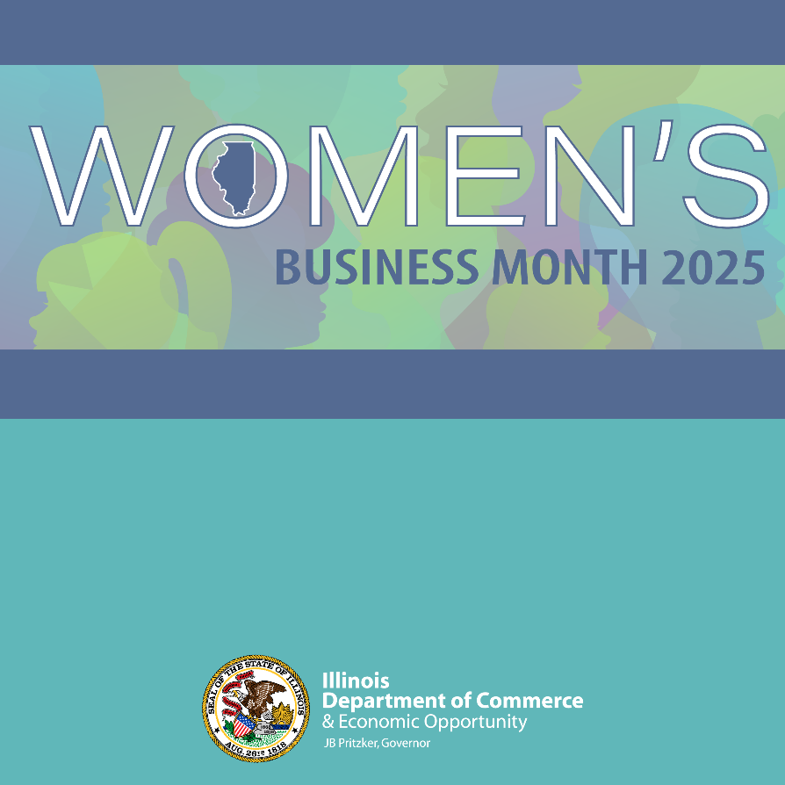

**LinkedIn**

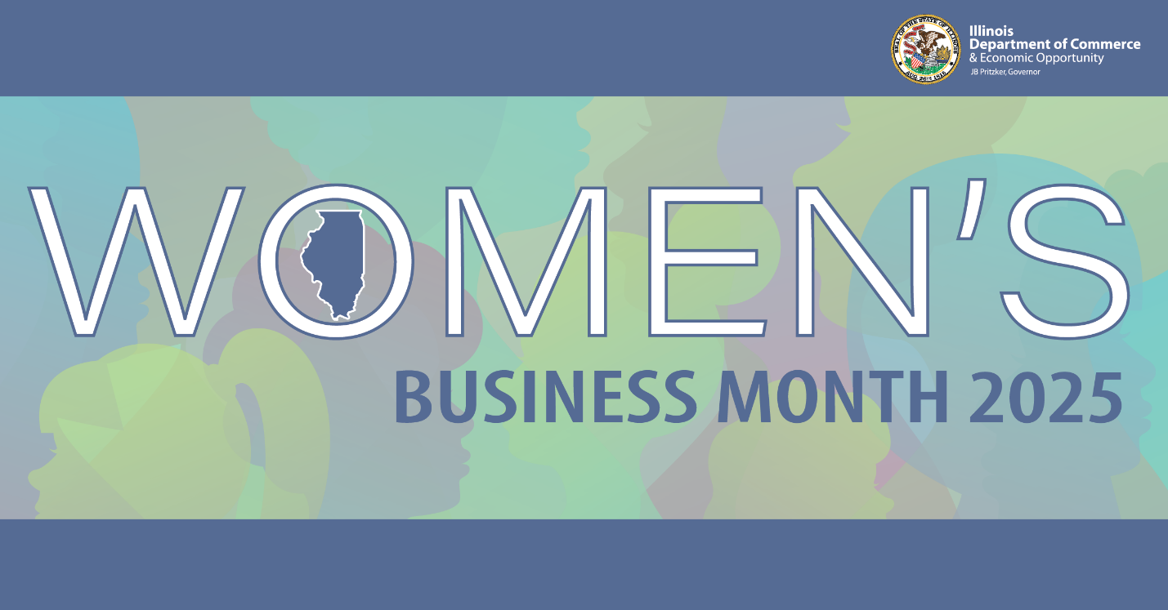

**X/Bluesky**

