Pushing Forward Economic Strength:
Elevating Latino/a/e/x Access & Equity Summit
Social Media Toolkit

Join the Illinois Department of Commerce and Economic Opportunity (DCEO) - Office of Minority Economic Empowerment (OMEE), as we host the Pushing Forward Economic Strength: Elevating Latino/a/e/x Access & Equity Summit on July 27, 2023. Below you will find tips, sample social media posts, graphics, and ideas on celebrating and promoting the Summit!

SOCIAL MEDIA TIPS:
- Be sure to use the official hashtags to amplify the movement
  - #ILSupportLatinoBiz
  - #ILLatinxSummit
  - #ILLatinoEconomicPower
- Follow, Tag & RT (Re-tweet) DCEO and your favorite Latino/a/e/x -owned businesses to inform them of the summit and uplift their businesses:
  - DCEO Handle: @IllinoisDCEO
  - DCEO Facebook
  - DCEO Twitter
  - DCEO LinkedIn
- Use visuals like the provided graphics
- For Twitter, be mindful of character limits (280 characters)
- Make it your own! Tailor content to your stakeholders.

AMPLIFY PARTNERS:
Show your support by tagging and amplifying posts from our Elevating Latino/a/e/x Access & Equity Summit partners:
Partner Name | Twitter | Facebook | LinkedIn
Center for Changing Lives | @CCLchicago | Center for Changing Lives | Center for Changing Lives
Chicago Latina Magazine | N/A | Chicago Latina Magazine | Chicago Latina Magazine
Chicago Federal Executive Board | @ChicagoFEB | Chicago Federal Executive Board | Chicago Federal Executive Board
City Colleges of Chicago - Malcolm X College | @MX_College | Malcom X College | Malcom X College
IC U Latinas | IC U Latinas
Sunshine Enterprises | @EnterprisesSun | Sunshine Enterprises | Sunshine Enterprises
Southwest Chicago Chamber of Commerce | @SWChiChamber | Southwest Chicago Chamber of Commerce | Southwest Chicago Chamber of Commerce

CONTACT:
For questions on the toolkit, feel free to reach out to Diana Alfaro, Latinx Business Development Manager, at diana.alfaro@illinois.gov or Anggi Lewis, at anggi.lewis@illinois.gov

Facebook/LinkedIn: Pushing Forward Economic Strength:
Elevating Latino/a/e/x Access & Equity Summit
Facebook/Linkedin Example #1:
Celebrate Latino/a/e/x businesses, network, and learn about resources to grow your business. The Summit will include speakers and workshops on topics including:
✅ Access to capital
✅ Government contracting
✅ Workforce
✅ Marketing
✅ And more!

Register here: https://bit.ly/3rndqwf #ILLatinxSummit #ILSupportLatinoBiz #ILLatinoEconomicPower

Facebook/LinkedIn Example #2:
Illinois is proud to have more than 116K Latino/a/e/x businesses! Want to take your business to the next level and learn about resources, network, and celebrate the success of Latino/a/e/x businesses?
Join the Latino/a/e/x Economic Summit on 7/27 in Chicago! The free event includes networking opportunities, speakers, workshops and more.
Register here: https://bit.ly/3rndqwf
COMPRA, SUPPORT, and SHOP local Latino/a/e/x -owned Businesses all year long!
#ILLatinxSummit #ILSupportLatinoBiz #ILLatinoEconomicPower

Twitter: Pushing Forward Economic Strength:
Elevating Latino/a/e/x Access & Equity Summit
Twitter example #1:
🚨 Attn Entrepreneurs🚨
Join the Latino/a/e/x Economic Summit in Chicago on 7/27 to learn about
✅ Access to capital
✅ Government contracting
✅ Marketing & more

Learn more & register here: https://bit.ly/3rndqwf #ILLatinxSummit

Twitter example #2:
⭐Event⭐

Are you an entrepreneur looking to network & learn about resources & strategies to take your business to the next level?

Join the Latino/a/e/x Economic Summit in Chicago on 7/27 – register today and learn more: https://bit.ly/3rndqwf #ILLatinxSummit
Instagram: Pushing Forward Economic Strength:
Elevating Latino/a/e/x Access & Equity Summit
NOTE: Instagram does not enable links in captions; if you are promoting on Instagram please put the link in your bio. and reference it in the caption

Instagram example #1:
Attention Business Owners: Want to celebrate the Latino/a/e/x business community, network, and learn about resources to grow your business? Join the Latino/a/e/x Summit on 7/27 to learn more about:
✅ Access to capital
✅ Government contracting
✅ Workforce
✅ Marketing
✅ And more!

Register today (link in bio)! #ILLatinxSummit #ILSupportLatinoBiz #ILLatinoEconomicPower

Instagram example #2
🚨Attn Entrepreneurs 🚨
Illinois is proud to have more than 116K Latino/a/e/x businesses! Want to take your business to the next level and learn about resources, network, and celebrate the success of the Latino/a/e/x business community?
Join the Latino/a/e/x Economic Summit on 7/27 in Chicago! This free event includes networking opportunities, speakers, workshops and more.
Register today – space is limited (link in bio)! #ILLatinxSummit #ILSupportLatinoBiz #ILLatinoEconomicPower

SAMPLE NEWSLETTER/E-BLAST:
The Illinois Department of Commerce & Economic Opportunity (DCEO) - Office of Minority Economic Empowerment (OMEE) is hosting the Pushing Forward Economic Strength: Elevating Latino/a/e/x Access & Equity Summit on July 27th, 2023. Summit will include speakers and workshops covering topics such as access to capital, government contracting, workforce, marketing, knowing your rights as a business that uses an ITIN, and much more.

Register here.

And remember to COMPRA, SUPPORT, and shop LOCAL Latino/a/e/x -owned Businesses all year long!

#ILLatinxSummit #ILSupportLatinoBiz #ILLatinoEconomicPower

GRAPHICS/IMAGES:
Below is a collection of social media graphics. To save: right-click, select “save as picture”, and save.

FACEBOOK - Pushing Forward Economic Strength: Elevating Latino/a/e/x Access & Equity Summit:
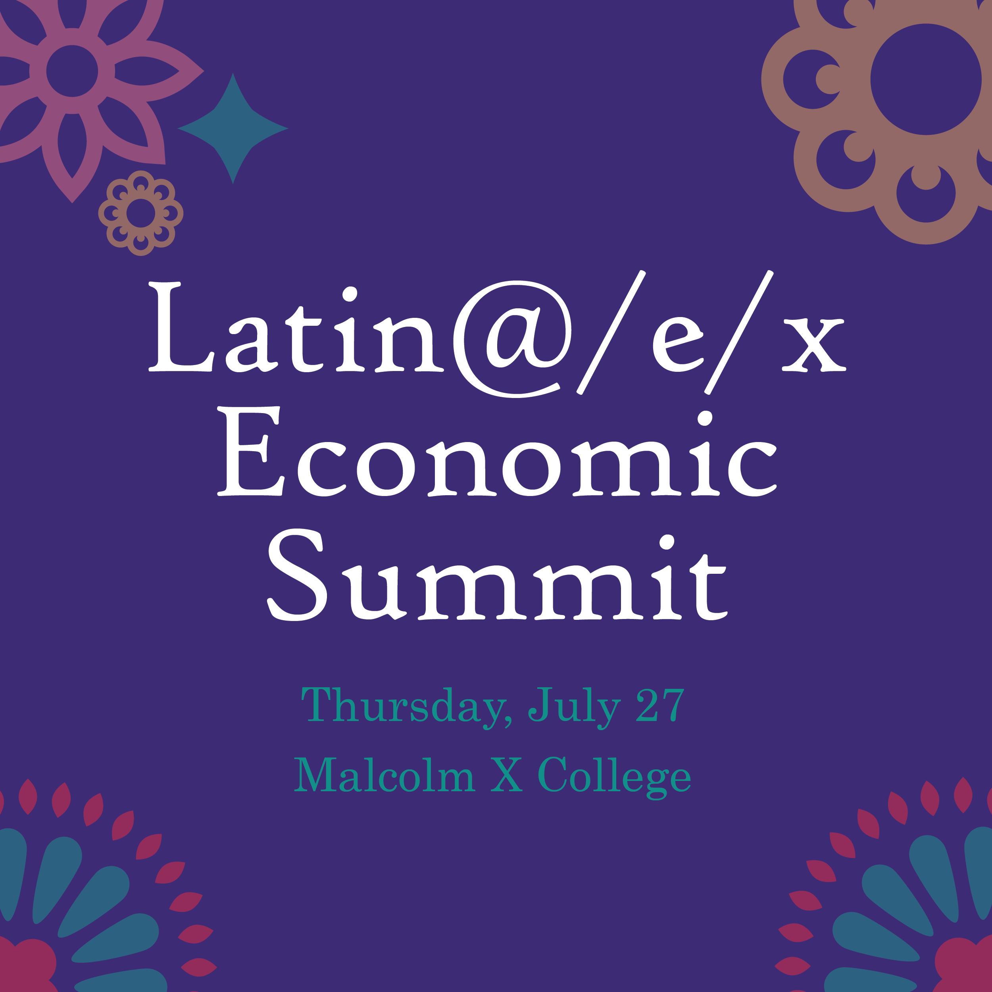

TWITTER Pushing Forward Economic Strength: Elevating Latino/a/e/x Access & Equity Summit:
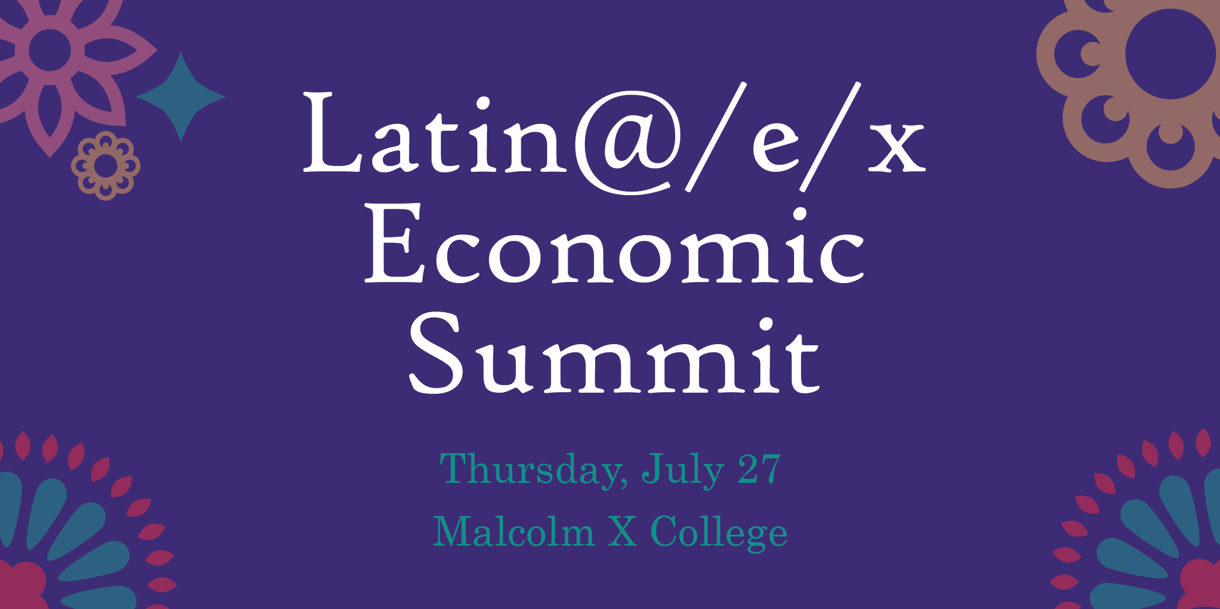

LINKEDIN Pushing Forward Economic Strength: Elevating Latino/a/e/x Access & Equity Summit: