Rising Together: Empowering and Shaping the Future Strategically
2nd Annual Latin@ Economic Summit Social Media Toolkit

Join the Illinois Department of Commerce and Economic Opportunity (DCEO) - Office of Minority Economic Empowerment (OMEE), as we host the 2nd Annual Latin@ Economic Summit on Thursday, July 18, 2024. Below you will find tips, sample social media posts, graphics, and ideas on celebrating and promoting the Summit!

SOCIAL MEDIA TIPS:
- Be sure to use the official hashtags to amplify the movement
  - #ILSupportLatinoBiz
  - #ILLatinxSummit
  - #ILLatinoEconomicPower
- Follow, Tag & RT (Re-tweet) DCEO and your favorite Latin@/o -owned businesses to inform them of the summit and uplift their businesses:
    - DCEO Handle: @IllinoisDCEO
    - DCEO Facebook
    - DCEO Twitter
    - DCEO LinkedIn

- Use visuals like the provided graphics
- For Twitter, be mindful of character limits (280 characters)
- Make it your own! Tailor content to your stakeholders

AMPLIFY PARTNERS:
Show your support by tagging and amplifying posts from our Summit partners:

Partner Name | Twitter | Facebook | LinkedIn
BMO Harris Bank | @BMO_US | BMO Harris Bank | BMO Harris Bank
Center for Changing Lives | @CCLchicago | Center for Changing Lives | Center for Changing Lives
Chicago Latina Magazine | N/A | Chicago Latina Magazine | Chicago Latina Magazine
Hispanic American Construction Industry Association (HACIA) | @HACIAworks | Hispanic American Construction Industry Association (HACIA) | Hispanic American Construction Industry Association (HACIA)
IC U Latinas | N/A | @IC U Latinas | N/A
The Southwest Collective | @swcollectivechi | Southwest Collective | N/A
Sunshine Enterprises | @EnterprisesSun | Sunshine Enterprises | Sunshine Enterprises
United Credit Union | @unitedcreditu | United Credit Union | United Credit Union
Federal Executive Board | N/A | N/A | N/A

CONTACT:
For questions on the toolkit, feel free to reach out to Diana Alfaro, Latinx Business Development Manager, at diana.alfaro@illinois.gov or Anggi Lewis, at anggi.lewis@illinois.gov
SAMPLE POSTS:

Facebook/Linkedin Example #1:
Celebrate Latina/o businesses, network, and learn about resources to grow your business at the 2nd annual Latina/o Economic Summit on Thursday, July 18th. The Summit will feature:
✅ Matchmaking opportunities for funding
✅Networking opportunities
✅Support on navigating certifications
✅And more!

Register here: https://bit.ly/45nTWYq #ILLatinxSummit #ILSupportLatinoBiz #ILLatinoEconomicPower

Facebook/LinkedIn Example #2:
Are you a business owner or entrepreneur looking to take your business to the next level? Join the 2nd Annual Latina/o Economic Summit on 7/18 in Chicago! The free event includes networking opportunities, speakers, workshops and more.

Register here: https://bit.ly/45nTWYq
#ILLatinxSummit #ILSupportLatinoBiz #ILLatinoEconomicPower

Twitter example #1:
Attn Entrepreneurs
Join the Latina/o Economic Summit in Chicago on 7/18! The free event includes networking opportunities, speakers, workshops and more. Make sure to register - https://bit.ly/45nTWYq #ILLatinxSummit

Twitter example #2:
Are you an entrepreneur looking to network & learn about resources & strategies to take your business to the next level?

Join the 2nd Annual Latina/o Economic Summit in Chicago on 7/18 – register today -https://bit.ly/45nTWYq #ILLatinxSummit

Instagram example #1:
Want to take your business to the next level and learn about resources, network, and celebrate the success of the Latina/o business community?
Join the 2nd Annual Latina/o Economic Summit on 7/18 in Chicago! This free event includes networking opportunities, speakers, workshops and more.
Register today – space is limited (link in bio #ILLatinxSummit #ILSupportLatinoBiz #ILLatinoEconomicPower

NOTE: Instagram does not enable links in captions; if you are promoting on Instagram please put the link in your bio. and reference it in the caption

SAMPLE NEWSLETTER/E-BLAST:
The Illinois Department of Commerce & Economic Opportunity (DCEO) - Office of Minority Economic Empowerment (OMEE) Latinx Business Colectivo is hosting the 2nd Annual Latin@ Economic Summit - Rising Together: Empowering and Shaping the Future Strategically on July 18th, 2024. The bilingual event will feature matchmaking opportunities for funding, guidance on building and sustaining business networks - scheduled networking opportunities, navigating certifications, and more. Attendees will gain valuable information on marketing and crafting an elevator pitch for their business!

Make sure to secure your spot today, https://bit.ly/45nTWYq

GRAPHICS/IMAGES:
Below is a collection of social media graphics. To save: right-click, select “save as picture”, and save.

TWITTER
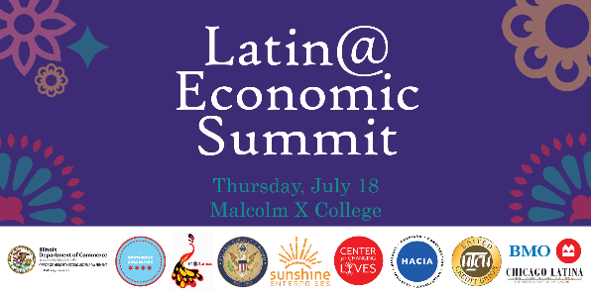
FACEBOOK
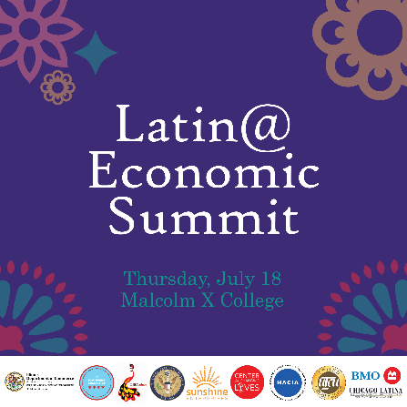
LINKEDIN
