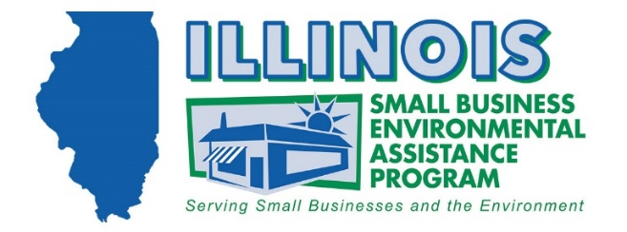
Selecting an Environmental Consultant

Why Hire an Environmental Consultant?

Solutions for environmental clean ups, complications, or human health risks can be complex and require expertise. A consultant can help navigate the hazards and regulations relevant to your project to get your project done correctly, safely, and in compliance the first time, saving you time and the costs of fixing mistakes.

How Can I Find a Consultant?

The Small Business Environmental Assistance Program (SBEAP) maintains the Illinois Environmental Services Directory, which is a directory of providers of environmental services/consulting in Illinois. This directory lists environmental consultants and service providers along with their areas of expertise and the services they provide. The directory is composed of consultants that voluntarily listed themselves with SBEAP and is not comprehensive of all environmental consultants in Illinois. Consultants can also be located by asking for recommendations within your business network, inquiring with professional organizations you are a member of, and by doing a web search for “environmental services” or “environmental consultants”. Look for consultants that have expertise in the services that you need.

How Do I Engage a Consultant?

Once you have chosen an environmental consult or service provider that you wish to consider further, you should; request a quote, inquire about their firm and experience, and check their references.

When requesting a quote, be sure to provide detailed information about your property such as site history and land use, materials and products used, wastes produced and potential or real contamination, the source of your water supply, and the current uses of surrounding properties.

When inquiring about the consultant’s firm and experience, you should ask about; their experience with clean-ups or services like yours, how many years of experience they have working in Illinois and complying with state regulations, their level of insurance for errors and liability, and references you can contact.

When conferring with a consultant’s references, consider inquiring about; the type and size of the project the consultant performed for them including what contaminants were cleaned up, if the consultant kept them updated on the status of the project and stayed on schedule, and if problems were resolved to their satisfaction.

